**Normalization results for pairs 7_0.png_7_1.png from subset png\texture_nature**

**7_0.png: 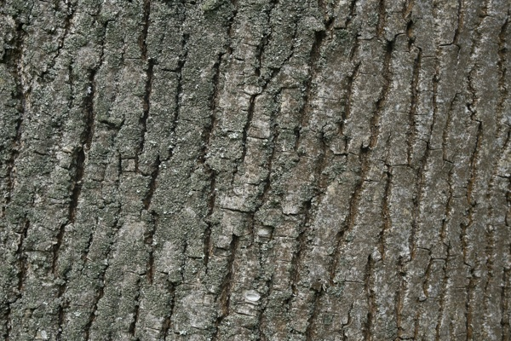7_1.png:** 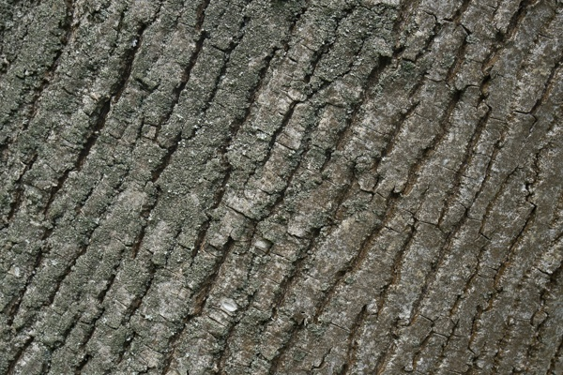

**Table 1 - Found homography parameters and normalization accuracy assessment**

|  |  |  |  |  |  |  |  |  |  |  |  |  |  |  |  |
| --- | --- | --- | --- | --- | --- | --- | --- | --- | --- | --- | --- | --- | --- | --- | --- |
| Original:  img1: 0 img2: 0 | h11 | h12 | h13 | h21 | h22 | h23 | h31 | h32 | h33 | avg ErrPar (param) | avg ErrIM (pixel) | max ErrIM | avg ErrCPM (corner) | max ErrCPM | Expert rate |
| SIFT | 0,838 | -0,27 | 81,18 | 0,255 | 0,901 | -75,282 | -0 | 0 | 1 | 0 | 1,15 | 4,106 | ~ | ~ |  |
| SURF128 | 0,841 | -0,27 | 81,087 | 0,264 | 0,901 | -76,163 | -0 | 0 | 1 | 0 | 1,065 | 2,941 | ~ | ~ |  |
| SURF64 | 0,816 | -0,271 | 82,586 | 0,242 | 0,867 | -66,411 | -0 | 0 | 1 | 0 | 1,109 | 3,996 | ~ | ~ |  |
| ORB | 0,819 | -0,269 | 82,076 | 0,244 | 0,873 | -67,46 | -0 | 0 | 1 | 0 | 0,921 | 3,503 | ~ | ~ |  |
| ORB1000 | 0,843 | -0,27 | 80,769 | 0,266 | 0,903 | -76,304 | -0 | 0 | 1 | 0 | 1,021 | 3,369 | ~ | ~ |  |
| BRISK | 0,838 | -0,27 | 80,99 | 0,258 | 0,898 | -74,788 | -0 | 0 | 1 | 0 | 1,059 | 3,637 | ~ | ~ |  |
| KAZE | 0,839 | -0,272 | 81,592 | 0,264 | 0,9 | -76,206 | -0 | 0 | 1 | 0 | 0,792 | 3,514 | ~ | ~ |  |
| AKAZE | 0,834 | -0,27 | 81,255 | 0,256 | 0,888 | -72,91 | -0 | 0 | 1 | 0 | 0,874 | 3,158 | ~ | ~ |  |
| Original matrix |  |  |  |  |  |  |  |  |  |  |  |  |  |  |  |

where h11, h12, h13, h21, h22, h23, h31, h32, h33 - parameters of found homography matrix H* or of original one H;   
avgErrPar - average error of found parameters, the accuracy of found homography matrix parameters with a preliminary minimax normalization of found and original matrices;  
avgErrIM - average error of inlier coordinate matching;  
inliers - correct matches; outliers - false matches;  
maxErrIM – maximum error of inlier coordinate matching;  
avgErrCPM - average error of corner point matching;  
maxErrCPM - maximum error of corner point matching;  
expert rate - experts assessment of normalization accuracy with a 5-point scale: 0 - normalization failed, 1 - insufficient, 2 - satisfactory, 3 - good, 4 – excellent.

**Table 2 - Quantitative evaluation of descriptors, precision and recall estimation (with found overlap)**

|  |  |  |  |  |  |  |  |  |  |  |  |  |  |  |  |  |
| --- | --- | --- | --- | --- | --- | --- | --- | --- | --- | --- | --- | --- | --- | --- | --- | --- |
| Name | NP1 | NP2 | NM | NI | DP1 | DP2 | OP1 | OP2 | NPO1 | NPO2 | NMO | DPO1 | DPO2 | Precision | RecallO1 | Comments |
| SIFT | 3931 | 3939 | 1981 | 1563 | 0,0164 | 0,0164 | 88,5425 | 85,625 | 3531 | 3422 | 1981 | 0,0166 | 0,0167 | 0,789 | 0,4427 |  |
| SURF128 | 3618 | 3503 | 462 | 376 | 0,0151 | 0,0146 | 88,8975 | 84,9887 | 3401 | 3195 | 461 | 0,0159 | 0,0157 | 0,8139 | 0,1106 |  |
| SURF64 | 3618 | 3503 | 780 | 505 | 0,0151 | 0,0146 | 89,4158 | 84,9638 | 3425 | 3193 | 779 | 0,016 | 0,0157 | 0,6474 | 0,1474 |  |
| ORB | 26797 | 26895 | 10622 | 7811 | 0,1117 | 0,1121 | 89,37 | 84,9683 | 26356 | 25923 | 10621 | 0,1229 | 0,1271 | 0,7354 | 0,2964 |  |
| ORB1000 | 1000 | 1000 | 421 | 344 | 0,0042 | 0,0042 | 89,0212 | 84,8825 | 985 | 985 | 421 | 0,0046 | 0,0048 | 0,8171 | 0,3492 |  |
| BRISK | 11816 | 11848 | 3936 | 3446 | 0,0492 | 0,0494 | 88,73 | 85,3729 | 11279 | 10975 | 3936 | 0,053 | 0,0536 | 0,8755 | 0,3055 |  |
| KAZE | 1366 | 1393 | 793 | 678 | 0,0057 | 0,0058 | 88,7896 | 85,0979 | 1246 | 1217 | 791 | 0,0058 | 0,006 | 0,855 | 0,5441 |  |
| AKAZE | 1472 | 1471 | 826 | 772 | 0,0061 | 0,0061 | 88,9633 | 85,1329 | 1430 | 1400 | 826 | 0,0067 | 0,0069 | 0,9346 | 0,5399 |  |

where NP - number of found key points; NP1, NP2 - number of found key points for image1 and image2 respectively;  
NM - number of matches found with NNDR method, NM=NI+NO;  
NI - number of inliers found with RANSAC method;  
NO - number of outliers discarded with RANSAC method;   
DP - density of key points (per cent), DP= NP/(height x width) , height, width - vertical and horizontal image sizes respectively (pixels)  
DP1, DP2 - density of key points points for image1 and image2 respectively;  
OP1, OP2 - overlap percentage for image1 and image2 respectively;  
NPO1, NPO2 - number of found key points on overlap for image1 and image2 respectivelyy;  
NMO - number of matches on overlap found with NNDR method;  
DPO1, DPO2 - density of key points points on overlap for image1 and image2 respectively;   
OA - overlap area (pixels), OA1, OA2 - overlap area for image1 and image2 respectively;  
DPO1= NPO1/OA1; DPO2= NPO2/OA2;  
Precision = NI/ NM - the rate to evaluate the part of inliers to all found matches with NNDR method;  
RecallO1 = NI/ NPO1 - completeness of inlier retrieval relative to the number of all key points on overlap for image1. The rate illustrates usefulness of the found key points for normalization.

**Table 3 - Estimation of time costs**

|  |  |  |  |  |  |  |  |  |  |  |
| --- | --- | --- | --- | --- | --- | --- | --- | --- | --- | --- |
| Name | NP1 | NP2 | DesT1, sec | DesT2, sec | MatchT, sec | InlierT, sec | AvgDesT, ms | AvgMatchT, ms | AvgInlierT, ms | TotalNormT, sec |
| SIFT | 3931 | 3939 | 0,066783 | 0,068355 | 0,136114 | 0,001307 | 0,01717 | 0,068709 | 0,000836 | 0,272558 |
| SURF128 | 3618 | 3503 | 0,083976 | 0,083178 | 0,095478 | 0,000586 | 0,023477 | 0,206662 | 0,001559 | 0,263219 |
| SURF64 | 3618 | 3503 | 0,092828 | 0,082075 | 0,052966 | 0,001158 | 0,024543 | 0,067905 | 0,002293 | 0,229027 |
| ORB | 26797 | 26895 | 0,049047 | 0,048592 | 1,554913 | 0,007553 | 0,001818 | 0,146386 | 0,000967 | 1,660105 |
| ORB1000 | 1000 | 1000 | 0,012885 | 0,012766 | 0,003179 | 0,000555 | 0,012825 | 0,00755 | 0,001613 | 0,029385 |
| BRISK | 11816 | 11848 | 0,186176 | 0,186738 | 0,338169 | 0,002486 | 0,015758 | 0,085916 | 0,000721 | 0,713569 |
| KAZE | 1366 | 1393 | 0,117354 | 0,117819 | 0,017583 | 0,000692 | 0,085244 | 0,022172 | 0,001019 | 0,253448 |
| AKAZE | 1472 | 1471 | 0,016255 | 0,01583 | 0,007489 | 0,000917 | 0,010902 | 0,009065 | 0,001188 | 0,040491 |

where DesT – descriptor creation time (time for key point detection and descriptor computation), DesT1, DesT2 – creation time of descriptors for image1 and image2 respectively;  
MatchT - retrieval time of matching found with NNDR method for the pair;  
InlierT – inlier retrieval time found with RANSAC method for the pair;  
AvgDesT – average time for one descriptor creation;  
AvgMatchT - average time for one match retrieval with NNDR method;  
AvgInlierT – average time for one inlier retrieval with RANSAC method;  
TotalNormT – total normalization time for the pair.