**Normalization results for pairs 8_0.png_8_1.png from subset png\texture_nature**

**8_0.png: 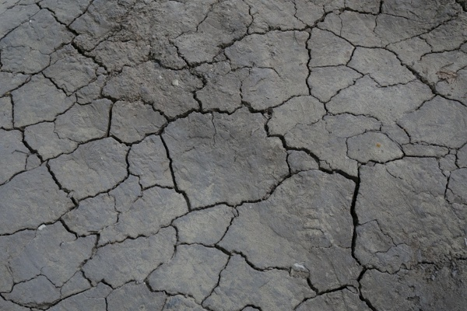8_1.png:** 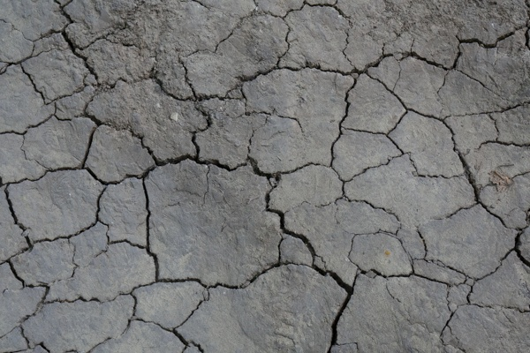

**Table 1 - Found homography parameters and normalization accuracy assessment**

|  |  |  |  |  |  |  |  |  |  |  |  |  |  |  |  |
| --- | --- | --- | --- | --- | --- | --- | --- | --- | --- | --- | --- | --- | --- | --- | --- |
| Original:  img1: 0 img2: 0 | h11 | h12 | h13 | h21 | h22 | h23 | h31 | h32 | h33 | avg ErrPar (param) | avg ErrIM (pixel) | max ErrIM | avg ErrCPM (corner) | max ErrCPM | Expert rate |
| SIFT | 1,058 | -0,199 | -14,577 | 0,229 | 1,247 | -50,319 | -0 | 0 | 1 | 0 | 1,109 | 3,601 | ~ | ~ |  |
| SURF128 | 1,068 | -0,179 | -15,833 | 0,255 | 1,286 | -57,006 | -0 | 0 | 1 | 0 | 1,527 | 3,588 | ~ | ~ |  |
| SURF64 | 1,083 | -0,189 | -17,443 | 0,257 | 1,29 | -57,942 | 0 | 0 | 1 | 0 | 1,505 | 3,249 | ~ | ~ |  |
| ORB | 1,072 | -0,2 | -15,183 | 0,259 | 1,256 | -55,514 | 0 | 0 | 1 | 0 | 1,343 | 3,698 | ~ | ~ |  |
| ORB1000 | 1,059 | -0,159 | -17,176 | 0,23 | 1,313 | -56,639 | -0 | 0,001 | 1 | 0 | 1,369 | 3,9 | ~ | ~ |  |
| BRISK | 1,064 | -0,196 | -14,854 | 0,246 | 1,257 | -53,843 | -0 | 0 | 1 | 0 | 1,175 | 4,187 | ~ | ~ |  |
| KAZE | 1,077 | -0,2 | -14,907 | 0,257 | 1,296 | -59,239 | 0 | 0 | 1 | 0 | 1,229 | 3,147 | ~ | ~ |  |
| AKAZE | 1,076 | -0,198 | -15,525 | 0,252 | 1,261 | -54,837 | 0 | 0 | 1 | 0 | 1,133 | 2,865 | ~ | ~ |  |
| Original matrix |  |  |  |  |  |  |  |  |  |  |  |  |  |  |  |

where h11, h12, h13, h21, h22, h23, h31, h32, h33 - parameters of found homography matrix H* or of original one H;   
avgErrPar - average error of found parameters, the accuracy of found homography matrix parameters with a preliminary minimax normalization of found and original matrices;  
avgErrIM - average error of inlier coordinate matching;  
inliers - correct matches; outliers - false matches;  
maxErrIM – maximum error of inlier coordinate matching;  
avgErrCPM - average error of corner point matching;  
maxErrCPM - maximum error of corner point matching;  
expert rate - experts assessment of normalization accuracy with a 5-point scale: 0 - normalization failed, 1 - insufficient, 2 - satisfactory, 3 - good, 4 – excellent.

**Table 2 - Quantitative evaluation of descriptors, precision and recall estimation (with found overlap)**

|  |  |  |  |  |  |  |  |  |  |  |  |  |  |  |  |  |
| --- | --- | --- | --- | --- | --- | --- | --- | --- | --- | --- | --- | --- | --- | --- | --- | --- |
| Name | NP1 | NP2 | NM | NI | DP1 | DP2 | OP1 | OP2 | NPO1 | NPO2 | NMO | DPO1 | DPO2 | Precision | RecallO1 | Comments |
| SIFT | 1703 | 1816 | 669 | 456 | 0,0071 | 0,0076 | 73,7929 | 90,9004 | 1310 | 1631 | 668 | 0,0074 | 0,0075 | 0,6816 | 0,3481 |  |
| SURF128 | 2577 | 2729 | 293 | 156 | 0,0107 | 0,0114 | 74,64 | 89,7958 | 2137 | 2566 | 291 | 0,0119 | 0,0119 | 0,5324 | 0,073 |  |
| SURF64 | 2577 | 2729 | 499 | 278 | 0,0107 | 0,0114 | 74,1442 | 89,66 | 2124 | 2565 | 496 | 0,0119 | 0,0119 | 0,5571 | 0,1309 |  |
| ORB | 6485 | 7301 | 1499 | 1044 | 0,027 | 0,0304 | 74,0363 | 88,6912 | 5889 | 7057 | 1497 | 0,0331 | 0,0332 | 0,6965 | 0,1773 |  |
| ORB1000 | 1000 | 1000 | 269 | 178 | 0,0042 | 0,0042 | 74,9625 | 91,9763 | 977 | 991 | 269 | 0,0054 | 0,0045 | 0,6617 | 0,1822 |  |
| BRISK | 2307 | 2613 | 561 | 384 | 0,0096 | 0,0109 | 74,0483 | 89,8896 | 2002 | 2487 | 561 | 0,0113 | 0,0115 | 0,6845 | 0,1918 |  |
| KAZE | 536 | 647 | 244 | 165 | 0,0022 | 0,0027 | 73,5387 | 90,0117 | 454 | 617 | 244 | 0,0026 | 0,0029 | 0,6762 | 0,3634 |  |
| AKAZE | 459 | 562 | 201 | 139 | 0,0019 | 0,0023 | 74,3554 | 89,41 | 421 | 545 | 199 | 0,0024 | 0,0025 | 0,6915 | 0,3302 |  |

where NP - number of found key points; NP1, NP2 - number of found key points for image1 and image2 respectively;  
NM - number of matches found with NNDR method, NM=NI+NO;  
NI - number of inliers found with RANSAC method;  
NO - number of outliers discarded with RANSAC method;   
DP - density of key points (per cent), DP= NP/(height x width) , height, width - vertical and horizontal image sizes respectively (pixels)  
DP1, DP2 - density of key points points for image1 and image2 respectively;  
OP1, OP2 - overlap percentage for image1 and image2 respectively;  
NPO1, NPO2 - number of found key points on overlap for image1 and image2 respectivelyy;  
NMO - number of matches on overlap found with NNDR method;  
DPO1, DPO2 - density of key points points on overlap for image1 and image2 respectively;   
OA - overlap area (pixels), OA1, OA2 - overlap area for image1 and image2 respectively;  
DPO1= NPO1/OA1; DPO2= NPO2/OA2;  
Precision = NI/ NM - the rate to evaluate the part of inliers to all found matches with NNDR method;  
RecallO1 = NI/ NPO1 - completeness of inlier retrieval relative to the number of all key points on overlap for image1. The rate illustrates usefulness of the found key points for normalization.

**Table 3 - Estimation of time costs**

|  |  |  |  |  |  |  |  |  |  |  |
| --- | --- | --- | --- | --- | --- | --- | --- | --- | --- | --- |
| Name | NP1 | NP2 | DesT1, sec | DesT2, sec | MatchT, sec | InlierT, sec | AvgDesT, ms | AvgMatchT, ms | AvgInlierT, ms | TotalNormT, sec |
| SIFT | 1703 | 1816 | 0,05053 | 0,052823 | 0,024777 | 0,000972 | 0,029378 | 0,037036 | 0,002132 | 0,129103 |
| SURF128 | 2577 | 2729 | 0,068028 | 0,070504 | 0,054544 | 0,001791 | 0,026116 | 0,186157 | 0,011482 | 0,194868 |
| SURF64 | 2577 | 2729 | 0,067078 | 0,067912 | 0,029887 | 0,001632 | 0,025457 | 0,059893 | 0,005868 | 0,166509 |
| ORB | 6485 | 7301 | 0,016717 | 0,018022 | 0,106279 | 0,001506 | 0,002522 | 0,070899 | 0,001442 | 0,142523 |
| ORB1000 | 1000 | 1000 | 0,009207 | 0,009305 | 0,002985 | 0,000867 | 0,009255 | 0,011096 | 0,004868 | 0,022364 |
| BRISK | 2307 | 2613 | 0,034285 | 0,038658 | 0,017734 | 0,000882 | 0,014827 | 0,031611 | 0,002296 | 0,091559 |
| KAZE | 536 | 647 | 0,108885 | 0,105678 | 0,003266 | 0,000824 | 0,183239 | 0,013386 | 0,004991 | 0,218653 |
| AKAZE | 459 | 562 | 0,016498 | 0,016291 | 0,001337 | 0,000736 | 0,032465 | 0,006653 | 0,005294 | 0,034863 |

where DesT – descriptor creation time (time for key point detection and descriptor computation), DesT1, DesT2 – creation time of descriptors for image1 and image2 respectively;  
MatchT - retrieval time of matching found with NNDR method for the pair;  
InlierT – inlier retrieval time found with RANSAC method for the pair;  
AvgDesT – average time for one descriptor creation;  
AvgMatchT - average time for one match retrieval with NNDR method;  
AvgInlierT – average time for one inlier retrieval with RANSAC method;  
TotalNormT – total normalization time for the pair.