**Normalization results for pairs 9_0.png_9_1.png from subset png\texture_nature**

**9_0.png: 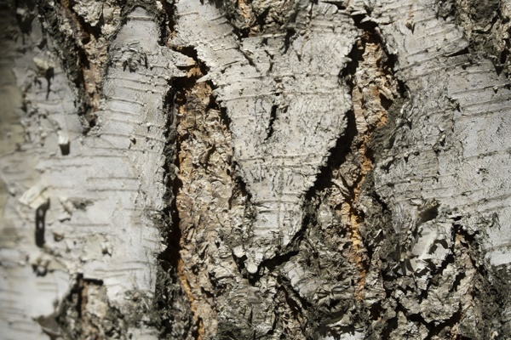9_1.png:** 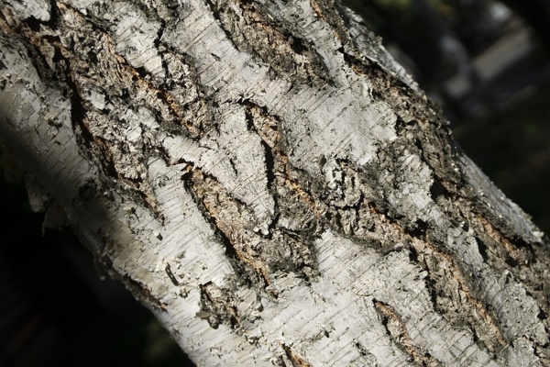

**Table 1 - Found homography parameters and normalization accuracy assessment**

|  |  |  |  |  |  |  |  |  |  |  |  |  |  |  |  |
| --- | --- | --- | --- | --- | --- | --- | --- | --- | --- | --- | --- | --- | --- | --- | --- |
| Original:  img1: 0 img2: 0 | h11 | h12 | h13 | h21 | h22 | h23 | h31 | h32 | h33 | avg ErrPar (param) | avg ErrIM (pixel) | max ErrIM | avg ErrCPM (corner) | max ErrCPM | Expert rate |
| SIFT | 0,365 | 0,249 | 101,502 | -0,259 | 0,372 | 210,788 | -0 | -0 | 1 | 0 | 0,801 | 2,443 | ~ | ~ |  |
| SURF128 | 0,367 | 0,244 | 101,111 | -0,258 | 0,37 | 210,223 | -0 | -0 | 1 | 0 | 1,158 | 3,314 | ~ | ~ |  |
| SURF64 | 0,373 | 0,255 | 99,761 | -0,256 | 0,377 | 209,619 | 0 | -0 | 1 | 0 | 1,112 | 3,177 | ~ | ~ |  |
| ORB | 0,372 | 0,244 | 101,2 | -0,256 | 0,369 | 210,24 | 0 | -0 | 1 | 0 | 0,894 | 3,771 | ~ | ~ |  |
| ORB1000 | 0,363 | 0,271 | 99,76 | -0,268 | 0,396 | 209,622 | -0 | 0 | 1 | 0 | 0,876 | 2,867 | ~ | ~ |  |
| BRISK | 0,369 | 0,237 | 101,226 | -0,255 | 0,361 | 210,243 | 0 | -0 | 1 | 0 | 0,924 | 2,954 | ~ | ~ |  |
| KAZE | 0,382 | 0,249 | 98,18 | -0,252 | 0,374 | 208,954 | 0 | -0 | 1 | 0 | 0,797 | 2,278 | ~ | ~ |  |
| AKAZE | 0,36 | 0,254 | 100,937 | -0,261 | 0,377 | 209,386 | -0 | -0 | 1 | 0 | 0,847 | 2,649 | ~ | ~ |  |
| Original matrix |  |  |  |  |  |  |  |  |  |  |  |  |  |  |  |

where h11, h12, h13, h21, h22, h23, h31, h32, h33 - parameters of found homography matrix H* or of original one H;   
avgErrPar - average error of found parameters, the accuracy of found homography matrix parameters with a preliminary minimax normalization of found and original matrices;  
avgErrIM - average error of inlier coordinate matching;  
inliers - correct matches; outliers - false matches;  
maxErrIM – maximum error of inlier coordinate matching;  
avgErrCPM - average error of corner point matching;  
maxErrCPM - maximum error of corner point matching;  
expert rate - experts assessment of normalization accuracy with a 5-point scale: 0 - normalization failed, 1 - insufficient, 2 - satisfactory, 3 - good, 4 – excellent.

**Table 2 - Quantitative evaluation of descriptors, precision and recall estimation (with found overlap)**

|  |  |  |  |  |  |  |  |  |  |  |  |  |  |  |  |  |
| --- | --- | --- | --- | --- | --- | --- | --- | --- | --- | --- | --- | --- | --- | --- | --- | --- |
| Name | NP1 | NP2 | NM | NI | DP1 | DP2 | OP1 | OP2 | NPO1 | NPO2 | NMO | DPO1 | DPO2 | Precision | RecallO1 | Comments |
| SIFT | 4915 | 3576 | 576 | 503 | 0,0205 | 0,0149 | 100 | 20,7604 | 4915 | 921 | 576 | 0,0205 | 0,0185 | 0,8733 | 0,1023 |  |
| SURF128 | 3000 | 2453 | 110 | 85 | 0,0125 | 0,0102 | 100 | 20,8333 | 3000 | 732 | 110 | 0,0125 | 0,0146 | 0,7727 | 0,0283 |  |
| SURF64 | 3000 | 2453 | 178 | 131 | 0,0125 | 0,0102 | 100 | 20,7696 | 3000 | 730 | 178 | 0,0125 | 0,0146 | 0,736 | 0,0437 |  |
| ORB | 22561 | 22246 | 1440 | 1342 | 0,094 | 0,0927 | 100 | 20,8462 | 22561 | 8311 | 1440 | 0,094 | 0,1661 | 0,9319 | 0,0595 |  |
| ORB1000 | 1000 | 1000 | 101 | 90 | 0,0042 | 0,0042 | 100 | 21,0779 | 1000 | 533 | 101 | 0,0042 | 0,0105 | 0,8911 | 0,09 |  |
| BRISK | 10084 | 9944 | 801 | 655 | 0,042 | 0,0414 | 100 | 20,8888 | 10084 | 3346 | 801 | 0,042 | 0,0667 | 0,8177 | 0,065 |  |
| KAZE | 1962 | 1647 | 124 | 105 | 0,0082 | 0,0069 | 100 | 20,9496 | 1962 | 493 | 124 | 0,0082 | 0,0098 | 0,8468 | 0,0535 |  |
| AKAZE | 2048 | 1808 | 134 | 107 | 0,0085 | 0,0075 | 100 | 20,9017 | 2048 | 626 | 134 | 0,0085 | 0,0125 | 0,7985 | 0,0522 |  |

where NP - number of found key points; NP1, NP2 - number of found key points for image1 and image2 respectively;  
NM - number of matches found with NNDR method, NM=NI+NO;  
NI - number of inliers found with RANSAC method;  
NO - number of outliers discarded with RANSAC method;   
DP - density of key points (per cent), DP= NP/(height x width) , height, width - vertical and horizontal image sizes respectively (pixels)  
DP1, DP2 - density of key points points for image1 and image2 respectively;  
OP1, OP2 - overlap percentage for image1 and image2 respectively;  
NPO1, NPO2 - number of found key points on overlap for image1 and image2 respectivelyy;  
NMO - number of matches on overlap found with NNDR method;  
DPO1, DPO2 - density of key points points on overlap for image1 and image2 respectively;   
OA - overlap area (pixels), OA1, OA2 - overlap area for image1 and image2 respectively;  
DPO1= NPO1/OA1; DPO2= NPO2/OA2;  
Precision = NI/ NM - the rate to evaluate the part of inliers to all found matches with NNDR method;  
RecallO1 = NI/ NPO1 - completeness of inlier retrieval relative to the number of all key points on overlap for image1. The rate illustrates usefulness of the found key points for normalization.

**Table 3 - Estimation of time costs**

|  |  |  |  |  |  |  |  |  |  |  |
| --- | --- | --- | --- | --- | --- | --- | --- | --- | --- | --- |
| Name | NP1 | NP2 | DesT1, sec | DesT2, sec | MatchT, sec | InlierT, sec | AvgDesT, ms | AvgMatchT, ms | AvgInlierT, ms | TotalNormT, sec |
| SIFT | 4915 | 3576 | 0,067584 | 0,059871 | 0,134578 | 0,000628 | 0,015246 | 0,233642 | 0,001248 | 0,26266 |
| SURF128 | 3000 | 2453 | 0,076919 | 0,063109 | 0,05853 | 0,000509 | 0,025683 | 0,532089 | 0,005987 | 0,199067 |
| SURF64 | 3000 | 2453 | 0,068331 | 0,063206 | 0,031123 | 0,000584 | 0,024271 | 0,174848 | 0,004455 | 0,163244 |
| ORB | 22561 | 22246 | 0,043199 | 0,041472 | 1,125453 | 0,00112 | 0,001889 | 0,781564 | 0,000834 | 1,211244 |
| ORB1000 | 1000 | 1000 | 0,013532 | 0,012328 | 0,003301 | 0,00037 | 0,012929 | 0,032683 | 0,004111 | 0,029531 |
| BRISK | 10084 | 9944 | 0,158346 | 0,145893 | 0,23395 | 0,000804 | 0,015186 | 0,292072 | 0,001227 | 0,538993 |
| KAZE | 1962 | 1647 | 0,119797 | 0,097745 | 0,025605 | 0,000409 | 0,060202 | 0,20649 | 0,003894 | 0,243556 |
| AKAZE | 2048 | 1808 | 0,02014 | 0,017345 | 0,012633 | 0,00048 | 0,009713 | 0,094276 | 0,004488 | 0,050599 |

where DesT – descriptor creation time (time for key point detection and descriptor computation), DesT1, DesT2 – creation time of descriptors for image1 and image2 respectively;  
MatchT - retrieval time of matching found with NNDR method for the pair;  
InlierT – inlier retrieval time found with RANSAC method for the pair;  
AvgDesT – average time for one descriptor creation;  
AvgMatchT - average time for one match retrieval with NNDR method;  
AvgInlierT – average time for one inlier retrieval with RANSAC method;  
TotalNormT – total normalization time for the pair.