**Project Title: Smart Device Repair Services Management System**

**Milestone 1**

**1.1. Conceptual Modeling**

### **1.1.1. Application Domain Description**

In our system, **Users[ name,email,phone,password,...]** serves as a **supertype**, representing all individuals who interact with the platform, including both **Customers[Prefered Contact Method, Loyalty Points]** and **Employees[Job title, Salary, Hire Date, Shift]**. **Customers** are **users** who book **repair services[service_name (e.g., Battery replacement), description,price,time_taken]**, browse available repairs, and manage their **repair appointments[date_time,status (Pending, Completed, Cancelled), total_price (Final price for all selected services)]**.

On the other hand, **Employees** are **users** responsible for managing **repair appointments**, updating repair statuses, and ensuring smooth service execution. **Employees** may include **technicians**, who perform the actual repairs, **customer support staff**, who assist users with inquiries, and **admin** that manage overall the system. While both Customers and Employees share common attributes such as **name, email, phone, and password**, Employees have additional permissions, allowing them to **modify repair details, update repair appointments statuses, and manage payment[amount,status (Paid, Unpaid), payment_method, payment_date] processing**. This structured user hierarchy ensures clear role differentiation while maintaining an efficient repair management workflow.

The system supports different **device types[type_name (e.g., Smartphone, Tablet…),description]**, each associated with **multiple brands[brand_name (e.g., Samsung, Apple), country (Country of origin), founded_year]**. Every brand, in turn, offers a variety of **device models[model_name (e.g., Galaxy A55), release_year (Year the model was released)]**, ensuring that **customers** can find the correct **repair service** for their specific device. Each **repair service** is tied to a particular **device model** and includes essential details such as **service name, description, price, estimated time for repair**. **Users** can select **multiple repair services** (e.g., battery replacement and screen repair) for the same device in a single **repair appointments**. Additionally, the system allows **users** to choose from different **service methods[method_name (Visit Store, Send Device, Pickup), estimated_time, cost],** but only **one service method** should be selected. The estimated time and cost of the service may vary depending on the selected method.

The **repair appointments** process includes selecting a **date and time** for the repair, ensuring convenience for the **users**. Once a **repair appointments** is confirmed, it is assigned a **status** (e.g., Pending, Completed, Canceled) that updates throughout the service process. **Users** also receive information about the **total cost** of the selected services and can proceed with **payment** using various methods such as **credit card, PayPal, or cash on delivery**.

The system maintains an organized structure of its relationships: **Users** can **place multiple repair appointments,** and each repair appointments can include **multiple repair services**. Additionally, the system supports an **administration role** where **admins** can **manage repair services,** update pricing, and oversee **repair appointments**. This structure ensures an efficient, user-friendly experience while allowing service providers to maintain a well-organized repair management system.

### **1.1.2. Logical Design**

The Entity-Relationship (ER) diagram for the repair management system follows **CHEN notation**, capturing all essential elements of the application domain. The diagram represents key entities, such as **User**, **Customer**, **Employee**, **RepairAppointment**, **RepairService**, **ServiceMethod**, **Payment**, **DeviceModel**, **Brand**, and **DeviceType**, along with their attributes and relationships. The relationships are clearly defined, ensuring necessary functionalities are supported, such as customers making **repair appointments**, employees managing services, and services being associated with appointments and payments. The **many-to-many** relationships, such as between **RepairAppointment** and **RepairService**, are properly modeled using associative entities. This design ensures that the system accurately reflects the business logic and can handle all operations related to service requests, appointments, payments, and device management, as required.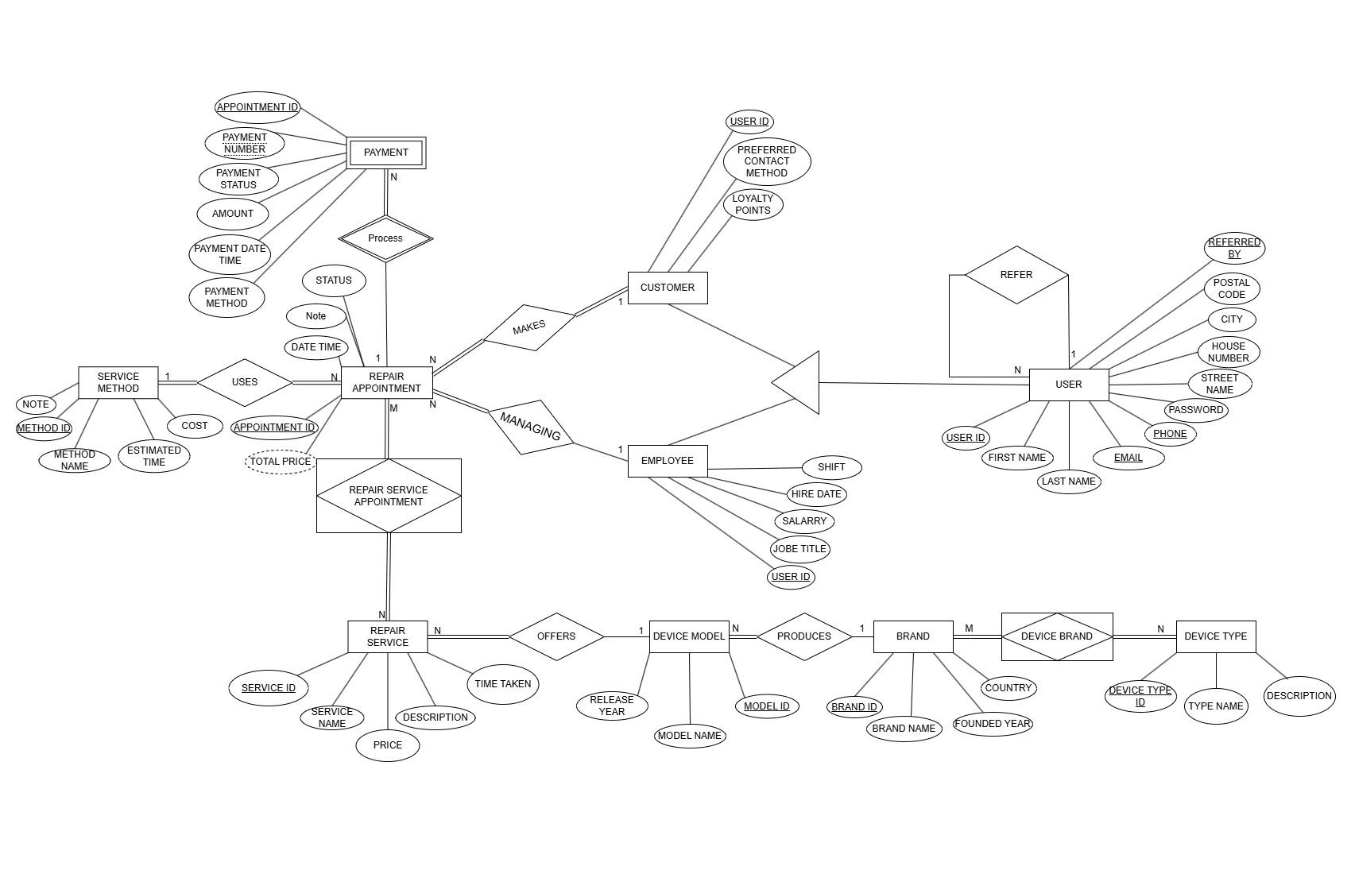

**1.1.3. Relational Modeling**

**User**: Stores information about users, including their contact details, address, and unique identifiers. It is the base table for other entities like customers and employees.

| **Column Name** | **Data Type** | **Description** |
| --- | --- | --- |
| **user_id** | **INT (PK)** | **Unique identifier for the user** |
| **first_name** | **VARCHAR(50)** | **First name of the user** |
| **last_name** | **VARCHAR(50)** | **Last name of the user** |
| **email** | **VARCHAR(100)** | **User's email (must be unique)** |
| **phone** | **VARCHAR(15)** | **Contact phone number** |
| **password** | **VARCHAR(255)** | **Encrypted user password** |
| **street_name** | **VARCHAR(100)** | **Street address** |
| **house_number** | **VARCHAR(10)** | **House number** |
| **city** | **VARCHAR(50)** | **City of residence** |
| **postal_code** | **VARCHAR(10)** | **Postal code** |
| **referred_by** | **INT (FK → User)** | **Referral user ID (if any)** |

**Customer**: Inherits from the User table and includes additional details specific to customers, such as preferred contact method and loyalty points.

| **Column Name** | **Data Type** | **Description** |
| --- | --- | --- |
| **user_id (PK, FK → User)** | **INT** | **Customer's user ID** |
| **preferred_contact_method** | **VARCHAR(50)** | **Preferred way to contact customer** |
| **loyalty_points** | **INT** | **Reward points earned by the customer** |

**Employee**: Inherits from the User table and stores employee-specific data like job title, salary, hire date, and assigned shift.

| **Column Name** | **Data Type** | **Description** |
| --- | --- | --- |
| **user_id (PK, FK → User)** | **INT** | **Employee's user ID** |
| **job_title** | **VARCHAR(50)** | **Job title of the employee** |
| **salary** | **DECIMAL(10,2)** | **Monthly salary** |
| **hire_date** | **DATE** | **Date of employment** |
| **shift** | **VARCHAR(50)** | **Assigned work shift** |

**Repair Appointments**: Represents a customer’s repair appointments, linking to the Customer table, including details like repair appointments date/time, status, and total cost.

| **Column Name** | **Data Type** | **Description** |
| --- | --- | --- |
| **appointment_id** | **INT (PK)** | **Unique repair appointments ID** |
| **customer_id** | **INT (FK → Customer)** | **Customer who made the repair appointments** |
| **employee_id** | **INT (FK → Employee)** | **Employee who manage and process it** |
| **method_id** | **INT (FK → Service Method)** | **Service methods (e.g., Pickup)** |
| **date_time** | **DATETIME** | **Scheduled date and time** |
| **status** | **ENUM('Pending', 'Completed', 'Cancelled')** | **repair appointments status** |
| **total_price** | **DECIMAL(10,2)** | **Total cost of selected services** |

**Repair Service**: Stores information about repair services offered, including the service name, description, price, and estimated time to complete.

| **Column Name** | **Data Type** | **Description** |
| --- | --- | --- |
| **service_id** | **INT (PK)** | **Unique ID of the service** |
| **service_name** | **VARCHAR(100)** | **Name of the service** |
| **description** | **TEXT** | **Description of the service** |
| **price** | **DECIMAL(10,2)** | **Price of the service** |
| **time_taken** | **INT (Minutes)** | **Estimated repair time (minutes)** |

**Repair Service Appointments** : An associative entity that establishes a many-to-many (M:N) relationship between repair appointments and repair services, linking each repair appointments to one or more repair services selected by the customer.

| **Column Name** | **Data Type** | **Description** |
| --- | --- | --- |
| **service_id** | **INT (FK → Repair Service)** | **Related Repair Service ID** |
| **bookin_id** | **INT (FK → repair appointments)** | **Related repair appointments ID** |

**Service Method**: Details different service methods (e.g., Pickup), including the method name, estimated time, and associated cost.

| **Column Name** | **Data Type** | **Description** |
| --- | --- | --- |
| **method_id** | **INT (PK)** | **Unique service method ID** |
| **method_name** | **VARCHAR(50)** | **Service method type (e.g., Pickup)** |
| **estimated_time** | **INT (Minutes)** | **Estimated time for completion** |
| **cost** | **DECIMAL(10,2)** | **Additional cost for this method** |
| **note** | **TEXT** | **Additional notes** |

**Payment**: Tracks payment transactions related to repair appointments, including payment amount, status, method, and transaction details.

| **Column Name** | **Data Type** | **Description** |
| --- | --- | --- |
| **appointment_id** (PK, FK → RepairAppointment) | **INT** | **Related repair appointment ID** |
| **payment_number(PK)** | **VARCHAR(50)** | **Unique transaction number** |
| **amount** | **DECIMAL(10,2)** | **Payment amount** |
| **payment_status** | **ENUM('Paid', 'Unpaid')** | **Status of the payment** |
| **payment_method** | **VARCHAR(50)** | **Payment method (e.g., Credit Card)** |
| **payment_date_time** | **DATETIME** | **Date and time of the transaction** |

**Device Type**: Describes different types of devices (e.g., smartphone, tablet).

| **Column Name** | **Data Type** | **Description** |
| --- | --- | --- |
| **device_type_id** | **INT (PK)** | **Unique device type ID** |
| **type_name** | **VARCHAR(100)** | **Name of the device type** |
| **description** | **TEXT** | **Description of the device type** |

**Brand**: Represents brands of devices (e.g., Samsung, Apple).

| **Column Name** | **Data Type** | **Description** |
| --- | --- | --- |
| **brand_id** | **INT (PK)** | **Unique brand ID** |
| **brand_name** | **VARCHAR(100)** | **Name of the brand** |
| **country** | **VARCHAR(50)** | **Country of origin** |
| **founded_year** | **YEAR** | **Year brand was founded** |

**Device Type Brand**: An association table linking Device Types and Brands to define the relationships between them.

| **Column Name** | **Data Type** | **Description** |
| --- | --- | --- |
| **device_type_id** | **INT (FK → Device Type)** | **Related device type ID** |
| **brand_id** | **INT (FK → Brand)** | **Related brand ID** |