1. **Writing question (10 points)**

**Please provide one example each for scientific data and information data. Describe why you think the data you select is a scientific (or information) data.**

Scientific Data: Data of the levels of electric conductivity of different solutions is a good example of scientific data.

It is Scientific data as it has measurable coordinates that are used to represent it namely conductivity, molarity and concentration of solution. This data can be collected in the real world through experimentation. The data is also continuous as we can determine an estimated conductivity of a solution between any two given data points. Therefore, I believe that this is a good example of scientific data.

Information Data: A data set of the number of people diagnosed with cancer and go into remission in a region over a period is a good example of information data.

My reasoning for this is that there are no fixed coordinates for us to determine this data with. Each patient is different and as such the data is very abstract. This data is also discreet as their records are individual. This is why I believe that this data is an example of information data.

1. **Individual plots/charts generation (40 points)**

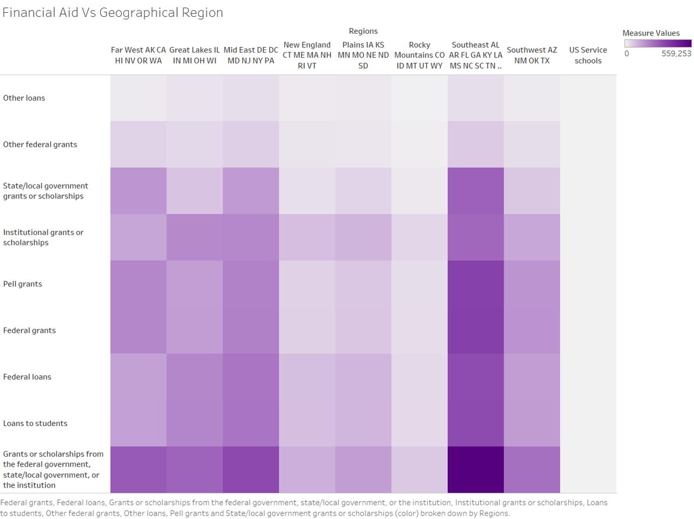

Figure 1:Number of full-time, first-time students receiving financial aid, by geographic region and type of aid: 2015-16

This plot is from the dataset of Financial aid Vs Geographical Region. It gives us a picture of how various grants and loans distributed over different geographical regions for the year 2015-2016. The gradient represents the amount of funding from the lightest being the lowest to the darker shades representing higher funding. It allows us to see which regions received the most funding and which regions were not so well endowed.

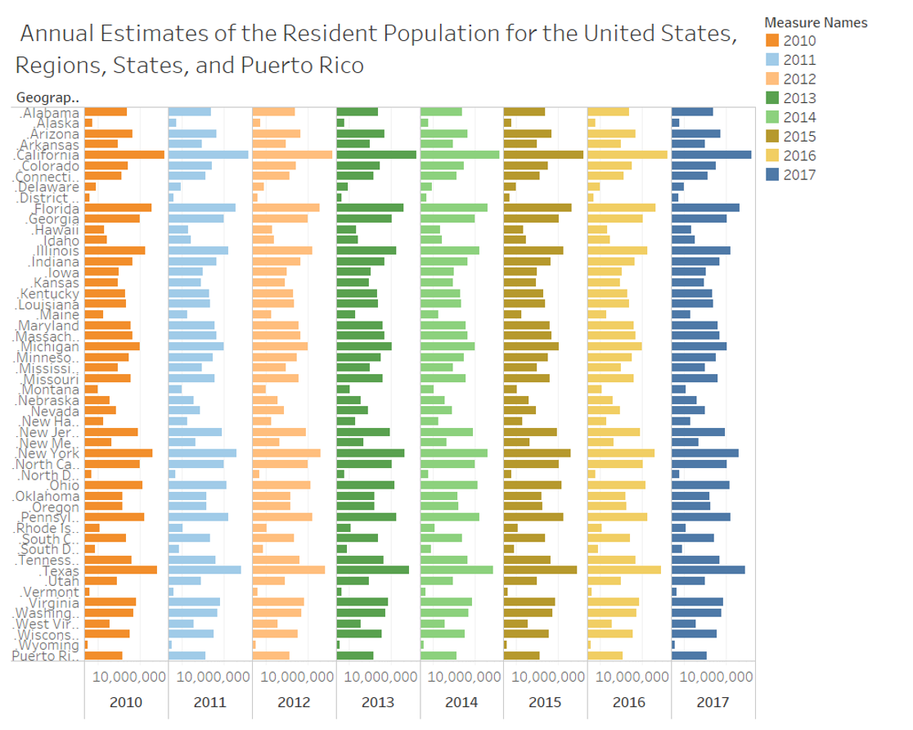

Figure 2: Annual Estimates of the Resident Population for the United States, Regions, States, and Puerto Rico: April 1, 2010 to July 1, 2017

This plot is from the data set of Annual Resident Population for the US, Regions, States and Puerto Rico from 2010 to 2017. This plot had to be scaled logarithmically to show the distinctions more accurately. This graph although a little crowded makes it easy to observe the population levels over the years.

1. **Plots/charts for storytelling (50 points)**



Figure 3:Number of full-time, first-time students receiving financial aid, by geographic region and type of aid: 2015-16

From this data set we can observe the distribution of financial aid through the different regions and states of the United States. From the plot we can clearly observe that the grants/scholarships from the federal government ,local government and institutions is the highest aid provided across the board. Meanwhile other federal grants and loans seem to be the lowest across the board.

Another trend to observed is that some regions are more endowed than others. Specifically the region of South East consisting of AL AR FL GA KY LA MS NC SC TN VA WV seems to have had the most Financial aid dispensed for students on the other hand the region with the least financial aid provided was the Rocky Mountain region consisting of CO ID MT UT WY during the year 2015-16.

Finally, we can see that US service schools seem to have the least amount of financial aid provided.

From this data we could derive that there may not be as many full-time students or first-time students going to college. Currently many prefer to work and take college classes part time thus allowing them to afford their own education and balance a professional career. We could also reason that there may be several returning students who decided to continue and finish their higher education after a break. Due to the cost of education many students may prefer these options. Considering this we could draw another observation that the South east region has the greatest number of first time, full time students.



Figure 4: Annual Estimates of the Resident Population for the United States, Regions, States, and Puerto Rico:2010 to 2017

This is the plot for Resident Population of the US, regions ,states and Puerto Rico over eight years. Initially due to the large values of population data it was hard to make any interpretations. Therefore, the axis had to be scaled logarithmically .Once that was done, we could see small differences in the bar graphs. We can see that through the years the population for each state has seen no drastic change. However, the above plot does not make it easy to gather this at a single glance so instead of a bar plot I changed my plot to a line graph with a separate line for each year as shown below. This improved representation makes it easier to see that there is not a major change in the population over the years as the lines seem to overlap for most part. To make this more evident the axis has been scaled logarithmically and the zero has been removed.

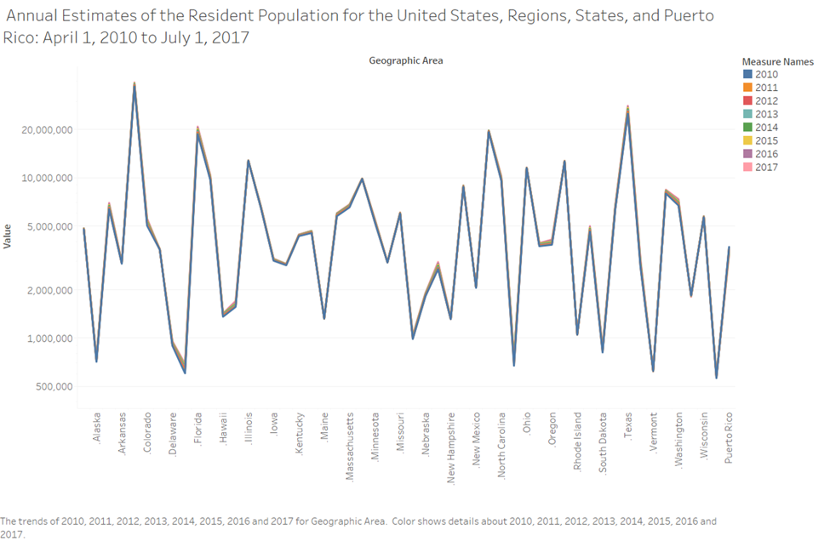

Figure 5:Annual Estimates of the Resident Population for the United States, Regions, States, and Puerto Rico: April 1, 2010 to July 1, 2017

From this graph it is apparent that the lines are overlapping for most part except for a few increased peaks. This improved representation makes it easier to understand that there has been no significant rise or drop in population throughout the country over the past eight years. This pattern, we could attribute it to improved healthcare and declining birth rates. With the advancements in modern medicine it has become possible for people to live longer, and due to the raising concerns over the environment and overpopulation family planning has become more common these days.

1. **(Optional) Compile the provided skeleton code and report your success in the form of screen shots (5 points)**

