**1.1What are the ISSUES of the rainbow color scheme? Please find one to two examples from the provided data sets to illustrate these issues. You can use the rainbow_color() function provided in the end of this description to help you answer this question.**

The rainbow color map is based on the light spectrum. It can be very visually pleasing but not always easy to read and understand.

The first issue with the rainbow color scheme is that the relationship between the colors is not as intuitive. We can see the assorted colors but it’s not very obvious the sequence to put them in. Although if we look at the values used to differentiate the colors on the HSV or RGB color space the difference in colors makes it appear discrete. This discrete appearance is another problem with the rainbow color scheme , there appear to be sharp transitions in data due to the changes in the hues. This makes understanding the visualization more challenging when compared to a single color with different saturations.

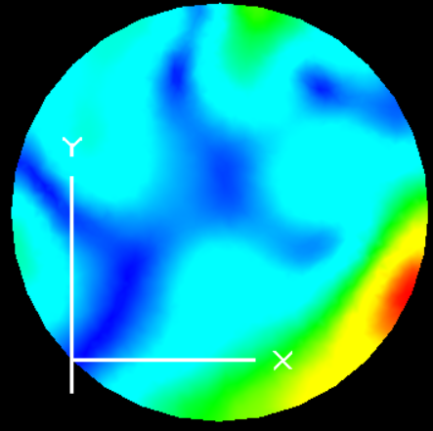

From this example we can notice that it is both difficult to identify which color represents which range and also to understand the increasing/decreasing values of the data being presented.

**1.2 In what situations that rainbow colors can be used?**

Rainbow color scheme is still widely used due to the fact that having multiple colors is visually pleasing. Also, because it has a sense of familiarity for people viewing the visualization. It can be very useful in situations to read data values using a key to identify the relation between the color value and data value. This can come in handy with 2d plots and data sets that just need to visually communicate the different segments of data.

**3.1 Implement the “blue-white-red (BWR)” and the “heat map” continuous color schemes (30 points)**

**Apply these two color schemes to the provided data and report what you see (any extrema and saddle points in the data? Is the field smooth? Any patterns? Etc.)**

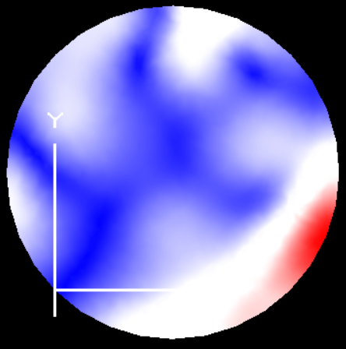 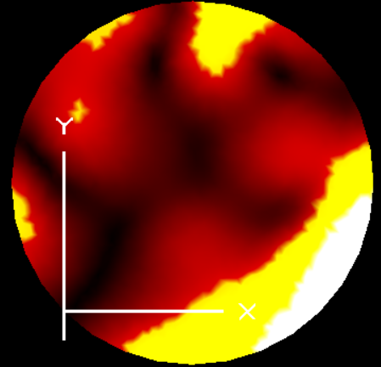

From both these color schemes we can see the areas in which the minimum and maximum data is stored . Although the heat map can provide a more accurate picture of how these values are distributed through out. The BWR is helpful in identifying the areas of min and max.

We can clearly see the pattern in the center and the side of the images that represent the least and highest data clusters.

**3.3 Implement the following user interactions (40 points)**

**(a) Provide an interface for the user to modify the value in the data range that is mapped to white for the BWR. Report what you discover for the given data sets. Given a particular data set, which threshold value for white is more suitable? Why?**

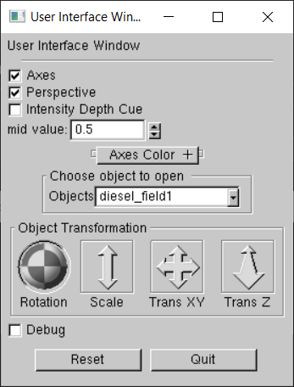

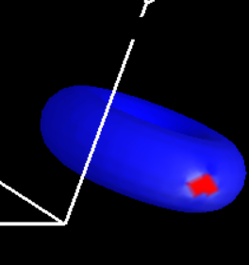 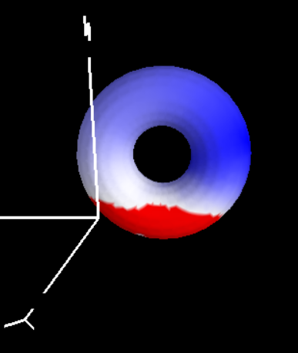

From observing the data set the torus data shows the most difference with a change in the white range . with the original white range defaulted to the middle of the data set the image on the left is the result. Here there is a saturation of color at one point on the torus. The picture on the right is the result after changing the value of mid to 0.038 . This shows the color is distributed more and we can actually see points of white.

The other data sets also had similar changes with some having a more even distribution of red to blue a lower the white threshold value than the middle or average value. This shows us that the average value is not always ideal to take as the threshold instead depending on the distribution of data the mode of the data range might be more suitable to be used as the threshold. This is because the mode would be the most repeated value and this would allow us to more easily observe the minimum and maximum values of the data set which might not occur as often and therefore might be overlooked when using an average or median.

**(b) In addition to the linear mapping, provide one non-linear mapping from the data value to colors. Describe how you design your new color mapping (or transfer) function and how the generated result with the new function different from the linear mapping. Which mapping function do you think is more suitable for the data? Why?**

For this assignment for a non-linear mapping I modified the simple rainbow mapping given. To make it nonlinear I decided to move the max value form the actual maximum to the middle value and map the values occurring after that to the max value. This provided a more detailed distribution of colors in the range of values till the middle and then mapped the values after that to an extreme value.

This was different from linear mapping in the sense that it allowed us to observe the values more closely in the first half of the data range. Some of the detail within this section could easily be missed when considering the full range of values.

Both Linear and nonlinear mapping have their own advantages. Deciding which mapping is more suitable for a data set depends on the data. We can make this decision by understanding the data distribution , if the data is focused on one segment of the range or if we need to increase the contrast between two sections of the data then non linear mapping would provide useful as we can focus on these areas more and change the mapping of data.

However, if we have a more uniformly distributed data set then a linear mapping would work just as well. It will all come down to the data set in question.