CSE574 Introduction to Machine Learning

Programming Assignment 1

**Classification and Regression**

Group 7

**Problem 1: Experiment with Gaussian Discriminators**

Implemented Linear Discriminant Analysis(LDA) and Quadratic Discriminant Analysis(QDA), we trained both the methods using the sample training data. Developed two functions ldaTest and qdaTest which returns the true labels for a given test data set and the accuracy using the labels for the test data set.

Below is the accuracy of LDA and QDA on the provided test data set,

|  |  |
| --- | --- |
| Methods | Accuracy |
| LDA | 97.0 |
| QDA | 96.0 |

And here is the plot of the discriminating boundary for LDA and QDA is,

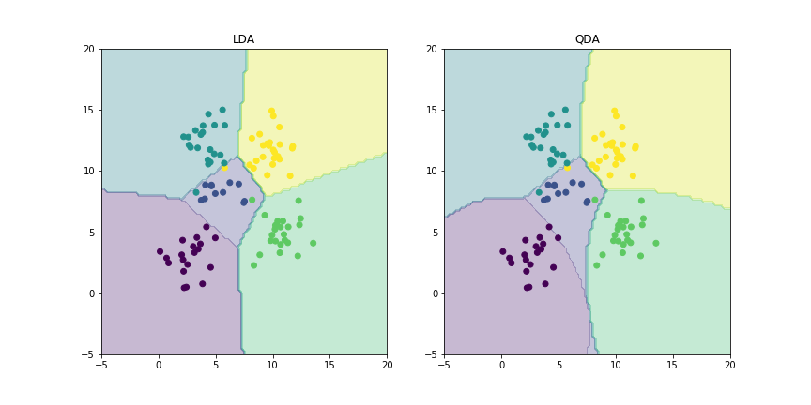

As we can see in the plot that, there is a difference in discriminating boundary for LDA and QDA. The reason for that is, LDA does linear discriminating boundary between the points belonging to different classes. While on other hand, QDA learns a quadratic one. If the actual boundaries are linear, QDA may have a higher model bias. Here we have a limited data set. And if you divide your already sparse dataset into the constituent classes and compute the covariance matrix for each, that might be inaccurate. In this type of scenario(limited data set), it is better to simplify the entire process and use a common covariance matrix that’s computed from the entire data set.