**Telemedicine Online Platform Free Bootstrap Template**

**Login Form**

**Member Registration**

* Fullname
* Gender
* Data of birth
* Phone number
* Email
* Address
* Profile Picture
* Username
* Password

**Admin Dashboard**

* Number of Patients
* Number of Doctors
* Number of Services
* Income

**Patient Information – Add, update**

* Fullname
* Gender
* Data of birth
* Phone number
* Email
* Address
* Profile Picture
* Username
* Password
* Status – pending, active, inactive

**Doctor Information**

* Full name
* Gender
* Qualification – text area
* Profile Picture
* Email
* Contact
* Clinic Map
* Username
* Password
* Account Status – pending, active, inactive

**Services**

* Service Name
* Amount
* Doctor

**Payment List**

* Appointment Code
* Doctor
* Patient
* Service
* Amount
* Status – accepted, declined, pending
* Remarks

**Income Report**

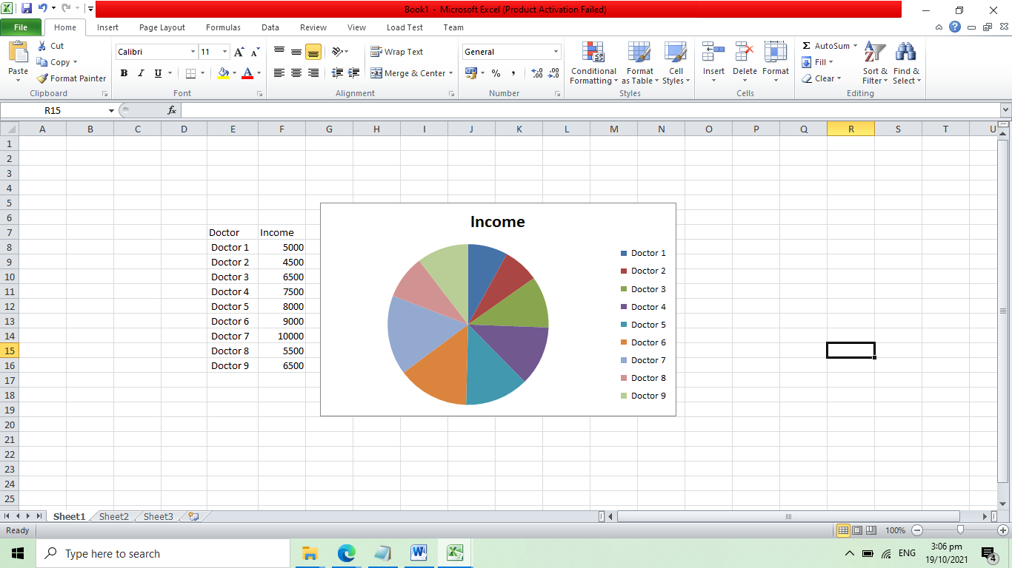

**Doctor Account**

**Doctor Dashboard**

* Number of patient
* Number of appointment
* Number of services offered
* Total income

**List of Appointments**

* Patient
* Date
* Time
* Service name
* Amount
* Meeting Link – Google Meet, Zoom
* Status – pending, cancelled, approved, completed

**Income Report by Service**

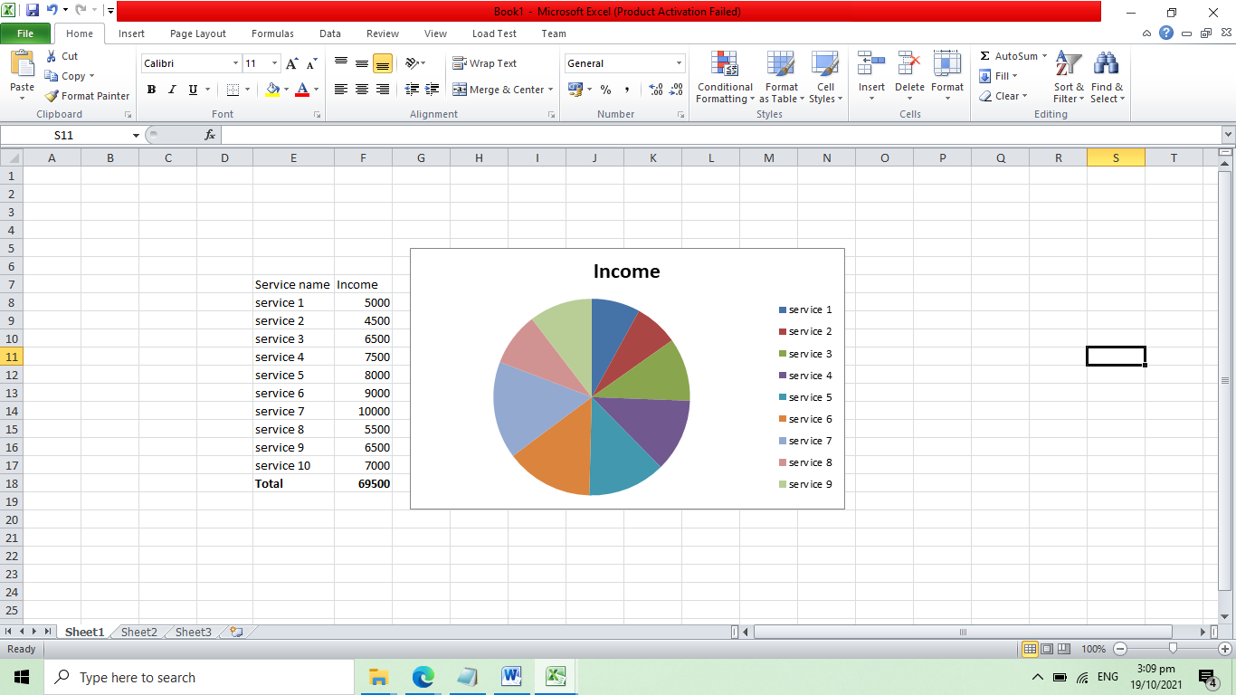

**Patient Account**

**Patient Dashboard**

* Number of doctors
* Number of services

**View Doctor Profile and View Map**

* Doctor name
* Map
* Services

**Reserve Appointment**

* Doctor
* Service
* Date
* Time
* Remarks
* Meeting Link – Google Meet, Zoom
* Status – pending, cancelled, approved, completed

**Payment**

* Appointment code
* Doctor
* Service
* Amount
* Proof of Payment – upload receipt
* Status – accepted, declined, pending
* Remarks