**Farm API Guide**

1. Prerequisites
   1. Visual Studio (if using cmd to run the project, no need)
   2. .Net 8 Installed
   3. SQL Server installed
2. Clone Project Repository
   1. git clone <https://github.com/knksinthujan/cas-farm-management.git>
   2. cd cas-farm-management
3. **Running the project using cmd**
   1. Run cmd “cd FarmApi”
   2. Run cmd “dotnet tool install --global dotnet-ef”

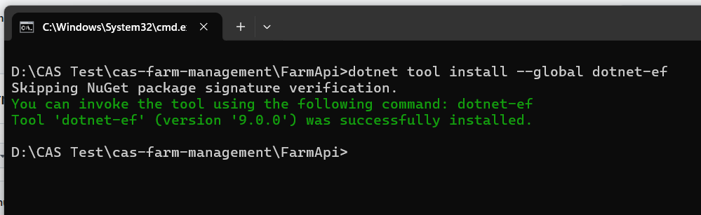

* 1. Change the connection string in appsettings.json

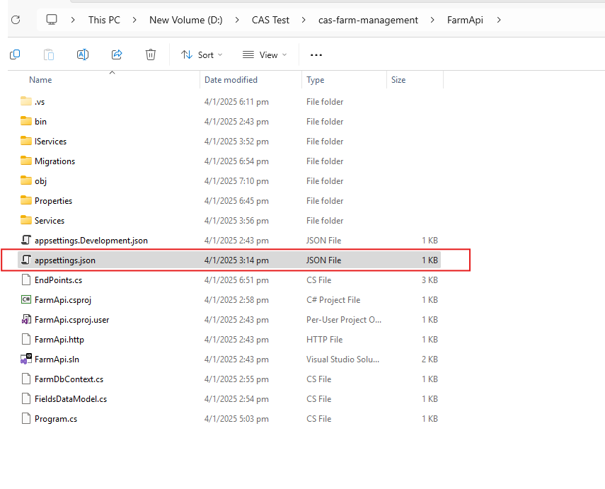

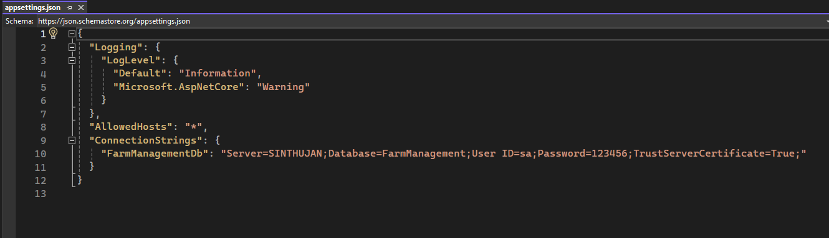

* 1. Run cmd “dotnet ef database update” (if not able to do this, use attached script OR .bak file to restore DB)

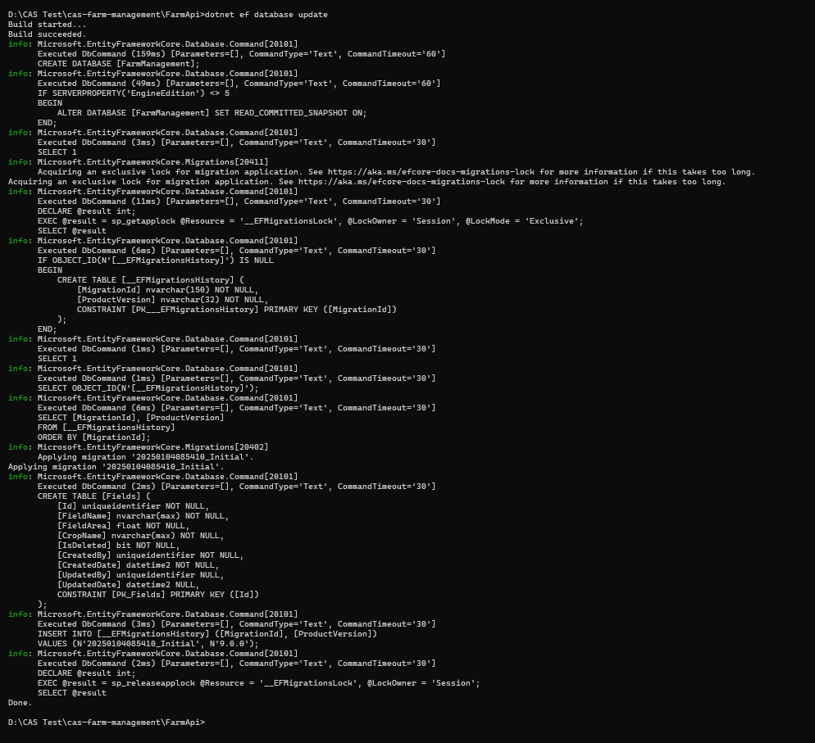

* 1. Now you should able to see created db and tables

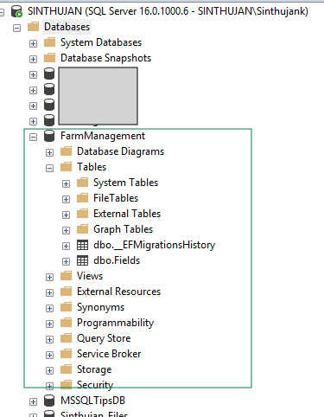

* 1. Run cmd “dotnet restore”

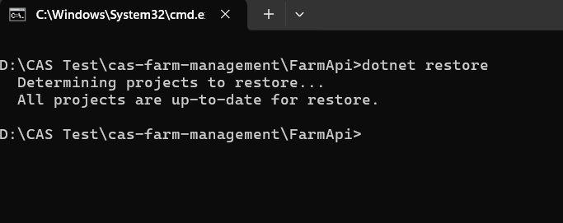

* 1. Run cmd “dotnet run”

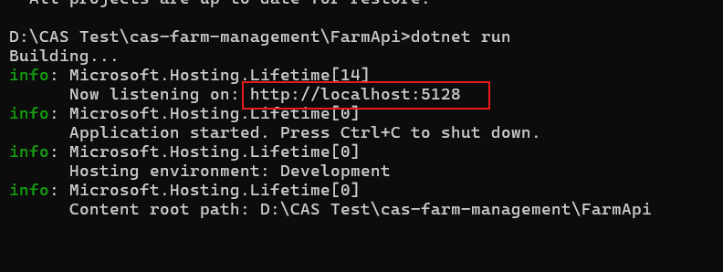

Now the project is running

* 1. Open <http://localhost:5128/connection-check> (Check listening port)

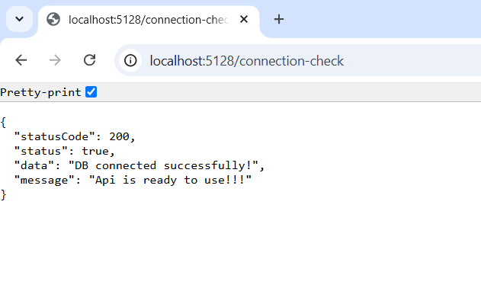

*****You are done with API setup*****