**Farm Web Api Guide**

1. Prerequisites
   1. Visual Studio (if using cmd to run the project, no need)
   2. .Net 8 Installed
   3. SQL Server installed
2. Clone Project Repository (If you have done this from API no need here)
   1. git clone <https://github.com/knksinthujan/cas-farm-management.git>
   2. cd cas-farm-management
3. **Running the project using cmd**
   1. Change the API base URL (FarmApiBaseUrl) according to the API setup in appsettings.json

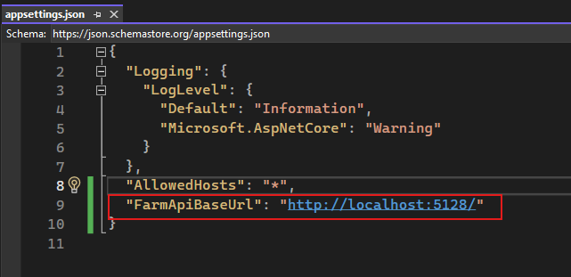

* 1. Run cmd “cd FarmWebUI\FarmManagement”
  2. Run cmd “dotnet restore”

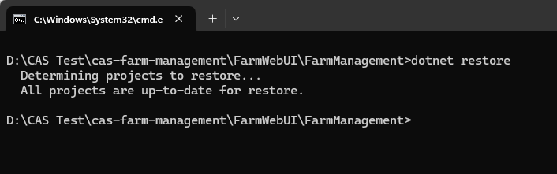

* 1. Run cmd “dotnet run”

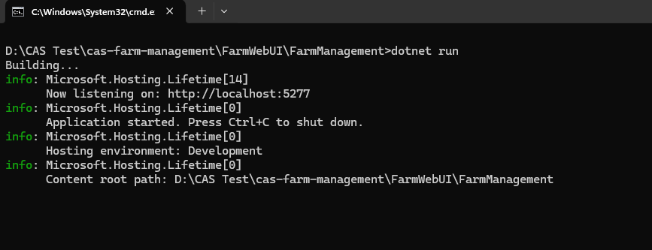

Now the project is running

* 1. Open <http://localhost:5277/> (Check listening port)

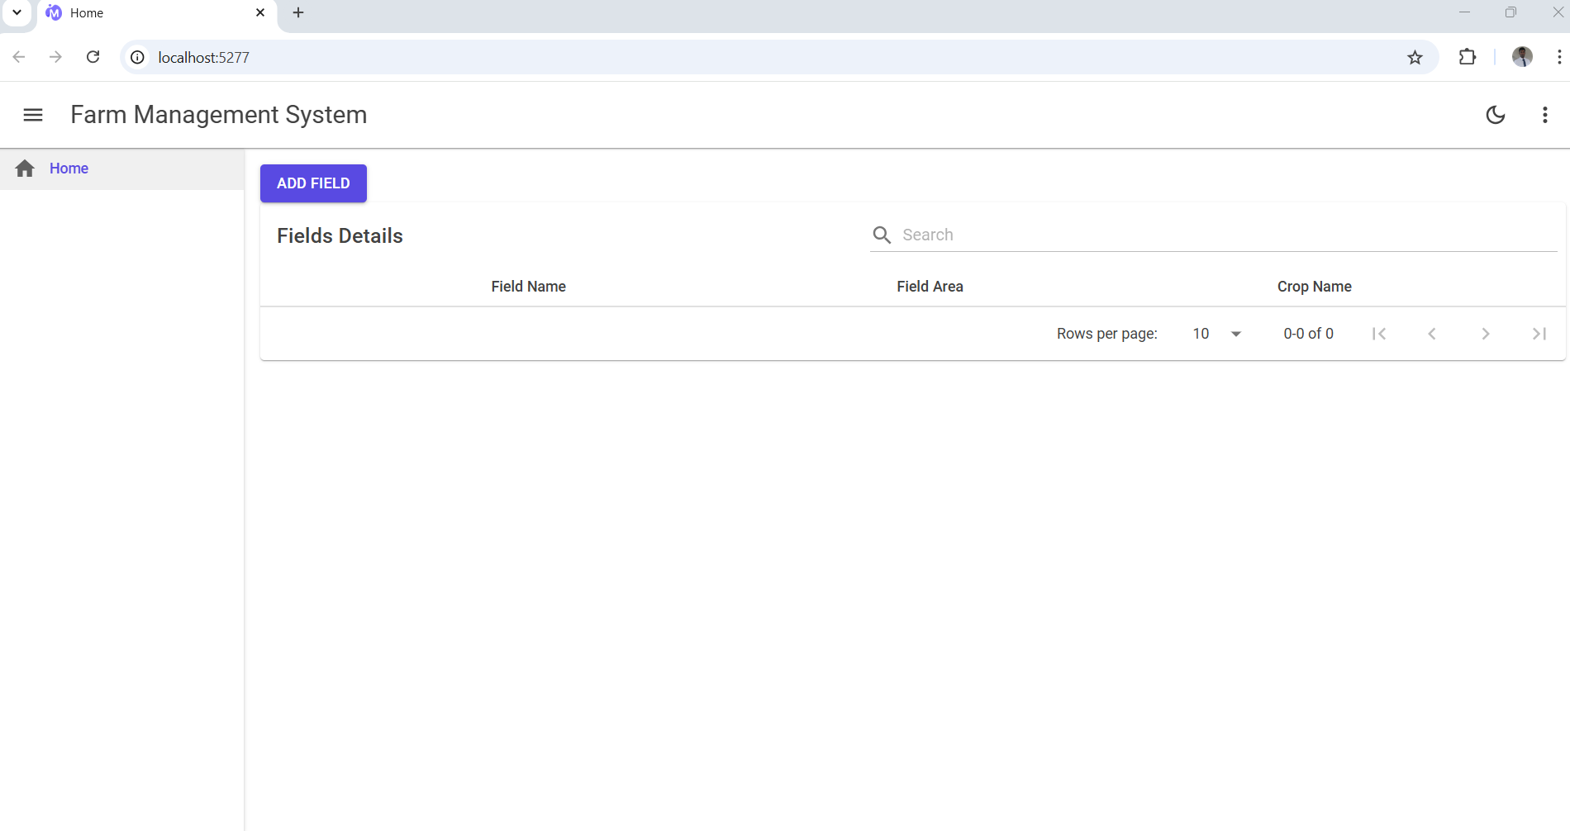

1. **Running the project using Visual Studio**
   1. Open the project using the .sln file

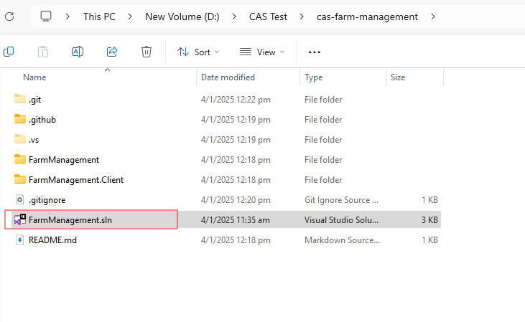

* 1. Change the API base URL (FarmApiBaseUrl) according to the API setup in appsettings.json
  2. Click on the Run button (Make sure Startup Project is FarmManagement)

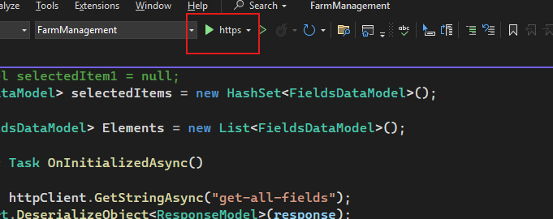

* 1. 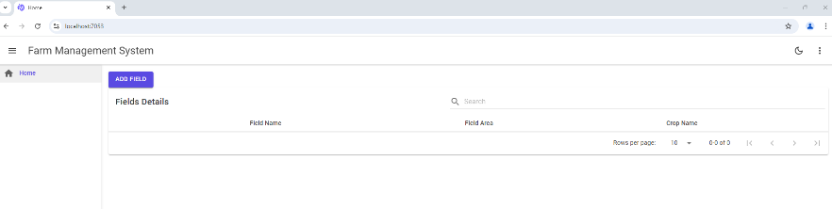The default browser will be opened and you can see the home page.

