* 1. The power of the brain

1. Average energy consumption in human brain per action potential:
$$E=\frac{P_{Brain}}{N_{Neu}ν}=2⋅{10}^{-10} J$$

2. Average energy consumption in human brain per synaptic event:
$$E=\frac{P_{Brain}}{N_{Syn}ν}=2⋅{10}^{-14} J$$

3. Energy consumption per spike and synaptic event in simulation:
$$E_{spike}=\frac{P_{K}t}{N_{Neu, K}}=24.6J$$

$$E_{syn}=\frac{P_{K}t}{N_{Neu, K}⋅N_{partner}}=0.004J$$

4. Scale up of simulations:
$$P_{scale}=100⋅P_{K}=1.26GW$$

5. Power after speed up the K computer:

$$P_{speed}=\frac{t_{simul}}{t_{real}}P_{scale}=3024GW$$

The nuclear power plant Sedai has two reactors, each with 890 MW output.

* 1. Stimulus Currents

Simplified equivalent circuit:

$$C_{m}\frac{du}{dt}=g_{l}\left(u-E_{l}\right)+I_{ext}$$

1. Dirac delta function: $I\left(t\right)=I_{0}⋅\frac{C_{m}}{g_{l}}δ\left(t-t_{0}\right)$

$$C_{m}\frac{du}{dt}=g_{l}\left(u-E_{l}\right)+I_{0}⋅\frac{C_{m}}{g_{l}}δ\left(t-t_{0}\right)$$

Look for solution of homogenous equation:

$$C_{m}\frac{du}{dt}=g_{l}u$$

$$\frac{du}{u}=\frac{g_{l}}{C_{m}}dt⇒u=De^{\frac{g_{l}}{C_{m}}t}$$

$D→D\left(t\right)$:

$$C_{m}\dot{u}=C_{m}\dot{D}\left(t\right)e^{\frac{g_{l}}{C_{m}}t}+D\left(t\right)g_{l}e^{\frac{g_{l}}{C_{m}}t}=g_{l}D\left(t\right)e^{\frac{g_{l}}{C_{m}}t}-g_{l}E_{l}+I_{0}\frac{C_{m}}{g_{l}}δ\left(t-t_{0}\right)$$

$$\frac{dD}{dt}=e^{-\frac{g_{l}}{C_{m}}t}\left(\frac{I_{0}}{g_{l}}δ\left(t-t_{0}\right)-\frac{g_{l}}{C_{m}}E_{l}\right)$$

$$D\left(t\right)-D_{0}=\int{e^{-\frac{g_{l}}{C_{m}}t}\frac{I_{0}}{g_{l}}δ\left(t-t_{0}\right)dt}-\int{e^{-\frac{g_{l}}{C_{m}}t}\frac{g_{l}}{C_{m}}E_{l}dt}=\frac{I_{0}}{g_{l}}e^{-\frac{g_{l}}{C_{m}}t_{0}}θ(t-t_{0})+E_{l}e^{-\frac{g_{l}}{C_{m}}t}$$

Putting everything together yields:

$$u\left(t\right)=\left(D_{0}+\frac{I_{0}}{g_{l}}e^{-\frac{g_{l}}{C_{m}}t_{0}}θ(t-t_{0})+E_{l}e^{-\frac{g_{l}}{C_{m}}t}\right)e^{\frac{g_{l}}{C_{m}}t}=D_{0}e^{\frac{g_{l}}{C_{m}}t}+\frac{I_{0}}{g_{l}}e^{\frac{g_{l}}{C_{m}}\left(t-t_{0}\right)}θ(t-t_{0})+E_{l}$$

1. Step current: $I\left(t\right)=I_{0}⋅Θ\left(t-t_{0}\right)$

The homogenous solution is the same as before, so:

$$D-D_{0}=\frac{1}{C_{m}}\int{e^{-\frac{g_{l}}{C_{m}}t}I_{0}Θ\left(t-t_{0}\right)dt}-\int{e^{-\frac{g_{l}}{C_{m}}t}\frac{g_{l}}{C_{m}}E_{l}dt}=\frac{\frac{I_{0}}{C_{m}}C_{m}}{g_{l}}θ\left(t-t_{0}\right)\left(e^{-\frac{g_{l}}{c_{m}}t_{0}}-e^{-\frac{g_{l}}{c_{m}}t}\right)+E_{l}e^{-\frac{g_{l}}{C_{m}}t}$$

Putting everything together yields:



$$u\left(t\right)=D_{0}e^{\frac{g_{l}}{C_{m}}t}+E_{l}+\frac{I_{0}}{g_{l}}θ(t-t_{0})(e^{\frac{g_{l}}{C_{m}}\left(t-t_{0}\right)}-1)$$

1. Exponential current: $I\left(t\right)=I_{0}⋅Θ\left(t-t_{0}\right)⋅\frac{C_{m}}{τ_{s}g_{l}}⋅\exp\left(-\frac{t-t_{0}}{τ_{s}}\right)$

Using the same as before:

$$D-D_{0}=\frac{1}{C_{m}}\int{e^{-\frac{g_{l}}{C_{m}}t}}I_{0}Θ\left(t-t_{0}\right)\frac{C_{m}}{τ_{s}g_{l}}\exp\left(-\frac{t-t_{0}}{τ_{s}}\right)dt-\int{e^{-\frac{g_{l}}{C_{m}}t}\frac{g_{l}}{C_{m}}E_{l}dt}=\frac{1}{τ_{s}g_{l}}e^{\frac{t_{0}}{τ_{s}}}I_{0}\int_{t_{0}}^{∞}{\exp\left(-\left(\frac{g_{l}}{C_{m}}+\frac{1}{τ_{s}}\right)t\right)dt}+E_{l}e^{-\frac{g_{l}}{C_{m}}t}=\frac{1}{τ_{s}g_{l}}e^{\frac{t_{0}}{τ_{s}}}I_{0}\frac{1}{\frac{g_{l}}{C_{m}}+\frac{1}{τ_{s}}}\left(\exp\left(-\left(\frac{g_{l}}{C_{m}}+\frac{1}{τ_{s}}\right)t_{0}\right)-\exp\left(-\left(\frac{g_{l}}{C_{m}}+\frac{1}{τ_{s}}\right)t\right)\right)θ(t-t_{0})+E_{l}e^{-\frac{g_{l}}{C_{m}}t}=\frac{I_{0}}{g_{l}}\frac{1}{\frac{g_{l}τ_{s}}{C_{m}}+1}\left(\exp\left(-\frac{g_{l}}{C_{m}}t_{0}\right)-\exp\left(-\left(\frac{g_{l}}{C_{m}}+\frac{1}{τ_{s}}\right)t\right)\right)θ(t-t_{0})+E_{l}e^{-\frac{g_{l}}{C_{m}}t}$$

Putting everything together:

$$u\left(t\right)=E_{l}+D_{0}e^{\frac{g_{l}}{C_{m}}t}+\frac{I_{0}}{g_{l}}\frac{1}{\frac{τ_{s}}{C_{m}}+1}θ\left(t-t_{0}\right)\left(e^{-\frac{g_{l}}{C_{m}}\left(t-t_{0}\right)}-\exp\left(-\frac{t}{τ_{s}}\right)\right)$$

1. In the limit of very short synaptic time constants $τ_{s}→0$ we get:

$$\lim_{τ_{s}→0}{u\left(t\right)}=E_{l}+D_{0}e^{\frac{g_{l}}{C_{m}}t}+θ\left(t-t_{0}\right)\left(\frac{I_{0}}{g_{l}}e^{-\frac{g_{l}}{C_{m}}\left(t-t_{0}\right)}\lim_{τ_{s}→0}{\frac{1}{\frac{τ_{s}}{C_{m}}+1}}-\frac{I_{0}}{g_{l}}\lim_{τ_{s}→0}{\frac{1}{\frac{τ_{s}}{C_{m}}+1}\exp\left(-\frac{t}{τ_{s}}\right)}\right)=E_{l}+D_{0}e^{\frac{g_{l}}{C_{m}}t}+θ\left(t-t_{0}\right)\left(\frac{I_{0}}{g_{l}}e^{-\frac{g_{l}}{C_{m}}\left(t-t_{0}\right)}-\frac{I_{0}}{g_{l}}\right)$$

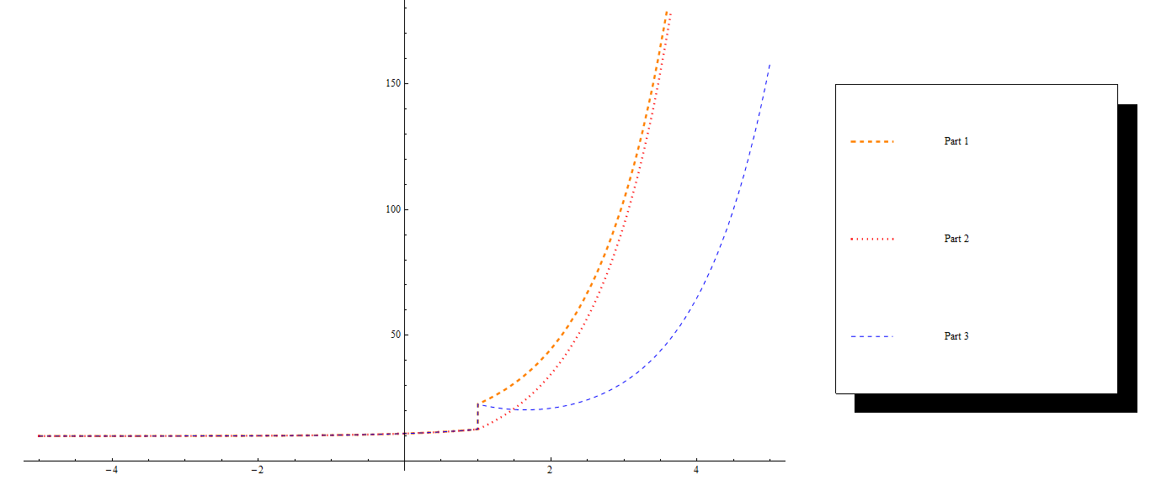1.3 Facets Live!

Two-neuron demo: output firing rate of first neuron as a function if its input current:

Firing rate of second neuron as a function of its input firing rate:

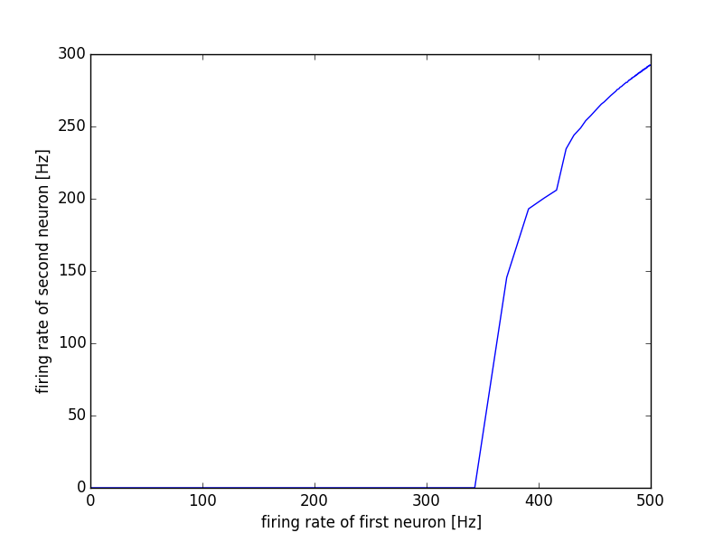

#!/usr/bin/env python2

# encoding: utf-8

import pyNN.nest as sim

def two_neuron_example(

current=1000.0,

time_simulation=2000.,

weight=0.4,

neuron_parameters={

'v_rest' : -65.0,

'cm' : 0.1,

'tau_m' : 1.0,

'tau_refrac' : 2.0,

'tau_syn_E' : 10.0,

'tau_syn_I' : 10.0,

'i_offset' : 0.0,

'v_reset' : -65.0,

'v_thresh' : -50.0,

},

):

"""

Connects to neurons with corresponding parameters.

The first is stimulated via current injection while the second receives

the other one's spikes.

"""

sim.setup(timestep=0.1, min_delay=0.1)

pulse = sim.DCSource(amplitude=current, start=0.0, stop=time_simulation)

pre = sim.Population(1, sim.IF_curr_exp(**neuron_parameters))

post = sim.Population(1, sim.IF_curr_exp(**neuron_parameters))

pre.record('spikes')

post.record('spikes')

sim.Projection(pre, post, connector=sim.OneToOneConnector(),

synapse_type=sim.StaticSynapse(weight=weight),

receptor_type='excitatory')

pulse.inject_into(pre)

sim.run(time_simulation)

# rates in Hz

rate_pre = len(pre.get_data('spikes').segments[0].spiketrains[0])\

/ time_simulation * 1000.

rate_post = len(post.get_data('spikes').segments[0].spiketrains[0])\

/ time_simulation * 1000.

sim.end()

return rate_pre, rate_post

import matplotlib.pyplot as plt

import numpy as np

rate_pre = []

rate_post = []

current = []

for curr in np.linspace(0,500,1000):

pre, post = two_neuron_example(current=curr)

rate_pre.append(pre)

rate_post.append(post)

current.append(curr)

# Plot results

plt.figure(1)

plt.plot(current,rate_pre)

plt.xlabel('input current')

plt.ylabel('firing rate of first neuron [Hz]')

plt.savefig('figure1.png')

plt.figure(2)

plt.plot(rate_pre,rate_post)

plt.xlabel('firing rate of first neuron [Hz]')

plt.ylabel('firing rate of second neuron [Hz]')

plt.savefig('figure2.png')