**Scala instruction 0**

**Setup coding environment**

This instruction shows how to prepare the environment for running Scala code locally.

It’s done the easiest possible way – using IntelliJ automatic project creation.

1. **Install IntelliJ IDEA on your computer**

IntelliJ IDEA is an IDE for writing code in JVM languages (like Java, Kotlin, Scala). It’s developed by JetBrains (like e.g. Pycharm).

Go to [https://www.jetbrains.com/idea/download/](https://www.jetbrains.com/idea/download/#section=windows) and download installation file for your platform for Community version (free version).

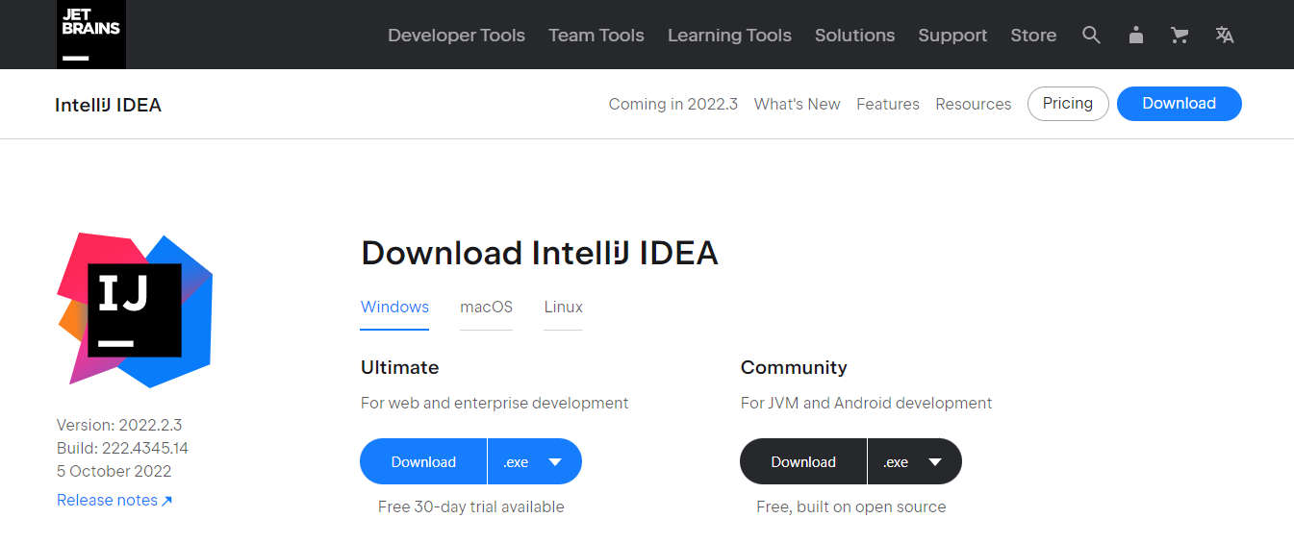

Run the installation file and install IntelliJ IDEA.

1. **Install Scala plugin for IntlliJ IDEA.**

Unfortunately, IntelliJ does not support Scala by default. To start coding in this language using IntelliJ, we need to download and enable the Scala plugin. We have two ways to achieve that:

* When You run IntelliJ for the first time, you can install the Scala plugin when IntelliJ IDEA suggests downloading featured plugins

Or …

* You can go to *File > Settings > Plugins* and install the Scala plugin

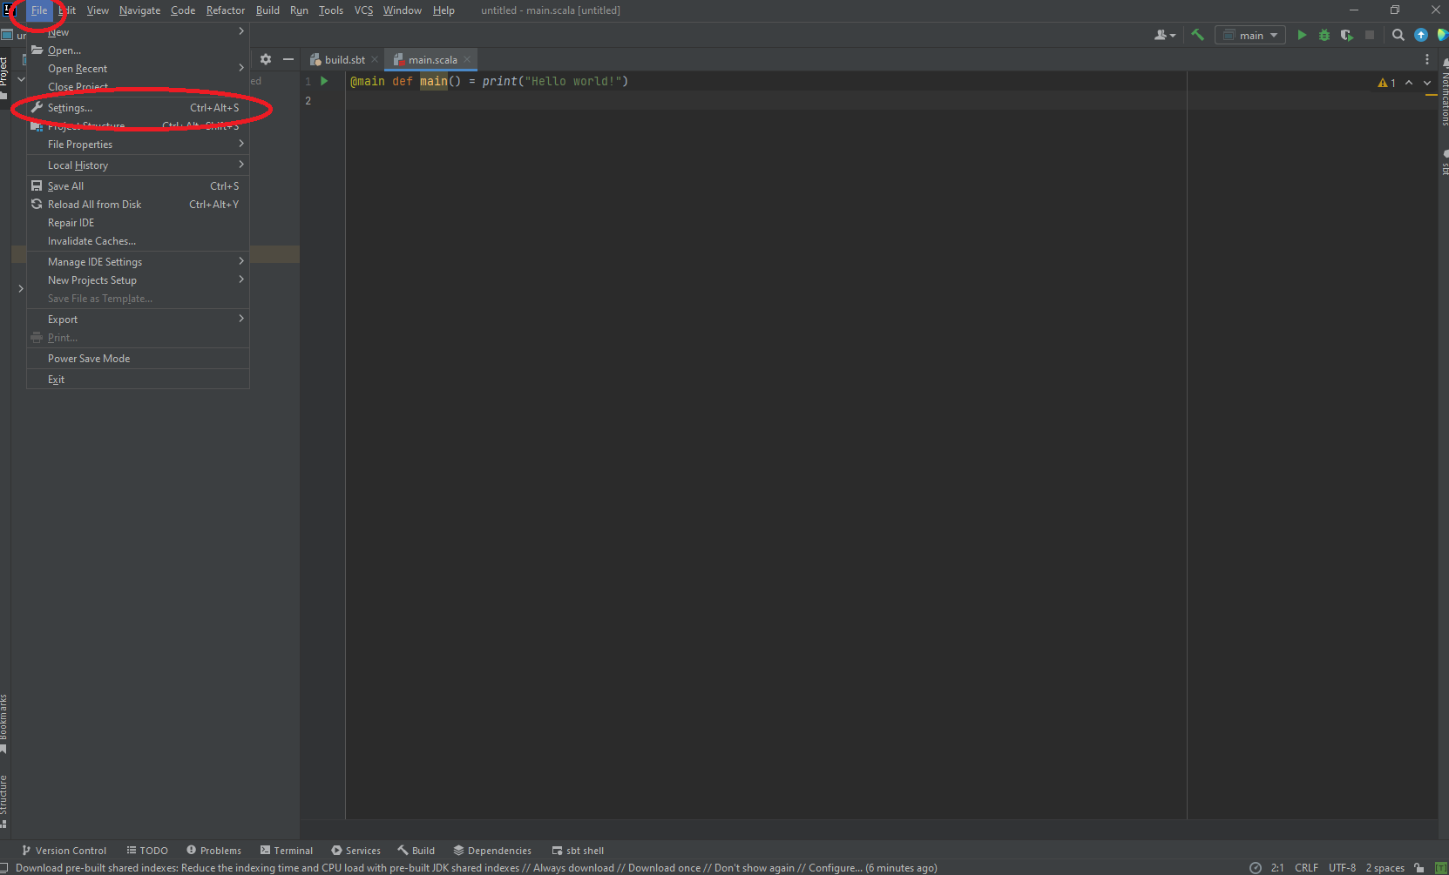

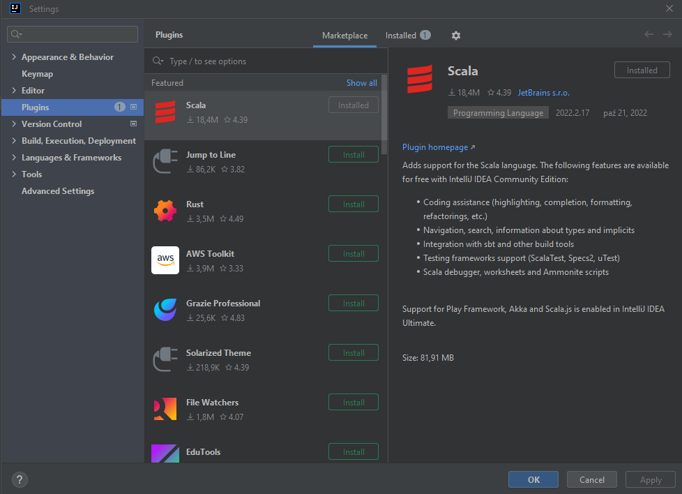

1. **Create new Scala project (downloading dependencies automatically)**

Create new IntelliJ project. If the *Welcome* screen opens, click New Project. Otherwise, from the main menu, select *File > New > Project*.

Choose the name for your new project and – if you want – specify its location on your computer.

Next let’s look at *JDK* – JDK is necessary to run Scala code (JDK – *Java Development Kit*, it’s a package containing Java, JVM and some other tools). Therefore, we need to tell IntelliJ where it can find JDK on the computer.

If you have already some JDK specified – you can leave it as it is (probably you have installed some JDK on your computer and IntelliJ detected it). Otherwise, choose option *Download JDK*, download JDK and select it here.

Other settings:

* As the language choose *Scala*
* As the build system choose *sbt*
* Change Scala version to newest one (**starting with 3**)
* Nearby *sbt* and *Scala* select *Download sources* (so that IntelliJ will download them by itself)

And we can go ahead! 😊 Click *Create*.

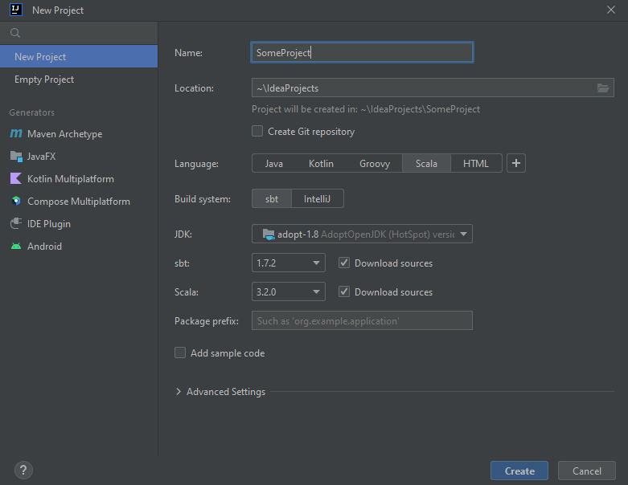

1. **See how the project looks like**

Let’s see how our brand-new project looks like 😊

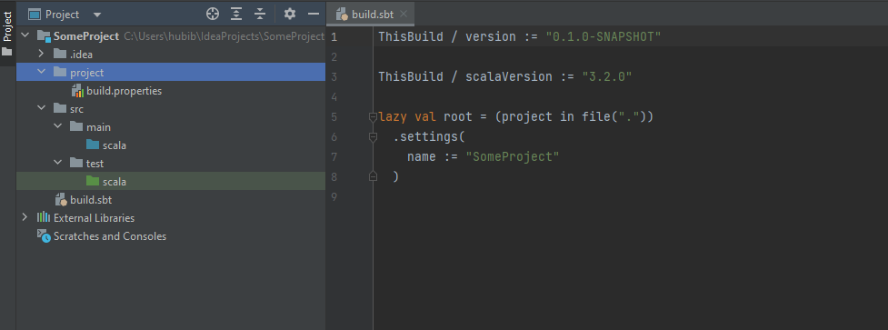

We decided to use *sbt* (*scala build tool*) as our build tool – it is a program that helps you to manage your code and your project structure.

We can see that IntelliJ and sbt created some project structure initially.

First of all, we have *build.sbt* file – this file contains the *build definition* for our project (we can set some settings here for example).

We’ve got also some directories automatically created. We we’ll place our source code in *main* directory. In *test* directory one can place tests for source code from *main*. This is default sbt project structure.

1. **Run sample Scala code.**

Create new file in *main* directory and name it *hello.scala*.

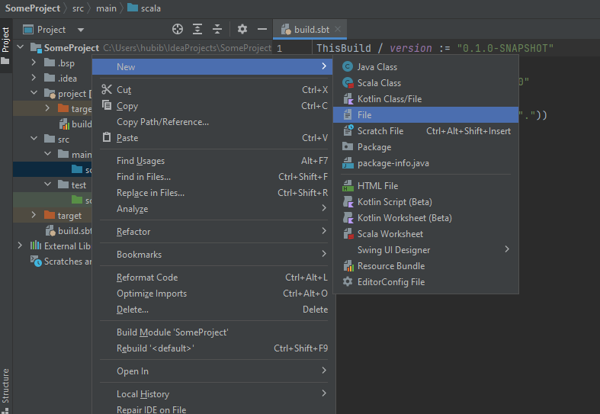

Next, put the following code into this file:

@main def hello() = println("Hello!")

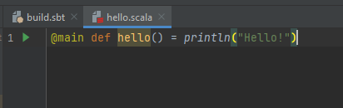

You can run this code clicking green *play* button.

You’ll see *Hello!* In the command line at the bottom.