Parachute
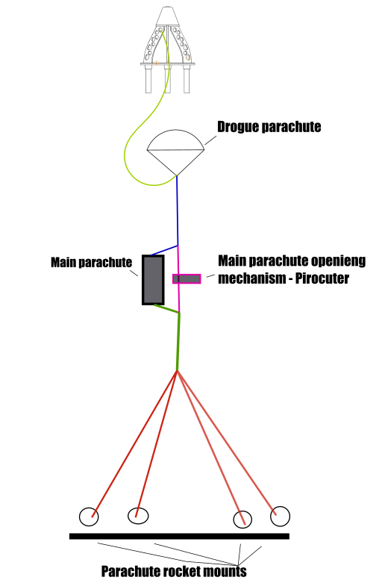
- Kevlar ropes everywere
- splicing the rope - no knots!!!!!!

ABS
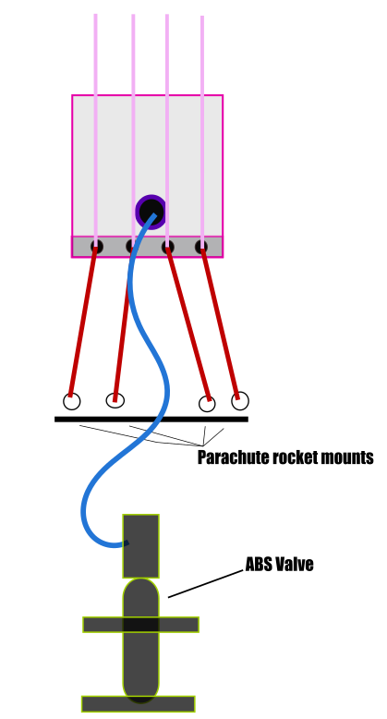
- Kewlar ropes
- 6-8mm pnematic tubes
- Fully assembled ABS

ABS+Parachute
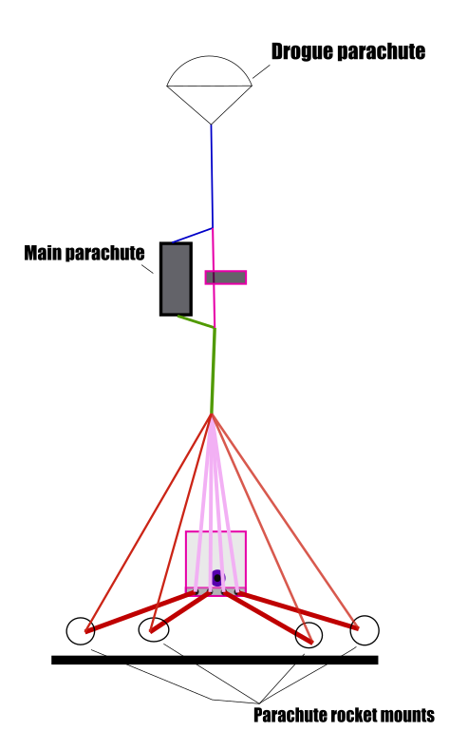

1. | Prepare ABS
2. | Prepare Parachute

