


Drogue chute testing
for unpowered flight

Made by:
- Michał Skiba
-
Approved by:
-

Table of Contents:
1. List of sensors 3
1.1. Pressure sensors 3
1.2. Temperature sensors 4
1.3. Miscellaneous sensors 4
2. Sensor’s schema 5
2.1. Pressure sensors 5
2.2. Temperature sensors 5
2.3. Miscellaneous sensors 6
3. Phases of flight 6
3.1. Boost phase 7
3.2. Separation 7
3.3. Unpowered ascent 7
3.4. Drogue parachute ejection 8
3.5. Descent on Drogue 8
3.6. Main parachute unfold 8
3.7. Descent on Main 9
3.8. Auxiliary buoyancy system (ABS) opening 9
3.9. Recovery 9

Introduction
Main goal of those test is establishing the drag coefficient (called later as C_{D}) of the drogue chute that was made for the purpose of this phase. To be able to predict real freefall of the mock-up ramjet stage of the rocket (later called as rocket).
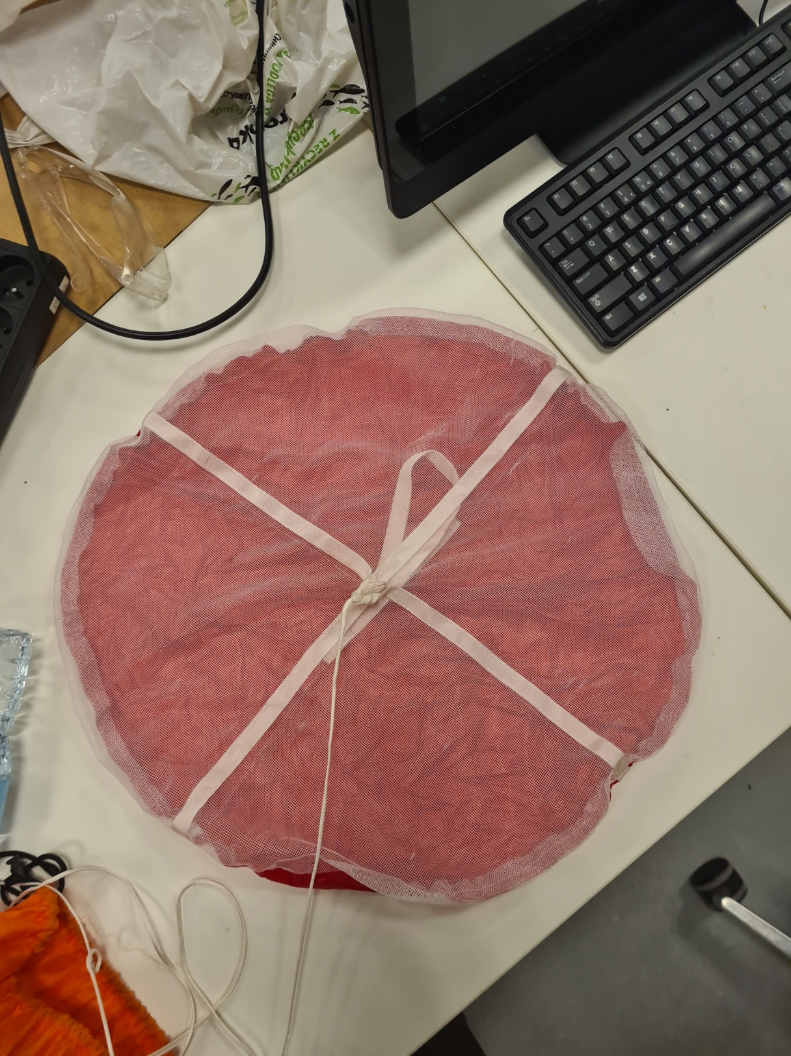
Figure 1.1 drogue chute

Theoretical drag
Theoretical drag of the chute was computed to be equal to 1, therefore slowing down entire rocket to 43 m/s of terminal velocity.
$${C_{D}}_{pracital}=\frac{2mg}{v^{2}ρS}$$
Equation 1.1 – formula used to compute drag coefficient

$$v=\sqrt{\frac{2mg}{C_{D}ρS}}$$
Equation 1.2 – formula used to compute terminal velocity

Struggles to compute drag coeficient

