


Sensors in RAMJET
for unpowered flight

Made by:
- Michał Skiba
- Maciej Grzywka
Approved by:
-

Table of Contents:
1. HUB’s 3
2. List of sensors 3
2.1. Pressure sensors 3
2.2. Temperature sensors 4
2.3. Miscellaneous sensors 5
3. Sensor’s schematic 5
3.1. Pressure sensors 5
3.2. Temperature sensors 6
3.3. Miscellaneous sensors 6
4. Phases of flight 7
4.1. Boost phase 8
4.2. Separation 8
4.3. Unpowered ascent 8
4.4. Drogue parachute ejection 9
4.5. Descent on Drogue 9
4.6. Main parachute unfold 9
4.7. Descent on Main parachute 10
4.8. Auxiliary buoyancy system (ABS) opening 10
4.9. Recovery 10

HUB’s
Hub – place where pressure sensors are placed – pressure sensors are placed in sealed boxes and each sensor is connected by tube with pressure port. We use gauge pressure sensors to measure pressure in rocket and absolute pressure sensors to measure pressure in hub.

Why do we use hubs:
- To measure reference pressure for gauge pressure sensors,
- To mitigate fluctuations of reference pressure to increase measurement accuracy,
- To mitigate the risk of having slightly different reference pressures for each sensor,
- Hubs can be closer to pressure probe – it is easier to connect sensors electronically to main computer than making pneumatic connection through hole rocket,
No | Hub name | Location
1. | Hub 1 | Diffuser
2. | Hub 2 | Tank
3. | Hub 3 | Tank (for Combustion Chamber sensors)
4. | Hub 4 | Diffuser (Extension of Hub 1)

List of sensors

Pressure sensors
Id | Name | Type | Hub | Description
1. | Cone G1 (G1) | gauge | 1 | Pressure sensor in cone to measure rocket velocity
2. | Cone G2 (G2) | gauge | 1 | Pressure sensor on inlet cone to measure static pressure after first shock wave
2. | Cone G3 (G3) | gauge | 1 | Pressure sensor on inlet cone to measure static pressure after second shock wave
4. | Cone G4 (G4) | gauge | 1 | Pressure sensor on inlet cone to measure static pressure after terminal shock wave in annular channel
5. | Diff G1 (G5) | gauge | 4 | Pressure sensor on widest part of diffuser to check for flow separation
6. | Diff G2 (G6) | gauge | 4 | Pressure sensor on the middle part of diffuser to check for flow separation
7. | Diff G3 (G7) | gauge | 4 | Pressure sensor on thinnest part of diffuser to check for flow separation
8. | Diff G4 (G8) | gauge | 4 | Pressure sensor on cylindrical part of diffuser to check for pressure after injectors
9. | Diff G5 (G9) | gauge | 4 | Pressure sensor to measure air velocity in diffuser
10. | Diff A1 (A1) | absolute | 1 | Pressure sensor to measure pressure in hub 1
11. | Diff A2 (A2) | absolute | 1 | Redundant pressure sensor to measure pressure in hub 1
12. | Out Tank A1 (A12) | absolute | 2 | Pressure sensor to measure ambient static pressure
13. | In Tank G1 (G13) | Gauge | 2 | Pressure sensor to measure pressure in annular part before diffuser and check for eventual normal shock wave inside
14. | In Tank G2 (G14) | Gauge | 2 | Pressure sensor to measure pressure in diffuser at different stations
15. | In Tank G3 (G15) | Gauge | 2 | Pressure sensor to measure pressure in diffuser at different stations and to measure static pressure for “Diff 5” for velocity measurement
16. | In Tank G4 (G16) | Gauge | 2 | Pressure sensor to measure pressure in diffuser at different stations
17. | In Tank A1 (A17) | Absolute | 2 | Pressure sensor to measure pressure in hub 2
18. | In tank A2 (A18) | Absolute | 2 | Redundant pressure sensor to measure pressure in hub 2
19. | Out Belt A1 (A19) | Absolute | 3 | Pressure sensor to measure ambient static pressure (It can be compared with “Out Tank 1”)
20. | FH G1 (G20) | Gauge | 3 | Pressure sensor to estimate the size of recirculation zone after the Flame holder
21. | FH G2 (G21) | Gauge | 3 | Pressure sensor to estimate the size of recirculation zone after the Flame holder
22. | FH G3 (G22) | Gauge | 3 | Pressure sensor to estimate the size of recirculation zone after the Flame holder
23. | FH G4 (G23) | Gauge | 3 | Pressure sensor to measure static pressure for “FH 1“– “FH3”
24. | CC G1 (G24) | Gauge | 3 | Pressure sensor to measure pressure in combustion chamber
25. | CC G2 (G25) | Gauge | 3 | Pressure sensor to measure pressure on the nozzle throat
26. | CC A1 (A26) | Absolute | 3 | Pressure sensor to measure pressure in hub 3
27. | CC A2 (A27) | Absolute | 3 | Redundant pressure sensor to measure pressure in hub 2
28. | Diff A28 (A28) | Absolute | 4 | Pressure sensor to measure pressure in hub 4
29. | Diff A29 (A29) | Absolute | 4 | Redundant pressure sensor to measure pressure in hub 4
30. | Reff Ax G30 | Gauge | 2 | Axial gauge reference sensor to account for acceleration
31. | Reff Per G31 | Gauge | 2 | Gauge reference sensor in direction of Hub2 pressure sensor to account for acceleration
32. | Reff Per A32 | Absolute | 2 | Absolute reference sensor in direction of Hub2 pressure sensor to account for acceleration
33. | Reff Ax G33 | Gauge | 3 | Redundant axial gauge reference sensor to account for acceleration
34. | Reff Per G34 | Gauge | 3 | Redundant gauge reference sensor in direction of Hub2 pressure sensor to account for acceleration
35. | Reff Per A35 | Absolute | 3 | Redundant absolute reference sensor in direction of Hub2 pressure sensor to account for acceleration

Temperature sensors
No | Name | Hub | Type | Description
1. | Pico Th1 | 1 | Thermistor | Thermistor on Raspberry Pico in hub 1
2. | Cone Th1 | 4 | Thermistor | Sensor to measure temp of the cone
3. | Cone Th2 | 4 | Thermistor | Sensor to measure temp of the cone
4. | Diff Th1 | 4 | Thermistor | Sensor to measure conditions in the electronics hub
5. | Pico Th4 | 4 | Thermistor | Thermistor on Raspberry Pico in hub 4
6. | Diff Out Th1 | 2 | Thermistor | Sensor to evaluate temps in flow, on the diffuser
7. | Out Tank Th1 | 2 | Thermistor | Environmental temp
8. | Out Tank Th2 | 2 | Thermistor | Environmental temp
9. | Pico Th2 | 2 | Thermistor | Thermistor on Raspberry Pico in hub 2
10. | CC Th1 | 3 | Thermistor | Sensors that register temps in a few regions of Combustion Chamber
11. | CC Th2 | 3 | Thermistor
12. | CC Th3 | 3 | Thermistor
13. | FH Th1 | 3 | Thermistor | Sensor that measures the flow temp on the Flame Holder
14. | Boost Th1 |  | Thermistor | Sensor to measure booster temperature and indicate separation
15. | CC Tc1 |  | Thermocouple | Optional sensor used to measure temperature in combustion chamber
16. | CC Tc2 |  | Thermocouple | Optional sensor used to measure temperature in combustion chamber

Miscellaneous sensors
No | Name | Type | Description
1. | IMU HiG | Pressure s., Th. s., gyros, accelerometers, | STEMMA QT ADXL375 High G - module with a 3-axis accelerometer - Kamami on-line store
2. | IMU LoG | -II- | Gravity - czujnik BMX160 + BMP388 - DFRobot Sklep Botland
3.

Sensor’s schematic

Pressure sensors
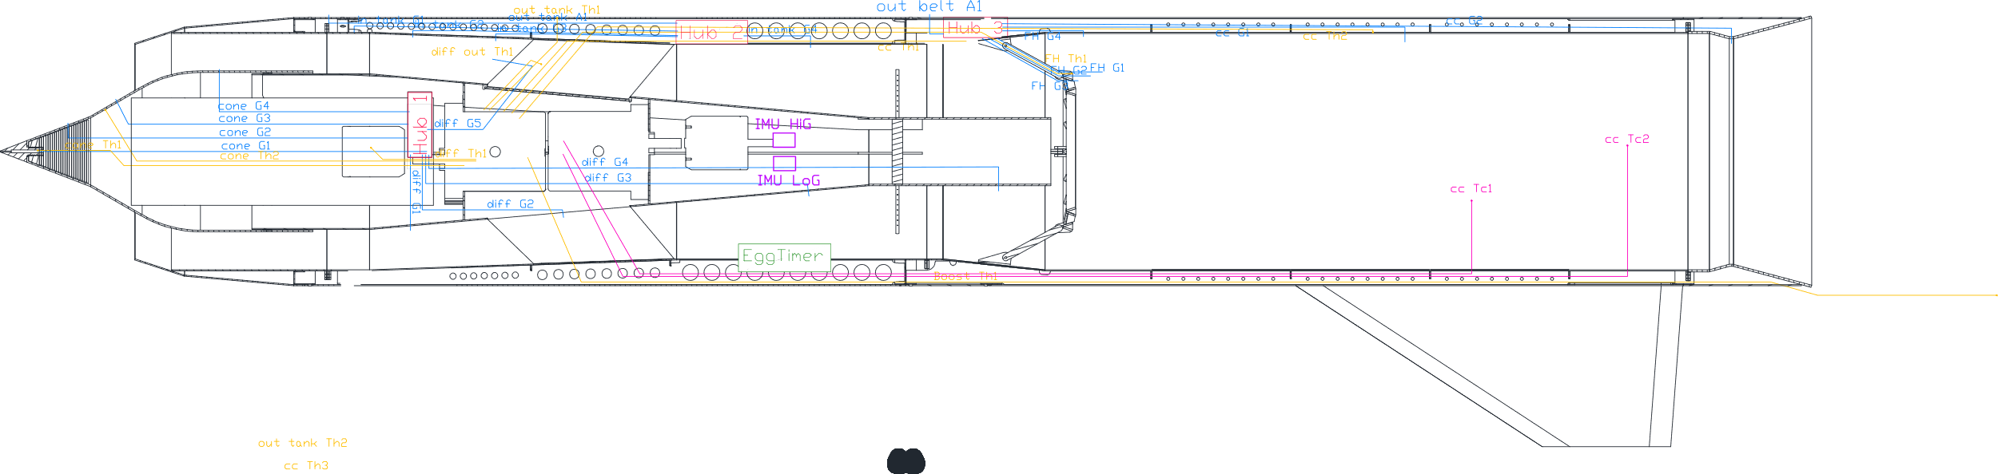

Temperature sensors

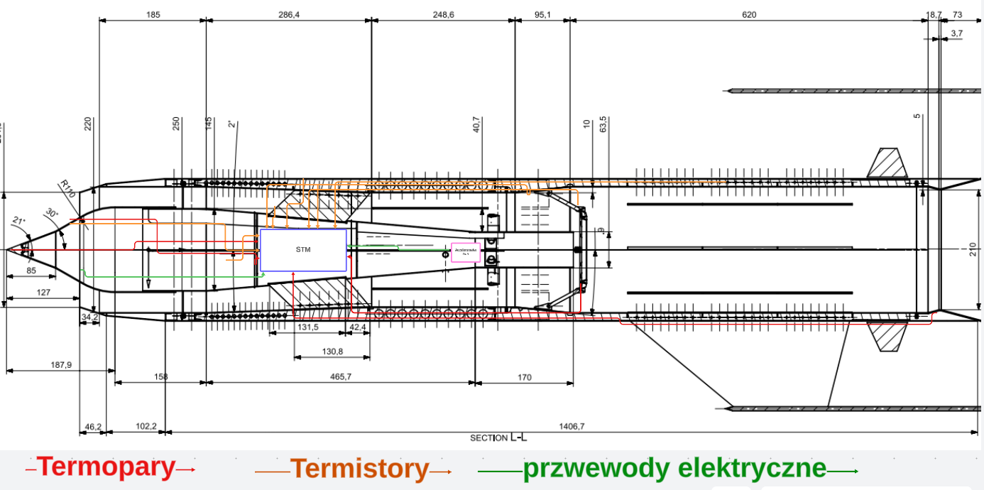

Miscellaneous sensors
There are two accelerometers shown on temperature sensors diagram (pink)

Phases of flight
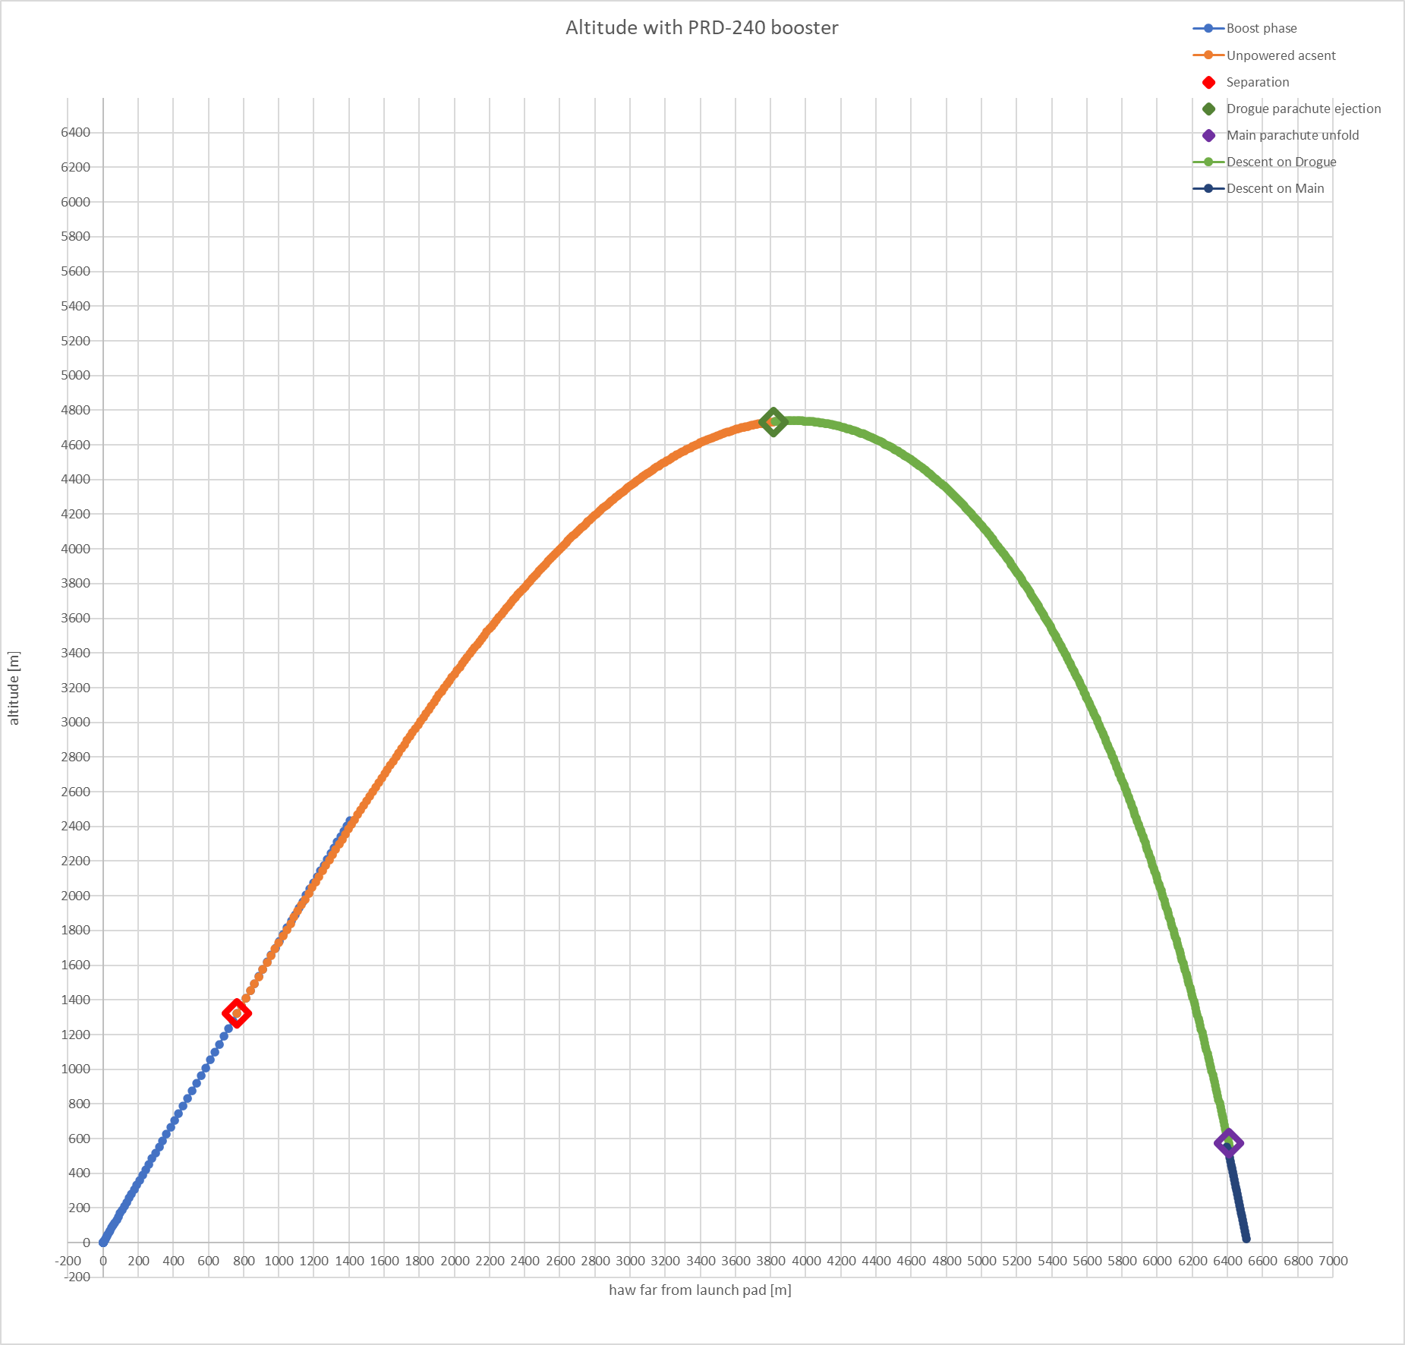

Boost phase

phase duration | 5s
Pressure sensors sample rate | 100Hz
Thermistors sensors sample rate | 10Hz
Thermocouple sample rate | 10Hz
High G accelerometer | 100Hz
Accelerometer and gyroscopes | 100Hz

Separation
Cypress cutter triggered by EggTimmer

Unpowered ascent

phase duration | 22s
Pressure sensors sample rate | 100Hz
Thermistors sensors sample rate | 10Hz
Thermocouple sample rate | 10Hz
High G accelerometer | 10Hz
Accelerometer and gyroscopes | 100Hz

Drogue parachute ejection
- Charge ignited/valve opened triggered by Eggtimer
- Charge ignited to cut sensor air-line triggered by Eggtimer hopefully the same signal to trigger both

Descent on Drogue
phase duration | 118s
Pressure sensors sample rate | 10Hz
Thermistors sensors sample rate | 5Hz
Thermocouple sample rate | 5Hz
High G accelerometer | 1Hz
Accelerometer and gyroscopes | 100Hz

Main parachute unfold
Cypress cutter triggered by Eggtimmer

Descent on Main parachute
phase duration | 50s
Pressure sensors sample rate | 1Hz
Thermistors sensors sample rate | 1Hz
Thermocouple sample rate | 1Hz
High G accelerometer | 1Hz
Accelerometer and gyroscopes | 10Hz

Auxiliary buoyancy system (ABS) opening
ABS inflates in contact with water.

Recovery
GPS beacon should start to transmit
phase duration | God knows
Pressure sensors sample rate | 0Hz
Thermistors sensors sample rate | 0.01Hz
Thermocouple sample rate | 0Hz
High G accelerometer | 0Hz
Accelerometer and gyroscopes | 0Hz

