


Pneumatic cutter Test
first 3d printed version

Made by:
- Michał Skiba
-
Approved by:
-

Table of Contents:
1. Warning 3
2. List of parts 3
3. Check list 3

Warning


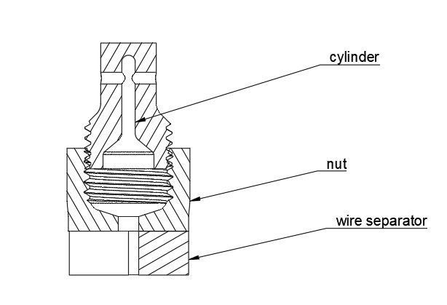
This one test is dangerous, don’t be an idiot.

List of parts
- Cylinder
- Nut
- Wire separator
- Ignitor
- Guillotine
- 4mm pneumatic line
- DC Power Supply Variable
- Wires for dc power supply with clips
- Vice
- Wide pipe in which you can put vice
- Some cover for pipe
- Some canvas to catch debris

Check list
- Put pneumatic line to cylinder
- Put guillotine to cylinder
- Put your safety glasses on and hearing protection
- Put ignitor to nut make sure that wires are twisted with each other
- Thread nut on cylinder
- Put hole assembly to vice
- Put vice to pipe
- Make sure that DC power supply don’t have any voltage
- Disconnect wires from DC power supply
- Touch to end of wires to make sure that there is no voltage on wires
- Untwist ingniter wires and connect wires to the igniter
- Put cover and canvas on pipe to protect your self from debris
- Make sure that there is no voltage on DC power supply
- Make sure everyone have eye and hearing protection on
- Connect wires to DC power supply
- To explode igniter increase voltage to 4V

