


Injector test
test of orifice injector using 3d printer nozzles

Made by:
- Michał Skiba
Approved by:
-

Table of Contents:
1. HUB’s 3
2. List of sensors 3
2.1. Pressure sensors 3
2.2. Temperature sensors 4
2.3. Miscellaneous sensors 5
3. Sensor’s schematic 5
3.1. Pressure sensors 5
3.2. Temperature sensors 6
3.3. Miscellaneous sensors 6
4. Phases of flight 7
4.1. Boost phase 8
4.2. Separation 8
4.3. Unpowered ascent 8
4.4. Drogue parachute ejection 9
4.5. Descent on Drogue 9
4.6. Main parachute unfold 9
4.7. Descent on Main parachute 10
4.8. Auxiliary buoyancy system (ABS) opening 10
4.9. Recovery 10

Introduction
The goal of this test Is to measure how different hole size injectors atomize the kerosene. Additionally, it can be measured volumetric and mechanical efficiencies of pump.

Setup

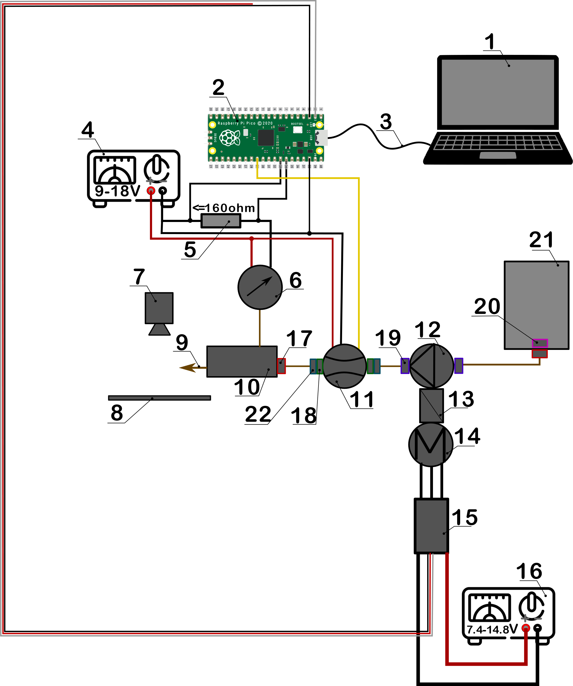
Figure 2.1 Experiment setup

22 | 2 | Hydraulic nipple 12x1.5 6L - 16x1.5 10L
21 | 1 | Fuel tank
20 | 1 | Nut M12x1.5
19 | 2 | Hydraulic nipple BSP 3/8'' - M12x1.5
18 | 2 | Coupling (mufa) BSP 1/2'' - M16x1.5
17 | 2 | Hydraulic nipple M12x1.5 - M12x1.5
16 | 1 | Power supply for pump motor
15 | 1 | ECS
14 | 1 | Electric motor
13 | 1 | Gear transmission
12 | 1 | Gear pump
11 | 1 | Flow meter
10 | 1 | Manifold block
9 | 1 | Tested injectors
8 | 1 | Background bord for good contrast
7 | 1 | Slow motion camera
6 | 1 | Pressure transducer
5 | 1 | Resistor (55-160 Ohm)
4 | 1 | Power supply for pressure sensor and flow meter (9-18V)
3 | 1 | Micro USB - USB cable
2 | 1 | Raspberry pi Pico
1 | 1 | Laptop
No | Qty | Name

