Salmon River Adventures

Site Plan

## Overview

**Site Purpose**

The objective of the Salmon River Adventures website is to deliver clear, prompt, and meaningful information regarding the services provided. A simple portal that provides the information in a manner that draws the viewer into the site with easy and comfort. Providing the visitor with necessary details, while at the same time assuring safety and security in a water rafting adventure. The visitor will be able to preview various rafting adventures. In each adventure outline, there will be images displayed that convey fun and excitement for people of all ages. Small, direct summaries of each adventure will explain what is offered in the respective adventure and will coincide with the images. The website will be responsive in mobile (small), tablet (medium), and desktop (large) formats.

**Target Audience**

All individuals, groups, and families wanting to experience outdoor adventure in water rafting. School clubs, business getaways, team building activities, birthday parties and special events and another other group events are catered too. Our goal is to bring everyone closer to nature in a manner that they may have never experienced before. While doing so, they will learn skills how to safely, as a group, navigate the waters under various conditions. From beginners that have never been in a boat, to individuals that are seasoned in white water rafting, we can deliver an experience that is suitable to their skills.

## Color Scheme

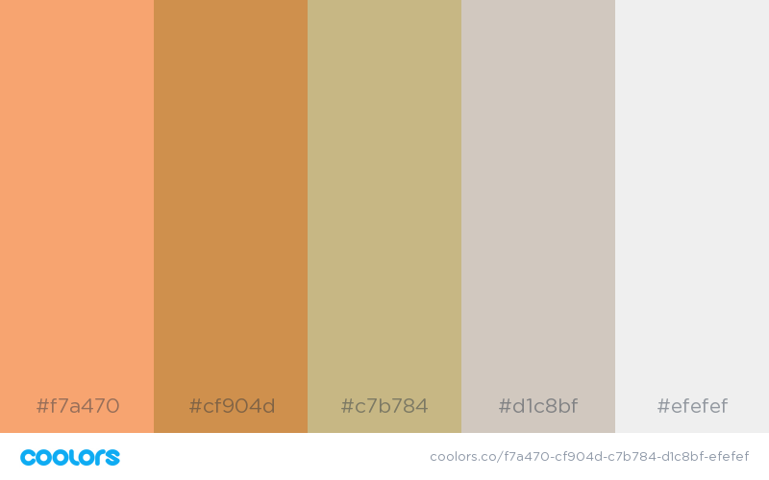

|  |  |  |  |
| --- | --- | --- | --- |
| **Primary** | **Secondary** | **Accent** | **Accent** |
| #C7B784 | #D1C8BF | #CF904B | #EFEFEF |
| Super Accent | #F7A470 |  |  |

## Typography

### Heading Font: Montserrat

### Montserrat Black is a sharp, bold, font that easily catches the attention of the reader.

### Paragraph (Body) Font: Martel

### Martel is a subtle serif font that is a good contrast to the bold lines of the Montserrat.

|  |  |  |  |  |
| --- | --- | --- | --- | --- |
| Navigation | Montserrat | 30px | #C7B784 | Text |
| Heading 1 (h1) | Montserrat | 28px | #CF904D | Text |
| Heading 2 (h2) | Montserrat | 24px | #F7A470 | Text |
| Paragraph Text (p) | Martel | 20px | #000000 | Text |

## Site Map

## Wireframe Sketches

### Large:

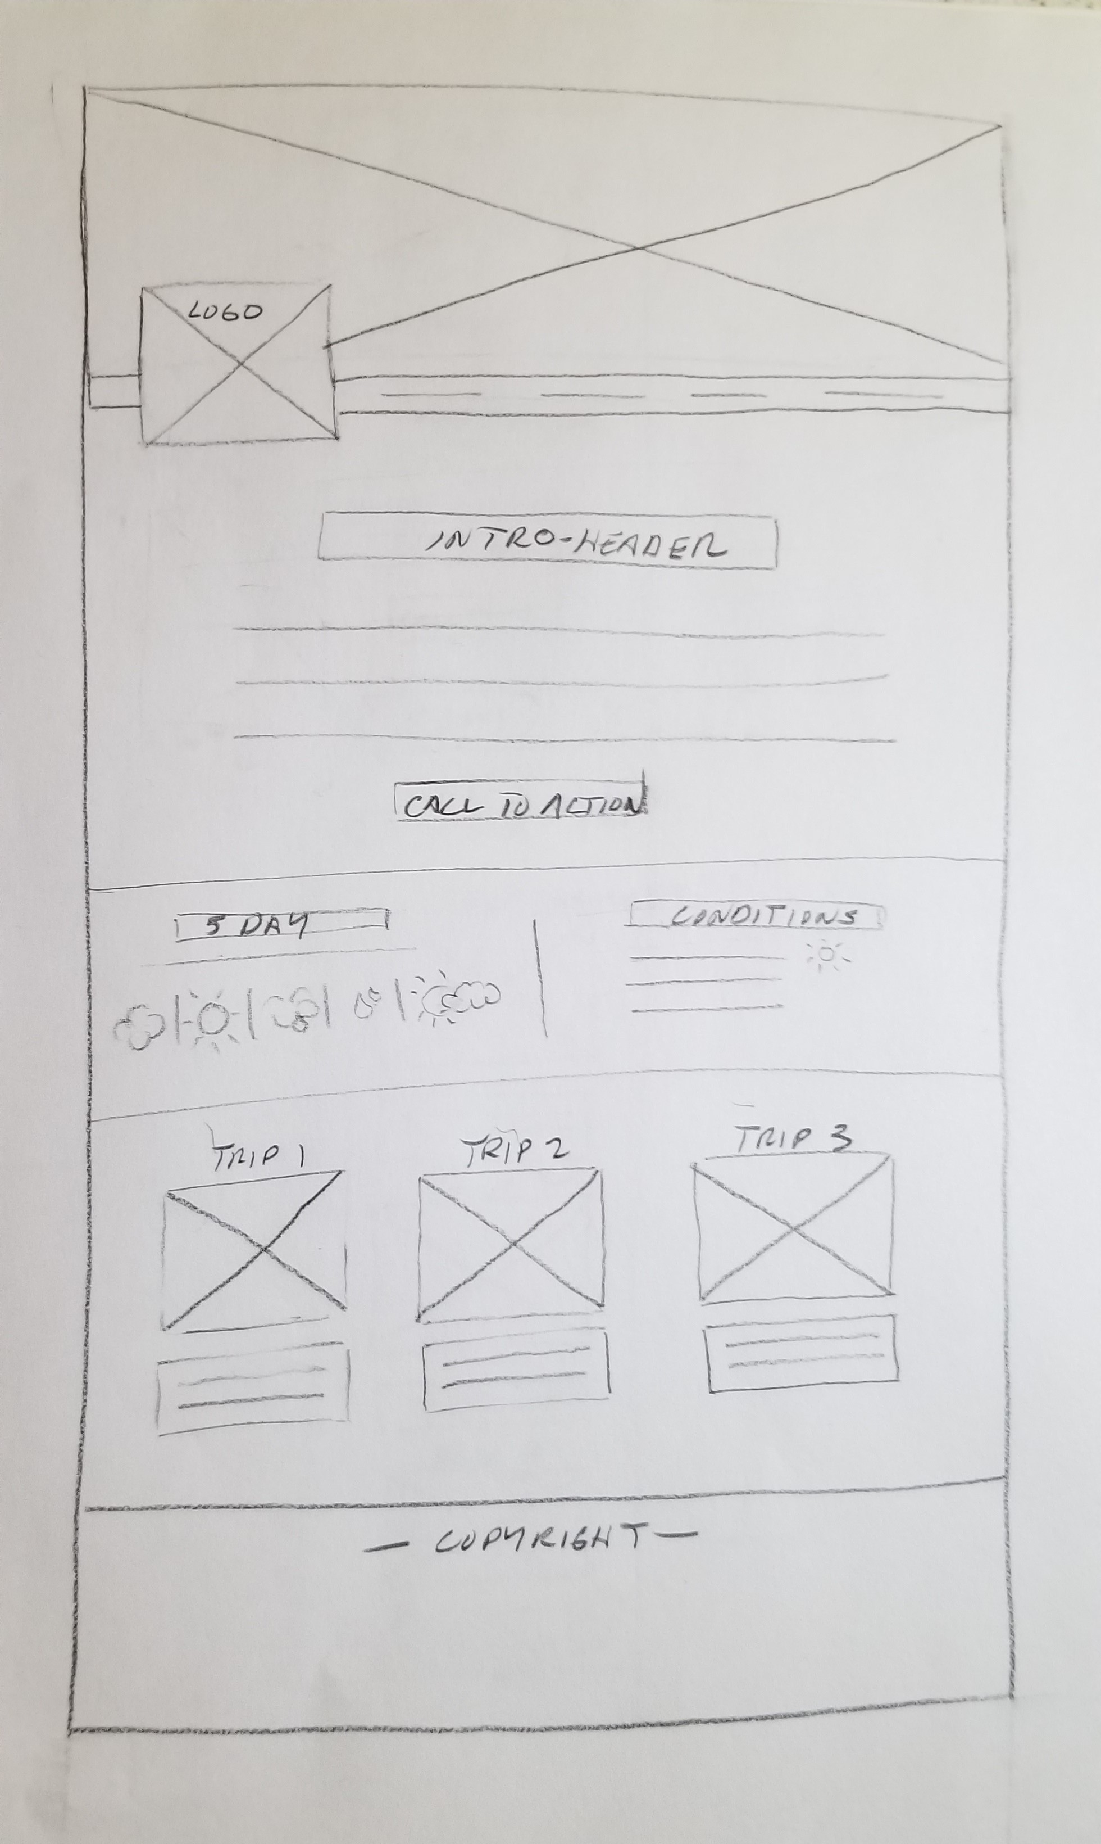

### Medium:

### C:\Users\Tom\AppData\Local\Microsoft\Windows\INetCache\Content.Word\full_crop.jpg

### Small:

