The Battle

# Concept

Two players are fighting against each other on a battlefield out of hexagons. Every player has a castle on each side and the goal is to destroy the castle from the other player. The battle is structured in rounds, each player gets in his round a certain amount of gold, which he can use to buy troops.

## Screenshot

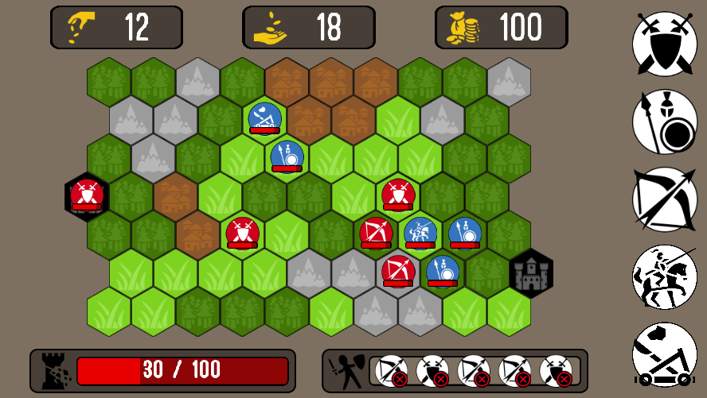

# Rounds and Actions

## Beginning of Battle

Before a battle starts the server decides which player starts. This player will also build the battlefield and send it to the other player. In the first round each player has to place his castle. The castle can be placed on the border of the player’s side of the field.

## Round

At the beginning of the round the active player gets 30 Gold minus the sum of the salaries from the troops on the battlefield.

To speed up the battle takes a round just 15 seconds. The other player can just watch during this time.

Every turn which is made gets send to the opponent application and gets verified. Because of this, can the opponent see every turn in real-time. If a turn doesn’t pass the verification the game gets quitted, because this is only possible if at least one application is corrupt.

## Actions

### Create Troops

With your gold you can produce new troops.

You can queue until 3 troops. The gold gets spend when you put the troop into the queue and gets fully refunded when you remove it from the queue.

New troops spawn at the beginning of the round in the castle.   
If there is already a troop in the castle, this troop get pushed out to a free field next to the castle.   
If every field around is taken by troops of the opponent, this troop get pushed away to the next free field.   
If there are more then one field free or all taken, the field in which the troop get pushed is determined by the following rule:

For the castle on the left side of the battlefield it’s the field with the lowest sum of x and y coordinate. If the sum of two fields is same the one with the lowest y coordinate is chosen.

For the castle on the right side of the battlefield it’s the field with the highest sum of x and y coordinate. If the sum of two fields is same the one with the highest y coordinate is chosen.

### Move Troops

Every troop has based on the type a certain number of fields per round (FPR) which they can move. If the way goes over a field which has a special FPR value, the specified amount gets used to pass/enter the field.

A Troop cannot move over fields which are already taken by another troop. Doesn’t matter if it is your own troop or from the opponent.

If you try to move a troop to a field which is taken by an opponent’s troop you attack it. The attack itself (last move into the taken field) costs always just one FPR. After an attack the troop has automatically zero FPR.

### Fights

Just the damage bonuses of the field which is attacked effects the damage calculation in fights. This are the used formulas to calculate the fight.

Defender HP – ((Attacker Attack Damage * Field bonus * Troop bonus) * Incoming Damage Field bonus)

Attacker HP - (Defender Defend Damage * Field bonus * Troop bonus)

After the fight every troop gets removed from the battlefield which has not any HP anymore.

If the defender troop got killed, the attacker moves into the attacked field. If not, he stays at the neighbour field where he came from.

# Battlefield

The battlefield is made out of 19 x 7 hexagons. The map gets generated at the start of each game. Every field gets randomly one of the following types assigned. The major part of the battlefield will be grass.

## Grass

* +50% Damage Knight

## Forrest

* 3 FPR Knight
* +50% Damage Archer and Spearman

## Mountain

* 4 FPR All
* +100% Defence Damage All

## Settlement

* 2 FPR All
* +50% Damage Swordsman

## Castle

* 2 FPR All
* Special: Can be attacked -> 300 HP
* +200% Defence Damage All
* -50% Incoming Damage All

# Troops

## Swordsman

* Price: 10$
* Time to Build: 2 Round
* Salary: 3$
* Speed: 4 FPR
* Health points: 40 HP
* Attack Damage: 10
* Defence Damage: 15
* Special:
  + +30% against Spearman

## Spearman

* Price: 7$
* Time to Build: 1 Round
* Salary: 2$
* Speed: 5 FPR
* Health points: 30 HP
* Attack Damage: 8
* Defence Damage: 10
* Special:
  + +150% against Knight

## Archer

* Price: 10$
* Time to Build: 2 Round
* Salary: 3$
* Speed: 5 FPR
* Health points: 20 HP
* Attack Damage: 25
* Defence Damage: 30

## Knight

* Price: 25$
* Time to Build: 4 Round
* Salary: 6$
* Speed: 8 FPR
* Health points: 100 HP
* Attack Damage: 25
* Defence Damage: 15

### Catapult

* Price: 10$
* Time to Build: 2 Round
* Salary: 2$
* Speed: 2 FPR
* Health points: 60 HP
* Attack Damage: 5
* Defence Damage: 10
* Special:
  + +2000% against Castle

## Balancing

The Game can be made faster with changing the Time to Build, Salary and Speed Value.

# Implementation Concept

## Use Case / Application Flow Diagram

**Client**

**Server**

Loading Screen

Signup

Login

Main Menu

Registration

Authentication

User Data

Multiplayer

Singleplayer

User Management

Search opponent

Battle Starter

Build Battlefield

Game

Corrupt Game

Finish Game

Replay

Log Game

Save Stats

Analyse Game

Tasks which happen on 2 Clients and has to be Sync

Dev Mode

Just for Development

## Multiplayer Battle Sequence Diagram

