Computer Architecture

Final Exam

Spring 2015

2015/06/10
02:00 P.M. – 03:15 P.M.

Total: 130 points

Read Me First

- 답은 한글로 적어도 좋습니다.
- If you cheat on exam, you will get an “F” for the course.
- Some questions have several subproblems. Make sure that you put all the answers for the subproblems in one place on your answer sheet.

Visit the course homepage for the final exam scores and grades.
The exact schedule will be announced on the homepage.

Problem 1. [40]
Consider a memory hierarchy with the following parameters:
14-bit virtual addresses, 12-bit physical addresses, 64-byte page size, 4-way set-associative TLB with 16 entries, physically addressed direct mapped cache with 16 lines and 4-byte block size.
Using the snapshot of the memory hierarchy shown on the next page, answer the following questions.
(We assume that the memory is byte addressable and all memory accesses are to 1-byte words (not 4-byte words).)
- [12 = 3x4] For the virtual address 0x03d7,
Is this access TLB hit or TLB miss? ( )
What is the physical address for this virtual address? ( )
Is this access cache hit or miss? ( )
What is the byte returned from the cache? If there is a cache miss, indicate by MEM. ( )
- [12 = 3x4] For the virtual address 0x0020,
Is this access TLB hit or TLB miss? ( )
What is the physical address for this virtual address? ( )
What is the byte returned from the cache? If there is a cache miss, indicate by MEM. ( )
- [8] For the virtual address 0x0040, explain how this access will be serviced. If 0x0040 is accessed using the same steps as 0x03d7 (of (a)), answer by A. Similarly, if 0x0040 takes the same steps as 0x0020, answer by B.
- [8] When we changed the direct mapped cache to have 32 lines (instead of 16 lines), the L1 cache access time for a given virtual address has significantly increased. What might be a possible reason for this increase in the L1 cache access time?

Page Table (Only the first 16 PTEs) ------------------------------------------------------

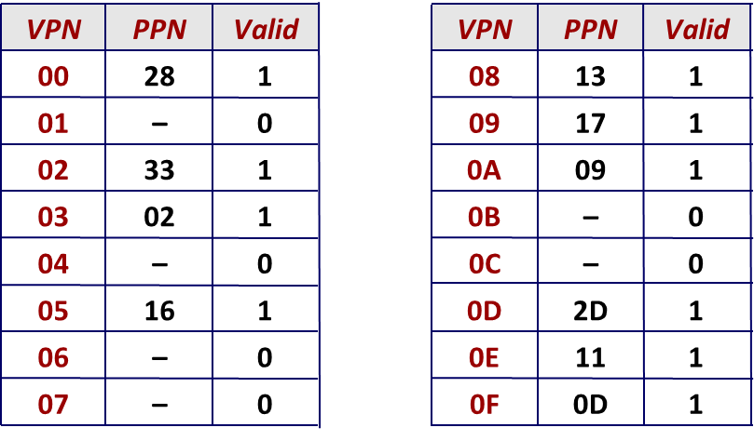
Cache ----------------------------------------------------------------------------------------

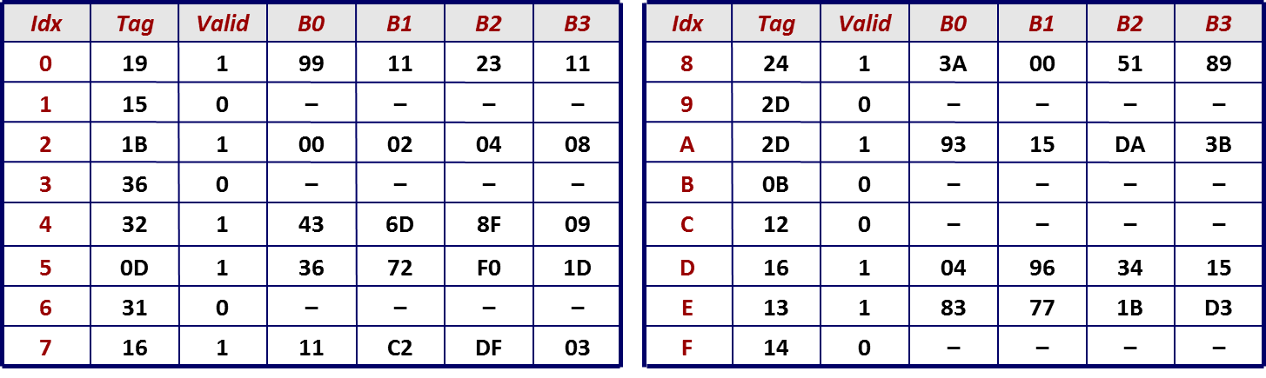

TLB -------------------------------------------------------------------------------------------

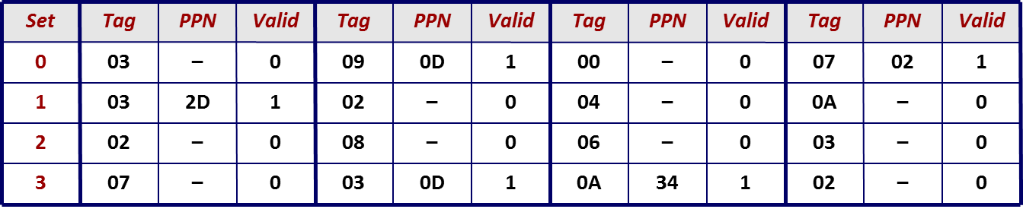

Problem 2. [10]
32바이트 크기의 cache 메모리를 채택하는 초소형프로세서 mRISC를 설계하려고 한다. mRISC가 사용할 수 있는 전체 메모리 크기가 64바이트이고 하나의 cache block 크기가 4바이트임을 가정하고 아래 질문에 답하시오. (64바이트의 메모리는 편의상 B0, ... , B15의 16개의 4바이트 크기의 메모리 블록으로 나누어진다고 약속한다.)

mRISC의 중요한 benchmark program인 L100는 아래와 같은 메모리 블록 접근을 100번 반복하는 특성이 있다:
(B0->B2->B4->B6->B8->B10->B12->B14)
- mRISC가 2-way set associative cache를 채택한다면 L100을 수행하는 동안 총
몇 회의 cache miss가 발생하는가? (블록 replacement policy는 LRU를 가정.)
- mRISC가 fully-associative cache를 채택한다면 L100을 수행하는 동 안 총
몇 회의 cache miss가 발생하는가? (블록 replacement policy는 LRU를 가정.)

Problem 3. [10]
In our cache design, we used the middle bits (of a given address) for the set index instead of other choices. For example, we may use the high-order bits as the set index. Explain why the middle bits are better as the set index.

Problem 4. [10]
We have a program segment consisting of two conditional branches, B1 and B2, which are executed multiple times during a single execution of the program segment. Below are the outcomes of each branch when the program segment was executed (T for taken and N for not taken):
B1: T-T-T-N-T
B2: T-T-N-T-T-N-T
Assume that each branch has its own prediction buffer. Compare the prediction results of two branch prediction schemes: (1) 1-bit predictor, initialized to predict taken and (2) 2-bit predictor, initialized to weakly predict taken. For each scheme, count the number of correct predictions and the number of incorrect predictions.

Problem 5. [20]
Decide if the following statements are true or false. If your answer is false, argue why the statement is not true. (If the answer is false but you don’t provide enough argument to justify your answer, you will get no point.)
- [10] Increasing the depth of pipelining always increases performance.
- [10] Increasing the cache associativity always improves the miss ratio.

Problem 6. [10]
In the 5-stage pipelined computer we studied, the following code segment may cause an incorrect behavior when ‘jne t’ was mispredicted to be taken. Explain when and why such behavior occurs. (Hint: 0xFF is an invalid instruction code.)
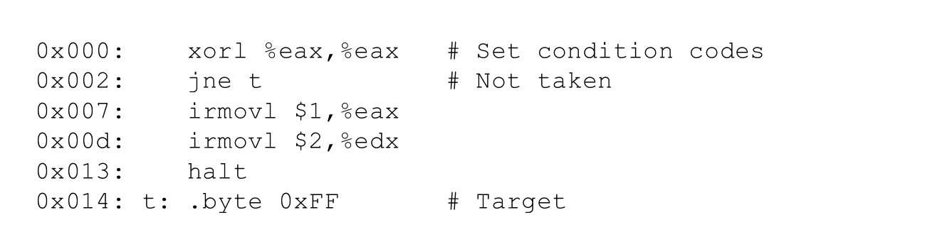

Problem 7. [10]
For the load/use hazard, data forwarding is not effective. Explain why this is the case and describe how this hazard is typically resolved.

Problem 8. [10]
One of the key design principles of designing high-performance systems is to make the common case fast. Give one case where this principle was successfully applied. Give your explanation based on the following framework:
- The definition of the common case
- How to improve the performance for the common case
- Impact of the proposed improvement on non-common cases

Problem 9. [10]
- [5] The designers of a processor made two design changes. One change can reduce the clock cycle time by 50% and the other change can reduce the CPI by 25%. What is the average reduction for these two design changes (in percent) in terms of the time to execute an instruction? (Note: You do not need to simplify your expression.) (힌트: the average reduction for these two design changes란 두 개의 design change가 각기 동일한 reduction효과를 가진다고 가정할 때 각 기법의 reduction효과가 무엇인지를 묻는 질문)

- [5] 200 jobs are processed on a computer. The first 100 jobs are processed at 50 jobs per day and the second 100 jobs are processed at 100 jobs per day. What is the average rate of processing 200 jobs?

