Remove text that starts with “Lorem…”

Put appropriate icons for New Supplier, Potential Landlord and Employment Opportunity

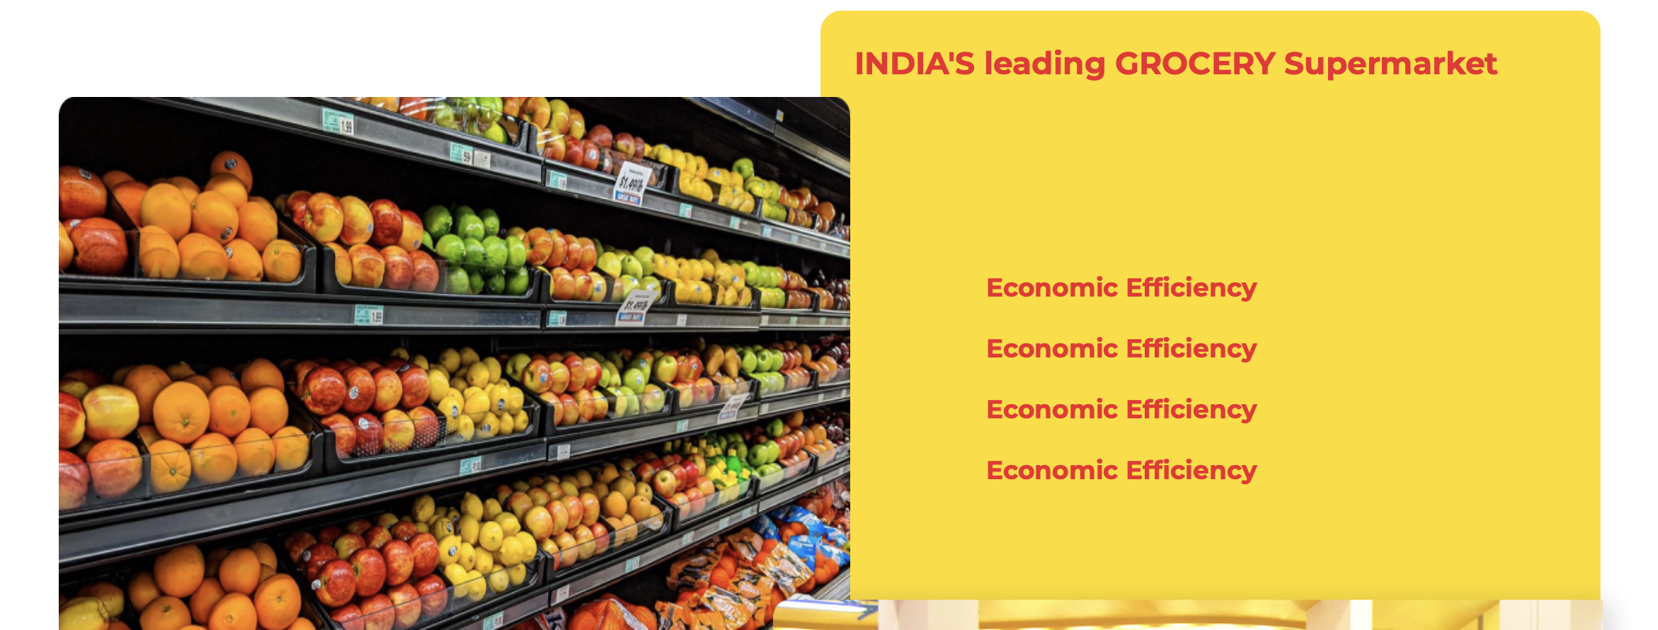

Why is “Economic Efficiency” getting repeated? If you want you can put the values there, product focus, determination & persistence, collaboration, Ownership

Amar – Why are we the best, please let us know what should go in here

**Our Values**

**~~“Culture to deliver the pillars of our value proposition”~~**

**“Values which drive the culture of our organisation”**

##### Owenership

Spell check

Vertical and horizontal alignment of the bullet points

**Our Store Presence**

**We are currently present in Kolkata, IN & expanding rapidly all across the country**

**Our presence** – Sumosave is currently present in following suburbs of **Kolkata**

**Tangra**Ground Floor, Active Acres Business Park

**Maheshtalla**opp Batanagar main gate (coming soon*)

**Kanchrapara**Ghoshpara Road (coming soon*)

Please remove the *

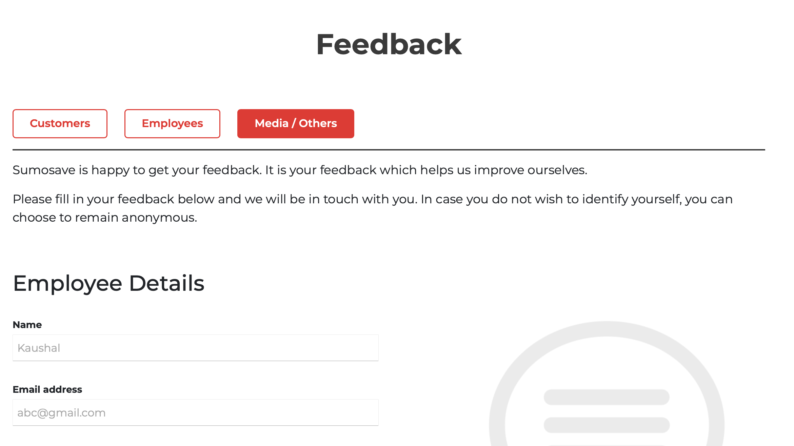

Customers, Employees and Media/Others buttons are not working correctly. I have clicked on Media/Others but Employees details are shown below.

In Customers, default the Store Name to “Kolkata”

Partner with us the fields what was given is not reflecting. Pls check.