**Module: Authorize.net Payment Module**

**Date: 21-Apr-2015**

***Code Camp Active Enrolment List:***

Create a new table which is used to store the users who actively enrolled to the code camp plan. This table is used to log the details of the users who enrolled to the code camp which used to verify the user who contacts the Knodemy admin or support team to cancel the code camp plan. Since, there is no direct option to cancel the plan by the user.

**Table Name:**

mdl_enrol_activeenrol_list

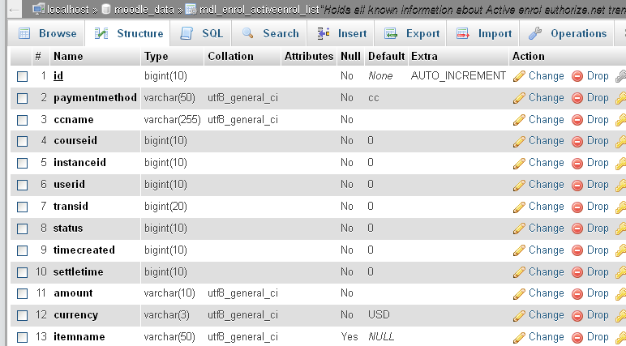

***SQL Script:***

*CREATE TABLE IF NOT EXISTS `mdl_enrol_activeenrol_list` (*

*`id` bigint(10) NOT NULL AUTO_INCREMENT,*

*`paymentmethod` varchar(50) NOT NULL DEFAULT 'cc',*

*`ccname` varchar(255) NOT NULL DEFAULT '',*

*`courseid` bigint(10) NOT NULL DEFAULT '0',*

*`instanceid` bigint(10) NOT NULL DEFAULT '0',*

*`userid` bigint(10) NOT NULL DEFAULT '0',*

*`transid` bigint(20) NOT NULL DEFAULT '0',*

*`status` bigint(10) NOT NULL DEFAULT '0',*

*`timecreated` bigint(10) NOT NULL DEFAULT '0',*

*`settletime` bigint(10) NOT NULL DEFAULT '0',*

*`amount` varchar(10) NOT NULL DEFAULT '',*

*`currency` varchar(3) NOT NULL DEFAULT 'USD',*

*`itemname` varchar(50) DEFAULT NULL,*

*PRIMARY KEY (`id`)*

*) ENGINE=InnoDB DEFAULT CHARSET=utf8 COMMENT='Holds all known information about Active enrol authorize.net transactions' AUTO_INCREMENT=1 ;*