**Tables Related to Payment Module Knodemy**

**Date:** April 24, 2015

Ref. SQL Script file: payment-related-tables.sql

**Table Name :** mdl_authorize_cardcredential

CREATE TABLE IF NOT EXISTS `mdl_authorize_cardcredential` (

`id` int(11) NOT NULL AUTO_INCREMENT,

`userid` bigint(100) NOT NULL,

`profileid` bigint(100) NOT NULL,

`paymentid` bigint(100) NOT NULL,

`details` varchar(200) DEFAULT NULL,

`status` int(10) NOT NULL,

`timecreated` varchar(200) NOT NULL,

PRIMARY KEY (`id`)

) ENGINE=InnoDB DEFAULT CHARSET=utf8 AUTO_INCREMENT=1 ;

**Table Name :** mdl_authourize_student_mins

CREATE TABLE IF NOT EXISTS `mdl_authourize_student_mins` (

`id` int(11) NOT NULL AUTO_INCREMENT,

`userid` int(11) DEFAULT NULL,

`courseid` int(11) DEFAULT NULL,

`coursename` varchar(50) DEFAULT NULL,

`reference_id` bigint(20) DEFAULT NULL,

`amount` bigint(20) DEFAULT NULL,

`status` int(11) DEFAULT NULL,

`initial_minutes` int(11) DEFAULT NULL,

`total_minutes` int(11) DEFAULT NULL,

`packagename` varchar(100) DEFAULT NULL,

`timecreated` int(11) DEFAULT NULL,

`timemodified` int(11) DEFAULT NULL,

PRIMARY KEY (`id`)

) ENGINE=InnoDB DEFAULT CHARSET=latin1 AUTO_INCREMENT=1 ;

**Table Name :** mdl_authourize_activeenrol_list

CREATE TABLE IF NOT EXISTS `mdl_enrol_activeenrol_list` (

`id` bigint(10) NOT NULL AUTO_INCREMENT,

`paymentmethod` varchar(50) NOT NULL DEFAULT 'cc',

`ccname` varchar(255) NOT NULL DEFAULT '',

`courseid` bigint(10) NOT NULL DEFAULT '0',

`instanceid` bigint(10) NOT NULL DEFAULT '0',

`userid` bigint(10) NOT NULL DEFAULT '0',

`transid` bigint(20) NOT NULL DEFAULT '0',

`status` bigint(10) NOT NULL DEFAULT '0',

`timecreated` bigint(10) NOT NULL DEFAULT '0',

`settletime` bigint(10) NOT NULL DEFAULT '0',

`amount` varchar(10) NOT NULL DEFAULT '',

`currency` varchar(3) NOT NULL DEFAULT 'USD',

`itemname` varchar(50) DEFAULT NULL,

PRIMARY KEY (`id`)

) ENGINE=InnoDB DEFAULT CHARSET=utf8 COMMENT='Holds all known information about Active enrol authorize.net transactions' AUTO_INCREMENT=1 ;

**Table Name :** mdl_authourize_activerecurring_list

CREATE TABLE IF NOT EXISTS `mdl_enrol_activerecurring_list` (

`id` bigint(10) NOT NULL AUTO_INCREMENT,

`paymentmethod` varchar(30) NOT NULL DEFAULT 'cc',

`startdate` date NOT NULL,

`ccname` varchar(255) NOT NULL DEFAULT '',

`courseid` bigint(10) NOT NULL DEFAULT '0',

`instanceid` bigint(10) NOT NULL DEFAULT '0',

`userid` bigint(10) NOT NULL DEFAULT '0',

`subscribeid` bigint(20) NOT NULL DEFAULT '0',

`status` bigint(10) NOT NULL DEFAULT '0',

`timecreated` bigint(10) NOT NULL DEFAULT '0',

`settletime` bigint(10) NOT NULL DEFAULT '0',

`amount` varchar(10) NOT NULL DEFAULT '',

`currency` varchar(3) NOT NULL DEFAULT 'USD',

`itemname` varchar(200) NOT NULL DEFAULT 'None',

PRIMARY KEY (`id`)

) ENGINE=InnoDB DEFAULT CHARSET=utf8 COMMENT='Holds' AUTO_INCREMENT=1 ;

**Table Name :** mdl_enrol_authorize

CREATE TABLE IF NOT EXISTS `mdl_enrol_authorize` (

`id` bigint(10) NOT NULL AUTO_INCREMENT,

`paymentmethod` varchar(50) NOT NULL DEFAULT 'cc',

`refundinfo` bigint(30) NOT NULL DEFAULT '0',

`ccname` varchar(255) NOT NULL DEFAULT '',

`courseid` bigint(10) NOT NULL DEFAULT '0',

`instanceid` bigint(10) NOT NULL DEFAULT '0',

`userid` bigint(10) NOT NULL DEFAULT '0',

`transid` bigint(20) NOT NULL DEFAULT '0',

`status` bigint(10) NOT NULL DEFAULT '0',

`timecreated` bigint(10) NOT NULL DEFAULT '0',

`settletime` bigint(10) NOT NULL DEFAULT '0',

`amount` varchar(10) NOT NULL DEFAULT '',

`currency` varchar(3) NOT NULL DEFAULT 'USD',

`itemname` varchar(50) DEFAULT NULL,

PRIMARY KEY (`id`),

KEY `mdl_enroauth_cou_ix` (`courseid`),

KEY `mdl_enroauth_use_ix` (`userid`),

KEY `mdl_enroauth_sta_ix` (`status`),

KEY `mdl_enroauth_tra_ix` (`transid`)

) ENGINE=InnoDB DEFAULT CHARSET=utf8 COMMENT='Holds all known information about authorize.net transactions' AUTO_INCREMENT=1 ;

**Table Name :** mdl_knouser_allocated_mins

CREATE TABLE IF NOT EXISTS `mdl_knouser_allocated_mins` (

`id` int(11) NOT NULL AUTO_INCREMENT,

`userid` int(11) DEFAULT NULL,

`allocated_minutes` int(11) DEFAULT NULL,

`scheduled_minutes` int(11) DEFAULT NULL,

`inactive_completed_mins` int(11) DEFAULT NULL,

`active_mins` int(11) DEFAULT NULL,

`status` int(11) DEFAULT NULL,

`timecreated` int(11) DEFAULT NULL,

`allocate_timemodified` int(11) DEFAULT NULL,

`scheduled_timemodified` int(11) DEFAULT NULL,

PRIMARY KEY (`id`)

) ENGINE=InnoDB DEFAULT CHARSET=latin1 AUTO_INCREMENT=1 ;

**Table Name :** mdl_paypal_package

***Description:*** This is an existing table, so we just alter the “duration” & “name” field values in table “mdl_paypal_package”. Update a table ‘mdl_paypal_package’ with sql query. It’s stores the updated course list.

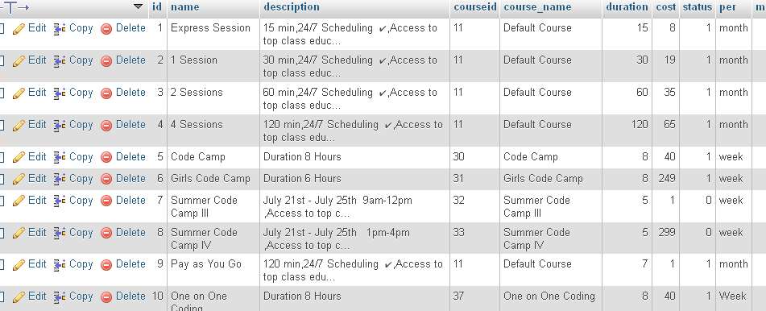

***Execute SQL Query:***

*UPDATE `mdl_paypal_package` SET `duration` = '15' WHERE `mdl_paypal_package`.`id` =1;*

*UPDATE `mdl_paypal_package` SET `duration` = '30' WHERE `mdl_paypal_package`.`id` =2;*

*UPDATE `mdl_paypal_package` SET `duration` = '60' WHERE `mdl_paypal_package`.`id` =3;*

*UPDATE `mdl_paypal_package` SET `duration` = '120' WHERE `mdl_paypal_package`.`id` =4;*

*UPDATE `mdl_paypal_package` SET `name` ='Code Camp',`description` = 'Duration 8 Hours',`course_name` = 'Code Camp',`cost` ='40',`duration` = '8',`max_students` ='1' WHERE `mdl_paypal_package`.`id` =5;*

*UPDATE `mdl_paypal_package` SET `name` ='Girls Code Camp',`description` = 'Duration 6 Hours',`course_name` = 'Girls Code Camp',`cost` ='249',`duration` = '8' WHERE `mdl_paypal_package`.`id` =6;*

*UPDATE `mdl_paypal_package` SET `status`='0' WHERE `mdl_paypal_package`.`id` =7;*

*UPDATE `mdl_paypal_package` SET `status`='0' WHERE `mdl_paypal_package`.`id` =8;*