Knowledge Distance: One Culture, Two Cultures or Many Cultures?

X. Nick Zhang

Abstract
In 1950s, C.P. Snow pointed out that the scientific culture and the literary culture are becoming increasingly alienated. This alienation evolved into the science war in 1990s. As an armistice, several scientists and sociologists edited an anthology The One Culture. Kagan’s book The Three Cultures studied the differences between the natural sciences, the social sciences and the humanities. Wilson expressed the wish for unity of knowledge in his book Consilience. But all their works are qualitative. Here, we put forward the concept of knowledge distance and define its calculation method so that we can quantitatively measure the distance between different branches of knowledge. We apply the measure to large sets scientific literatures. By observing the change of knowledge distance with time, we can understand the evolution process of different cultures. We hope to provide a new scientific methodology for the study of knowledge.

Scientific culture, including natural sciences and mathematics, is sometimes abbreviated to STEM (Science, technology, engineering and mathematics) whereas literary culture generally refers to humanities and social sciences. Microsoft's Academic Map (MAG) (Arnab Sinha, 2015 and Wang, Kuansan,2019) has collected more than 240 million academic publications, including mainly academic papers, and some books and patents. MAG uses Concept Detection and Taxonomy Learning techniques to establish ontology hierarchy of concepts. In MAG, concepts are also called FOS (“fields of study”). At the top of the hierarchy are about 20 or so academic disciplines, such as mathematics, physics, engineering, political science and so on. This almost corresponds to the academic division of an institution of higher education. Each discipline or field may contain several subfields, for example, under Mathematics, there are Algebra, Topology and so on, while under Algebra, furtherly there are Lie algebra, Group theory and so on. We attempt to quantitatively measure the relationships among different fields or disciplines in MAG and procure academic evolution patterns over time.

Knowledge distance. Citation count is the most common measurement for studying academic literatures. However, the simple citation-based metrics and its variations do not exactly characterize the inter-relationships among the disciplines, and cannot provide an adequate framework for studying knowledge evolution. Google semantic similarity function (Cilibrasi and Vitanyi, 2007) can measure the semantic distance between different entities. It was used to model the semantic relevance between different articles or pages in Wikipedia, see (Milne and Witten, 2008). Experiments have shown that it consistently outperforms other measurements both in terms of accuracy and robustness, with another advantage of fairly agnostic to data size, therefore resilient to citation-inflation.

We extend the semantic distance to measure the distance between different academic fields rather than single articles in MAG. In the context of original semantic distance, where a single article is regarded as a node, we treat an entire academic field as a node. A field is a collection of all publication entities belonging to it. The inbound link of this collection is the sum of the inbound links of all articles it contains, and the outbound link is the sum of the outbound links of all articles it contains.

We call this generalized collection-based distance function, knowledge distance, which can be calculated by the following formula:
$$kd(x,y)=\frac{log(max(|X|,|Y|))-log(|X∩Y|)}{log(|G|)-log(min(|X|,|Y|))}$$
Here, x and y are the collections of all articles in two academic fields, the capitals X and Y are the collections of all articles connected to x and y via references, and G is the entire collection of all MAG articles. We slice the whole MAG articles into different collections according to publication years, for example, G_{y} represents the collection of all academic publications up to the year y, and P_{y} represents all publications published in the year y. G_{y-1} is G_{y}$-$P_{y}. Generally, $kd(x,y)$ <=1, whereas in case $kd(x,y)$ >1, we set it to be 1. We then can calculate relevance or closeness between x and y as $kr\left(x,y\right)=1-kd(x,y)$.
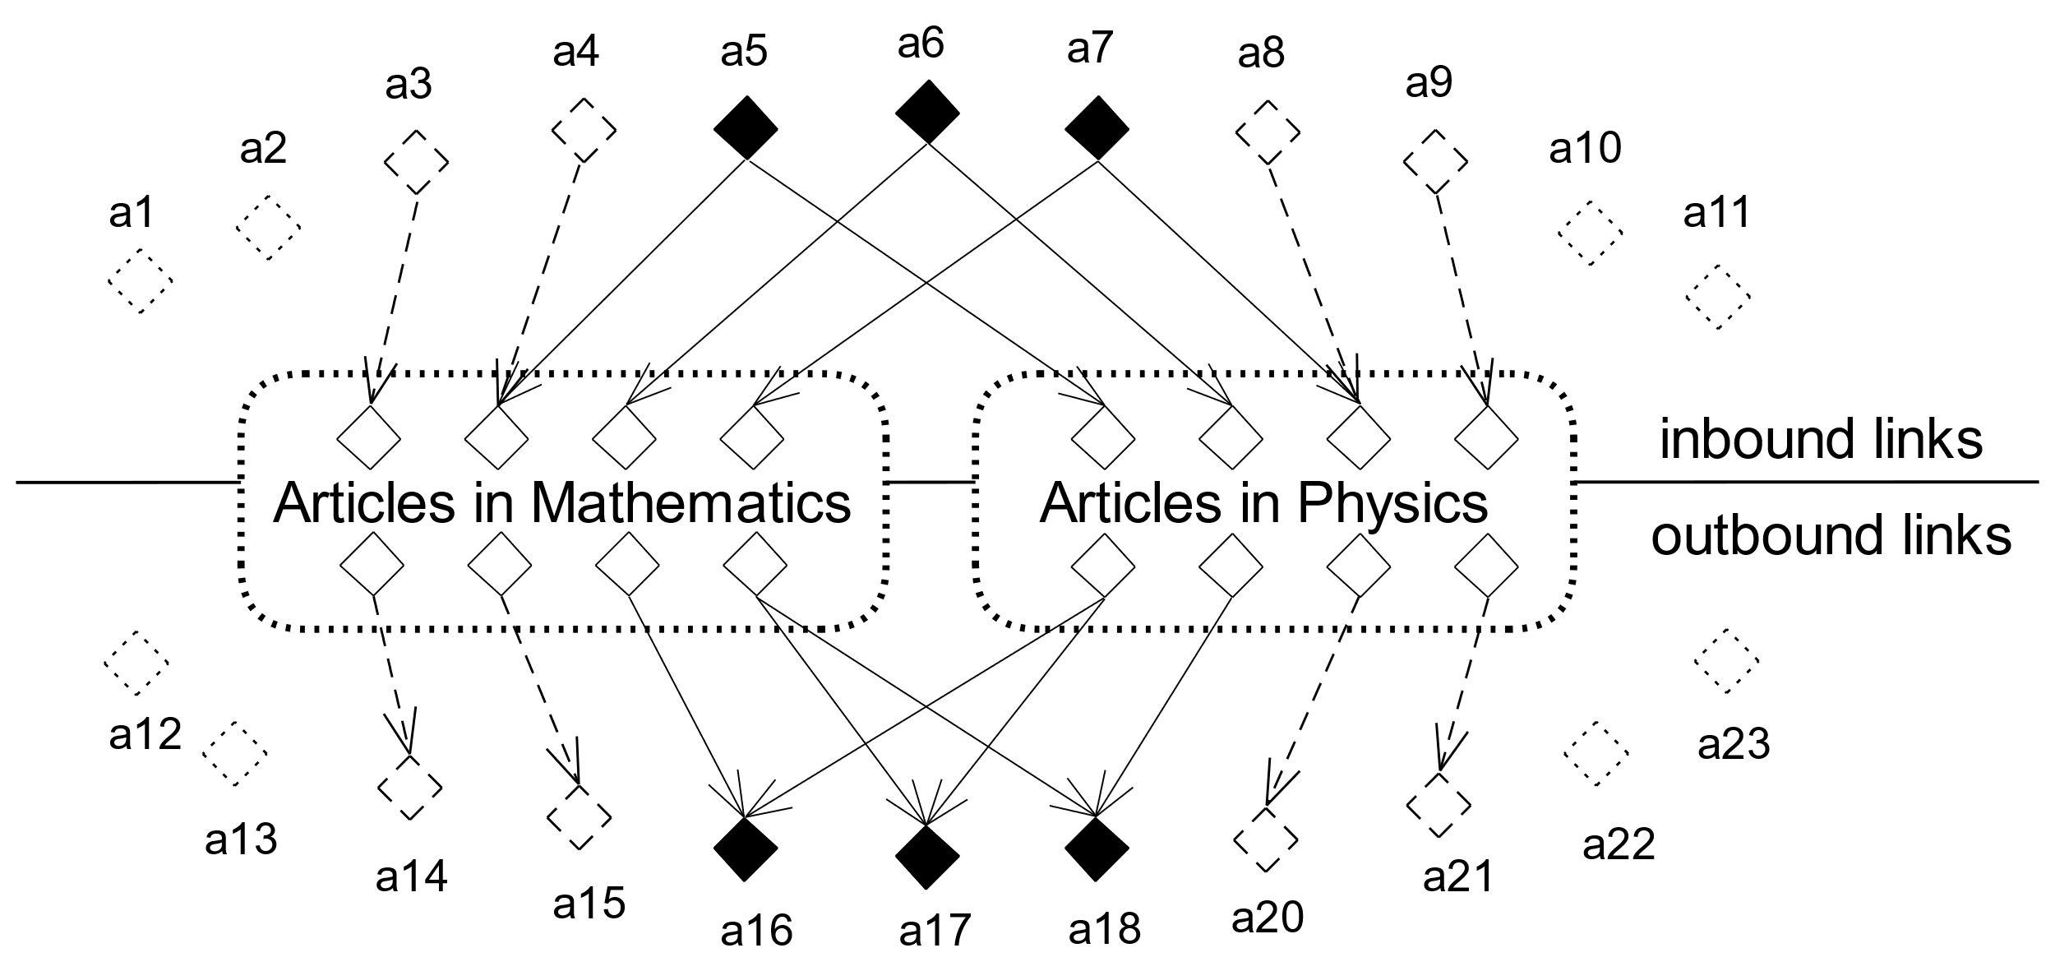
Figure 1 Collections of articles in Mathematics and Physics, solid diamonds represent intersections of articles with inbound links or outbound links
Before applying knowledge distance, some data preprocessing is needed. First, based on outbound citations of all articles, inbound citations can be calculated as following
$$R_{j}=\bigcup_{i=1}^{n}{r_{ji}}=\bigcup_{i=1}^{n}{c_{ij}}$$
where ${R_{j} denote the total inbound citations to the article j, c}_{ij}$ the outbound citation from the article i to the article j and $r_{ji}$ the inbound citation to the article j from the article i, which is the reverse of $c_{ij, }$.

All books and patents are deleted as well as articles that have no inbound references. The time range is from 1955 to 2020, and more than 70 million articles are prepared. We can plot knowledge distance over years.

First, we use knowledge distance to calculate the distance between mathematics and all other academic fields. Kant said about the importance of mathematics in natural science in Metaphysical Basis of Natural Science: "a doctrine of nature will contain only as much proper science as there is mathematics capable of application there.". Chemistry was not considered as proper science in Kant's days. D'Arcy Thompson believed that the criterion of a proper science lies in its relationship with mathematics as well. In his time, chemistry has become a proper science, but biology not yet. Richard Feynman once simply partitioned CP Snow's two cultures into "people had or not had the experience of understanding mathematics well enough to appreciate nature once". Cohen has studied the interaction between natural science and social science, and thought that social science is “softer” than natural science. If we take the degree of closeness to mathematics as a measure of hardness of an academic field, then computer science and physics are the hardest. It is interesting to note that biology has always been the softest in the natural sciences, and the distances between mathematics and chemical and biology are even greater than that between mathematics and political science. Other than computer science, engineering and physics, almost all disciplines are getting farther and farther away from mathematics. Eugene Wigner's famous saying "unreasonable effectiveness of mathematics in the natural sciences" is more appropriately reflected here as “unreasonable effectiveness of mathematics in computer science, engineering and physics”, as Hamming wisely revised.

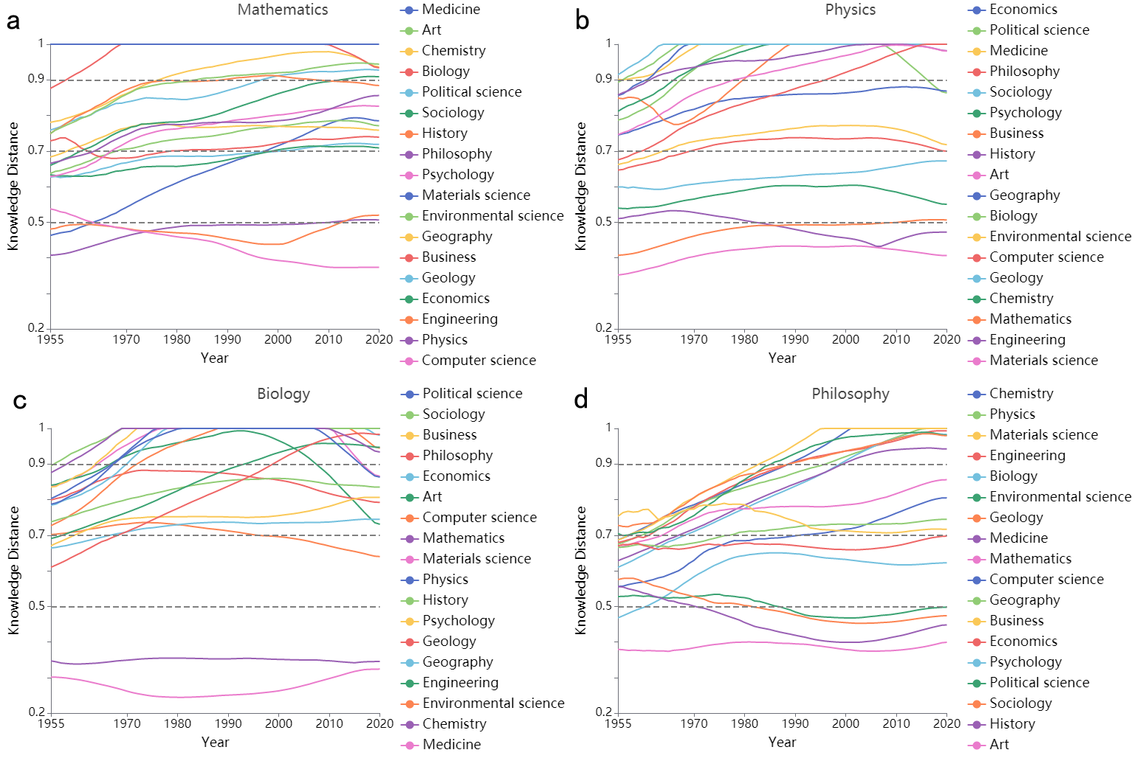
Figure 2 Knowledge distances between certain disciplines and others

Calculating the knowledge distance between physics and other disciplines, we can see that before the year 2000, physics was almost always the farthest from biology and medicine, which can support Ernst Mayr and Arbesman's statements that physics and biology are two distinct kinds of thinking. Except mathematics and engineering, which are the mostly always closest to physics, other STEM disciplines are generally close to physics, and sometimes getting closer in recent years, but disciplines other than STEM are farther away from physics.

Taking biology as the baseline, we can see that it is close to chemistry and medicine, but far from all other disciplines. Around the year 2000, engineering began to approach biology, while after 2010, mathematics and computer science are getting closer to biology.

It is obvious that those closest to philosophy are humanities and social sciences. Practical physical scientists and engineers are least concerned about it. The closeness between philosophy and some scientific disciplines, such as psychology, is possibly caused by the inertia of academic inheritance. Sciences outside psychology that are separated from philosophy earlier have drifted farther and farther away.

Knowledge cluster and knowledge coupling threshold. Each discipline has 2 or 3 closely coupled disciplines, such as mathematics and computer science and physics; biology and medicine and chemistry. In generally, apart from closely coupled disciplines, the knowledge distances among academic fields have become farther and farther with time. It is not surprising that there is a great distance between STEM, and social and humanities sciences, and the speed of separation from two cultures is accelerating. We can define the knowledge coupling degree of disciplines by knowledge distance. The closer the knowledge distance is, the higher the coupling degree. We use cluster to refer to closely coupled discipline groups. We divide the cluster relationship between all disciplines into four categories by the knowledge distance: Family <=0.5; Neighbor 0.5-0.7; Stranger: 0.7-0.9; Alien >0.9. The disciplines within a Family keep a relatively close distance, with little change and sometimes even getting closer and closer. The distance between disciplines in Neighbor is getting farther and farther, and this trend is very obvious in disciplines in Stranger and Alien. Even within STEM, disciplines outside Family are getting farther and farther away. The only exception is that the cluster of (Mathematics, Computer science), and the cluster of (Biology, Chemistry, Medicine). They have stopped the process of estrangement since around year 2000 and started to become closer.

In general, there are fewer family members in STEM, but more family members in humanities and social sciences. The only exception is psychology, which is in the sociology family. If A and B are in a family, B and C are in another family, then in most cases, A and C are at least neighbors with a couple of exceptions, such as mathematics and computer science are in the same family, but the distance between physics and computer science is fluctuating around 0.7. The cluster formed by family are relatively stable, for example (Mathematics, Computer Science) and (Biology, Chemistry, Medicine).

If we draw a graph, the nodes represent disciplines in MAG in a particular year and before, and the size of the nodes represents the number of articles that are contained within. When the knowledge distance between disciplines is less than a given value, which we call kct, knowledge coupling threshold, an edge is linked between the two disciplines. This way the relationship between disciplines can be displayed by a gravity diagram. When the kct is gradually increased, we will go through the process from multiple cultures to two cultures, and eventually reach the single unified culture, which is the ideal state of Wilson's consilience.

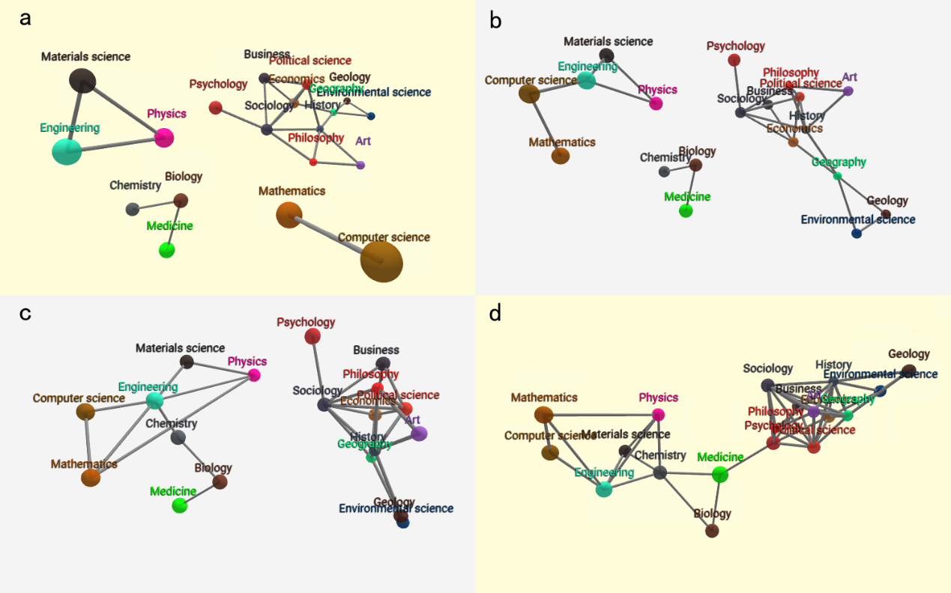
Figure 3 Increasing the knowledge coupling threshold until consilience

Taking the year 2020 as an example, when kct is set to 0.4, all disciplines are divided into 9 independent clusters. When the kct is increased to 0.45, the number of clusters is reduced to 6, (Mathematics, Computer Science), (Engineering), (Physics, Material Science), (Biology, Chemistry, Medicine), (Economics, Business, Sociology, Psychology, Political Science), and (Philosophy, Art, History, Geography, Geography, Environmental science). The previously independent cluster (Geography, Geography, Environmental Science) is connected to the cluster (Philosophy, Art, History) via a link between Geography and History. When the kct is further increased to 0.48, the number of clusters becomes 4, and STEM is divided into three clusters, namely (Biology, Chemistry, Medicine), (Mathematics, Computer Science) and (Physics, Material Science, Engineering), while humanities and social sciences are all unified into one cluster. The classification of these four clusters is always stable, except that before the year 1978, Computer Science belonged to the cluster of that Physics was located via the link with Engineering. This shows that computer science has become more and more mathematical in recent years, and it may also explain that computer science departments belong to engineering school in some universities and science school in others.

When the kct is increased to 0.5, the number of clusters is reduced to 3, the cluster (Biology, Chemistry, Medicine) is still independent, while other STEM disciplines are merged together because of the connection between computer science and engineering, while literary culture has been unified earlier. This is different from Kagan's division of the three cultures, natural sciences, social sciences and humanities. Here social sciences and humanities are closely related. The soft science cluster (chemistry, biology, medicine) always holds together, while hard STEM disciplines combine into a cluster. In fact, the kct of the cluster (Biology, Chemistry, Medicine) is very low and stable, ranging from 0.34 to 0.35. The threshold of literary culture is generally very low, among which the disciplines tend to be homogeneous. We observed the data from 1955 to 2020, and when the threshold was set to 0.5, these three divisions never changed.

When the kct is increased to 0.53, all disciplines show two cultures, all STEM disciplines are condensed together. Perhaps geologists will be disappointed to see that they are put to the softer bank instead of the harder one. When the kct reaches to 0.63, all disciplines are consolidated, and a fragile link of the two cultures is between medicine and psychology. The kct for the unification of literary culture is generally low so it is relatively easy to form a cluster, while the kct for scientific unification is higher. This may be caused by the fact of STEM is more subdivided. When literary culture is firstly unified, science is still divided among several isolated clusters. The kct of integrating all disciplines is getting higher and higher.

The knowledge coupling threshold can be regarded as a measurement of knowledge consilience. If we plot the threshold values over years, we can see that the thresholds of almost every cluster increase with time. An exception is that when the number of clusters is 2, the kct declines after 2003, which is due to the closer distance between chemistry and engineering, which makes it easier to merge the cluster (Biology, Chemistry, Medicine) and rest of STEM clusters. In a sense, there is still hope for all disciplines of STEM to converge.

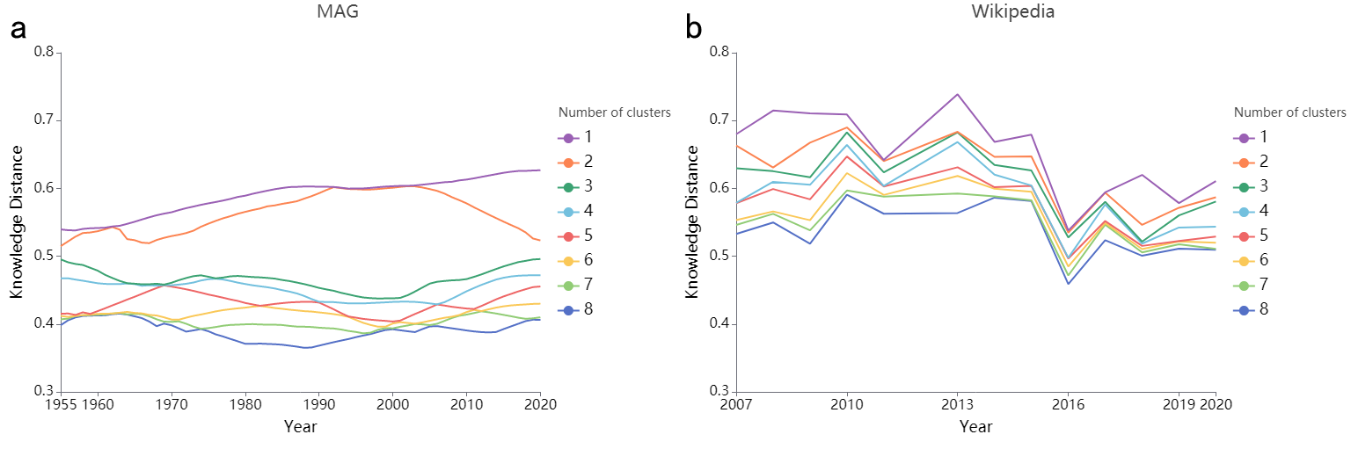
Figure 4 The change of knowledge coupling threshold over years
In addition to MAG, we also studied Wikipedia. We collected Wikipedia for 14 years, one snapshot every year, from 2007 to 2021 with exception of year 2012 due to technical reason. Unlike MAG, Wikipedia's ontology is classified and edited manually. For almost every academic discipline, there is a Wikipedia Category which contains subfields of that discipline. For example, the Category that contains all subfields of mathematics is called "fields of mathematics". We take articles contained in all sub categories in two levels down from each discipline. We get a collection of more than 210,000 articles, then repeat the method we used when studying MAG. We observe that the order of knowledge distance of Wikipedia is similar to that of MAG. We also find that unlike MAG, the knowledge distance is slightly tightened with time, instead of getting farther and farther away. The knowledge coupling threshold is getting smaller and smaller. Compared with MAG, Wikipedia data has relatively small number of years, and the conclusion is not as certain as MAG's and more years of research is needed.

Conclusions. Knowledge distance is an effective measurement for relationships among different knowledge branches. Knowledge coupling threshold can trace how knowledge branches are clustered. It is evident, from annual changes of the coupling threshold of MAG, that knowledge is getting more and more segregated. We do not know how the goal of Ed Wilson is attainable at present. It is worthwhile to spend more efforts on machine-maintained encyclopedias, such as Wikipedia, that may offer some hope.

References
Snow, C.P. The Two Cultures, reissue edition (Cambridge University Press, 2011).

Labinger, J.A. & Collins, H. The One Culture? A Conversation about Science (University of Chicago, 2001).

Cohen, I.B. Interactions: Some Contacts between the Natural Sciences and the Social Sciences (MIT Press, 1994).

Kagan, J. The Three Cultures: Natural Sciences, Social Sciences and Humanities in the 21st Centuries, (Cambridge University Press, 2009).

Wilson, Edward O. Consilience: The Unity of Knowledge, (Pantheon Books, 1999).

Sinha, A., Shen, Z., Song, Y., Ma, H., Eide, D., Hsu, B., & Wang, K. An Overview of Microsoft Academic Service (MAS) and Applications. In Proceedings of the 24th International Conference on World Wide Web (WWW ’15 Companion). ACM, New York, NY, USA, 243-246. DOI=http://dx.doi.org/10.1145/2740908.2742839 (2015).

Wang, K., et al, A Review of Microsoft Academic Services for Science of Science Studies, Frontiers in Big Data vol.2 December (2019).

Fortunato S., et al., Science of science. Science 359 (March), (2018).

Cilibrasi, R.L. & Vitanyi, P.M.B. The Google Similarity Distance. IEEE Transactions on Knowledge and Data Engineering 19(3), 370-383 (2007).

Milne, D., & Witten, I.H. An effective, low-cost measure of semantic relatedness obtained from Wikipedia links. Proceedings of the AAAI 2008 Workshop on Wikipedia and Artificial Intelligence (2008).

Petersen, M., et al, Methods to account for citation inflation in research evaluation. Research Policy 48, 1855–1865 (2019)

Kant, I. Metaphysical Foundation of Natural Science (Cambridge University Press, 2011).

Wigner, E. P. The unreasonable effectiveness of mathematics in the natural sciences, Comm. Pure Appl. Math., 13, Feb. (1960).

Hamming, R. W. The Unreasonable Effectiveness of Mathematics. The American Mathematical Monthly, 87(2) 81-90 (1980).

Mayr, E. The Growth of Biological Thought (Belknap Press, 1982).

Thompson, D. On Growth and Form (Dover Publications, 1992).

Arbesman, S. Over Complicated : Technology at the Limits of Comprehension (Current, 2016).

Acknowledgements The author is grateful to H.F. Lu and Y.B. Ni for technical assistance and Thomas Zhang, Edward Zhang and Wei Zhao for discussions.
Author Information Correspondence and requests for materials should be addressed to nick@iwuzhen.org

Wuzhen Institute, D310, No. 9 Jiuhuan Road, Hangzhou, Zhejiang Province 310008, China

