Chapter I : What is Fascism?
“Bash the fash” is a common slogan for Antifa. Antifa is an anti-fascism group, so obviously the enemy is anyone associated with fascism. Fascism in its pure form, a la Mussolini, has been gone since the early 1940s, so obviously the movement isn't anti-Mussolini. Nazism, in an extremely simplified description, is a variant of fascism with a eugenics component. The goal of this chapter is to provide historical context for fascism, discuss social groups who have been labeled as fascist in modern times and finally, discuss what fascism means to Antifa and how it compares to constructs of fascism throughout history.
In any social movement seeking to change the status quo in society, the enemy must be clearly defined. Everyone has a different mental image of “fascist” or “nazi”. By exploring fascism throughout history to the present day, the goal is to define fascism, demonstrate how to the definition of fascism has evolved and clearly define the enemy of Antifa.
Historical Fascism
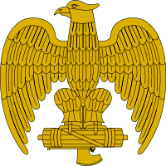

Figure 1.1 – The Italian symbol for Fascism commonly displayed on uniforms.

“In the Fascist conception of history, man is man only by virtue of spiritual process to which he contributes as a member of the family, them as a social group, the nation, and in function of history to which all nations bring their contribution.”1
Benito Mussolini & the Original Fascist Movement
The original fascist movement, Mussolini's Fascist Party of Italy, emerged as a result of a combination of individual circumstances and social, economic and political factors leading up to and immediately following World War I. Fearing a proletariat uprising similar to the Bolshevik revolution which brought Joseph Stalin into power of the Soviet Union, unfavorable economic conditions as a result of war and a possessing a grave distrust of the current Italian government, led by Prime Minister Luigi Facta, many Italians – including Italian Catholics – were willing to take up arms and overthrow the perceived corruption of the time.
However, without the Italian Socialist Party revoking Benito Mussolini's membership as a result of his pro-war stance, Mussolini would have likely remained a lifelong socialist. “You cannot get rid of me because I am and always will be a socialist. You hate me because you still love me”, Mussolini exclaimed, post-expulsion from the Italian Socialist Party in 19142. Despite using the socialist party as a common enemy to unite the country against, the bulk of policy influence can be traced back to Mussolini's previous involvement in socialist movements.
Mussolini's early exposure to socialist policies influenced his later political views and actions as leader of the Fascist Party. Throughout his childhood, Mussolini was exposed to a positive view of socialism and revolution. Mussolini was born Benito Amilcare Andrea Mussolini, with the name Benito inspired by the Mexican revolutionary Benito Juarez, and the two middle names associated with two historical heroes of anarchist-socialism, Amilcare Cipriani and Andrea Costa. His father, Alessandro, served on the local socialist concil. Per Benito, Alessandro's “heart and mind were always filled and pulsing with socialist theories”.3
In 1902, Mussolini emigrated to Switzerland to avoid compulsory military service in the Italian Royal Army. During his time in Switzerland, Mussolini became exposed to the philosophy of Friedrich Nietzsche and syndicalist Georges Sorel. Georges Sorel openly advocated for the use of violent force to overthrow liberal democracy and capitalism. Mussolini gradually became more and more actively involved in the socialist movement, working as a journalist for L'Avveniore del Lavatore and as a secretary for the Italian worker's union in Laussane. Gaining a reputation as being a problematic individual and potential revolutionary, Mussolini was arrested (Figure 1.1) for inciting political viollence during a general labor strike in Berne, Switzerland, and was subsequently reported back to Italy.
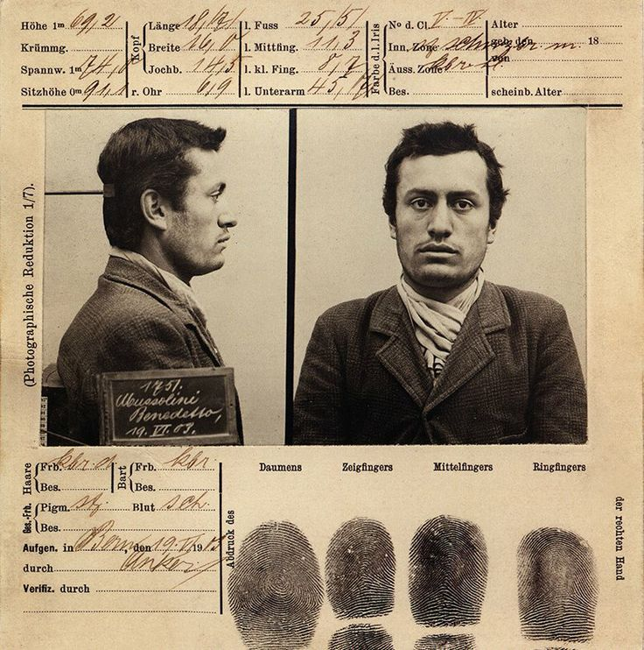

Figure 1.2 – Benito Mussolini's booking document from arrest.
Following deportation to Italy, Mussolini became active in the Italian socialist movement, working his way up the ranks in the Partito Socialista Italiano (PSI, or the Italian Socialist Party). He sought change through revolutionary, not political, action, as evidenced by his comment following a 1913 police shooting of seven protesting farmworkers, “Death to those who massacre the people! Long live the revolution!”4 His involvement in PSI was relatively short-lived, as a result of his support for Socialist International (SI), a socialist and communist organization who supported violent insurrections and revolutionary action in general during the early twentieth century. The neutral stance of PSI was detrimental to Italy's own interests, per Mussolini, and was the beginning of his split from the socialists in the country.
After his split with PSI, Mussloni served in the Regio Esercito Italiano (Royal Italian Army) until 1917, when he suffered physical injury and was discharged unceremoniously. After serving in World War I and observing the detrimental effects of the war on the Italian economy and the morale of the Italian people, Mussolini shifted his focus away from pure socialism to a nationalism / socialism hybrid platform, created under the Partito Nazionale Fascista (National Fascist Party). NFP gained significant support from the military, business class, other right-wing aligned groups such as the conservative party. This spawned a militant group of revolutionaries, Milizia Volontaria per la Sicurezza Nazionale, more commonly known as the Squadristi or “Blackshirts”.
Gaining a majority following required making compromises, engaging in scare tactics and drafting a variety of truces. Mussolini attempted to create a truce with the PSI. Mussolini drafted the Pacification Pact, which was dissolved in less than a year, in November 1921. Even though he was unable to create an alliance with the Italian Socialist Party, the National Fascist Party continued to gain support, with approximately 700,000 members in July 19225. In August 1922, an anti-fascist movement attempted a general strike, but failed as a result of lack of support from the general population.
Even though Mussolini was unable to win over the majority of identified socialists in Italy, he utilized his persuasiveness on other important demographic groups within Italy. One key group was returning veterans, with hundreds of thousands of veterans returning from World War I unable to locate work6. Mussolini identified issues with winning veterans over with communism and socialism, given the typical veteran's sense of camaraderie and strong national identity. Mussolini explained his socialist-influenced policies under the guise of nationalism to the veterans who felt abandoned after the war, given the inability of the Italian government to provide all of the necessary services and pensions due to financial collapse and the lack of readily available employment. The veterans provided the Fascist Party with a strong group of allies, both prior to the coup d'etat as well as in the early years of the regime.
The region where Italy resides is historically known for Rome, where the Vatican is located. Until 1870, the Pope was the authority over Rome and the surrounding area. However, with the unification of the kingdom of Italy, the Papal States lost control over a significant portion of previously held land. As a result, the papacy held a grudge against the Italian government. Prior to the 1921 election, the Catholic Popular Party, fighting against the upcoming Fascists, were able to gain parliamentary seats, up to 107, with the Fascists only being elected to 35 seats. The Conservatives constructed a coalition with the Fascist party to gain a parliamentary majority. When Parliament convened, Mussolini gave his first speech, where he discussed the importance of Rome being the spiritual home for hundreds of millions of Catholics throughout the world and his desire to restore a Christian society7. Convincing the Pope to abandon the Catholic Popular Party and embrace the Fascist Party was essential to Mussolini's rise into power, as it provided him with a significant base to draw support. While seemingly an incompatible alliance – the Fascists and the Papacy – both Mussolini and the Catholic Church sought an ending of the liberal democratic regime, as well as a restoration of an orderly, authoritarian political structure.
1922 was the year of the Fascists rise to power and overthrow of the existing government. Pope Pius XI, the newly elected pope, was concerned about Mussolini and his National Fascist Party, especially given violence against Catholic Action, while simultaneously questioning whether it would be a good idea to directly oppose the Blackshirts. Witnessing the crushing defeats the socialists and other opposition groups experienced during the spring and summer of 1922, and while possessing a negative view of parliamentary government, Pope Pius XI refused to align himself with the Catholic Party, nor with any other political party initially, and Cardinal Gasparri, the Vatican Secretary of State, mailed out a circular to all Italian bishops advising political neutrality.
In October 1922, Mussolini and the Quadrumvirates, consisting of Emilio de Bono, Michele Bianchi, Italo Balbo and Cesare De Vecchi, proceeded with a plan for the National Fascist Party to siege control of Rome. A few days prior to the March on Rome, Mussolini contacted the United States Ambassador Richard Washburn Child, who provided encouragement to proceed with his plans. Led by the Quadrumvirs, the March on Rome proceeded, followed by the current leader, Prime Minister Luigi Facta, ordering a state of seige on Rome and requested assistance from King Victor Emannuel III. Under pressure from Mussolini and the National Fascist Party, King Emannuel III refused to sign Prime Minister Facta's military order and subsequently, on October 29th, 1922, the king granted Benito Mussolini the position of Prime Minister.
“Always an irresponsible improviser, a half madman, half criminal, gifted only – but to the highest degree – in the arts of 'propaganda' and mystification.8”
Following Mussolini's coup d'etat, he sought to forge strategic alliances to ensure his ability to remain in power, and in favor with the populace. Given Rome, and the kingdom of Italy in general, and historic and present strong ties to the Catholic Church, Mussolini saw an opportunity to gain public support and stave off potential rebellion by forming a strong alliance with the Catholic Church. This seemingly conflicts with Mussolini's early history of despising Christianity and the perceived corruption of the Catholic Church. However, when an alliance was a net positive for supporting his dictatorial agenda, Mussolini repeatedly had no issue with making compromises with portions of his ideology to advance towards his political ends.
Restoring order to Italy appeared to be immensely difficult in the first few years. As a result, Mussolini appointed himself “Il Duce”, the dictator, in 1925. Given his core political views being socialist, he utilized price controls and nationalization of commerce to attempt to improve the value of the lira, which was in decline as a result of international speculation against non-gold-backed currencies. His deflationary policy and mandatory wage decreases had limited effectiveness in the short-term, other than to boost the value of Italian exports on the international market. His other planned economy policies had mixed results throughout his administration.
Mussolini sought to build the Italian people into a strong group of nationalistic militants. The Opera Nazionale Balilla included seven youth organizations designed to create a future generation of loyal Italian fascists. University students were required to join Gioventu Universitaria Fascita (GUF) as a monitoring mechanism for anti-fascist views. Mussolini's relationship with the Pope was treacherous at times, given reports of violence against competing youth groups, especially Catholic Action. Mussolini attempted to distance himself from the violent actions, and at times publicly derided those who participated in violent action against Catholic groups, when it favored his administration.
Most people are unaware of Mussolini's early years, with the mainstream focus of Mussolini being on the late 1930s through the end of World War II. Mussolini sought to expand Italy's power by briefly conquering Eithiopia and Albania, and forming an alliance with Adolf Hitler, a regime with a relatively similar approach to governance as the National Fascist Party. Due to technological inferiority and a profoundly weaker military, especially compared to the Germans and the combined Allied forces, Mussolini lost control over a significant portion of Italy. In late 1942, Mussolini was removed from power by the King, and subsequently installed as a puppet dictator over northern Italy by Hitler until the end of the war.
After the Axis forces surrendered to the Allied forces, Mussolini attempted to flee to Switzerland, disguised as a German soldier. While traveling with a German convoy near the village of Dongo, communist-led forces under command of Pier Luigi Bellini delle Stelle and Urban Lazzaro halted the convoy. Bellini delle Stelle and Lazzaro demanded all Italians be handed over, and in return, the German convoy would be permitted to proceed. As a result, Mussolini and his passengers, disguised as Germans, were discovered, taken captive, and on the following day, Mussolini, his mistress and sixteen other Fascist leaders were executed per orders from Communist Party leadership.
Whenever discussing fascism in an academic or historical sense, the most proper definition is that of Mussolini, a nationalistic form of socialism (differentiated from communism, which tends to be international, and socialism, which seeks to break down prior nationalistic bonds), where the state is the central authority in all matters, and classical liberal ideals such as individualism are rejected in favor of collectivism. Depending on the political spectrum utilized, Fascism is labeled as either a far-right ideology, or a far-left ideology, and unlike communism, where the stated, but never materializing, Utopian end goal is a complete abolition of the state, Fascism recognizes the constant need for a strong, central state.
If Mussolini and the National Fascist Party are the sole reference for constructing a definition of what fascism is, then fascism may be defined as follows: a form of authoritarian governance consisting of collectivist and nationalistic policies, with a planned economy consisting of a significant majority of industry being under national control. However, this definition of fascism fails to encompass the ideology Antifa and other modern-day anti-fascist groups are fighting against, except on possibly a superficial level, where both Antifa's modern day perception of fascism and Mussolini's NFP are totalitarian, nationalistic systems with populist elements. The strong sense of national identity common to Fascism conflicts with the anarcho-communist rejection of the state.

Adolf Hitler & the Nazi Party
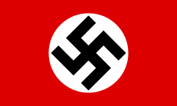

Figure 1.3 – The National Socialist German Worker's Party flag.
The political ideology of Nazism, or “fascism with a small 'f'”9, was essentially a different phenomenon from Italian Fascism, despite being geographically and historically bound together. Fascism is only briefly discussed in Mein Kampf, with total coverage of less than a few paragraphs, Benito Mussolini and Adolf Hitler, while holding some mutual respect for each other, frequently criticized each other, with Hitler referring to Italian Fascism as “Kosher fascism” and Mussolini referring to Hitler as a “gramophone with just seven tunes and once he finished playing them he started all over again”10. Nazism and Italian Fascism shared the traits and ideals of both being socialist movements, with the focus being on nationalism instead of globalism, reactionary in the sense of wanting to restore previously held values of the common people through a recreation of tribal impulses, a focus on building a strong military and utilizing military force to quash counter-movements, centralized dictatorial power and a hatred of Lockean liberalism and a desire to nationalize industry. Both were totalitarian movements with more in common with far left movements such as communism and socialism than right-wing movements of libertarianism and conservatism. As stated by Jonah Goldberg (2014) in Liberal Fascism, “The battle between the Nazis and the communists was a case of two dogs fighting for the same bone.” Richard Pipes stated, “Bolshevism and Fascism were heresies of socialism.”11
Nazism differed from Italian Fascism with the focus on identity politics, especially focused on race, with the pinnacle group being the German of antiquity, and the scourge being capitalists, communists and so-called cowards, all of whom were portrayed as being part of a Jewish menace, while Mussolini's regime included persons of Jewish-origin up to the time when Adolf Hitler invaded and took over the bulk of Italy. Antisemitism was hardly a unique ideal to Nazism, as Joseph Stalin espoused antisemitic views in the Soviet Union as well. While Mussolini ensured universal suffrage for Italians, Adolf Hitler expressed a fear of women, considering them to be nothing more than “terrifying syphilis carriers”12.
Adolf Hitler's early years influenced his desire to advance the Nazi Party in his later years. As a young adult, Hitler became increasingly repelled by the values held by the German bourgeoisie, as well as perceiving a cultural shift away from so-called German people to a multicultural society, with Judaism having a perceived negative impact on the strong German people. Young Hitler was influenced by his hero, Dr. Karl Lueger, the head of the Christian Social Party, who espoused populist, antisemitic and socialist-inspired views. While working with Anton Drexler, he expressed the importance of focusing on the common good of the German people over individualism and liberty. Young Adolf was rejected to art school on two separate applications and spent a period of time after World War I incarcerated, both events which are believed to have impacted his disgust with society and desire for revolution.
Adolf Hitler served during World War I, leaving the service at the end of the war as a corporal. Unlike the socialist-leaning and communist party members, Hitler was furious at the surrender. However, in the late 1910s, Germany surrendered the war, signed the Treaty of Versailles and in the early 1920s, entered a period where due to industrial collapse, infrastructure destruction and restitution imposed by the Allied forces, leading to the collapse of the German, reaching 4 billion marks per one U.S. Dollar in November 192313. This led to increasing discontent amongst German citizens of all socioeconomic and political groups, but especially those labeled as “right-wing”: the conservatives and other fringe groups such as the up-and-coming Nazi Party, both of which never accepted the authority of the newly formed Republican government, nor fully acknowledged the validity of the Treaty of Versailles.
The Beer Hall Putsch was one of the first attempts at overthrowing the Republic. Hitler entered the Buergerbraukeller, with S.A. troops surrounding the hall, with a revolver in hand, while the Bavarian ruling triumvirate of Gustav von Kahr, Colonel Hans Ritter von Seisser and General Otto von Lossow sat helplessly and were subsequently forced into a back room, where after multiple threats were made by Hitler, deceptively agreed to accept positions within the supposed new government. With the help of WWI General Erich Ludendorff, Hitler began a march on Munich similar to Mussolini's March on Rome which occurred approximately one year prior. While disorganized and ultimately unsuccessful at its immediate goals, resulting in Hitler's arrest and subsequent 5 year, released after 8 months, sentence, it provided Hitler with adequate time to write Mein Kampf, as well as gain notoriety around the Nation. From this point in history until after the 1933 election, Hitler decided to adhere to the law, to gain the support of the German people through available legal routes, such as the electoral process and coalition-building14.
Upon Hitler's release from incarceration, he pondered what it would take to recreate a folklike traditional German state, focused on the archetypal German. A German who is physically strong, dedicated to the German people and advancement of a pure German race. From 1925 to 1929, the Nazi Party was rather stagnant. However, Hitler persevered and continued to organize. Two political organizations were created within the party, with P.O. I having a focus on undermining the government and P.O. II having the focus of establishing a Nazi state within Germany, prior to a complete takeover. Operatives were placed in states outside of the Republic, including Austria and the Sudetenland in Czechoslovakia15.
The Nazi Party continued to gain public support and seats following the 1929 depression, which was felt around the world. In January 1932, Adolf Hitler was faced with a decision: to attempt to run for the presidency against a very strong, highly favored candidate in Hindenburg and risk a loss, which would be a significant setback, or wait until a later election or pursue another plan of action. Despite having Joseph Goebbels and others within his campaign urge him to run, Hitler did not release an official decision until late February – a decision which was announced not by Hitler, but by Goebbels. In the first round of March voting, Hitler only obtained 30.1% of the vote, placing second and over 7 million votes behind Hindenburg, who failed to capture a majority. This created the necessity for a second round of voting, where Hitler was able to close the gap somewhat, cutting Hindenburg's lead down to less than 6 million votes, but Hindenburg was able to gain a majority in the second round, winning 53% of the vote to Hitler's 36.8%16.
On July 31st, the parliamentary elections concluded with the Nazi Party winning 230 of 608 seats, not a majority but the most of any other party by a significant margin17. Over the following few months, chaos ensured in the Republican government, with Hitler and the Nazi Party attempting to gain control. Finally, on January 30th, 1933, Adolf Hitler was awarded the chancellorship.
For the sake of brevity, the period from 1933 to 1945 will be covered in a cursory fashion in the remainder of this section, followed by a discussion of the national socialist platform and how it compares to Italian fascism. In the current year, the labels 'fascist' and 'nazi' are thrown around rather recklessly, without a real understanding of the semantics.
Following his appointment to Chancellor of Germany by the Weimer Repunlic President Paul von Hindenburg. Hitler eliminated all of the political opposition and many of the political offices, replacing with Nazi Party (NSDAP) members when deemed necessary. Upon Hindenburg's death on August 2nd, 1934, Hitler merged the Presidency and Chancellorship into a single position, resulting in Hitler being the sole Fuhrer of Germany. Germany was under totalitarian control, similar to Mussolini's position in Italy.
Hitler showed initial success implementing a planned, mixed economy, relying on heavy military spending, extensive public works and other projects, which facilitated the sharp decline in unemployment in Germany. These policies were similar to Mussolini's nationalization of industry and mixed economy approach in Italy. The economic policy possessed a racial component, prioritizing the well-being of “only those who have German blood, regardless of creed”18. The following points of Hitler's National Socialist Platform focused on economic growth, limiting or eliminating opportunities to non-Germans, and ensuring those who are considered pure German had access to employment and other resources:
7. We demand that the State shall above all undertake to ensure that every citizen shall have the possibility of living decently and earning a livelihood. If it should not be possible to feed the whole population, then aliens (non-citizens) must be expelled from the Reich.
8. Any further immigration of non-Germans must be prevented. We demand that all non-Germans who have entered Germany since August 2, 1914, shall be compelled to leave the Reich immediately.
Therefore we demand:
11. That all unearned income, and all income that does not arise from work, be abolished.
12. Since every war imposes on the people fearful sacrifices in blood and treasure, all personal profit arising from the war must be regarded as treason to the people. We therefore demand the total confiscation of all war profits.
13. We demand the nationalization of all trusts.
14. We demand profit-sharing in large industries.
15. We demand a generous increase in old-age pensions.
16. We demand the creation and maintenance of a sound middle-class, the immediate communalization of large stores which will be rented cheaply to small tradespeople, and the strongest consideration must be given to ensure that small traders shall deliver the supplies needed by the State, the provinces and municipalities. 19
Similar to international socialism / communism as well as Italian fascism, the “common good before individual good” was emphasized. Individualism was suppressed, and with Hitler's regime and unlike Mussolini's, gypsies, Jews, immigrants of non-German or non-Aryan blood, the mentally ill and other groups deemed inferior were suppressed and as a result of the Holocaust, many tragically lost their lives.
Nazism and fascism are both totalitarian government systems, with nationalized industry, focused on the state as the central authority. In both systems, the state is higher than any outside group, including the Catholic Church. However, when beneficial, both Mussolini and Hitler coordinated with the papacy for their own gain. Militarism is a focus of both systems. One system had the “blackshirts” and the other had the “brownshirts”. Numerous similarities at minimum place Fascism and Nazism next to each other on the political spectrum.
Nazism differs from fascism in practice and policy in a few major areas. The most important difference is the focus on race. While Mussolini had a general idea of the archetypal Italian, he did not implement race-based policies in the manner of Hitler. In Nazism, those of non-German blood were an inferior class, incapable of mobilizing and improving conditions. Resources were allocated for those individuals who Hitler deemed to be pure Germans. In Mussolini's system, some social mobility was possible, with Jews holding high office positions until Hitler took over Italy in the early 1940s. Jews were forbidden from holding office positions during the Third Reich and mass extermination of so-called inferior races occurred during Hitler's reign.
In summary, both Nazism and Fascism are dictatorship systems of a radical authoritarian nationalisu type, utilizing socialist policies such as a planned economy and a focus on the greater good for the community over individual rights. Both reject classical liberalism and anarchism. Both reject Marxism, but implement numerous Marxist policies when it comes to the economy. Both systems encourage revolution and focus on middle-class over the so-called bourgeoisie.
Despite being placed on the far-right of a typical left-right political spectrum, Fascism, Nazism, Socialism and Communism are all totalitarian systems, with planned economies, communalism over individualism, making Fascism and Nazism much like two sibings fighting over the same toy. Nationalism is what differentiates Fascism from Marxism.
One final issue, enforced in Italian Fascism and Nazism, but also a frequently discussed issue by the Progressives in the United States: gun control. Even before the Nazis became the dominant party in Germany, gun control laws were passed, such as the 1928 Firearms Law. One of the first laws passed by Hitler stripped gun ownership rights away from numerous groups deemed to be inferior or dangerous, including the Jews and Communists20.

Japanese Fascism
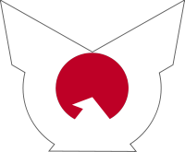

Figure 1.4 – Imperial Rule Assistance Association (Taisei Yokusankai) symbol.
Extending the definition of Fascism a bit further, the World War II-era Japanese system of governance has been associated with fascism, even being labeled as fascist by some. While definitely not a true fascist system as compared to Italian Fascism, the Japanese system includes enough elements of fascism to be worthy of at least a cursory discussion.
The Japanese have a long, storied history, starting as a group of loosely linked tribes who began to unify during the Kofun, Asuka, Nara and Heian periods. In 794, Heian-kyo, modern-day Kyoto, became the capital of Japan, marking the beginning of the Heian period, also referred to as the golden age. Throughout the bulk of Japanese history, the Japanese were rather isolated from Western culture. This changed in the 19th century – the period of Japanese history that will be the focus of discussion in this book.
The Meiji era (1868 – 1912) signified the first half of the modern Japanese empire – a shift from an isolated feudal system to a modern, international powerhouse. It also signified the start of a shift towards the Japanese imperialist system, totalitarian in nature, of Japan's World War II era. In 1868, the Five Charter Oath was passed, which allowed all socioeconomic classes to be involved in politics, revoked laws restricting certain social groups from certain types of employment, a shift towards a fair legal system and advocacy for advancing and strengthening imperial rule. The stated goal was to establish a democratic system of governance, which was established in the late 19th century.
In 1912, the Taisho era began. This era lasted until 1926, a much shorter period mostly due to the sickly nature of Emperor Taisho. Japan allied itself with the Allies, who permitted Japan to expand its influence in Asia, expanding its empire into Chinese territories. Japan was a major producer of industrial goods during the war, resulting in significant financial gains during the war, as well as continued prosperity as a result of industrial growth following the war. Taisho governed with more progressive approach than the previous emperor, expanding state authority and involvement in industry and societal issues. Towards the end of the Taisho era, parliamentary influence decreased and the influence of military leaders increased, resulting in a militarization of the government.
In 1926, the Showa era began, which ended in 1989, with the death of the emperor of this period, Emperor Hirohito. In the preceding paragraphs, only a very cursory overview of Japanese imperialism was covered – just enough to provide enough background information for you, the reader, to do further research if this is a topic of interest to you. The late 1920s is where the government takes a serious turn towards policies compatible with fascism.
In 1923, a major earthquake occurred in the Tokyo and surrounding area, which destroyed over 60 percent of residential properties and killed approximately 100,000 citizens. In the aftermath, widespread looting and arson occurred, which many blamed on individuals of non-Japanese ethnicity – especially the Koreans – and leftists – especially the communists and socialists. Japanese mobs took to the streets, assaulting and murdering those accused of being associated with the criminal activity. Many historians believe the earthquake and its immediate aftermath triggered a society shift towards ultra-nationalism.
Common to other fascist regimes, the leader is assumed to be not only the civil leader, but also the spiritual leader, of the country. Italian Fascism superficially appears to violate this claim. However, Mussolini frequently battled the Pope for ultimate authority, and only made successions when it was of benefit. Economic depression hit Japan, as well as much of the rest of the world, during 1929. This, combined with rising militarism and a series of political assassinations, provided an excuse for Emperor Hirohito to fire the Prime Minister. The replacement Prime Minister was assassinated in 1932, by officers of the Japanese Navy. Subsequent Prime Ministers were drawn from military leaders, not from civilian positions. Militarism, and drawing leadership from military positions instead of civil positions, is a common theme amongst the Japanese Imperial government, and the German Nazi and Italian Fascist governments.
Italy sought to expand into Africa, taking brief control over Eithiopia and Albania; Germany sought to expand into the rest of Europe, seizing control over Czechoslovakia, Poland, France and numerous other nations. Japan, much like the previously mentioned regimes, sought to take control over much of East Asia, seizing control over Manchuria and other areas of East Asia. The Japanese Army engaged in vile actions of brutality, including massacring over. While Hirohito did not provide expressed consent to rape and murder innocent civilians, he failed to condone the actions of the military.
In September 1940, Japan signed the Tripartite Pact, where Japan, Italy and Germany mutually agreed to assist each other in case of an attack. This alliance was not unexpected, given the similarities in governance and ultimate goals, as well as enough geographic separation between each state. When Germany advanced close to Italy, Germany appeared to have no hesitation with conquering Italy as well, only keeping Mussolini around as a puppet dictator of Northern Italy. Given enough time and resources, any of these 3 nations would likely have attempted to conquer the entire planet, or at least the entire continent on which each subsided.
Anyone reading this book likely knows the end result of World War II. Japan surrendered after being firebombed and having two atomic bombs dropped, one on Nagasaki and the other on Hiroshima. Numerous books have been written on this subject, and the specifics are not important to this book. However, what is important is whether or not the Japanese imperialist government qualifies as an example of a fascist nation. While not a wholly fascist nation, exploring this example is beneficial to determine how to assess whether or not the categorization of fascist is appropriate for a given group.
Japan gradually moved towards a state-controlled economy prior to and especially during World War II. Japan attempted to silence critics of civilian and military policy, and after the death of the Prime Minister in 1932, the Prime Minister was chosen from the military. Militarism, a key factor associated with fascism, as well as a state-controlled economy, were both present in Japan. Japan engaged in military conquests to expand the state, and the Japanese society shifted towards ultra-nationalism, especially after the Earthquake.
Nazism focused on suppressing certain groups. Italian Fascism did not, and neither did Japan. Japan passed universal suffrage for men over the age of 25 in the mid-1920s. Italy and Germany both sought to take power away from so-called leftist groups – especially the communists and socialists – as did Japan.
The difficulty in assessing whether or not Japan can be classified as a fascist nation is not the previously discussed similarities to Nazism and Italian Fascism, but whether or not the above characteristics were a direct result of wartime policy or whether it was a separate shift in ideology that would have occurred regardless of the war and economic conditions. Hirohito's policies changed after the war, and Japan gradually shifted to a free market economy. It is unlikely that either Mussolini or Hitler would have allowed their nations to shift towards a free market economy had either stayed in power following World War II.
Spanish Fascism
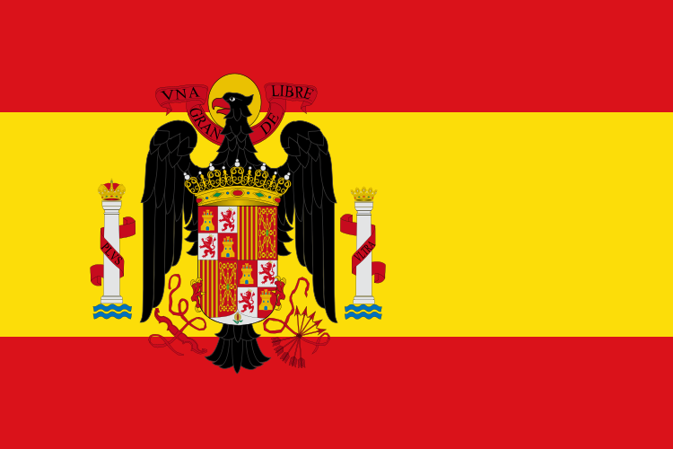
Figure 1.5 – 1945-1977 Flag of Spain.
Spain in the 1930s is an interesting study in government coup d'etats, as the government changed from a monarchy, to a liberal republic, to a nationalistic military regime within a single decade. Given that the Spanish government mostly abstained from fighting in World War II, refusing to take sides with either the Allied or Axis forces, the government emerging from the civil war was able to remain in power for many decades after the end of World War II. This creates a potential interesting study into the potential viability of fascist policies.
Attempts at liberal uprisings in Spain were not unique to the 1930s. Twelve successful coups occurred between 1814 and 1874, typically ending with a restoration of the monarchy. Nor were military coups unique to the 1930s, with a 1923 coup d'etat by the military which brought Miguel Primo de Rivera into power. The century prior to the Spanish Civil War was tumultuous, with conflicts occurring within and between various political groups. Anarchists, socialists, liberals, conservatives and monarchists struggled for rights and power.
On April 12th, 1931, royalist parties were handily defeated in the elections, in favor of liberal-leaning and socialist-leaning candidates. Despite winning the election and having a popular support, the Catholic organizations, monarchists and royalist-sympathizers, numerous military leaders and other so-called right-wing groups continued to organize and attempted to destabilize the government.
Civil unrest continued. Radicals on the left burned Catholic convents following the election. Several conflicts ensued, including a numerous conflicts between a syndicalist group, Confederacion Nacional del Trabajo (CNT), which grew to approximately 1 million members in 1932, and the Civil Guard, general strikes by worker's unions and other protests21. General Jose Sanjurjo attempted a military coup d'etat in August 1932, which failed and led to his subsequent incarceration.
In 1933, the government shifted towards a more right-leaning, militaristic government, as a result of winning the popular vote. The anarchists mostly abstained from voting – a group which tended to vote for left-leaning candidates. Alejandro Lerroux of the Radical Republican Party (RRP) reversed many of the liberal policies of the previous administration, and despite facing outrage from left-leaning groups, granted amnesty to the collaborators of General Jose Sanjurjo attempted coup d'etat. Wages of farm workers were cut and the military was purged of left-leaning individuals. Neither side was able to capture a majority in the government in the 1936 elections, and many leaders ignored supposed conspiracy theories regarding a possible attempt by the military to overthrow the government.
During the period leading up to the Spanish Civil War, many factions on the Nationalist-wing began to organize. Collaboration between the key groups would be necessary to ensure success in acquiring control over the government. The republican opposition was also very fragmented. While not necessary for the discussion of fascism specifically, the group dynamics of the Spanish Civil War are relevant to the discussion of current group dynamics between groups in the U.S.

The Nationalists
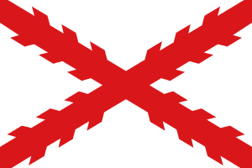
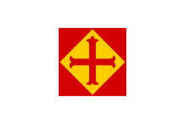

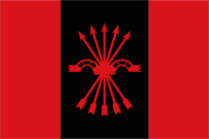
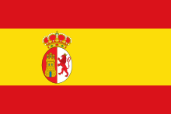

(Top-left to bottom-left, clockwise) Figures 1.6 – Carlist flag, previously used in Catholic monarchy, 1.7 -
On the right, four key groups emerged: Carlists, the Confederacion Espanola de Derechase Autonomas (CEDA), the Monarchists and the Falange. In order to win the war, and implement a cohesive government, General Franco required each group to pledge support for his cause.
The Monarchist (Alfonsine) party supported the traditional royal family, the descendents of Queen Isabella II, who was the daughter of Ferdinand VIII. At the time of the Spanish Civil War, the royal lineage consisted of King Alfonso XIII, who went into exile upon the rise of the Republican government, and his son, Don Juan. Despite only having marginal public support, support amongst Nationalist army officers was significant. With the monarchy perceived as a necessity for a return of the morality, values and cultural norms of “Old Spain”, any coup d'etat either respect the traditional monarchical lineage, or at minimum, implement a social structure compatible with that of old Spain21.
Two major organizations emerged to support the Nationalist movement during the war, Accion Espanola and Renovacion Espanola. Both organizations are linked together, with Accion Espanola consisting of intellectuals advancing the ideals of monarchical Spain through literature, and Renovacaion Espanola serving as the political party wing of the group. Both organizations fought for preservation and advancement of La Raza, ethnic-cultural identitarianism focusing on the pure Spanish people and in some cases, Roman Catholic tradition. With the monarchists, the focal point was not on Catholism, but ethic identity. An analogous organization to Accion Espanola in modern-day America is Richard Spencer's National Policy Institute.
The monarchists weren't the only ultra-conservative, traditionalist sect of the Nationalist movement – the Carlists (Communion Tradicionalistas) sought the return and preservation of similar ideals. The point of contention, however, revolved around the monarchical lineage source: the Carlists rejected the aforementioned in favor of the rival Borbon line of Don Carlos. Placing a much more significant emphasis on Catholicism, this sect sought the implementation of a fundamentalist Catholic monarchy. Widespread support for the Carlists was lacking, but regional support, especially amongst the Navarrese, was significant enough to require support to ensure continued unification of the Spanish Kingdom.
Three groups within the Carlists provided auxilary support to the Nationalist movement: the Requetés (Carlist militia), pelayos (the youth movement), and margaritas (women's services). The Requetés, hailing mostly from Navarre, were an ultra-religious militia who regarded the Spanish Civil War as necessary, as a Crusade, and traveled with holy figures, important for morale, motivation and spiritual support.
Carlist Generals were reluctant in negotiations with General Francisco Franco. Despite also fighting against the Republicans, and both groups holding traditional values, the Carlists were more heavily in favor of God above all else, but also were in favor of regional rights, instead of a unified kingdom with Christian values, on a more equitable plane. Manuel Fal Conde, the political leader of the Carlists, frequently clashed with General Franco, and as a result, left for Portugal for temporary leave. Shortly after, in early 1937, the Carlists finally united with the Falange, which tilted the Nationalists towards a favorable outcome in the war.
The Confederacion Espanola de Derechas Autonomas (CEDA), is a consolidation of the conservative right, present before the Spanish Civil War. Aacion Popular and Parti Agrario, with the youth movement Juventudes de Accion Popular, combined to form CEDA. The coalition of right-wing groups were mostly Catholic, and highly competitive with the Republicans, given their staunch anti-Marxist stance. While Carlists viewed the Spanish Civil War as a religious crusade, CEDA viewed it as a war against Communism / Marxism, and to combat Marxism, emphasized authority, nation and hierachy. CEDA aligned itself with General Franciso Franco early in the war, with the youth movement members gradually shifting over to the Falange party.
The final core party of the Nationalist movement is the Falange, the Mussolini-style Fascist party. Given the goal of this chapter is to derive a working definition of fascism, a definition useful in modern times, Francisco Franco's post-war regime will mostly be discussed by in terms of Falange influence, and to what degree did Franco's policies align with Italian Fascism, or Fascist-like governments such as Hitler's National Socialist Reich, or to a lesser extent, Emperor Hirohito's imperialist regime.
Nationalism and racialism are core tenants of Falangism. In similar terms as the anarchist syndicalists and communists were the revolutionary parties of the Republicans, the Falangism party was the revolutionary party of the right. Along with the Carlists, incorporation of Portugal, Gilbratar and even the French Pyrenees was a central ambition. A significant percentage of Falangists viewed races as being valid constructs, with statistically significant differences in physical, emotional, intellectual and other domains of skills and traits between racial groups. Unlike Nazism, racial purity or separatist positions were not common, and were not accepted as mainstream Falangist ideology. “Every race has a particular cultural significance..” and “Hispanic supercaste [is] ethically improved, morally robust, and spiritually vigorous” were two quotations from Falangist works21.
Falangism is a totalitarian ideology, with all competing political ideologies repressed – a centralized government including dictator with a single-party system in a supporting role. Viewing classism as a problem in society, falangism rejects capitalism. However, the perception of the detrimental effects of Communism on national identity, given that the central authority for communist nations at this point in time was the Soviet Union, and also perceiving moral depravity in the Socialist Party, a different approach was taken – National Syndicalism. National Syndicalism focuses on cooperation of classes and service to a unified nation. Employees and employers mutually organize, with the sole condition being that the benefit to the nation comes above all else. The National Syndicalist system, in theory, provides more freedom for employee and employer than Communism or Socialism, and empowers the individual more so than a capitalist society.
Falangism focuses on the traditional family and gender roles. A woman is expected to be a loving mother and productive homemaker, while the man's duty is to provide for the family. This view is not considered radical in 1930s right-wing political ideology, but is deemed unacceptable and oppressive by the left-wing opponents.

The Republicans
While a discussion of the Republicans is of less importance in a chapter analyzing fascism, the anarchist, syndicalist, communist and socialist groups demonstrate current widely accepted Antifa political philosophy in practice on a significant scale23. The Republicans were a more scattered, combative party, less willing to come together on a common policy set, with frequent skirmishes throughout the Spanish Civil War.
Popular Front & Centrist / Progressives
Unión Republicana (UR)
Unión Republicana (UR), a Republican24 progressive party, formed in 1934 after a merger of several small, somewhat diverse, center-left and centrist parties, including the Radical Democratic Party, which split from the aforementioned Nationalist-siding C.E.D.A. This party actively participated in all Republican governments throughout the war, and continued to strive towards implementing socially liberal, secularist and progressive policies, despite being outlawed and officials in exile following Nationalist successful outcome in the war.
Izquierda Republicana (IR)
Izquierda Republicana (IR) was founded in 1934, during the period when tensions were rising and following a failed military coup d'etat. IR was able to unite with UR and ERC during the Civil War, as well as remain on relatively peaceful terms with the Socialists.
Esquerra Republicana de Catalunya (ERC)
Catalonia has a rich culture and history, with traditions and values separate from the rest of the Kingdom of Spain. Catalan nationalists founded a political party in 1931 and continue to advocate for Catalan independence. Esquerra Republicana is a center-left, nationalistic party, adhering to positions of democratic socialism, economic liberalism and soft euroscepticism25. ERC was one of many conflicting groups who fought the Nationalists, but the lack of unity and cohesion adversely effected the outcome of the Civil War for both a desire for Catalonian independence and a continuation of a Republican rule on a national level.
Socialist & Communist Affiliates
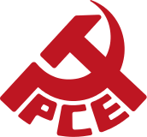


Partido Socialista Obrera de Espana (PSOE)
Partido Socialista Obrera de Espana (PSOE), also referred to as the Spanish Socialist Workers Party, was founded in 1879. During the Spanish Civil War, PSOE splintered into three wings: a Marxist revolutionary wing, a moderate democratic socialist wing, and a reformist wing. PSOE was banned in 1939, along with other political parties, during the reign of General Francisco Franco, and was revitalized in 1977.
Partido Comunista de Espana (PCE)
PCE, or the Communist Party of Spain, is blamed by many historians for being a factor in the Republican's loss in the Spanish Civil War. The Communists felt that revolution would have to wait until after the war and hesitated in acting on the threat of General Franco's military advances. By the time the Communist Party formed an organized militia, and obtained the assistance in the form of raw materials and troops, the Nationalists already possessed control over key regions of Spain, including a weapons factory outside of Madrid. Had the Communist Party acted earlier, and attempted a counter-revolution against the Nationalists, it is within the realm of possibility that Spain would have been a Communist, not Fascist, country for the decades following the war.
Marxist / Trotskyist Parties
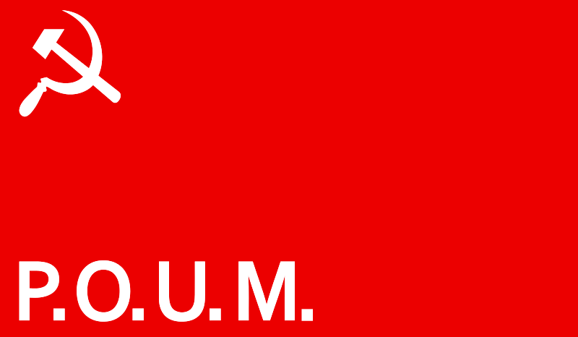

Figure 12 – Flag of The Worker's Party of Marxist Unification
Partido Obrero de Unificacion Marxista (POUM), or the Worker's Party of Marxist Unification, founded in 1935, advocated for Trotskyism, not communist policy dictated from central command – Stalin's Soviet Union. A political party primarily located in Catalonia, a hotbed of divided political ideologies, emerged as a response to civil discontent with the lack of reform in the civil and military framework of the state, believing the Republicans were too passive towards continued monarchical policies.
Sensing a gradual shift towards fascist policies in support of powerful clerical and corporate interests, POUM's mission was to restore power and independence to the workers from the rising fascists and democratic bourgeois.
As we gradually shift from more traditional and totalitarian factions of the Republicans, the groups of discussion begin to align more and more with the stated goals of the Antifa movement. Groups such as the UR, IR and ERC, while not perceived to be as immediate of a threat as the Nationalist and fascist right-wing groups, were still perceived as propagators of false rhetoric, full of unfulfilled promises and protectors of the corporate moguls, clerico-fascists and the monarchy.
Famous English writer George Orwell, who went to Spain to fight with POUM, summarized it well in his 1938 novel entitled Homage to Catalonia: “I have no particular love for the idealised “worker” as he appears in the bourgeois Communist's mind, but when I see an actual flesh-and-blood worker in conflict with his natural enemy, the policeman, I do not have to ask myself which side I am on.”

Anarchist, Syndicalist & Libertarian Affiliates
Confederacion Nacional de Trabajo (CNT)
CNT, and a group affilated Asociacion Internacional de los Trabajadores (AIT) and Federacion Anarquista Iberica (FAI), recognized as CNT-AIT and CNT-FAI respectively, was founded in 1910. Their creed was, "We make no distinction at the time of admission, we require only that you are a worker, student or unemployed. The only people who cannot join are those belonging to repressive organisations (police, military, security guards), employers or other exploiters". As one of the only regions to hold a functioning anarcho-syndicalist system of scale, both men and women engaged in work and took to the front lines, engaged in a variety of jobs, abandoned money for work and instead utilized vouchers, where services and products were sold in terms of labor hours (the vouchers counted this), not money. This movement continues to this day, fighting for worker's rights to unionize and for various issues related to the common good.
The Dictatorship – Fascist or Not?
For the purpose of this text, the actual battles of the war are rather irrelevant. Due to a variety of factors, including the Republicans having difficulty uniting under a single group, and outside nations helping each side, including significant support from Hitler and Mussolini on the side of the nationalists – albeit, the Nationalists received support from the Soviets – the Nationalists eventually won the war in 1939. General Francisco Franco took power as dictator and assembled a cabinet around him. While it would seem to an outsider with only cursory knowledge of the war that as a fascist-sympathizer, he would have appointed a mostly Falange cabinet, he did not. He appointed two former Falange (political parties were made illegal per dictatorial decree) to his cabinet, both of whom did not hold firmly to Falange doctrine and principles. Both of these members were eventually replaced, and replaced with individuals who had no ties to the Falange party. He was known as “El Caudillo”, meaning the leader, similar to other dictatorial regimes.
A common theme to fascist regimes is a military coup d'etat to gain control. This was the case in both Germany, where coup d'etats were attempted, and Italy, where Mussolini's March on Rome was successful. Militarism appears to be a common thread amongst fascist regimes, which General Francisco Franco had expansionary goals and focused heavily on ensuring Spain had a formidable military.
Franco, while providing occasional support in the form of supplies, mostly stayed neutral during the war, despite owing his victory in the Spanish Civil War mostly to the help of the Germans and Italians; without the help of either, the Republicans, with Soviet help, would have stood a much better chance at success. Due to his neutral stance, Spain did not face as significant of post-war hardship as the Axis countries, and Franco was able to retain dictatorial power over Spain. Franco led a totalitarian system of government in Spain until his death in 1975.
Conformity to a code of strict nationalism is a common feature of fascist governments. Franco's rule undoubtedly adhered to this. Following the war, tribunals were held for Republicans, most of whom were either executed or if lucky, imprisoned. Independent labor unions were outlawed. The only religion allowed to be practiced was Catholicism, and Spanish was made to be the official, and only, accepted language throughout the country. Catalan and Basque languages were deemed illegal, and all signs and other public displays utilizing other languages were destroyed.
Initially, Franco proclaimed ultimate authority over commerce, but allowed corporations and industries to operate without absolute control and orders from the state. This is similar to other regimes, where a form of corporatism, a government and corporation partnership, which historically seems to be more effective in the long-term than a completely planned economy as seen in the Soviet Union and at the time of this writing, Venezuela. Gradually over his term, he began to relax on the degree to which he policed industry, culture and other institutions.
Francisco Franco's rule over Spain was militaristic, required strict conformity to a defined sense of nationalism, deemed ultimate authority to the dictator with exception of allowing for Catholicism, which was required to be actively practiced during Franco's regime, and had a corporatist approach to economic policy. Similar to Mussolini, racial and ethnic cleansing policies and practices were not a primary, or even secondary issue.
After studying four historical regimes most commonly referred to as being fascistic, historical fascism can be defined as follows:
- A dictatorial system of governance, requiring absolute observation to a strict code of nationalism, with an emphasis on military prowess, and an economic policy focusing on a state and corporate partnership, with economic policy and business decisions always adhering to what is deemed in the best interest of the state.
American Falangist Party (AFP)
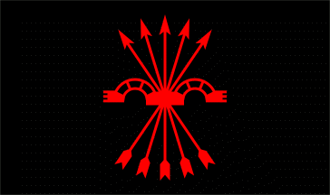

The American Falangist Party (AFP) – full-name being as follows: 'National Syndicalist American Falangist Party' – is a now-defunct political party which attempted to promote Fascism as a legitimate form of government in the United States, with no significant success. The movement is related to the National Synarchist Union (Mexico-based) movement. The group started in 1985 and disbanded in 2000.
Not every AFP member was willing to give up on a true Falangist party in America. As a political party, we will assess under each dimension whether or not it meets the criteria of fascist.
Assessment
Without nationalism, fascism fails to exist. AFP rejects racism in favor of National Unity, and given the cultural shifts when this party was founded, racism was one of the most divisive aspects of U.S. society. Only Christians are allowed to join. However, if AFP were to gain power, separation of church and state and freedom of religion would be protected. Homosexuality is prohibited in public – what goes on behind closed doors is no one's business – but being disruptive in public by acting out on homosexual urgers should carry a harsh sentence, perhaps “But any radical homosexual that disrupts a Religious service because they don't agree with what is being said or practiced by that church should be sentenced to a special labor camp for 20 years or in some cases executed.26”
A unified country through a suppression of ideas, appears to be the approach, with those with different beliefs being forced into hiding (i.e. homosexuality) was common. Church and state were separate, but Christianity was the only official religion, which by association, would likely force it down other religions as well. This was similar to Franco's and Mussolini's regimes, where a cohesive national identity was set forth by a supreme leader. While no mention of militarism is specifically listed in the remnants of the platform that are easily accessible, it wouldn't be a stretch to assume that a strong military to police the streets to ensure compliance as well as to protect the nation would be a priority if this party came into power.
Privately owned banked would be abolished, and large corporations would be under more control of the state. The working class should be allowed to make a living, while the excesses of capitalism must be reigned in.
This political party combined some syndicalist policies with the Falange platform of Spain, creating hybrid form of fascism. Nor were the policies as clear.
The Deplorables, Degenerates & Dangerous
Creativity Movement
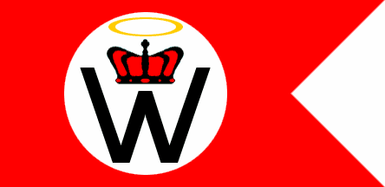
The Creativity Movement (TCM), formerly known as the World Church of the Creator, was founded by Ben Klassen in 1973. A splinter group, called Creative Alliance (CA), was formed by Matthew F. Hale in 1996 under a different name. As of 2003, the two groups, not known to interact with each other or share significant membership, have utilized the aforementioned names: TCM and CA.
The focus of this discussion will be TCM, with a sparse discussion of CA. Ben Klassen P.M.E., published numerous books and articles over the years, which constitute the holy writings of TCM. Nature's Eternal Religion (1973) remains the core book of the group. Despite the controversial nature of the group, and history of criminal activity amongst group members, the TCM and CA both qualify as official religious entities under federal law. IN Peterson vs. Wilmur Communications (2002), the United States District Court of the Eastern District of Wisconsin ruled in favor of TCM/CA, with legal help from the American Civil Liberties Union (ACLU). In Hale vs. Federal Bureau of Prisons (2015), another victory for TCM/CA was achieved, ruling that Creativity qualifies as a religion under the First Amendment of the United States Constitution, qualifies for tax-exempt status as such, and may be practiced in prison.
TCM is anti-homosexuality, anti-gay marriage and against transgenderism and other acts deemed to be part of a larger conspiracy to devalue the white race. Instances of this are numerous in documents, on message boards, etc. See Appendix III, 1.A. for supporting documentation. This is just one example amongst group members. On the Creativity Movement message board, a user named 'cov' on March 1, 2013, stated, “Everyday I am amazed of how low we have dropped.”, in response to the first openly gay Secretary serving in the United States Army. These are not the only examples of anti-homosexuality within The Creative Movement's doctrine. In Klassen's book, Nature's Eternal Religion, which is the WCOTC equivalent to the Qu'ran for Muslims or The Bible for Christians, it is quoted on page 260 saying:
“Any activity that hampers or imperils this noble objective is unnatural, and, therefore, a violation of Nature’s laws. We all clearly recognize, for instance, that homosexuality is unnatural and that such people are called deviates. We must also recognize that Nature harshly punishes deviates and extinguishes them from the face of the earth. It is quite clear, for instance, that a society of sexual deviates would be short-lived and Nature would wipe them from the face of the earth”.27
While an exclusionary organization – only white people allowed – it is neither misogynistic (women are allowed) nor nationalistic (worldwide chapters exist). Through the Sixteen Commandments28, preservation, propagation and proudness and purity of race are necessary. Jewish peoples are deemed to be an enemy, and all other religions are viewed as being a scam.
While this group doesn't have any of the elements of fascism, unless nationalism is perceived as some form of International white race, the only element is racial purity, common to Nazism. This group has been linked to heinous crimes, though.
On June 2nd, 2014, Antifa Philadelphia rallied against Creativity Movement and allies in Columbus, OH. This event did not draw many, nor did it seem to erupt into violence. Creativity Movement has abstained, for the most part, from recent rallies29.
American Nazi Party
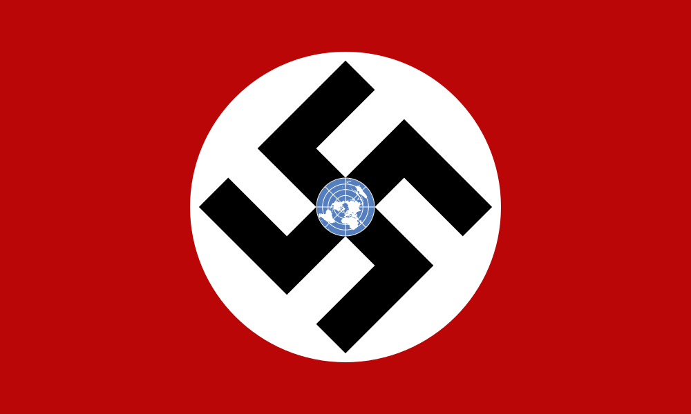
Figure 1.6 – American Nazi Party logo
?

Aryan Nations
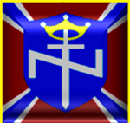

Figure 1.7 – Aryan Nation's emblem
?

National Alliance
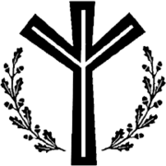

Figure 1.8 – National Alliance emblem
?

Aryan Brotherhood
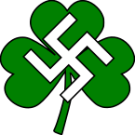

Figure 1.9 – Aryan Brotherhood symbol
?

National Socialist Movement (NSM)


Figure 1.10 – NSM logo
?

The “Alt-Right”


Figure 1.11 – Pepe the frog, a cartoon frog used for memes during 2016 presidential election.

?

Etymology of “Facism”

Antifa's Definition
Methodology & Findings
Given the qualitative nature of the epistemology of fascism, interviews were used as the primary tool. Interviews occurred face-to-face, via phone, e-mail, message boards such as 4chan and Reddit, and utilizing social media platforms, including Facebook, Twitter and Mastodon. For each individual, the question of “What is fascism?” was proposed during the interview, with varying follow-up questions as necessary.
75 members of Antifa were interviewed, with 7 members associating with the Indianapolis, Bloomington or other Indiana Antifa groups. The remaining members were from varying groups in California ( n = 20), Oregon ( n = 15), Washington ( n = 19 ) and the remaining from other Antifa groups around the country.
Through a textual analysis of the interviews, many common themes were discovered. “Hegemony” and variants of the word appeared in 53 of the interviews. “Corporate” and its variants, as well as “big business” and its variants, were discussed in all except 7 of the conversations. Racist, sexist, homophobic, xenophobic, and trans-phobic appeared in 48 of the discussions. Thirteen members mentioned “Zion” and its variants or comments involving Jewish people committing evil acts, such as poisoning the water supply on purpose, fraudulent world bank actions and beliefs in a group, etc. In other interviews, common themes included militarism, economic policy that purposely hurts the poor, lack. of caring about the health care of the poor, and centralized, dictatorial power.
<<discuss fascist definitions in literature>>
Discussion
?
Summary
?

Chapter II: History as a Cycle
?

Chapter III: Political Spectrum & Parties
?

Chapter IV: Philosophical & Political Theories
Neo-Marxism / Frankfurt school
Postmoderism
Post-modernism, typically viewed as being a subset of Marxist or Neo-Marxist thinking, is a core philosophical framework held by numerous academics, especially in the humanities, arts, social sciences and women's studies, ethnic studies and other activist disciplines. The funding of these activist disciplines as well as a lack of significant consequences to influential academics teaching that Western civilization is flawed to the point where the Marxist Utopian system, with the proper individual in charge to facilitate towards to the worker's utopia, should not only be striven towards, but in many cases, a cultural rebellion / revolution is necessary to change the fundamental way society is constructed to achieve these goals.
In the following chapter, the origins of modernism and postmodernism will be discussed in detail, with specific philosophers takes on each presented in an unbiased way. After setting the foundation, postmodernism will be discussed as it relates to the following:
(1) Changes in socio-cultural attitudes in general.
(2) Anti-fascist movements in the United States and where appropriate, throughout history and in present-day conflicts throughout the world.
Pre-Modern & Modern Philosophy
Pre-modern thought has its roots in mysticism and/or faith. Given the focus of this book on a movement within a Western culture, the most immediate and significant influences to pre-modern thought prior to Descartes and Bacon were the church and the state. Human nature under this perspective focused on God's will and original sin. Feudalism was the political system. Having a different philosophical viewpoint may be punishable by the church or state. The individual was subordinate to the collective and had little value outside of the system which the individual existed.
In contrast with pre-modern thinkers, Modern philosophers viewed the world in naturalist and objective terms, focusing on experience and deductive reasonings. Modern thinkers focus on the individual as a unit of reality, an individual's sovereignty and the human capacity to form one's own character. Feudal subordination was rejected in favor of systems which promoted the individual's ability to effect change in society. The founding fathers of the United States were modern thinkers who incorporated Judeo-Christian values with modernist concepts of personal autonomy and individual sovereignty.
Rationalism
Rene Descartes
Empiricism
John Locke
Counter-Enlightenment Period
Conflicts arose against Enlightenment-era philosophers and a competing school of philosophers who objected to the potential negative implications on the rationalist approach of Descartes and the empiricist approach of Locke.
Postmodernism
Modern-day postmodern thought emerged in the late 19th century in direct opposition to modern thought. Postmodern thought is anti-realist, meaning it is impossible to speak meaningfully about an independent existing reality, and substitutes social-lingustic constructionist accounts of reality. Postmodernism attacks the essential philosophical tenants of modernism, given the perspective of postmodernists that these exact tenants are used as a way to keep the powerful (the oppressors) in power and the oppressed under their control.
Subjectivity is key to postmodernism.

Chapter V: Alinskly's Rules for Radicals
INTRODUCTION
Tactical Rules
Rule #1: Power is not only what you have but the what the enemy thinks you have.
The struggle over power is central to the leftist view of society and the lack of power with the Have-Nots, the Proletariat, the impoverished, homosexuals, women, minority groups or whatever group du jour is determined to be oppressed. The Haves hold the power, and in order for society to change for the betterment of the masses, the Have-Nots must revolt. Revolution, not evolution, is the central tenant. Lack of action and indifference equates to support for the Haves. The ends justify the means, no matter the cost. I could go on and on with the rallying cries of the Left.
It's all Bumper sticker politics, no different than conservatives with their “Abortion stops a beating heart” bumper stickers. A coexist bumper sticker on a Toyota Prius never stopped an Islamicist terror attack, nor has a pro-life bumper sticker stopped an abortion. It's all virtue signaling from both sides of the aisle. A bumper sticker holds no value except the cost of the materials to create it, and the value in infuriating the opposition. Real power is what matters and how to obtain it, or at least bluff to advance the cause.
What is power? Is it material wealth? It would be, but not that doesn't fuy encapsulate power. Does holding high office make one powerful? Is power a social construction related to position in the political hierarchy? Power is an amorphous term, which changes depending on the groups involved and the goals of the group. In the most basic terms, power, as defined by Saul Alinsky (1971), is the “ability, whether physical, mental or moral, to act”. Alinsky elaborates by stating:
“Power is the very essence, the dynamo of life. It is the power of the heart pumping blood and sustaining life in the body. It is the power of active citizen participation pulsing upward, providing a unfiied strength for a common purpose. Power is the essential life force always in operation, either changing the world or opposing change. Power, or organized energy, may be a man-killing explosive or a life-saving drug. The power of a gun may be used to enforce slavery, or to achieve freedom.”
How does a group such as Antifa, Black Lives Matter or related groups enact change when the majority of Americans disagree with the means, if not also the ends? The group must appear to be significant in size, regardless of the actual size of the group. “Parade it visibly before the enemy”, states Alinsky. The group must show itself in the community, conceal the actual number of members but organize publicly in a manner that influences the masses to believe the size of the group is larger than it actually is. If you lack numbers, “stink up the place”! Make a ruckus! Make as much noise as possible and cause disruption to increase the perceived amount of power held by the group.
Antifa engages in this rule through utilization of the Black Bloc

Chapter VI: Psychological Underpinnings
?

Chapter VII: Leadership & Tactics
?

Chapter VIII: Allies & Associates
?

Chapter IX: Financial Background
?

Chapter X: The Civil War Begins
<introduction>

Presidential Inauguration (01/20/2017)
??

Charlottesville (08/12/2017)
The #UniteTheRight rally was planned in May for August 12th, 2017, as a protest for Lee Park being renamed, and to protect the Robert E. Lee statue, which the opposition advocated for tbe removal of said statue. #UniteTheRight was a coalition of white identitarian groups, groups who advocate for the preservation of European culture and history, and ensuring white, and preserving white, European values to ensure they remain a part of future generations. #
#UniteTheRight meeting orders explicity stated that it was to be a peaceful protest and while freedom of speech would not be suppressed, appropriate behavior was expected. Members of western chauvinist, white separatist, white supremacist, and National Socialist / neo-Nazi groups, or individuals holding similar views as the above groups, were welcomed to attend, as long as appropriate behavior standards were observed, and the members were present for the stated purposes of the rally.
The Participants
Sorting out the participants of the Charlottesville “Unite the Right” rally, and attempting to ascribe responsibility, intent or any motive is nearly impossible, especially after the permitted individuals were forcibly removed, and a cacophony of fringe groups and individual miscreants overran the gathering. The goal of this section is simply to identify the groups and discuss the basics about each group: general history, mission and goals, and pertinent leaders and members.
“Unite the Right” Organizers
Jason Kessler, a freelance writer and journalist, author of Midnight Roads, was the primary organizer of the #UniteTheRight rally, along with Eli Mosley, an alt-right activist

National Vanguard / Vanguard America
National Vangard, also referred to as Vanguard America, was founded by Kevin Alfred Strom in 2005, after a dispute with ranking officers at National Alliance.
Kevin Alfred Strom, the founder of the group,
James Alex Fields, Jr., associated with National Vanguard as evidenced by numerous photos of him in a National Vanguard uniform. However, on the National Vanguard website, David Sim's wrote an article entitled “Antifa versus 'Supremacists'”, where he states:
“Antifa don’t act as they do on principle. They merely pretend that acting on principle is what they are doing. I think someone rich is paying them a salary and providing them with transportation. If that rich sponsor were to have a heart attack or something, the Antifa might go away. If a foundation exists to continue Antifa’s funding, then it would have to be defunded by a legal action.
Otherwise, the only option is to fight fire with fire, which would escalate the fighting between the left and the right to real military conflict. This is the only other option because, as we have seen in Charlottesville, the police often don’t conduct themselves with professional impartiality. Instead they, or the politicians who give them their orders, act as extra pieces for the left on the chessboard, giving Antifa an unfair advantage.”
It's clear from this quote that engaging in physical conflict with Antifa is deemed not only acceptable, but necessary, given the lack of cooperation by the police, and skewed perspective of the mainstream media, leaving no choice but to engage in actual physical conflict. Given the police stood down in Charlottesville, as well as leaving National Vanguard members alone, despite having a history of members being connected to violent crimes, and publicly stating disdain for the opposition group.

Chapter XI: Final Thoughts

Appendix I
Bibliography
“1985-2001: A Short History of Anti-Fascist Action (AFA)”. Retrieved May 26, 2017, from https://libcom.org/history/articles/afa-anti-fascist-action.
Anti-Defamation League (ADL). CreativityMovement Extremism in America. New York: ADL, 2013.
Antifa Philadelphia. “CALL TO ACTION: Creativity Movement, NSM, and Blood & Honor in Columbus, OH” May 30, 2014. Retrieved August 24, 2017 from https://phillyantifa.org/call-to-action-june-2-creativity-movement-nsm-and-blood-honor-in-columbus-ohio
American Falangist Party. “Frequently Asked Questions”. Retrieved from http://www.freewebs.com/nsafp/faq.htm
Anderson, James M. The Spanish Civil War: A History and Reference Guide. Westport, CT: Greenwood Press, 2003.
Alinsky, Saul. Rules for Radicals: A Pragmatic Primer for Realistic Radicals. New York: Random House, 1971.
Allen, Gary. None Dare Call It Conspiracy. 1972.
“Antifa Goons Panic After Masked Professor Who Bludgeoned Trump Supporter with Bike Lock is Identified & Exposed”. The Gateway Pundit. June 7, 2017.
“Antifa Moron Complains 'Too Many Men in Movement' and Men Should Dress Like Women”. Libertas Daily. Accessed May 1, 2017 from http://libertasdaily.com/2017/03/26/antifa-moron-complains-many-men-movement.
Antifa Sacramento. “Points of Unity”. Accessed April 24, 2017 from http://antifasacblogs.com/points-of-unity.
“ANTIFA Upset for Not Being Able to Punch 'Nazis' Without Consequences”. ZeroHedge. April 22, 2017.
Arato, Andrew & Gebhardt, Eike, Eds. The Essential Frankfurt School Reader. New York: Continuum, 1985.
Azzi, Stephen Corrado. “The Historiography of Fascist Foreign Policy.” The Historical Journal, 36(1), March 1993.
Baginski, Max. “The Pioneer of Communist Anarchism in America.” Mother Earth, Vol 6, March 1911.
Balhorn, Loren. “The Lost History of Antifa.” May 8, 2017.
Barron, Benjamin. “A Mysterious Revival of Roman Passion.” Senior Thesis, Georgetown University.
BBC. The Spanish Civil War. (Original release 1983.), TV series.
Firstname Lastname, Title of Work, Format, directed/performed by Firstname Lastname (Original release year; City: Studio/Distributor, Video release year.), Medium.
Beevor, Anthony. The Battle for Spain: The Spanish Civil War 1936-1939. London: Penguin Books, 1982.
“Berkeley Antifa Attacker Unmasked as UC Employee? CNN & Young Turks Lookin' So Dumb.” ZeroHedge, Februry 3, 2017.
Boettke, Peter. Calculation & Coordination: Essays on Socialism & Transitional Political Economy. New York: Routledge, 2001.
Bowen, James et al. Changing Anarchism. Manchester, UK: Manchester University Press, 2004.
Caruso, Justin. “Berkeley Mayor Publicly Belongs to Violent Leftist Group.” The Daily Caller, April 24, 2017.
“The Colonial Cycle (1589-1692).” Retrieved June 5, 2017, from http://www.timepage.org/cyc/colo.html.
Coulter, Ann. Adios America. Washington, DC: Salem Media Group, 2015.
“Excerpts from Frame of Government of Pennsylvania, 1682”. Retrieved June 5, 2017, from http:///www.constitution.org/bcp/frampenn.htm.
Flynn, John. As We Go Marching. New York: Doubleday & Co, 1973.
Fontenis, Georges. Manifesto of Libertarian Communism. 1953.
“Forming an Antifa Group.” Accessed May 26, 2017, from https://itsgoingdown.org/wp-content/uploads/2017/02/howtoantifa-revised.pdf.
Graham, Robert. Anarchism: A Documentary History of Libertarian Ideas, Volume One: From Anarchy to Anarchism (300CE to 1939). Black Rose Media Books, 2005.
Goldberg, Jonah. Liberal Fascism: The Secret History of the American Left, from Mussolini to the Politics of Change. New York: Broadway Books, 2007.
Gordon, Andrew. A Modern History of Japan: From Tokugawa Times to the Present. New York: Oxford University Press, 2003.
Griffin, Roger. Fascism. New York: Oxford University Press, 1995.
Halbrook, Stephen. Gun Control and the Third Reich. Oakland, CA: The Independent Institute, 2013.
Hammer, Joshua. Yokohama Burning. New York: Free Press, a division of Simon & Schuster, 2006.
Haney, Jade. “Student Has Home Vandalized After 'Trolling' Antifa Groups.” Campus Reform, February 28, 2017.
Hattingh, Shawn. The Deepening Capitalist Crisis: From Blood and Dirt to Much Worse. Zabalaza Books.
Hayes, Peter. From Cooperation and Complicity: Degussa in the Third Reich. New York: Cambridge University Press, 2004.
Hicks, Stephen R.C. Explaining Postmodernism: Skepticism & Socialism from Rousseau to Foucault. Tempe, AZ: Scholargy Publishing, 2004.
The History Place. “25 Points of Hitler's Nazi Party”. Accessed August 7, 2017, from http://www.historyplace.com/worldwar2/riseofhitler/25points.htm.
Hitler, Adolf. Mein Kampf. Translated by Ralph Manheim. Boston, MA: Houghton Mifflin, 1999.
Hochschild, Adam. Spain in Our Hearts: Americans in the Spanish Civil War, 1936-1939. New York: Houghlin-Mifflin, 2016.
Hoppe, Hans-Hermann. A Theory of Socialism & Capitalism. Norwell, MA: Kluwer Academic Publishers, 2010.
Ingles, El. “The Blackhoods of Antifa.” The Brussels Journal. Accessed May 25, 2017, from https://www.brusselsjoiurnal.com/node/3566.
“The Italian Resistance”. YouTube video, 20 min. Posted March 2017.
Kertzer, David. The Pope and Mussolini: The Secret History of Pius XI and the Rise of Fascism in Europe. New York: Random House, 2014.
Klassen, Ben. P.M.E. Nature's Eternal Religion. Peoria, IL: Ben Klassen Library, 1973.
Kropotkin, Peter. Anarchist Communism: Its Basics and Principles, 1927.
Kropotkin, Peter. Communism & Anarchy, 1901.
La Révolution Espagnole, No 1, September 3, 1936.
Laila, Cristina. “Confirmed: Berkeley Mayor Jesse Arreguin Publicly Supports Violent Left-Wing ANTIFA Group”. The Gateway Pundit, April 21, 2017.
Lennard, Natasha. “Anti-Fascists Will Fight Trump's Fascism in the Streets”. The Nation, January 19, 2017.
Levant, Ezra. “Berkeley vs. Milo: 'That's Not a Protest. That's a Riot.” The Rebel, February 3, 2017.
Life Course Associates. “Generations in History”. Retrieved June 4, 2017 from http://www.lifecourse.com/assets/files/gens_in_history(1).pdf.
McInnes, Gavin. “In Berkeley Last Saturday, We Took the Culture Back.” The Rebel, April 17, 2017.
McInnes, Gavin. “Fighting 'Anti-Fascist' Protesters is Fun.” The Rebel, February 6, 2017.
Molyneux, Stefan. “Antifa Violence Exposed.” Filmed April 24, 2017. FreeDomainRadio, 44 min. Posted April 2017. http://www.youtu.be/Tb54GoVR2m4.
Morse, Brandon. “Antifa Group Behind Violent Riots Discovered to Have Ties to Pedophile Group.” The Blaze, May 1, 2017.
Morse, Brandon. “Antifa Wants Combat Training and Firearm After Losing the 'Battle for Berkeley'. The Rebel, April 21, 2017.
“Mostly Forgotten History: The Maryland Wars.” Retrieved June 5, 2017 from http://m.dailykos.com/story/2014/2/16/1278088/-mostly-forgotten-history-the-maryland-wars.
Mowat, R.B. History of European Diplomacy, 1451-1789. 1928.
Moywer, Daniel. “Spanish Civil War (CEDA)”. May 10, 2013. Retrieved August 18, 2017 from https://prezi.com/e25wxl5hf3kr/spanish-civil-war-ceda/.
Mussolini, Benito. “The Doctrine of Fascism.” 1932. Retrieved from http://www.worldfuturefund.org/wffmaster/Reading/Germany/mussolini.htm.
Nash, Charlie. “Four Arrested at Gavin McInnes Event as Antifa Protesters Become Violent”. Breitbart, February 2, 2017.
Pelz, William. A People's History of Modern Europe. Pluto Press, 2016.
Posobiec, Jack. “Antifa: Unmasking America's Most Dangerous Domestic Terrorists”. The Rebel, April 20, 2017.
Raico, Ralph. Great Wars & Great Leaders: A Libertarian Rebuttal. Auburn, AL: Ludwig von Mises Institute, 2010.
Reich, William. The Mass Psychology of Fascism. New York: Farrar, Straus & Giroux, 1970.
Rose City Antifa. “Statement on Strategy and Tactics for June 4th Rally”. May 24, 2017.
Ross, Chuck. “Look Who Funds the Group Behind the Call to Arms at Milo's Berkeley Event”. The Daily Caller, February 3, 2017.
Rubin, Barry. Silent Revolution: How the Left Rose to Political Power and Cultural Dominance. New York: Harper Collins, 2014.
“Rules of Engagement”. The Antifascist, 1, Spring 2005.
Saturday Night Live. “Aliens Attack Cold Open”. Episode 824. Directed by Don Roy King. Written by Chris Kelly, Sarah Schneider, and Bryan Tucker. NBC, March 11, 2017.
Savage, Michael. Abuse of Power. New York: St. Martin's Press, 2011.
Savage, Michael. The Enemy of Within. Nashville, TN: WND Books, 2003.
Savage, Michael. Government Zero: No Borders, No Language, No Culture. New York: Center Street, 2015.
Savage, Michael. Liberalism is a Mental Disorder. Nashville, TN: Nelson Current, 2005.
Savage, Michael. Stop the Coming Civil War: My Savage Truth. New York: Center Street, 2015.
Seldes, Georges. Sawdust Caesar: The Untold History of Mussolini. New York: Harper Brothers Publishers, 1935.A
Senate Education Committee. Amendment No. 1 to SB0723. http://www.capitol.tn.gov/Bills/110/Amend/SA0333.pdf.
“7 Steps That We Must Take to Defeat Antifa & Remove Violence from Political Discourse.” Sisyphean News. April 24, 2017. https://sisypheannews.com/2017/04/24/7-ways-to-eliminate-antifa.
Sheffield, Matthew. “Anti-fascist Radicals: Liberals Don't Realize the Serious Danger of the Alt-Right.” Salon.com, March 10, 2017.
Shirer, William. The Rise and Fall of the Third Reich. New York: Simon & Schuster, 1960.
Sims, David. “Antifa versus 'Supremacists'”. August 16, 2017. Retrieved August 18, 2017 from http://nationalvanguard.org/2017/08/antifa-versus-supremacists/.
Smith, Denis Mack. Mussolini: A Biography. New York: Vintage Books, 1983.
Stop Fascism. Chicago, IL: New America.
Strauss, William. The Fourth Turning. Three Rivers Press, 2009.
Strickland, Patrick. “US Anti-Fascists: We Can Make Racists Afraid Again”. Al Jazeera. February, 21, 2017.
Sunshine, Spencer. “The Changing Face of Anti-Fascists.” Truthout. January 18, 2017. https://www.brusselsjournal.com/node/3566.
“The Fascisti”. Current Opinion, October 1921, p. 430.
“Tennessee First State to Ban Domestic Terror Groups Antifa and BLM.” Sisyphean News. March 19, 2017. https://sisypheannews.com/2017/05/19/tennessee-first-state-to-ban-domestic-terror-groups-antifa-and-blm.
Trotsky, Leon. Fascism: What It Is & How To Fight It. 1930-1932. Retrieved from http://history.eserver.org/fighting-fascism.
Unite The Right. “Operation Unite the Right Charlottesville 2.0”. April 10, 2017. Retrieved August 8, 2017 from https://http://www.unicornriot.ninja/wp-content/uploads/2017/08/OpOrd3_General.pdf
Viehmann, Klaus. “Three Into One: The Triple Oppression of Racism, Sexism & Class”. Quaderni di Controinformazione, 21/22, February 1995.

Appendix II
Photo Credits
Chapter I
1.1
1.2
1.3
1.4
1.6 – Image is licensed under Wikimedia Commons.
1.7
1.8
1.9
1.10
1.11
1.12 – Author: Sevgart. Distributed under GNU Free Documentation License, Version 1.2
Appendix III
Supporting Documentation
Appendix 1.A
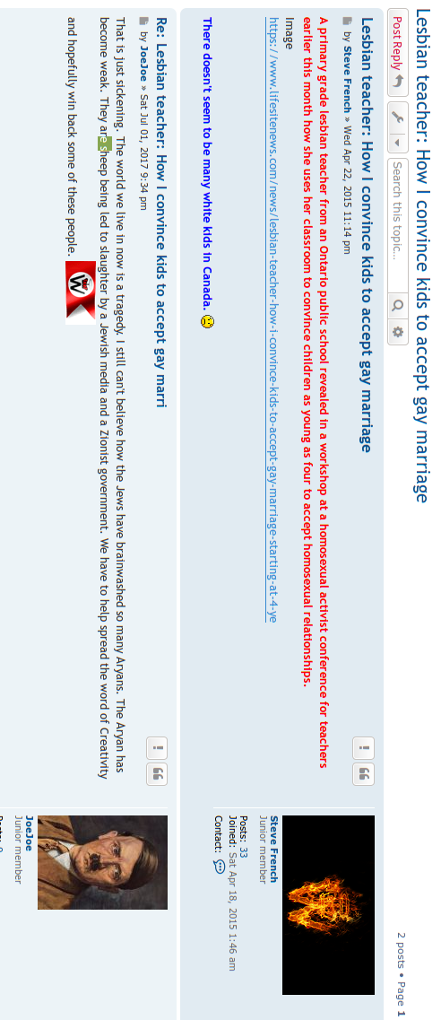
Appendix 1.B
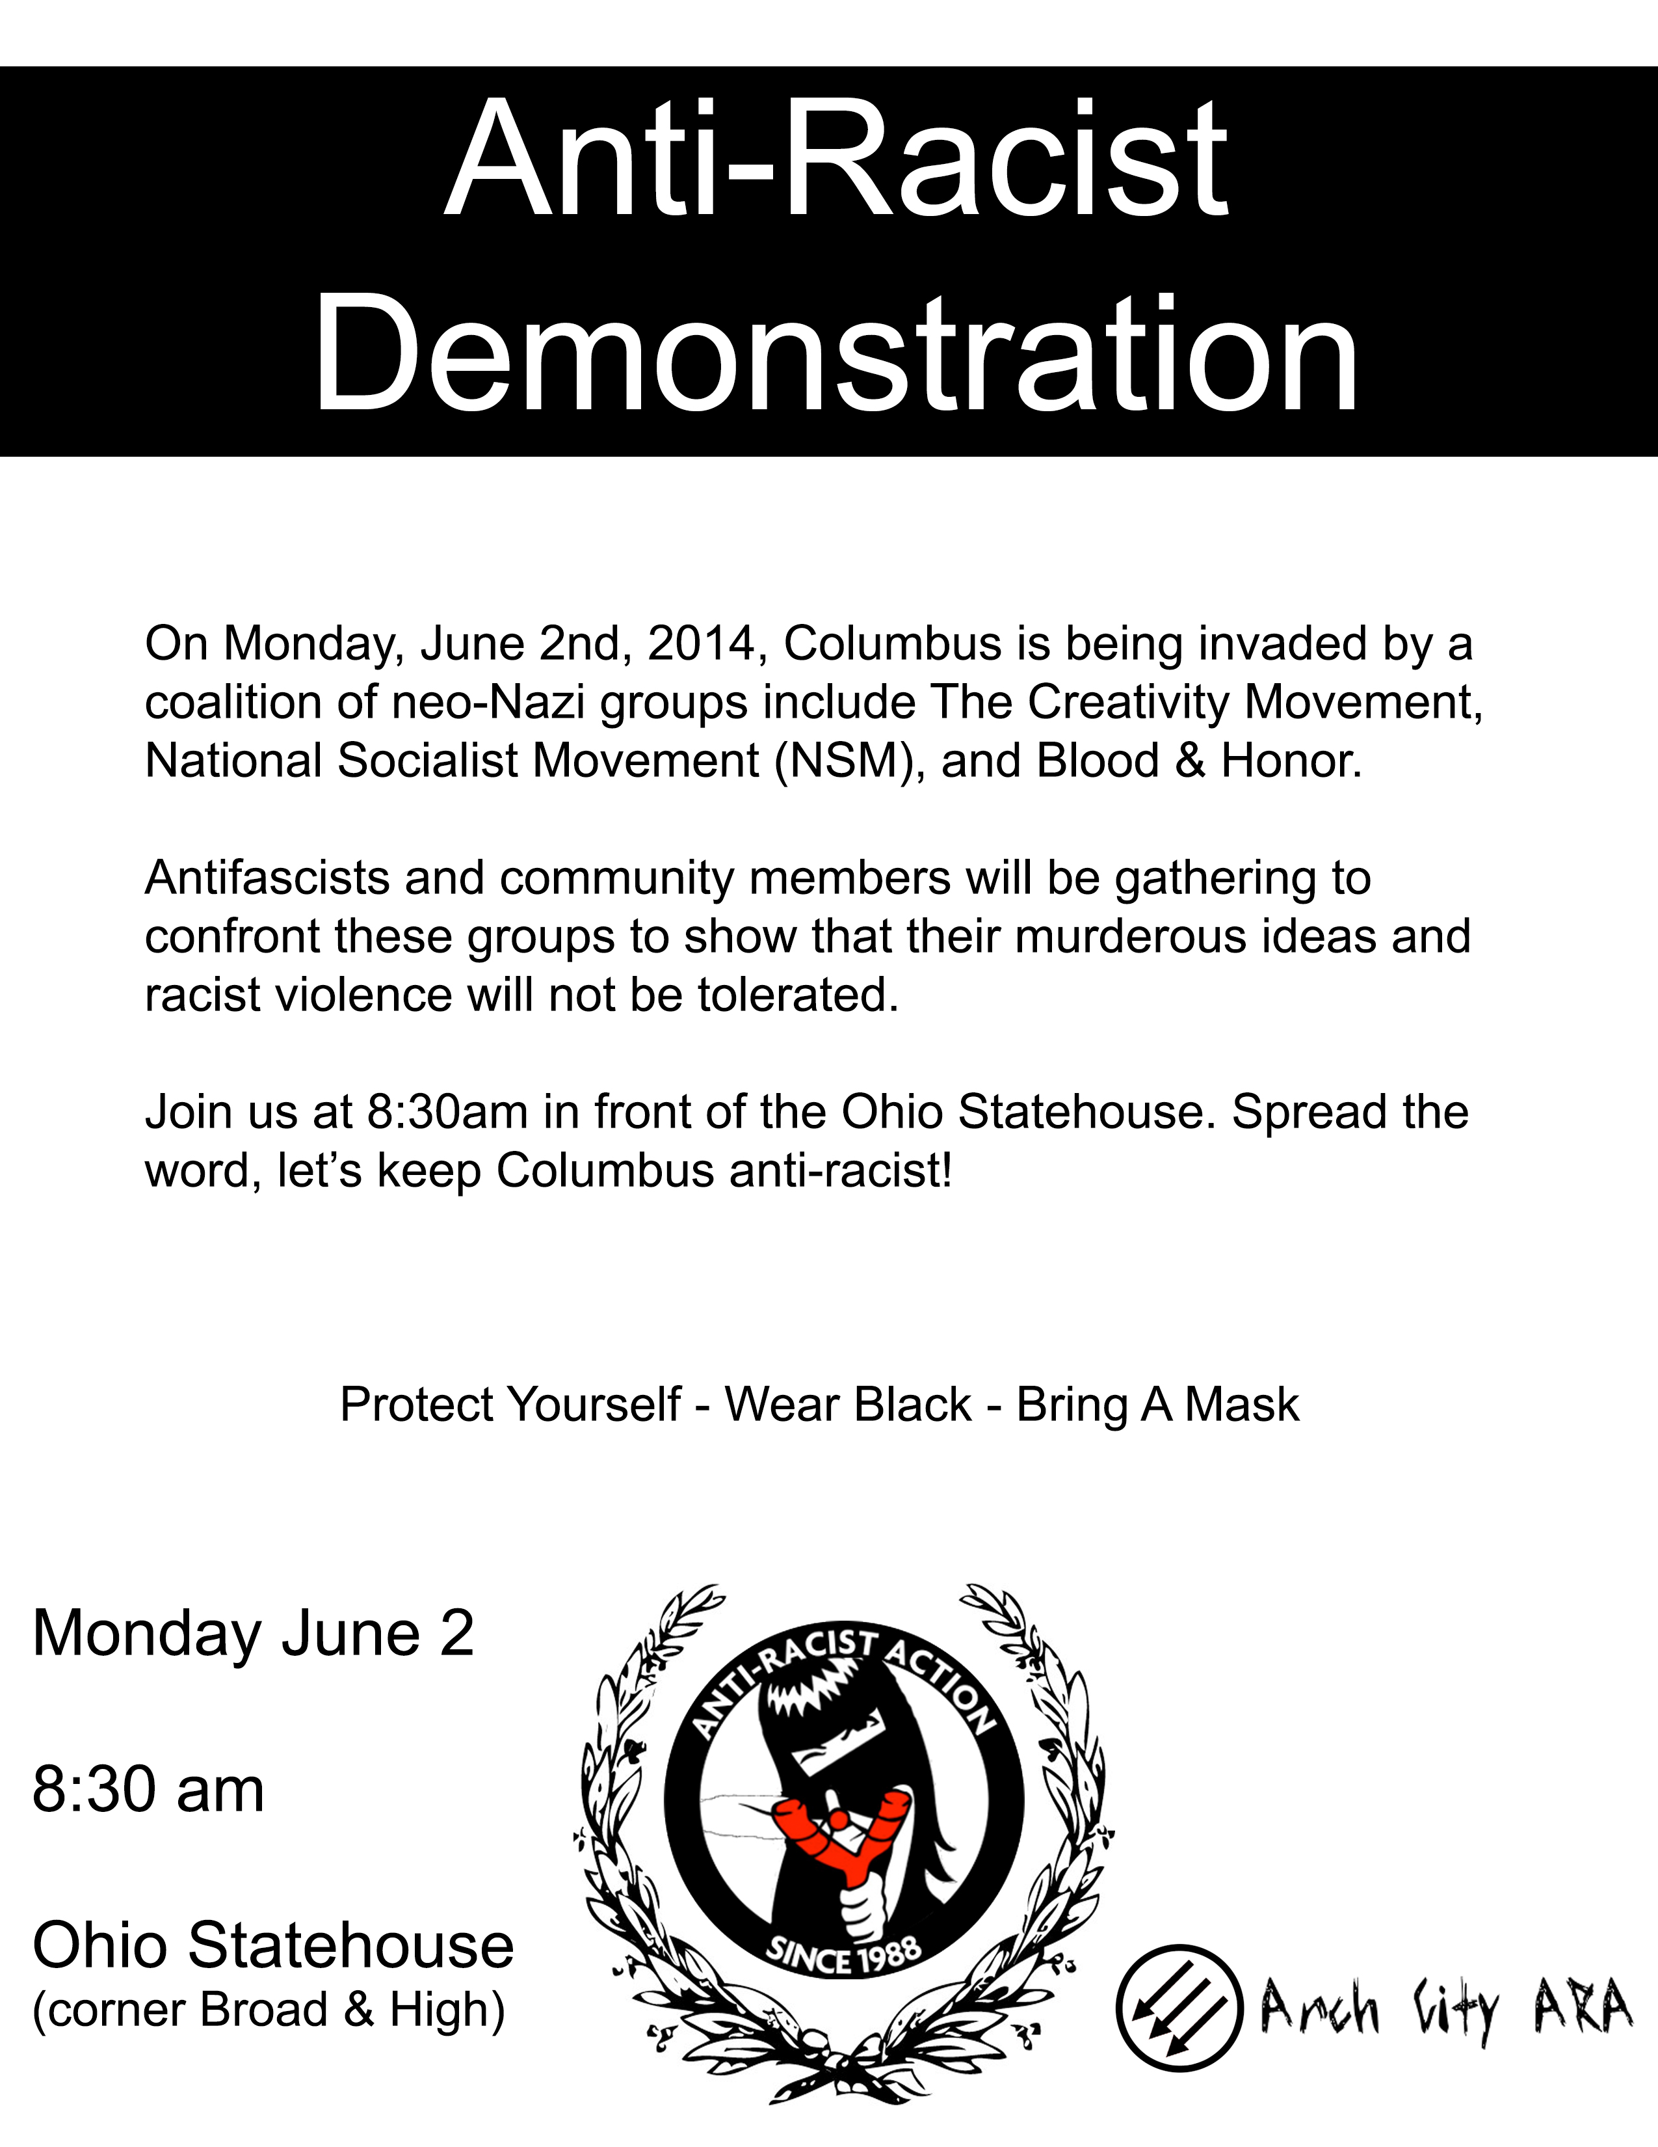
Appendix III
Interview Summaries
Interview with “Frank Smith”
08/24/17 @ 1:20-1:30
Prior to this interview, Frank Smith posted that my wife was “married 2 a nazi & is racist” and proceeded to call me a Nazi, Racist & Bigot. He used a likely false, online texting mechanism to set up a meeting at Purdue Memorial Union. Not much obtained from this interview, except F.S. stated interviewer was not ready and was still too closely tied to “the hegemony”. F.S. obliged with taking down posts related to author and family though.

1 Quote by Benito Mussolini, from The Doctrine of Fascism, 1932.
2 Quote by Benito Mussolini, from Denis Mack Smith's Mussolini: A Biography, 1983, pg. 8.
3 Quote from Jonah Goldberg's Liberal Facism, page 31.
4 Quote by Benito Mussolini. Cited in David Kertzer (2014)'s The Pope & Mussolini.
5 Statistic obtained from David Kertzer's The Pope & the Dictator (2014), pg 24.
6 David Kertzer's The Pope and the Dictator, page 25.
7 David Kertzer's The Pope and the Dictator, page 27.
8 Quote by Gaectano Salvemini, from Stephan Corrado Azzi's “The Histiography of Fascist Foreign Policy”. The Historical Journal, 36(1), March 1993.
9 Jonah Golderg's Liberal Fascism, pg 53.
1 0 Both quotes obtained from a secondary source: Jonah Goldberg's Liberal Fascism. The source materials utilized by Goldberg were reviewed for historical accuracy and may be obtained from pages 54 and 56 of aforementioned book.
1 1 Page 72 for first quote and page 74 for second quote of aforementioned book.
1 2 Mentioned on pge 62 of Jonah Goldberg's Liberal Fascism.
1 3 Pg 61 of William Shirer's The Rise and Fall of the Third Reich.
1 4 Specific historical information obtained from William Shrier's The Rise and Fall of the Third Reich, pgs 68 – 79.
1 5 Information in this paragraph obtained from Mein Kampf by Adolf Hitler and pg 110-121 in William Shrier's The Rise and Fall of the Third Reich.
1 6 Voting totals obtained from a secondary resource, William Shirer's The Rise and Fall of the Third Reich.
1 7 Pages 166 and 167 of William Shirer's The Rise and Fall of the Third Reich.
1 8 Discussed in Mein Kampf by Adolf Hitler.
1 9 All quoted points from the Nazi Party Platform were obtained from The History Place. “25 Points of Hitler's Nazi Party”. Accessed August 7, 2017, from http://www.historyplace.com/worldwar2/riseofhitler/25points.htm and subsequently verified through reading of Adolf Hitler's Mein Kampf, as well as William Shirer's The Rise and Fall of the Third Reich.
2 0 Page 29 in Stephen Halbrook's Gun Control in the Third Reich. Information verified in other materials as well, including Peter Hayes's From Cooperation to Complicity, Adolf Hitler's Mein Kampf, and William Shirer's The Rise and Fall of the Third Reich.
2 1 Data obtained from Anderson's The Spanish Civil War, and verified through two other references, Hochschild's Spain in Our Hearts and Beevor's The Battle for Spain.
2 1 Traditional political party information obtained from Beevor's The Spanish Civil War (in front of book) and BBC's documentary, The Spanish Civil War, a six part TV series released in 1983.
2 1 From page 190 of Robert Griffin's book entitled Fascism, published in 1995 by Oxford University press.
2 3 These groups are in order from most-to-least radical, by comparison to the 1930s Republican government and typical Republican (progressive liberal) policy
2 4 Republican in Spanish politics, specially in the 1930s, is more analogous with the U.S. Democratic Party, at least the Progressive, Socially liberal wing of the Democratic Party. Franklin D. Roosevelt is an example of an American politician with a platform and policies congruent with the Republicans of the Kingdom of Spain.
2 5 Soft euroscepticism refers to a position of opposing specific European Union policies and/or hold a belief that the European Union has overreached its authority. Soft eurosceptics do not necessarily desire an abolition of the European Union, but advocate for more localized, less centralized political power.
2 6 Obtained from the http://www.freewebs.com/nsafp/faq.htm
2 7 Included in Klassen's Nature's Eternal Religion on page 261.
2 8 Included in Klassen's Nature's Eternal Religion on page 262.
2 9 See Appendix 3 – 1.B – For event flyer.

