Traffic Sign Recognition using CNN
AI/ML Specialisation Capstone – Project 6 Report
Domain: Autonomous Mobility / Computer Vision • Dataset: German Traffic Sign Recognition Benchmark (GTSRB)
Submitted by
Aman Sah
Individual Project

Contents
1. Executive Summary
2. Problem Statement and Scope
3. Dataset and Data Access
4. Exploratory Data Analysis
5. Preprocessing and Data Splits
6. Models
7. Experiment Tracking and Hyperparameter Tuning
8. Evaluation on the Held-Out Test Set
9. Error Analysis and Robustness
10. Deployment Prototype
11. Usability for the Target Context
12. Success Criteria Assessment
13. Limitations, Risks and Responsible Use
14. Future Work
Appendix A – Per-Class Metrics
Appendix B – Reproducibility

1. Executive Summary
This individual project builds an end-to-end traffic-sign classification pipeline on the official GTSRB benchmark (51,839 images, 43 classes): reproducible data download, validation, EDA, leakage-safe splitting, a custom CNN baseline, a MobileNetV2 transfer-learning model, a hyperparameter sweep, held-out evaluation with error and robustness analysis, model compression, and a Streamlit upload-and-predict prototype.
Key results
- Final model: custom CNN (333K parameters) – test accuracy 98.42%, macro F1 0.976, top-5 accuracy 99.93% on the 12,630-image official test set.
- Fast and small: 9.0 ms per image on CPU; quantised TFLite model is 0.36 MB with no accuracy loss on a 1,000-image check.
- MobileNetV2 transfer learning underperformed (accuracy 88.96%, macro F1 0.854) – ImageNet features transfer poorly to tiny 64×64 sign crops and only the top 40 layers were fine-tuned. Diagnosis and fix are documented (Sections 6, 14).
- Weakest classes: Double curve (recall 0.73) and Bumpy road (0.75); most frequent confusion: Keep right → Roundabout mandatory (32 images).
- Main risk: accuracy collapses to 54.5% under Gaussian sensor noise (σ = 25), and some errors are made with ~100% confidence.
- The Streamlit prototype loads the saved model without retraining and was smoke-tested on three correct samples and one known failure.

2. Problem Statement and Scope
Traffic sign recognition is a core perception task in driver-assistance (ADAS) and autonomous-mobility systems. The task is formulated as 43-class image classification: given a cropped image of a single traffic sign, predict its category.
Objective: build a robust traffic-sign image classifier and deploy a prototype where users upload a sign image and receive the predicted class.
Target users: computer-vision learners, smart-mobility teams, ADAS prototyping teams and road-safety analysts.
In scope | Out of scope
GTSRB images and class labels | Real-time video processing
Baseline CNN and transfer-learning model | Detecting signs in full street scenes
Class imbalance handling and augmentation | Production-grade autonomous driving use
Per-class evaluation; upload-based prediction interface

Evaluation metrics (per problem statement): accuracy, macro F1-score, per-class recall, confusion matrix, top-k accuracy and inference time. Macro F1 is treated as the primary selection metric because it weights every class equally despite the 10.7× class imbalance.

3. Dataset and Data Access
Field | Details
Dataset | German Traffic Sign Recognition Benchmark (GTSRB)
Source | https://benchmark.ini.rub.de/gtsrb_dataset.html (archives hosted at sid.erda.dk)
Files used | GTSRB_Final_Training_Images.zip, GTSRB_Final_Test_Images.zip, GTSRB_Final_Test_GT.zip
Training set | 39,209 images in 43 class folders, 1,307 physical-sign tracks (≈30 frames each)
Test set | 12,630 images with ground-truth labels (official held-out set)
Annotations | Per-image CSV: filename, width, height, sign ROI (X1, Y1, X2, Y2), ClassId

The notebook downloads and extracts the archives automatically (skipping files already present), builds a dataframe of image paths and labels, and validates that all 43 class IDs are present, labels are in range, and no files are missing (0 missing).

4. Exploratory Data Analysis
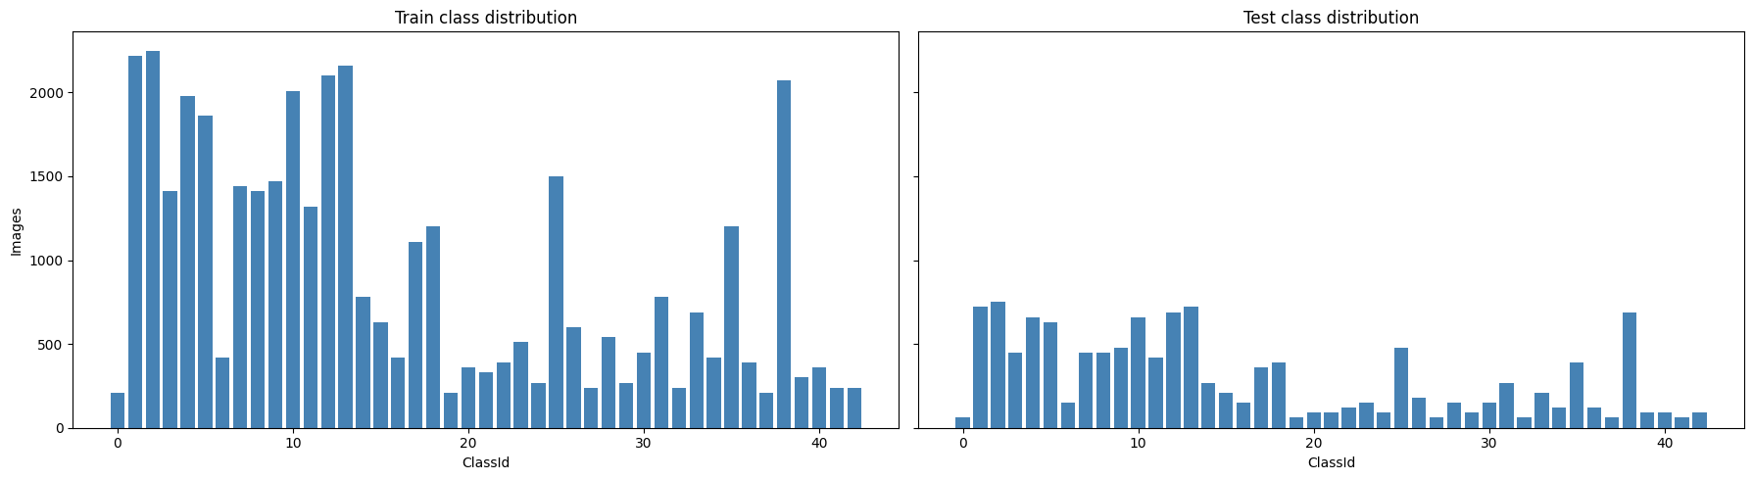
Figure 1: Class distribution of the training (left) and test (right) sets.
The training set is strongly imbalanced: the largest class, Speed limit (50 km/h), has 2,250 images while the smallest classes have only 210 – an imbalance ratio of 10.7×. The test set follows the same distribution, so headline accuracy alone would hide poor performance on rare classes; this motivates macro F1, per-class recall and class weighting.
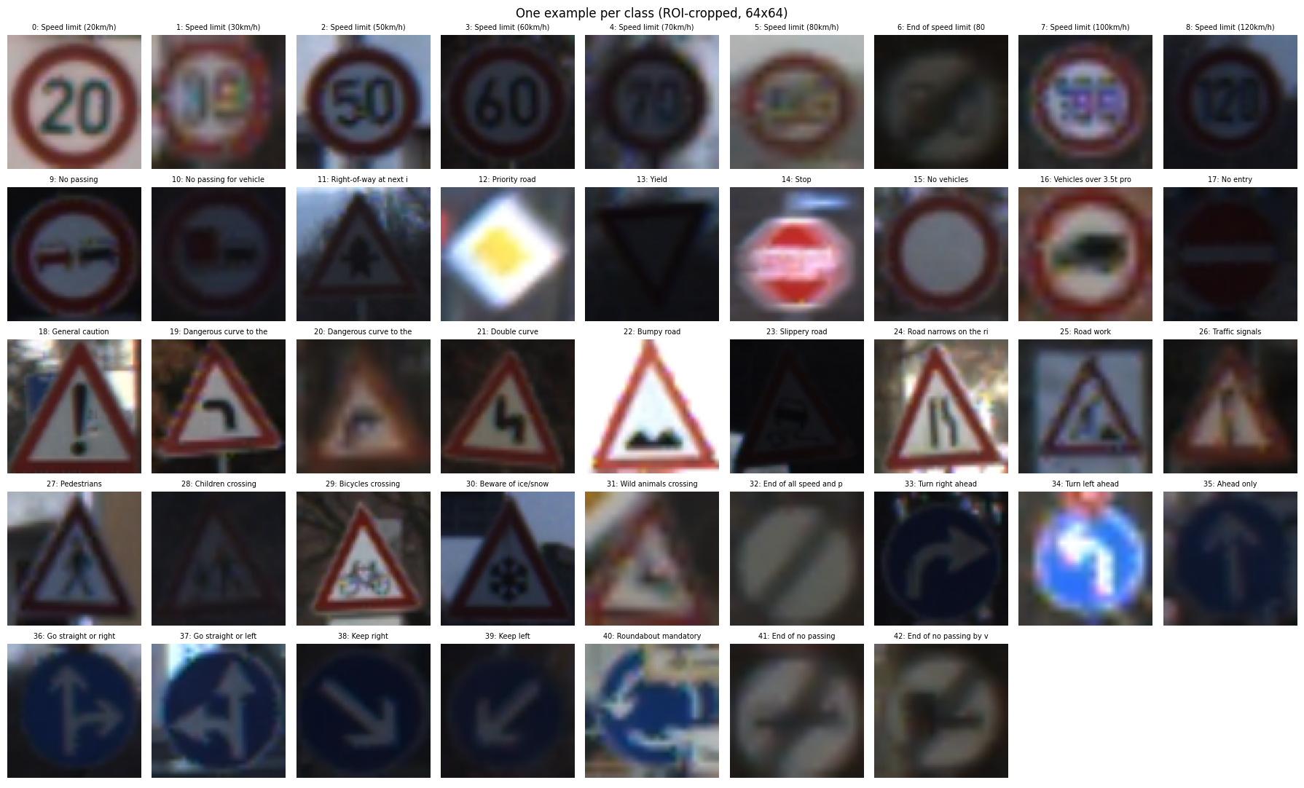
Figure 2: One ROI-cropped 64×64 example from each of the 43 classes.
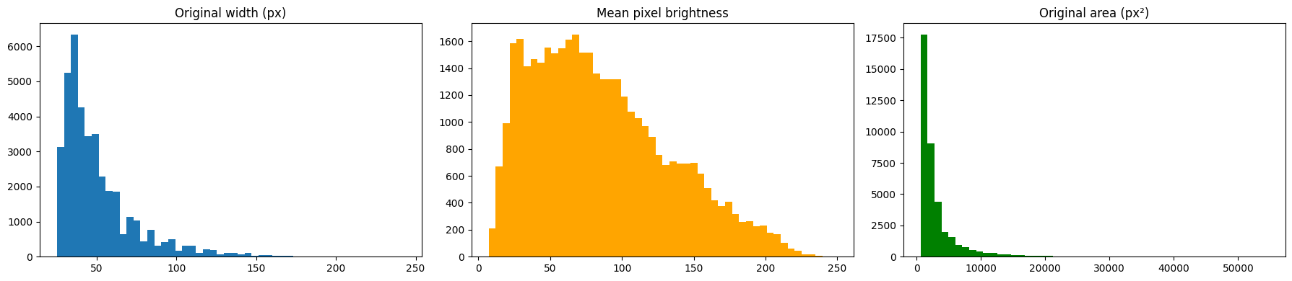
Figure 3: Original image width, mean pixel brightness and original image area.
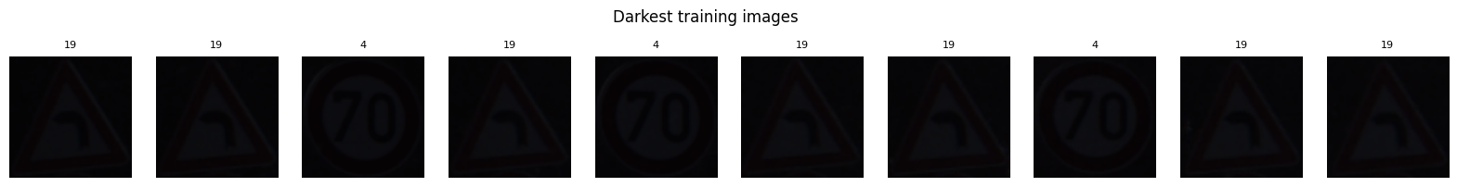
Figure 4: The ten darkest training images (labels shown above each image).
EDA observations
- Original images range from 25 to 243 px wide (mean ≈ 51 px); 3,121 images (8%) are narrower than 30 px, so many signs are small and blurry.
- Lighting varies widely: 10,657 images (27%) have mean brightness below 50/255 – many are very dark.
- Images come in tracks of ~30 near-identical frames of the same physical sign, so random splitting would leak near-duplicates into validation.
- Several classes are mirror images of each other (e.g. Turn left / Turn right ahead, Keep left / Keep right), so horizontal flips must not be used for augmentation.

5. Preprocessing and Data Splits
- ROI cropping and resizing: each image is cropped to its annotated sign ROI and resized to 64×64 RGB (bilinear).
- Normalisation inside the model: a Rescaling layer is part of each model, so the saved artifact accepts raw 0–255 pixels and training/serving preprocessing cannot drift apart.
- Leakage-safe split: train/validation is split with StratifiedGroupKFold (5 folds, groups = track ID), taking the first fold whose validation part contains every class. No track appears in both sets, and every class – including the rarest – has at least 30 validation images.
- Class imbalance: balanced class weights (range 0.41 – 4.86) are applied in the loss.
- Augmentation (training only, no flips): random rotation (±~14°), translation (10%), zoom (15%), contrast (30%) and brightness (30%).
Split | Images | Notes
Train | 31,349 | ≈80% of official training data
Validation | 7,860 | ≈20%, grouped by track, all 43 classes present
Test | 12,630 | Official GTSRB test set – used only for final evaluation

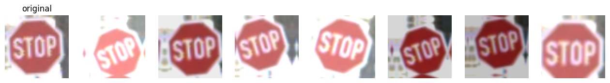
Figure 5: Augmentation examples for a Stop sign (original on the left).

6. Models

6.1 Baseline – custom CNN
Three convolutional blocks of [Conv 3×3 → BatchNorm → Conv 3×3 → BatchNorm → MaxPool → Dropout 0.3] with 32, 64 and 128 filters, followed by global average pooling, a 256-unit dense layer with dropout 0.5, and a 43-way softmax. 332,875 parameters. Trained with Adam (lr 1e-3), batch 128, up to 25 epochs, ReduceLROnPlateau (×0.5, patience 2) and early stopping (patience 5, best weights restored).
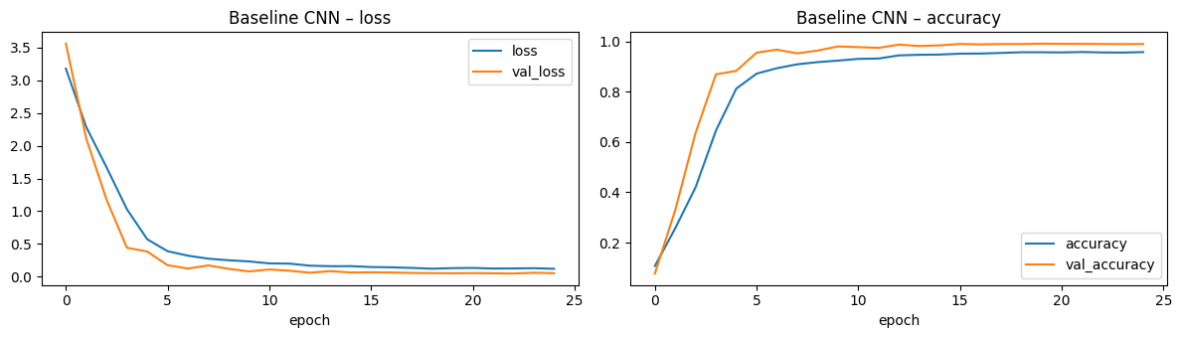
Figure 6: Baseline CNN training curves (training accuracy is lower than validation because training images are augmented).
The baseline trained for all 25 epochs (~28 minutes on CPU). The learning rate was halved three times and validation loss kept decreasing to ≈0.05, with no sign of overfitting. Best validation: accuracy 99.01%, macro F1 0.986.

6.2 Advanced – MobileNetV2 transfer learning
ImageNet-pretrained MobileNetV2 (chosen for its suitability for edge/ADAS hardware). The 64×64 input is upsampled to 96×96 and scaled to [-1, 1] inside the model, followed by global average pooling, dropout 0.3 and a 43-way softmax (2,313,067 parameters). Training used two phases: (1) backbone frozen, head trained for 10 epochs at lr 1e-3; (2) top 40 backbone layers unfrozen (BatchNorm kept frozen) and fine-tuned at lr 1e-4 for up to 20 epochs.
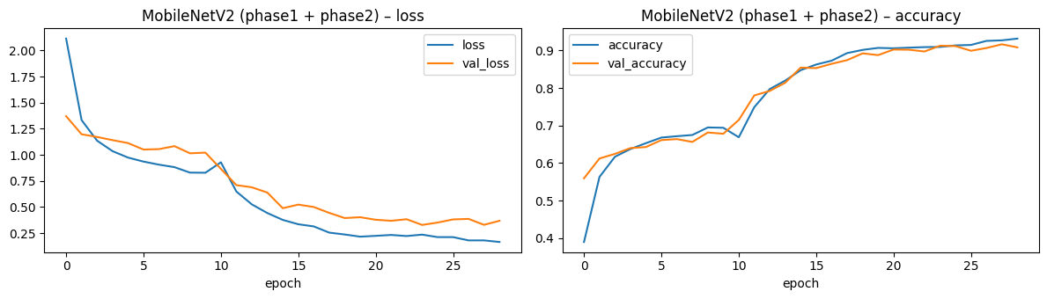
Figure 7: MobileNetV2 training curves (phase 1: epochs 0–9 frozen backbone; phase 2: epochs 10–28 fine-tuning).
Why the transfer model underperformed
- With the backbone frozen, validation accuracy plateaued at ≈68%: ImageNet features computed on tiny, upsampled 64 px sign crops do not separate the 43 classes well.
- Fine-tuning the top 40 layers lifted validation accuracy to ≈91%, but the learning rate decayed quickly (1e-4 → 1.25e-5) and early stopping ended phase 2 after 19 epochs.
- Most of the backbone (early, low-level filters) stayed frozen at ImageNet values, which limits adaptation to low-resolution sign imagery.
- Fix (not yet run): fine-tune the entire backbone (BatchNorm in inference mode) at lr ≈ 1e-4 – 3e-4 for more epochs, optionally at 128×128 input.

7. Experiment Tracking and Hyperparameter Tuning
Every run logs its configuration, parameter count, training time and best validation metrics to artifacts/experiments.csv, and per-epoch curves to artifacts/trainlog_<run>.csv. A time-boxed sweep (8 epochs per run) varied learning rate and dropout and ablated augmentation and class weights on the custom CNN.
Run | LR | Dropout | Augment | Class wt. | Val acc | Val macro F1 | Val top-5
Baseline CNN (25 ep) | 0.001 | 0.3 | yes | yes | 0.9901 | 0.9855 | 0.9962
sweep_5 (8 ep) | 0.001 | 0.3 | no | yes | 0.9855 | 0.9814 | 0.9957
sweep_6 (8 ep) | 0.001 | 0.3 | yes | no | 0.9865 | 0.9810 | 0.9981
sweep_3 (8 ep) | 0.001 | 0.1 | yes | yes | 0.9796 | 0.9774 | 0.9967
sweep_0 (8 ep) | 0.001 | 0.3 | yes | yes | 0.9613 | 0.9503 | 0.9905
sweep_2 (8 ep) | 0.003 | 0.3 | yes | yes | 0.9481 | 0.9452 | 0.9950
sweep_1 (8 ep) | 0.0003 | 0.3 | yes | yes | 0.9295 | 0.9290 | 0.9954
sweep_4 (8 ep) | 0.001 | 0.5 | yes | yes | 0.9413 | 0.9277 | 0.9917
MobileNetV2 (10+19 ep) | 1e-3 -> 1e-4 | 0.3 | yes | yes | 0.9128 | 0.8928 | 0.9882

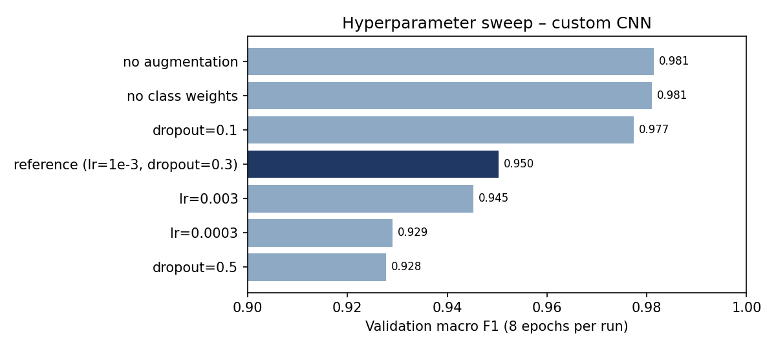
Figure 8: Validation macro F1 of the 8-epoch sweep runs (dark bar = reference configuration).
Interpretation
- Learning rate 1e-3 was the best of {3e-4, 1e-3, 3e-3} within the 8-epoch budget; both the lower and higher rates scored lower.
- Dropout 0.1 scored higher than 0.3 and 0.5 at 8 epochs – heavier regularisation slows convergence in a short budget.
- At 8 epochs, runs without augmentation or class weights scored slightly higher than the reference. This reflects slower convergence of the harder, augmented/re-weighted objective, not evidence that these techniques hurt; full-length runs are needed to measure their benefit.
- All runs use a single seed, so differences of ~0.5 F1 points are within run-to-run noise. Wall-clock training time for two sweep runs was inflated by a system sleep and is not reported here.
- Final model selection used validation macro F1 (Baseline CNN 0.986 vs MobileNetV2 0.893), never the test set.

8. Evaluation on the Held-Out Test Set
Model | Accuracy | Macro F1 | Top-5 acc. | Latency (ms/img, CPU) | Parameters
Baseline CNN (selected) | 98.42% | 0.976 | 99.93% | 9.0 | 332,875
MobileNetV2 (fine-tuned) | 88.96% | 0.854 | 99.01% | 28.6 | 2,313,067

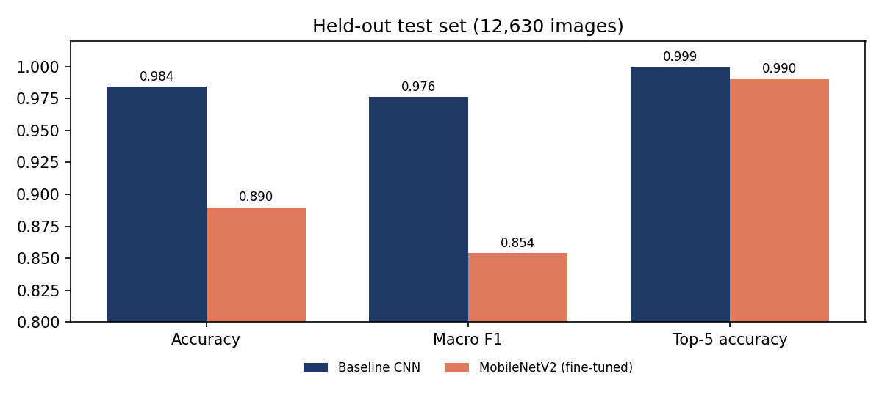
Figure 9: Test-set comparison of the two models.
The selected baseline achieves macro precision 0.976, macro recall 0.978 and macro F1 0.976 across the 43 classes (full per-class table in Appendix A). Latency was measured as single-image inference on an Apple M5 Pro CPU (100 images after warm-up).
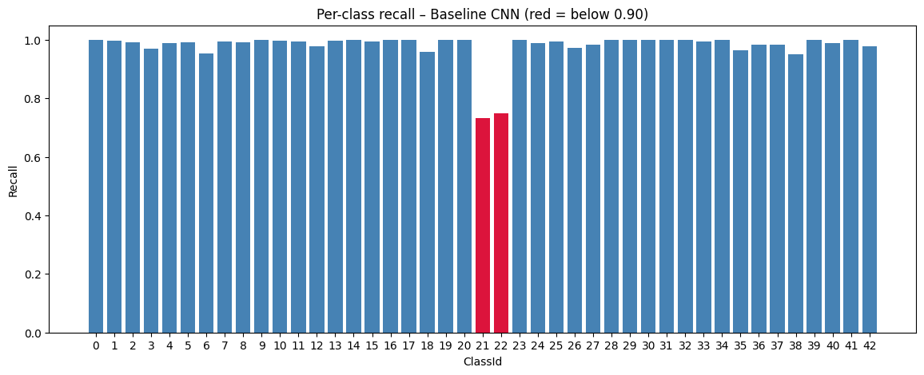
Figure 10: Per-class recall of the selected model (red bars are below 0.90).
Class | Precision | Recall | F1 | Support
21: Double curve | 0.868 | 0.733 | 0.795 | 90
22: Bumpy road | 0.957 | 0.750 | 0.841 | 120
38: Keep right | 0.995 | 0.951 | 0.973 | 690
6: End of speed limit (80km/h) | 1.000 | 0.953 | 0.976 | 150
18: General caution | 0.989 | 0.959 | 0.974 | 390
35: Ahead only | 0.997 | 0.964 | 0.980 | 390

Six lowest-recall classes. Low precision is concentrated in Roundabout mandatory (0.706), Double curve (0.868), End of no passing by vehicles over 3.5t (0.926) and Road work (0.937) – these classes absorb errors from visually similar signs.
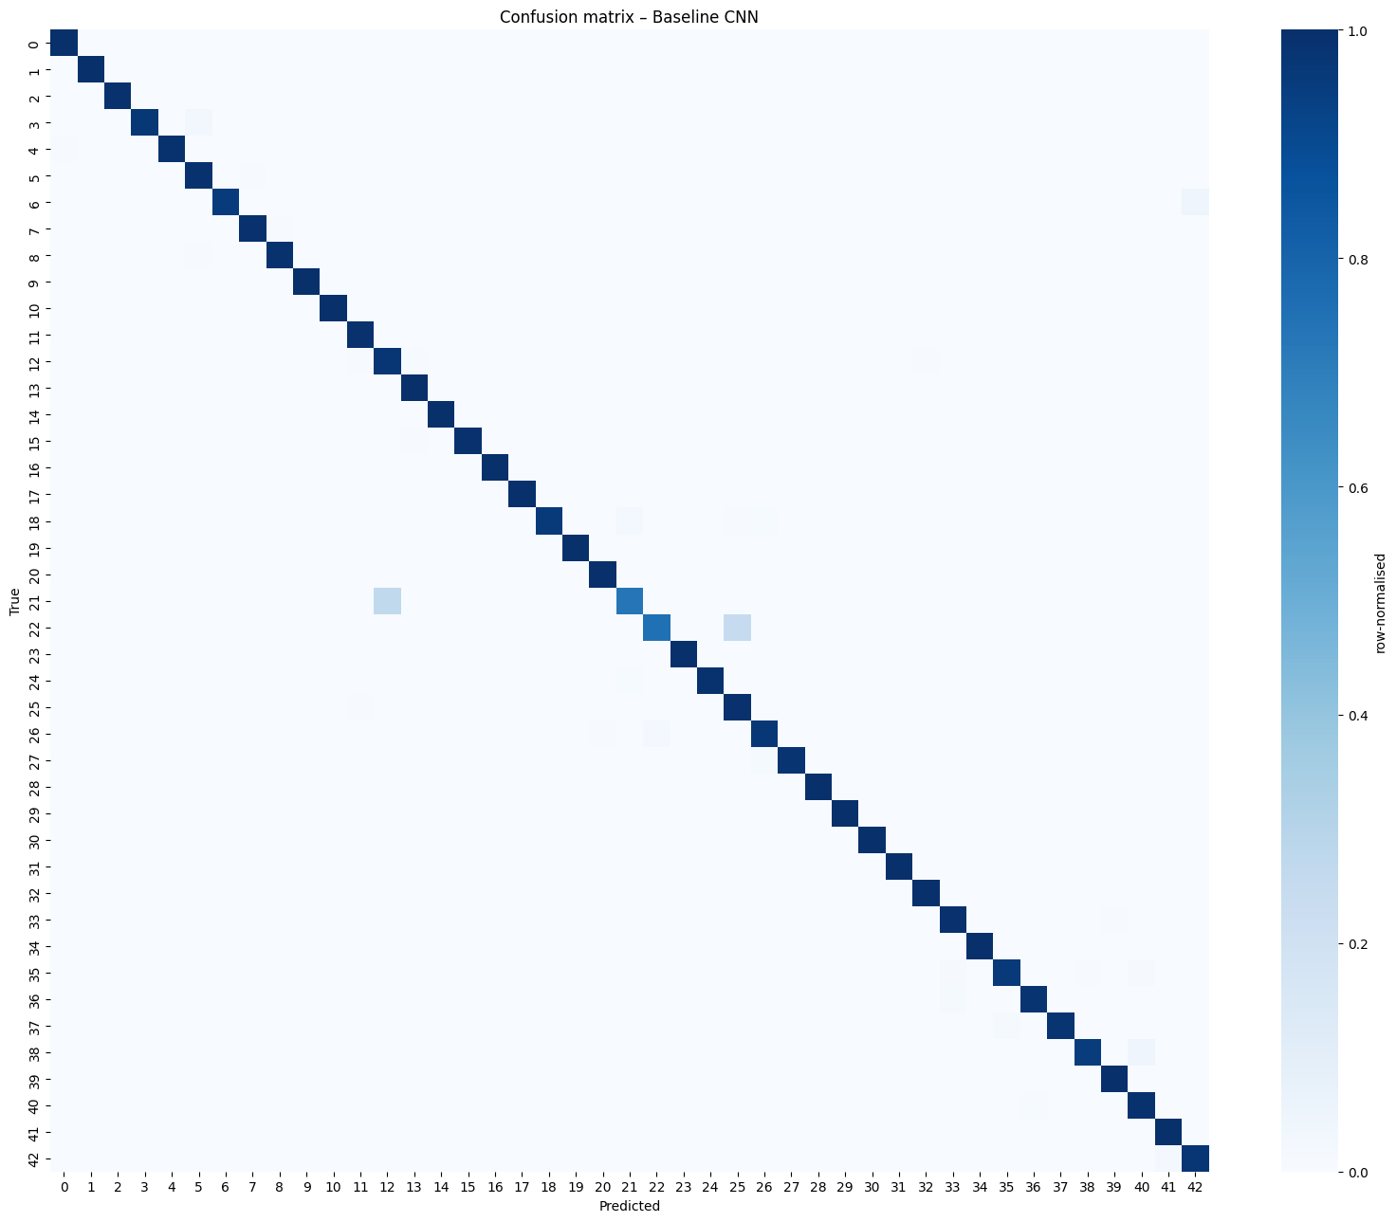
Figure 11: Row-normalised confusion matrix of the selected model on the test set.
Count | True class | Predicted as
32 | Keep right | Roundabout mandatory
30 | Bumpy road | Road work
24 | Double curve | Priority road
13 | Speed limit (60km/h) | Speed limit (80km/h)
9 | General caution | Double curve
7 | Priority road | Yield
7 | End of speed limit (80km/h) | End of no passing by vehicles over 3.5t
6 | Ahead only | Turn right ahead
5 | Ahead only | Roundabout mandatory
5 | Priority road | Right-of-way at next intersection

Ten most frequent confusions. Most are between signs that share shape and colour and differ only in a small inner pictogram (Bumpy road vs Road work, General caution vs Double curve) or arrow layout (Keep right vs Roundabout mandatory). The Double curve → Priority road confusion (24 images) is between dissimilar shapes and should be inspected for image-quality or labelling issues.

9. Error Analysis and Robustness
199 errors out of 12630 (1.58%) – mean confidence on errors 0.78 vs correct 0.99. Errors are generally made with lower confidence, so a confidence threshold is a useful safeguard – but some mistakes are made with near-100% confidence (below).
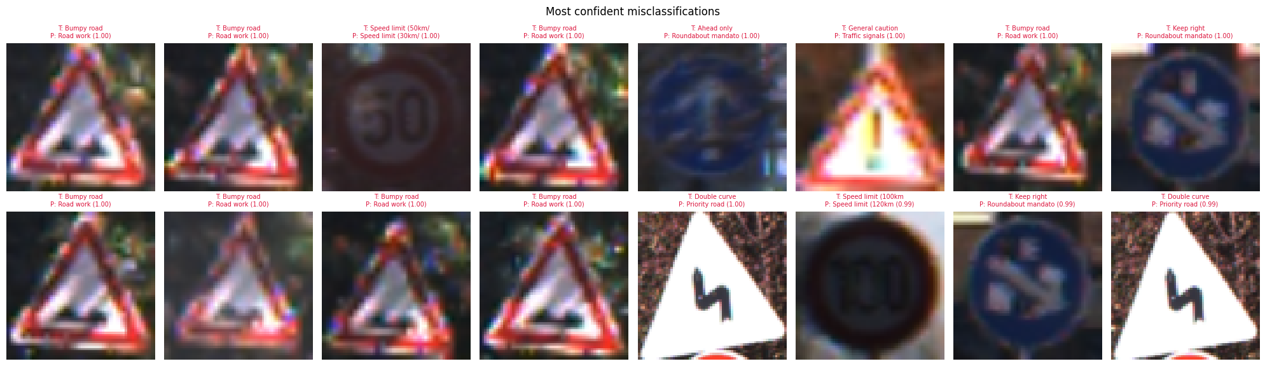
Figure 12: The 16 most confident misclassifications (T = true class, P = predicted class and confidence).
Original width (px) | Accuracy | Images
<30 | 97.48% | 1626
30-45 | 98.78% | 5470
45-60 | 98.95% | 2773
>60 | 97.75% | 2761

Brightness quartile | Accuracy | Images
darkest | 99.21% | 3158
dark | 98.32% | 3157
bright | 98.23% | 3157
brightest | 97.94% | 3158

Accuracy is lowest for the smallest signs (<30 px: 97.5%) as expected. Interestingly the darkest quartile is the most accurate (99.2%), suggesting brightness augmentation and the abundance of dark training images handle low light well; the brightest images are slightly harder, possibly because over-exposure washes out the inner pictogram.
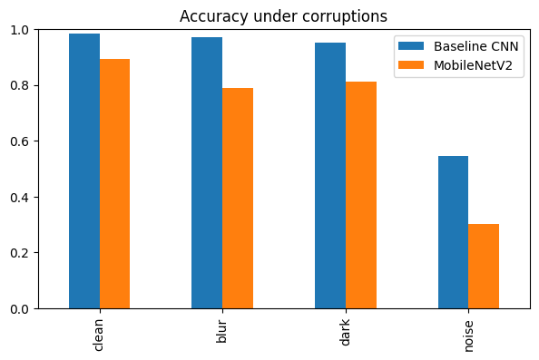
Figure 13: Accuracy on 3,000 test images under synthetic corruptions.
Condition | Baseline CNN | MobileNetV2
clean | 98.33% | 89.17%
blur | 97.00% | 78.87%
dark | 95.23% | 81.07%
noise | 54.53% | 30.30%

Corruptions: Gaussian blur (radius 2), darkening (×0.35), additive Gaussian noise (σ = 25). The baseline is fairly robust to blur and darkness (1.3 and 3.1 points drop) but accuracy collapses to 54.5% under sensor noise – noise was not part of the augmentation pipeline. This is the single most important robustness gap for real-camera use (Section 14).

10. Deployment Prototype
- Model artifact: artifacts/traffic_sign_model.keras (4.1 MB) plus artifacts/meta.json (class names, input size, model name).
- Compression: artifacts/traffic_sign_model.tflite with dynamic-range quantisation – 0.36 MB; accuracy on 1,000 test images 0.9890 (Keras model: 0.9890).
- Streamlit app (app.py): loads the saved artifact once (no retraining), accepts PNG/JPG/PPM uploads, resizes to 64×64, and shows the top prediction with confidence, a top-5 bar chart, and a warning when confidence is below 60%.
- Verified: the app was started headless and its health endpoint responded; the app's prediction path was run on the demo images below.
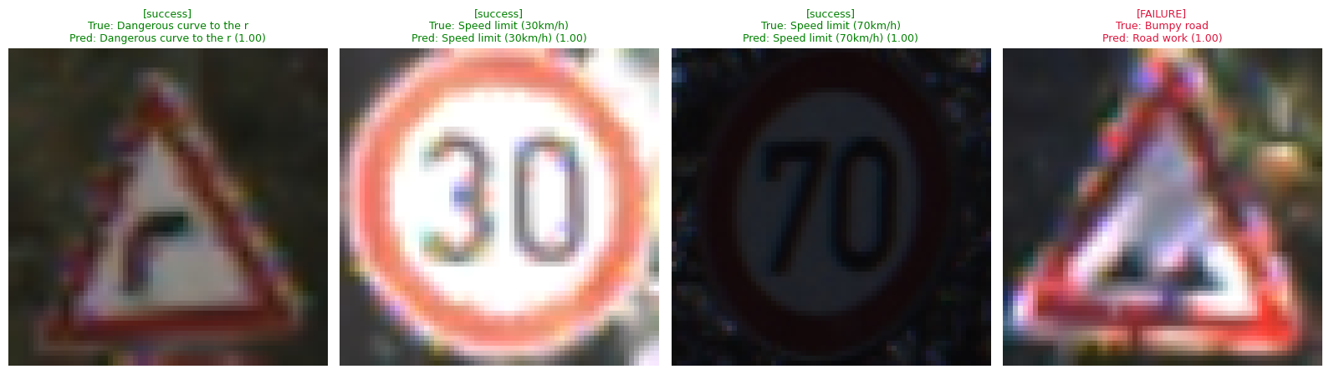
Figure 14: Demo: three correct predictions and one known failure (Bumpy road predicted as Road work with ~100% confidence).
How to run (from the project folder):
https://github.com/know-aman/traffic-sign-recognization
python -m venv .venv && source .venv/bin/activate
pip install -r requirements.txt
streamlit run app.py

The known failure illustrates the limitation of a confidence threshold: the model is certain but wrong, because Bumpy road and Road work share the red triangle and differ only in a small, blurry pictogram.

11. Usability for the Target Context
For the stated users – learners, ADAS prototyping teams and road-safety analysts working with cropped sign images – the model is usable:
- High and balanced accuracy (98.42% accuracy, 0.976 macro F1; 38 of 43 classes have recall ≥ 0.96).
- Low cost: 9 ms per image on a laptop CPU and a 0.36 MB quantised model, suitable for edge experimentation.
- Transparent behaviour: per-class metrics, confusion pairs and failure examples tell users exactly where not to trust it.
It is not suitable for in-vehicle decision-making: it assumes a pre-cropped sign, is fragile to sensor noise, can be confidently wrong, and was evaluated only on German signs from a curated benchmark.

12. Success Criteria Assessment
Success criterion (problem statement §13) | Status | Evidence
Dataset accessed from a documented public source and loaded reproducibly | Met | Official GTSRB archives downloaded by the notebook; validation checks pass
Meaningful baseline and an improved advanced model | Partially met | Strong baseline (macro F1 0.976); MobileNetV2 underperformed (0.854) – diagnosed, fix planned
Evaluation metrics appropriate and interpreted correctly | Met | Accuracy, macro F1, per-class recall, confusion matrix, top-5, latency
Deployed prototype works on new sample inputs | Met | Streamlit app loads saved artifact; demo predictions verified
Technical results connected to user/business value | Met | Section 11
Limitations, risks and responsible use stated honestly | Met | Sections 9 and 13

Deployment expectation (§10) | Status
Loads the trained model artifact without retraining | Met
Accepts user input in the expected format and returns clear output | Met (image upload → class, confidence, top-5)
Demo includes ≥3 sample predictions and one known failure case | Met (Figure in Section 10)
README with setup steps, dependencies and run instructions | Met (README.md, requirements.txt)

13. Limitations, Risks and Responsible Use
Risk | Observed evidence | Mitigation
Small or blurry signs misclassified | <30 px signs: 97.5% vs 99.0% for 45–60 px; blur costs 1.3 points | Zoom/blur augmentation; confidence warning in app; collect more small-sign data
Class imbalance hurts rare classes | Double curve (90 test images) recall 0.73; Bumpy road (120) recall 0.75 | Class weights and augmentation applied; targeted augmentation/oversampling of weak classes
Controlled dataset ≠ live road scenes | Noise σ=25 drops accuracy to 54.5%; pre-cropped German signs only | Add noise/JPEG/weather augmentation; evaluate on real dash-cam crops; add a detection stage
Confidently wrong predictions | Most confident errors at ~1.00 confidence (Figure 12) | Calibration (temperature scaling), out-of-distribution rejection, human review
Responsible use | Prototype trained on a public benchmark | Clearly labelled as educational; not a safety-certified autonomous-driving component

14. Future Work
- Fix the transfer model: fine-tune the full MobileNetV2 backbone with a higher learning rate and more epochs (optionally 128×128 input), and compare EfficientNet-B0, to test whether a pretrained backbone can match or beat the custom CNN.
- Noise robustness: add Gaussian noise, JPEG compression, motion blur and weather augmentation; re-run the corruption benchmark.
- Full-length ablations with multiple seeds to quantify the real benefit of augmentation and class weights.
- Confidence calibration and OOD rejection so the app can say “not sure” instead of being confidently wrong.
- Detection + classification pipeline (e.g. YOLO on GTSDB) for full street scenes, plus temporal smoothing across video frames.
- Packaging: FastAPI endpoint and Docker image alongside the Streamlit demo; ONNX/TFLite benchmarks on edge hardware.

Appendix A – Per-Class Metrics (Baseline CNN, test set)
ID | Class | Precision | Recall | F1 | Support
0 | Speed limit (20km/h) | 0.923 | 1.000 | 0.960 | 60
1 | Speed limit (30km/h) | 0.997 | 0.997 | 0.997 | 720
2 | Speed limit (50km/h) | 0.997 | 0.993 | 0.995 | 750
3 | Speed limit (60km/h) | 0.998 | 0.971 | 0.984 | 450
4 | Speed limit (70km/h) | 0.998 | 0.989 | 0.994 | 660
5 | Speed limit (80km/h) | 0.974 | 0.992 | 0.983 | 630
6 | End of speed limit (80km/h) | 1.000 | 0.953 | 0.976 | 150
7 | Speed limit (100km/h) | 0.991 | 0.996 | 0.993 | 450
8 | Speed limit (120km/h) | 0.991 | 0.991 | 0.991 | 450
9 | No passing | 0.998 | 1.000 | 0.999 | 480
10 | No passing for vehicles over 3.5t | 1.000 | 0.998 | 0.999 | 660
11 | Right-of-way at next intersection | 0.984 | 0.995 | 0.989 | 420
12 | Priority road | 0.966 | 0.978 | 0.972 | 690
13 | Yield | 0.989 | 0.999 | 0.994 | 720
14 | Stop | 1.000 | 1.000 | 1.000 | 270
15 | No vehicles | 1.000 | 0.995 | 0.998 | 210
16 | Vehicles over 3.5t prohibited | 1.000 | 1.000 | 1.000 | 150
17 | No entry | 1.000 | 1.000 | 1.000 | 360
18 | General caution | 0.989 | 0.959 | 0.974 | 390
19 | Dangerous curve to the left | 1.000 | 1.000 | 1.000 | 60
20 | Dangerous curve to the right | 0.978 | 1.000 | 0.989 | 90
21 | Double curve | 0.868 | 0.733 | 0.795 | 90
22 | Bumpy road | 0.957 | 0.750 | 0.841 | 120
23 | Slippery road | 1.000 | 1.000 | 1.000 | 150
24 | Road narrows on the right | 1.000 | 0.989 | 0.994 | 90
25 | Road work | 0.937 | 0.996 | 0.966 | 480
26 | Traffic signals | 0.972 | 0.972 | 0.972 | 180
27 | Pedestrians | 0.983 | 0.983 | 0.983 | 60
28 | Children crossing | 1.000 | 1.000 | 1.000 | 150
29 | Bicycles crossing | 1.000 | 1.000 | 1.000 | 90
30 | Beware of ice/snow | 1.000 | 1.000 | 1.000 | 150
31 | Wild animals crossing | 1.000 | 1.000 | 1.000 | 270
32 | End of all speed and passing limits | 0.952 | 1.000 | 0.976 | 60
33 | Turn right ahead | 0.963 | 0.995 | 0.979 | 210
34 | Turn left ahead | 0.984 | 1.000 | 0.992 | 120
35 | Ahead only | 0.997 | 0.964 | 0.980 | 390
36 | Go straight or right | 0.992 | 0.983 | 0.987 | 120
37 | Go straight or left | 1.000 | 0.983 | 0.992 | 60
38 | Keep right | 0.995 | 0.951 | 0.973 | 690
39 | Keep left | 0.989 | 1.000 | 0.994 | 90
40 | Roundabout mandatory | 0.706 | 0.989 | 0.824 | 90
41 | End of no passing | 0.968 | 1.000 | 0.984 | 60
42 | End of no passing by vehicles over 3.5t | 0.926 | 0.978 | 0.951 | 90

Appendix B – Reproducibility
Item | Value
Notebook | Traffic_Sign_Recognition.ipynb (all cells executed, outputs saved)
Hardware | Apple M5 Pro (arm64), CPU only
Software | Python 3.9.6, TensorFlow 2.19.1, Keras 3.10.0, scikit-learn 1.6.1, NumPy 2.0.2, pandas 2.3.3, Streamlit 1.50.0
Random seed | 42 (Python, NumPy, TensorFlow)
Input size / batch | 64×64 RGB / 128
Artifacts | artifacts/: traffic_sign_model.keras, .tflite, meta.json, experiments.csv, test_summary.csv, trainlog_*.csv, confusion_matrix.png
Prototype files | app.py, README.md, requirements.txt, demo_samples/

Environment note: TensorFlow 2.20 aborts on import on macOS when pyarrow (a Streamlit/pandas dependency) is installed (TensorFlow issue #98563); TensorFlow 2.19.x was used. On macOS, pin tensorflow < 2.20.
Run note: total wall-clock time for the notebook was inflated by ~7 hours of system sleep during the hyperparameter sweep; sleep pauses but does not alter training, so results are unaffected.

