NET-METERING BILLING SYSTEM

NAME OF APPLICATION
Net-Metering Billing System (NMBS)

1.0 ABSTRACT
The Net-Metering Billing System is a comprehensive, enterprise-grade web-based application designed to automate and streamline the billing processes for net-metered electricity accounts. Built on Spring Boot 3.2.2 framework with Java 21, the system manages the complete lifecycle of billing operations including account registration, meter management, meter reading collection, bill generation, invoice issuance, and fiscal integration with regulatory bodies.
The NMBS supports multiple customer categories including domestic, commercial, and MD commercial accounts, enabling flexible tariff configurations and usage-based billing calculations. The system incorporates robust security mechanisms with role-based access control, comprehensive reporting capabilities, real-time financial management dashboards, and fiscal compliance features. Through its intuitive web interface and RESTful APIs, the system serves as a centralized platform for utility providers to efficiently manage net-metering accounts while maintaining data integrity and regulatory compliance.

2.0 INTRODUCTION

2.1 Background
Net metering is a billing mechanism that encourages consumers to invest in renewable energy by allowing them to export excess electricity generated back to the grid in exchange for credits. This requires sophisticated billing systems capable of tracking both import and export energy flows, calculating complex tariffs, and generating accurate invoices that reflect the net consumption or net export balance.

2.2 Purpose and Scope
The Net-Metering Billing System addresses the critical need for automated billing management in utility companies that operate net-metering programs. The system is designed to:
- Automate Account Management: Streamline the registration and maintenance of net-metering accounts
- Track Energy Flows: Monitor both energy imports and exports with precise measurement capabilities
- Calculate Dynamic Bills: Support complex billing scenarios based on predefined tariff structures
- Ensure Compliance: Integrate with fiscal authorities to ensure regulatory and tax compliance
- Provide Visibility: Offer real-time dashboards and detailed reporting for stakeholders

2.3 Technology Stack
The system is built using modern, scalable technologies:
- Backend Framework: Spring Boot 3.2.2
- Programming Language: Java 21
- Database: MySQL
- Frontend: Thymeleaf templates with Bootstrap CSS and JavaScript
- Communication: REST APIs and WebSocket for real-time updates
- Authentication: Spring Security with role-based access control
- Deployment: Docker-compatible, cloud-ready architecture

3.0 PROBLEM DEFINITION

3.1 Current Challenges in Net-Metering Billing
Challenge 1: Complex Billing Calculations
Traditional billing systems are not equipped to handle the bidirectional energy flows inherent in net-metering. They struggle with:
- Tracking simultaneous imports and exports
- Calculating time-of-use rates
- Handling deemed benefits and export credits
- Managing power factor penalties for commercial accounts
Challenge 2: Multi-Category Account Management
Billing requirements vary significantly across different customer segments:
- Domestic accounts require simplified billing with basic net calculation
- Commercial accounts need detailed invoice breakdowns with VAT calculations
- MD Commercial accounts require sophisticated time-of-use billing with demand charges
- Each category demands different tariff structures and calculation engines
Challenge 3: Regulatory Compliance
Utility companies must:
- Integrate with fiscal authorities for tax compliance and invoice fiscalization
- Maintain audit trails for all financial transactions
- Generate compliant invoices meeting regulatory standards
- Ensure data integrity and prevent billing fraud
Challenge 4: Operational Inefficiency
Manual processes lead to:
- Delayed billing cycles due to manual meter reading collection
- High error rates in manual calculations
- Inefficient account onboarding and management
- Difficulty in generating ad-hoc reports for decision makers

3.2 Solution Requirements
The system must provide:
- Automated, accurate billing calculations supporting multiple account categories
- Flexible tariff configuration for various customer segments
- Integration with regulatory bodies for fiscal compliance
- Real-time visibility into financial metrics and account status
- Scalable architecture supporting thousands of concurrent accounts
- Role-based access control with granular permission management
- Comprehensive audit trails and transaction records
- User-friendly interfaces for both administrators and customers

4.0 OVERVIEW OF THE DEVELOPED APPLICATION

4.1 System Architecture
The Net-Metering Billing System follows a three-tier architecture:
Presentation Layer:
- Thymeleaf-based HTML templates rendering dynamic user interfaces
- Bootstrap CSS framework for responsive design
- Real-time updates via WebSocket communication
- Secure authentication and session management
Business Logic Layer:
- Service layer implementing core billing algorithms
- Controllers managing request routing and response handling
- Spring Security implementing authentication and authorization
- Transaction management ensuring data consistency
Persistence Layer:
- JPA repositories for CRUD operations
- MySQL database with optimized schema
- Lazy loading for performance optimization
- Support for complex queries and reporting

4.2 Core Modules
Account Management Module
- Create and register new billing accounts
- Update account details and contact information
- Manage account categories (Domestic, Commercial, MD Commercial)
- Track account lifecycle from registration to termination
- Support bulk account import via CSV
Meter Management Module
- Register meters to billing accounts
- Track meter specifications (manufacturer, model, serial number)
- Monitor meter status and lifecycle
- Support multiple meters per account
- Manage meter capacities and tariff assignments
Meter Reading Module
- Collect meter readings (import and export values)
- Validate readings for reasonability
- Track reading status (pending, processed, cancelled)
- Calculate consumption based on previous readings
- Support bulk reading imports
Billing Engine Module
- Generate bills based on collected meter readings
- Support different billing algorithms for account categories:
- Domestic accounts: Simple net calculation
- Commercial accounts: Complex multi-tier calculations with exports
- MD Commercial accounts: Time-of-use based with demand charges
- Apply tariff rates and taxes automatically
- Generate invoice numbers and track billing stages
Invoice Management Module
- Create invoices for different account categories
- Support multiple invoice types (combined, self, client, deemed benefit)
- Calculate VAT and other applicable taxes
- Generate QR codes for fiscal compliance
- Track invoice status (draft, issued, paid, cancelled)
Credit Note Module
- Issue credit notes for billing corrections
- Track credit note reasons and approvals
- Link credit notes to corresponding billing records
- Support credit note cancellation with audit trail
Tariff Management Module
- Define tariff rates for different customer categories
- Support time-of-use (ToU) based tariffs
- Configure charge rates and rating factors
- Manage tariff versions with effective dates
- Support net metering specific factors (import/export rates)
Financial Management Module
- Track payments and financial transactions
- Manage banking integration
- Generate financial reports and summaries
- Calculate account balances and outstanding amounts
- Support multi-currency operations
Reporting Module
- Generate comprehensive billing reports
- Produce financial summaries by period
- Create operational dashboards
- Support custom report generation
- Export reports in multiple formats
System Administration Module
- User and group management
- Role and permission configuration
- System settings and parameter management
- Currency configuration
- Organization hierarchy management

4.3 Key Features
1. Flexible Billing Calculation
- Supports net metering logic with import/export tracking
- Implements deemed benefit calculations
- Handles power factor penalties for commercial accounts
- Applies tiered tariff rates based on consumption levels
2. Robust Security
- Spring Security with form-based authentication
- Role-based access control (RBAC) with granular authorities
- Password management with expiry enforcement
- Session management and timeout protection
- Audit logging for all sensitive operations
3. Real-time Dashboards
- Organization-level billing summaries
- Current month billing overviews
- Performance metrics and KPIs
- Real-time data updates via WebSocket
4. Fiscal Compliance Integration
- Integration with Zimra (fiscal authority) for invoice fiscalization
- QR code generation for compliant invoices
- Digital signature support for financial documents
- Audit trail for all financial transactions
5. Multi-level Data Validation
- Server-side and client-side input validation
- Business rule enforcement
- Reading consistency checks
- Prevent duplicate recordings
6. Scalable Architecture
- Lazy-loaded entities for performance
- Optimized database queries
- Support for high-volume operations
- RESTful API design for flexibility

5.0 OBJECTIVES

5.1 Primary Objectives
1. Automate Billing Process
- Eliminate manual billing calculations and errors
- Reduce billing cycle time from weeks to hours
- Achieve 99.9% accuracy in bill generation
- Enable nearly real-time invoicing capability
2. Support Net-Metering Operations
- Accurately track energy imports and exports
- Calculate net consumption with complex tariff structures
- Manage deemed benefits and export credits
- Support multiple billing algorithms for different customer segments
3. Ensure Regulatory Compliance
- Generate fiscally compliant invoices meeting all standards
- Maintain comprehensive audit trails
- Prevent billing fraud through system controls
- Integrate with regulatory bodies seamlessly
4. Improve Operational Efficiency
- Reduce manual data entry and processing overhead
- Enable self-service account management for customers
- Accelerate account onboarding processes
- Minimize billing disputes through transparency
5. Enable Data-Driven Decision Making
- Provide real-time financial dashboards
- Generate comprehensive billing and financial reports
- Track KPIs and performance metrics
- Support predictive analytics for revenue forecasting

6.0 USE CASE DIAGRAM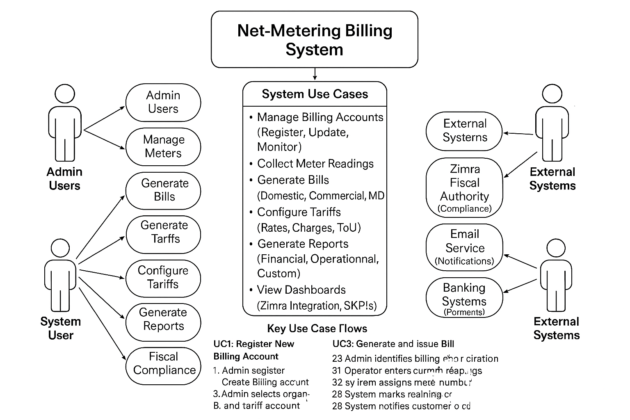

7.0 SCREENSHOTS
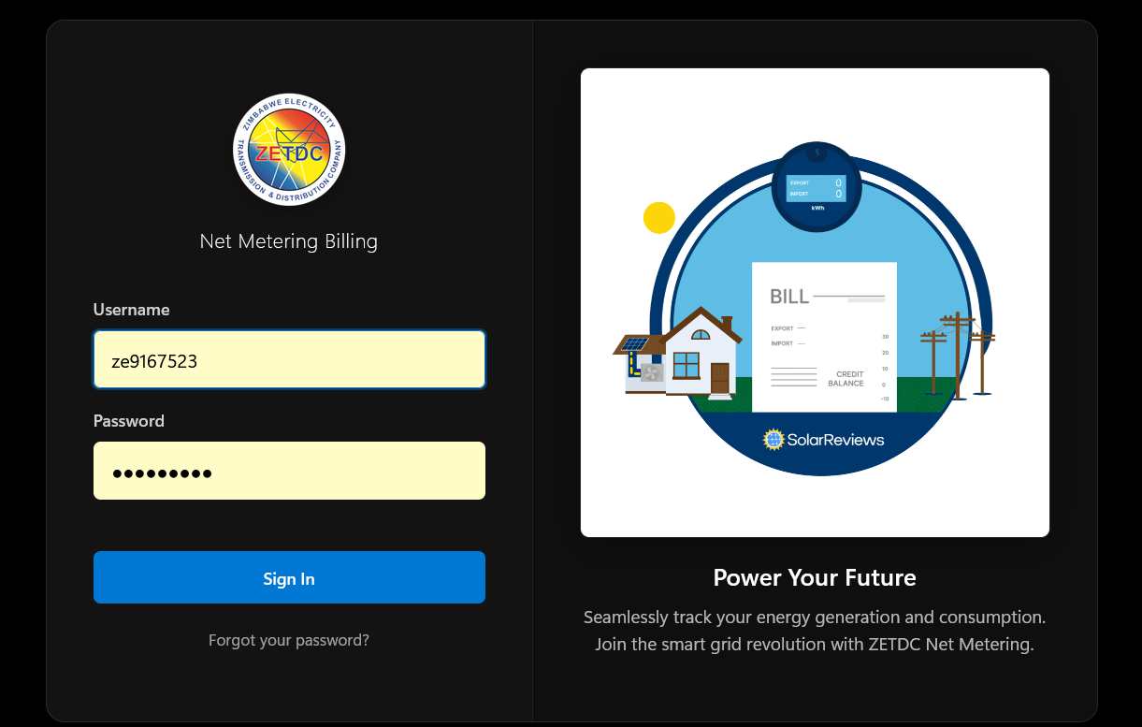
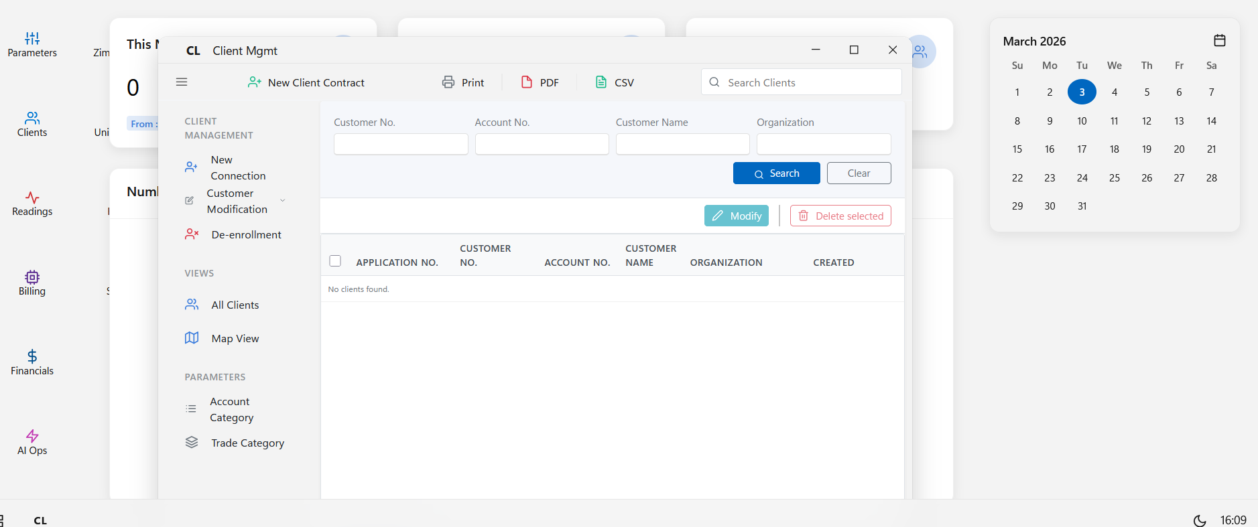

8.0 CONCLUSION

8.1 System Achievements
The Net-Metering Billing System represents a significant advancement in utility billing automation, delivering a comprehensive solution for managing net-metered electricity accounts. Through its sophisticated billing engine, flexible tariff configurations, and robust security framework, the system successfully addresses the complex challenges inherent in modern net-metering operations.
Key Achievements:
- Operational Excellence: Automated billing processes reduce cycle time and errors
- Regulatory Compliance: Full integration with fiscal authorities ensures legal compliance
- Financial Accuracy: Complex algorithms ensure precise billing across all customer segments
- Scalability: Enterprise-grade architecture supports unlimited growth
- User Experience: Intuitive interfaces serve diverse user audiences effectively

