PROJECT DOCUMENTATION
Metadata-Driven File Load
Talend and PostgreSQL
One Talend job and one config table that load any delimited file into a PostgreSQL staging table, with built-in validation, duplicate protection and an audit trail.
Item | Detail
Version | 1.0
Date | 27 October 2026
Status | Draft for review
Project | metadata_driven_file_processing
Main job | jb_file_load
Scope | File load into staging (implemented). Extract job (planned).

Contents
1. Executive summary
2. Problem statement and decision
3. Scope, assumptions and constraints
4. Solution architecture
5. Data model
6. Job design
7. Error handling and audit
8. Setup and operation
9. Testing
10. Performance and scalability
11. Strengths
12. Production readiness
13. Troubleshooting guide
14. Roadmap
Appendix A. SQL scripts
Appendix B. Java routine
Appendix C. Component code
Appendix D. Glossary

1. Executive summary
Loading files into a data warehouse normally means building a separate job for every file layout: a file input component, a column mapping, a table output and a deployment. This project replaces that with a single Talend job, jb_file_load, that is driven by a row in a config table.
A run needs only two inputs: a feed name and a file date. The job reads the feed's settings from PostgreSQL, finds the file, checks its structure, creates the staging table on the fly, streams the file into it with the PostgreSQL COPY command, and writes an audit row. A file that was already loaded stops the run, and every failure is recorded.

Why it matters
- New feeds without new jobs. Adding a feed means inserting one row into file_config.
- Built for large files. The file is streamed in 1 MB chunks and parsed by PostgreSQL, so memory use stays flat whatever the file size.
- Safe by default. Structure is validated before anything is loaded, duplicate files are blocked, and every run leaves an audit row.
- Plain code, no AI in the run path. The work is structured and rule-based, so ordinary code is cheaper, faster and more predictable (section 2).

Key facts
Item | Detail
Purpose | Load structured delimited files into PostgreSQL staging tables.
Tooling | Talend Studio (Data Integration, Java jobs), PostgreSQL, JDBC CopyManager.
Run inputs | FeedName and FileDate (context variables).
Control | One row per feed in file_config.
Outputs | A staging table with every column as text, and one row per run in file_load_audit.
Current status | Load job built. Config read, file resolution, duplicate check and the stop on duplicates have been observed in test runs. The remaining steps are built and pending end-to-end verification (section 9).
Next | Extract job, file archiving, parallel loading (section 14).

2. Problem statement and decision

2.1 Background
In almost all warehouse ETL work the flow is the same: structured files arrive, they are loaded into a staging area, the data is processed and transformed, and the result is extracted for analysis. The two ends of that flow, loading and exporting, deal with files that have a known structure: a delimiter, a header or a fixed list of fields, and a predictable file name.
The transformation step in the middle can be plain SQL running inside the database, which is fast because the data never has to leave the server. That leaves loading and exporting as the parts worth automating with a generic, configurable job.

2.2 The request
With AI use growing everywhere, we were asked to use AI to automate file loading. Before agreeing, we looked at what the work actually is. Because the files are structured, a description of the layout in a config table is enough for ordinary code to load them. The question became: if loading structured files can be done with simple, deterministic code, why pay for AI to do it?

2.3 Decision
We chose ordinary code for the run path, for the reasons below.
Reason | Explanation
Cost follows volume | AI models bill per token. Millions or billions of records mean billions of tokens on every run, every day. Code running on a database that is already in place costs almost nothing per row.
Reliability | AI is probabilistic. Even a fraction of a percent error rate across billions of rows means a very large number of bad records. With ordinary code, the same input gives the same output.
Speed | PostgreSQL reads the data as a stream through COPY. A round trip to a model for every chunk of data cannot compete.
Security and control | Customer data stays inside the environment, and every step can be audited and replayed.
Operations | Standard scheduling, logging and alerting already work with Talend and PostgreSQL. There is no new vendor, quota or outage to plan around.

2.4 Where AI belongs
This does not mean AI is useless in data engineering. It is very useful for unstructured sources, for exploring unfamiliar file formats, and for speeding up code generation. The rule of thumb for this project: use AI to build the pipeline, and use code to run it.

3. Scope, assumptions and constraints

3.1 In scope
- A config table that describes each feed.
- A Talend job that resolves the file, validates its structure, creates the staging table and loads the file.
- Duplicate protection, an audit table and an error path that records failures.

3.2 Out of scope for this version
- The extract job (planned, section 14).
- Transformations after staging, and scheduling.
- Archiving of processed files (the archive_path column exists but nothing moves the file yet).

3.3 Assumptions
- Talend Studio with Java jobs, and the PostgreSQL JDBC driver available to the job.
- The input file is on a path the machine running the job can read.
- Files are delimited text in UTF-8, with a header row or a field list in the config.
- Quoted fields use the double quote character.

3.4 Constraints
- Every staging column is text. Typing and validation happen in later steps.
- One file per run, and the staging table is dropped and recreated on every run.
- PostgreSQL allows at most 1,600 columns per table, which limits file width.
- Column names are lower-cased and cut to 55 characters (section 6.7).

4. Solution architecture
The Talend job sits between the input files and PostgreSQL. It reads its settings from the config table, loads the file into the staging table, and writes the outcome of every run to the audit table. A separate error path catches any failure and records it.
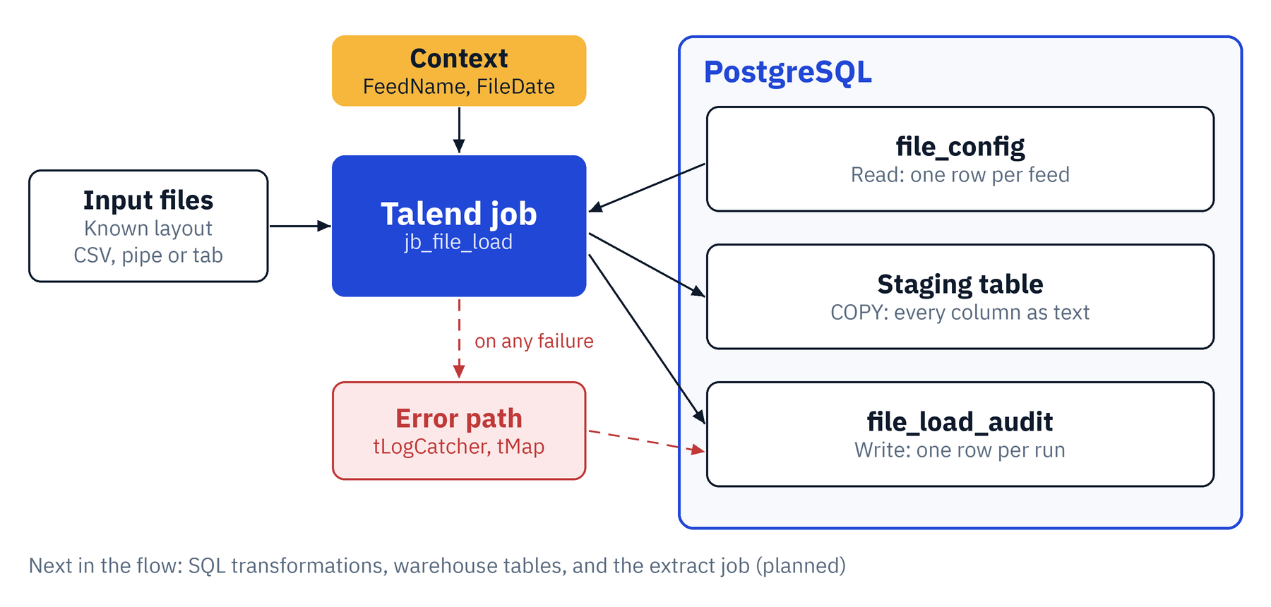
Figure 1. Solution architecture

4.1 Components
Component | Role
Input files | Delimited files with a known layout, such as CSV, pipe or tab separated.
Context variables | Connection settings, FeedName and FileDate. Kept in a Talend context group.
Talend job jb_file_load | Reads config, validates the file, builds the SQL and streams the file into PostgreSQL.
file_config | One row per feed: path, file name pattern, delimiter, header flag, field count, field names, staging table.
Staging table | Created on every run with one text column per file field.
file_load_audit | One row per run with status, row count, error message and job run id.
Error path | tLogCatcher, tMap and tDBOutput write a FAILED audit row when anything goes wrong.

4.2 Technology stack
Layer | Technology | Used for
Integration | Talend Studio, Data Integration | Job design, context groups, routines, execution.
Logic | Java (tJava components and a routine) | File name resolution, validation, SQL generation, streaming.
Database | PostgreSQL | Config, staging and audit tables; COPY for loading.
Connectivity | PostgreSQL JDBC driver | Connection and CopyManager for streaming.
Delivery | Git (planned) | Versioning jobs, contexts and SQL scripts.

5. Data model
Three tables take part: the config table that drives the job, the audit table that records every run, and the staging table that is recreated for each load.
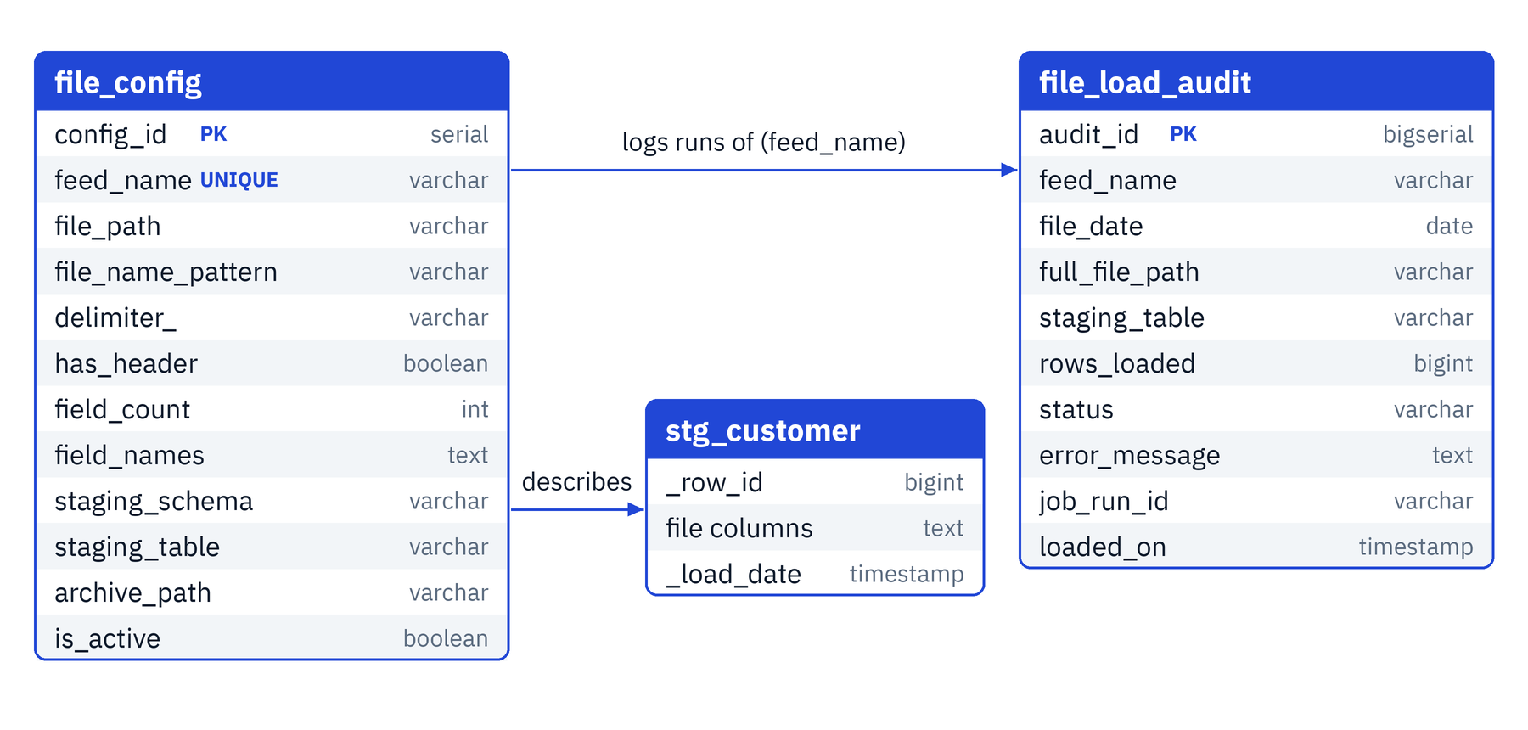
Figure 2. Data model

5.1 file_config
Column | Type | Purpose
config_id | serial, primary key | Surrogate key.
feed_name | varchar(100), unique | Name passed to the job as FeedName.
file_path | varchar(500) | Folder that holds the file. Use forward slashes.
file_name_pattern | varchar(200) | File name with date tokens, for example CUSTOMER_{yyyyMMdd}.csv.
delimiter_ | varchar(10) | , or | or TAB. The trailing underscore avoids a reserved word.
has_header | boolean | True if the first line is a header.
field_count | int | Expected number of fields.
field_names | text | Comma-separated names, used when there is no header.
staging_schema, staging_table | varchar(63) | Where the data lands. The table is recreated on every run.
archive_path | varchar(500) | Folder for processed files (not used yet).
is_active | boolean | True to enable the feed.

5.2 file_load_audit
Column | Type | Purpose
audit_id | bigserial, primary key | Surrogate key.
feed_name | varchar(100) | Feed that ran.
file_date | date | Value of FileDate.
full_file_path | varchar(500) | Exact file that was processed.
staging_table | varchar(200) | Fully qualified staging table.
rows_loaded | bigint | Rows copied by COPY.
status | varchar(20) | SUCCESS or FAILED.
error_message | text | Error text for failed runs.
job_run_id | varchar(50) | Talend pid of the run.
loaded_on, loaded_by | timestamp, varchar | Filled by defaults (now(), current_user).

5.3 Staging table
The job generates the staging table from the file's columns, so there is no fixed definition. Every file column is text. The table also carries _row_id (identity) and _load_date (default now()), which COPY leaves to their defaults because it names its target columns explicitly.

5.4 Indexes and constraints
A partial unique index on file_load_audit (feed_name, full_file_path) WHERE status = 'SUCCESS' allows only one SUCCESS row per file. Repeated FAILED rows for the same file do not collide.

5.5 Example config row
Column | Value
feed_name | CUSTOMER
file_path | E:/Work/talend/inbound
file_name_pattern | CUSTOMER_{yyyyMMdd}.csv
delimiter_ | ,
has_header | true
field_count | 5
staging_table | stg_customer

6. Job design

6.1 Context variables
Variable | Type | Purpose
DB_HOST, DB_PORT, DB_NAME | String | PostgreSQL server and database.
DB_USER, DB_PASS | String, Password | Credentials. Keep real values out of Git.
DB_SCHEMA | String | Schema that holds config, audit and staging tables.
FeedName | String | Which file_config row to use.
FileDate | String | Date in yyyy-MM-dd format, used to build the file name.

6.2 Global map keys
Components pass values to each other through the Talend global map. The key prefix is the name of the row link, so the keys below assume the links are named row1 and row2. If a link is renamed, the keys and the code must change with it.
Key | Set by | Used by
row1.<column> | Config tFlowToIterate | Resolve and parse steps. For example row1.file_path, row1.delimiter_.
row2.cnt | Duplicate-check tFlowToIterate | The Run if conditions.
fullFilePath | Resolve tJava | Duplicate check, parse, copy, audit.
ddlSql, copySql, stagingFq | Parse tJava | DDL, copy and audit steps.
rowsLoaded | Copy tJava | Audit step.
conn_tDBConnection_1 | tDBConnection_1 | Copy tJava (the shared connection).

6.3 Control flow
The job is a chain of subjobs. Solid links carry rows (Row) or loop over them (Iterate). Dashed links are triggers: OnSubjobOk moves to the next subjob when the previous one succeeds, and Run if checks a condition. After the duplicate check, a Run if trigger goes to the parse step when the count is zero and to tDie when it is not.
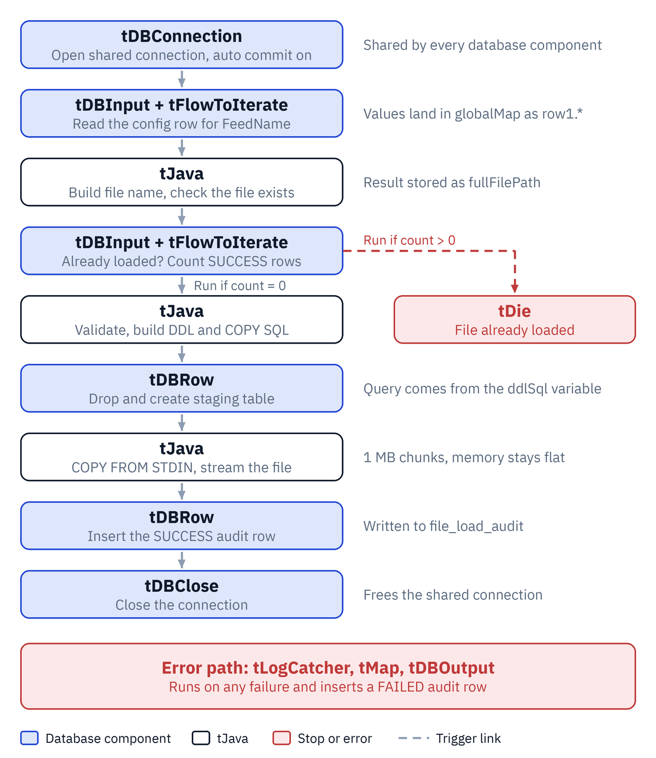
Figure 3. Control flow of jb_file_load

6.4 Component specification
# | Component | Key settings | Result
1 | tDBConnection_1 | PostgreSQL driver. Host, port, database, user and password from context. Schema from DB_SCHEMA. Auto commit on. | Shared connection.
2 | tDBInput (link row1) | Existing connection. Columns: file_path, file_name_pattern, delimiter_, has_header (Boolean), field_count (Integer), field_names, staging_schema, staging_table, archive_path. Query in Appendix C.4. | One config row.
3 | tFlowToIterate | Use the default (key, value) in global variables. | row1.* variables.
4 | tJava (config check) | Prints that the config loaded. Optional debug print of the global map. | None.
5 | tJava (resolve) | Builds the file name from the pattern and FileDate, checks the file exists. Code in Appendix C.1. | fullFilePath.
6 | tDBInput (link row2) | Column cnt (Long). Duplicate-check query in Appendix C.5. | row2.cnt source row.
7 | tFlowToIterate | Default key and value. | row2.cnt.
8 | tJava (gate) | Start point for the two Run if triggers. Can be empty. | None.
9 | tJava (parse) | Run if count is 0. Validates the structure, sanitizes names, builds the SQL. Code in Appendix C.2. | ddlSql, copySql, stagingFq.
10 | tDie | Run if count is above 0. Message "File already loaded: " + globalMap.get("fullFilePath"). | Job stops with an error.
11 | tDBRow (DDL) | Query is (String) globalMap.get("ddlSql"). Existing connection. | Staging table recreated.
12 | tJava (copy) | Streams the file through CopyManager. Code in Appendix C.3. | rowsLoaded.
13 | tDBRow (audit) | Inserts the SUCCESS row. Query in Appendix C.6. | Audit row.
14 | tDBClose | Component list: tDBConnection_1. | Connection closed.
15 | tLogCatcher | Catch Java exception and Catch tDie ticked. | Error row.
16 | tMap | Maps the error row to the audit columns (section 7.1). | Audit row structure.
17 | tDBOutput | Table file_load_audit, action Insert, existing connection. | FAILED row.

The Run if conditions are:
To the parse tJava: ((Long) globalMap.get("row2.cnt")).longValue() == 0
To tDie: ((Long) globalMap.get("row2.cnt")).longValue() > 0

6.5 Load sequence
The sequence below shows how one run moves between the job, the database and the file. The data itself passes through the job as a byte stream, one chunk at a time. Nothing is parsed or held in memory, so memory use stays flat whatever the file size.
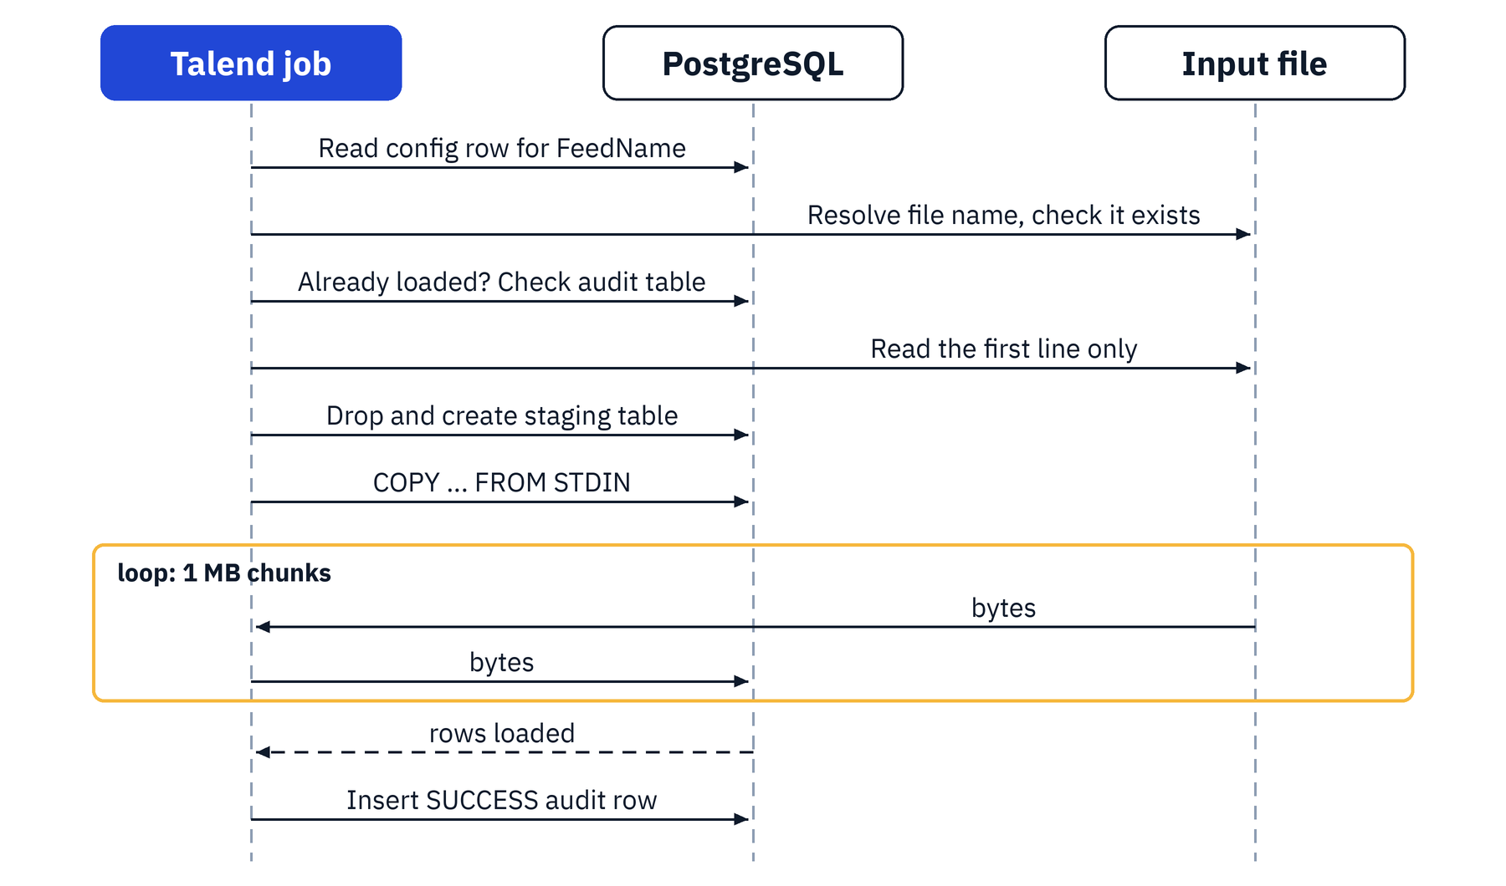
Figure 4. Load sequence

6.6 Structure validation
Case | Rule | Column names come from
File has a header | The header's field count must equal field_count. | The header row.
File has no header | The number of names in field_names must equal field_count, and the first data row must have the same number of fields. | field_names in the config.
Empty file | The run fails with the message that the file is empty. | Not applicable.

6.7 Column name sanitization
- Characters other than letters, digits and underscore become underscores, and names are lower-cased.
- An empty name becomes col1, col2 and so on, based on its position.
- A name that starts with a digit gets the prefix c_.
- Names are cut to 55 characters, and duplicates get a numeric suffix (name_2).
- Names are quoted when the DDL is built, so reserved words are safe.

7. Error handling and audit

7.1 Error path
tLogCatcher is not linked to the main flow. It fires on its own when any component throws an exception or when tDie runs. Its row goes through tMap into tDBOutput, which inserts a FAILED row into file_load_audit. The connection uses auto commit, so the audit row survives the failed run.
Remove any Var table in the tMap. Type the expressions directly into the output columns:
Output column | Type | Expression
feed_name | String | context.FeedName
file_date | Date (pattern yyyy-MM-dd) | TalendDate.parseDate("yyyy-MM-dd", context.FileDate)
full_file_path | String | (String) globalMap.get("fullFilePath")
status | String | "FAILED"
error_message | String | row3.message (use the name of your tLogCatcher link)
job_run_id | String | row3.pid

7.2 Run outcomes
Outcome | What happens | Audit row
Successful load | Staging table loaded, job ends normally. | SUCCESS with rows_loaded.
File already loaded | tDie stops the job with the message that the file was already loaded. The default tDie message is "the end is near", so set a clear message. | FAILED with the message.
Any other failure | An exception stops the job at the failing component. | FAILED with the exception text.

7.3 Duplicate protection and reprocessing
Before any work, the job counts SUCCESS rows for the feed and the exact file path. If the count is above zero, it stops. The partial unique index enforces the same rule in the database, so two simultaneous runs cannot both record success.
To load a file again on purpose:
- Confirm the earlier load should be replaced.
- Remove the SUCCESS row for the file (SQL below).
- Rerun the job with the same FeedName and FileDate.
DELETE FROM test.file_load_audit
WHERE feed_name = 'CUSTOMER' AND status = 'SUCCESS'
AND full_file_path = 'E:\Work\talend\inbound\CUSTOMER_20261020.csv';

8. Setup and operation

8.1 Prerequisites
- Talend Studio with Data Integration, and the PostgreSQL JDBC driver available to the job.
- A PostgreSQL database, a schema for the tables, and a database user that can create and drop tables in it.
- Network access from the machine running the job to the database.
- The input files in a folder readable by the machine running the job.

8.2 Installation
- Run the SQL scripts in Appendix A to create the config and audit tables and the sample config row.
- Create a context group with the variables in section 6.1.
- Create the FileUtil routine from Appendix B.
- Build the job as described in section 6.4. Name the row links row1 and row2, or adjust the code.
- Place a sample file in the folder named in file_path.

8.3 Running the job
In Studio, open the Run tab, choose the context group, check FeedName and FileDate, and click Run. To run outside Studio, build the job and call the generated script:
jb_file_load_run.bat --context_param FeedName=CUSTOMER --context_param FileDate=2026-10-20

8.4 Verification
SELECT COUNT(*) FROM test.stg_customer;
SELECT * FROM test.stg_customer LIMIT 5;
SELECT * FROM test.file_load_audit ORDER BY audit_id DESC;

8.5 Scheduling
Run the built job from the Talend Management Console, cron, Windows Task Scheduler or an orchestrator. Pass FeedName and FileDate as context parameters. A non-zero exit code means the run failed, and the audit table holds the reason.

9. Testing

9.1 Verified so far
In test runs the job read the config row, resolved the file name, ran the duplicate check, and stopped at tDie when the audit table already held a SUCCESS row for the file. The remaining steps (parse, DDL, copy, audit insert and the error path) are built and still need an end-to-end run. The plan below covers them.

9.2 Test plan
ID | Scenario | Expected result | Status
T1 | Load a file with a header for the first time. | Staging table holds all rows. SUCCESS audit row with the row count. | To run
T2 | Run the same file again. | Job stops at tDie with the already-loaded message. Staging data is unchanged. FAILED audit row. | Stop observed. Audit row to confirm.
T3 | File missing for the date. | Error "File not found". FAILED audit row. | To run
T4 | Header field count differs from field_count. | Error naming both counts. FAILED audit row. | To run
T5 | File without a header, names in field_names. | Columns named from the config. All rows loaded. | To run
T6 | A quoted value that contains the delimiter. | The value stays in one column. | To run
T7 | Empty file. | Error "File is empty". | To run
T8 | Unknown or inactive feed. | Error "No active config row found". | To run
T9 | Large file. | Load completes with flat memory. Timing recorded in section 10.4. | To run

10. Performance and scalability

10.1 Why the design suits large files
- Streaming. COPY ... FROM STDIN reads the file in 1 MB chunks and sends them straight to PostgreSQL, so memory stays flat.
- No row-by-row work in Talend. There is no file input, tMap or table output in the data path. PostgreSQL parses the data.
- Cheap control steps. Config, duplicate check and audit touch one row each, and the structure check reads only the first line.
- Large counts are handled. copyIn returns a long and rows_loaded is a bigint.

10.2 Limits
Limit | Effect | Mitigation
One COPY stream | Throughput is capped by one connection and one core. | Benchmark on a sample. Load parts in parallel if needed.
Logged writes | Normal tables write every row to the write-ahead log as well. | Create the staging table as UNLOGGED.
One transaction | A failure near the end rolls back the whole load. | Acceptable for staging, which is recreated. Splitting files limits the cost.
Network path | Every byte crosses the network from the job machine to the database. | Run the job on or near the database server.
Identity column | _row_id adds a sequence call per row. | Drop it for the fastest load if it is not needed.
Timeouts and disk | A long COPY can hit statement_timeout or fill the disk. | Check the user's timeout setting and size the disk for data plus indexes.

10.3 Recommendations for very large files
- Create the staging table as UNLOGGED (in the parse step, use CREATE UNLOGGED TABLE). Data is lost if the server crashes, which is acceptable for staging that can be reloaded.
- Send raw bytes to copyIn instead of characters (the copy code in Appendix C.3 already does).
- Run ANALYZE on the staging table after the load so later SQL transformations get good plans.
- Receive the source as several part files and run several COPY streams in parallel into the same table. Create the table once, before the parts start.

10.4 Benchmark record
The design has not been benchmarked at large volume yet. Fill in this table from your own tests.
Rows | File size | Load time | Rows per second | Notes

11. Strengths
Strength | Why it matters
One job for every delimited feed | A new feed is a config row, tested the same day.
Constant memory | The file streams through a fixed-size buffer, so file size does not change memory use.
Fast load path | PostgreSQL parses the data itself with COPY.
Safe by default | Structure is checked first, duplicates stop the run, and every run is audited.
Simple to operate | Plain SQL and a few lines of Java. Support staff change behavior through config rows.
No extra licensing for the load path | Uses the PostgreSQL driver and standard Talend components.
Portable design | The same pattern can be built on other platforms, for example SSIS and SQL Server.

12. Production readiness
This is a working pattern. Review the points below before it carries production data.

12.1 What to change
Area | Current | Change for production
Credentials | Set in the Talend context. | Use encrypted contexts or a secret manager and a least-privilege database role. Never commit passwords.
SQL building | Queries concatenate feed names and paths. | Validate inputs or use prepared statements. Restrict who can write to file_config.
Environments | One context group. | Separate dev, test and prod contexts with their own hosts and schemas.
Staging lifecycle | Table dropped and recreated each run. | Decide between replace and append. Use per-run table names if a feed can run twice at once.
Archiving | archive_path exists, nothing moves the file. | Add a step that moves the file after a successful load.
Half-written files | Not handled. | Require a control or .done file, or check that the file size is stable.
File format | UTF-8, double quote, CSV mode. | Make encoding, quote and escape configurable per feed. Handle byte order marks.
Error handling | FAILED row and non-zero exit code. | Add alerts (email, chat, ticket) and a retry policy in the scheduler.
Duplicate protection | Based on the full file path. | Consider a checksum or size check. Document the reprocessing steps.
Monitoring | Console messages. | Send job statistics and logs to central logging. Build a dashboard on file_load_audit.
Config governance | Direct table edits. | Add constraints, change control and an audit trail on file_config.
Security | Plain connection. | Use TLS (sslmode=require), restrict network access, and set permissions on the inbound folder.
Scheduling | Manual runs. | Use Talend Management Console, cron, Task Scheduler or an orchestrator.
Testing and delivery | Manual. | Keep a sample file per feed, add an automated test job, and version jobs and contexts in Git.
Naming | Links named row1 and row2. | Rename to cfg and dup for readability, and update the global map keys.
Time zones | _load_date uses the database clock. | Document the time zone and how FileDate relates to it.

12.2 Risks
Risk | Impact | Mitigation
Wrong feed settings | Rows load into the wrong columns or the run fails. | Constraints on file_config, a test file per feed, review of config changes.
Partial or corrupt file | Incomplete data in staging. | Control file or stable-size check before loading.
Staging table collision | Two runs overwrite each other. | Per-run table names or a lock on the feed.
Single stream too slow | Load window missed. | Benchmark early, use UNLOGGED, move to parallel parts.
Credential exposure | Unauthorized database access. | Secret management, least privilege, no passwords in Git.

13. Troubleshooting guide
Symptom | Cause and fix
"No active config row found" | The feed name does not match, is_active is false, or the global map keys do not match the link name. Print the global map to see the real key names.
NullPointerException in a Run if condition | The key (for example row2.cnt) does not exist. The link name differs, or "Use the default (key, value) in global variables" is not ticked on tFlowToIterate.
Job ends with "the end is near" | That is the default tDie message. Set the Die message to show the file name. The cause is usually that the file was already loaded.
Column not found, for example delimiter | The config column is delimiter_, so the key is row1.delimiter_.
tMap cell is red | A type mismatch, for example a Date expression in a String variable. Remove the Var table and type expressions into the output columns.
Audit insert fails on pid | The audit column is job_run_id. Rename the tMap output column.
"File not found" | Check file_path, file_name_pattern and that FileDate matches the file. Use forward slashes.
tPostgresqlConnection missing from the palette | Search for it, check you are in a Standard job, or use the generic tDB* or tJDBC* components with the PostgreSQL driver.
FAILED rows are not written | Auto commit is off on the connection, or the connection was closed before the error path ran.

14. Roadmap

14.1 Extract job (planned)
The extract follows the same pattern in the other direction: a config row describes what to extract, and the job writes the file.
- An extract_config table with source table or query, columns, date column, delimiter, quote, header flag, output path and file name pattern.
- A Java step builds the query and writes the file with COPY (query) TO STDOUT through CopyManager.copyOut, so PostgreSQL formats the rows.
- The file is written under a temporary name and renamed when complete, so a downstream process never sees a partial file.
- An extract_audit table and a duplicate check, as in the load.
- Parallel streams for large volumes, with the parts merged and the header added.

14.2 Other improvements
- Archive step after a successful load.
- Parallel loading of part files.
- Per-feed encoding and quoting options.
- Reject handling with an error file and a threshold.
- Alerting and central logging.

Appendix A. SQL scripts
Tables, index and the sample config row.
CREATE SCHEMA IF NOT EXISTS test;

CREATE TABLE test.file_config (
config_id serial PRIMARY KEY,
feed_name varchar(100) NOT NULL UNIQUE,
file_path varchar(500) NOT NULL,
file_name_pattern varchar(200) NOT NULL, -- CUSTOMER_{yyyyMMdd}.csv
delimiter_ varchar(10) NOT NULL, -- ',' or '|' or 'TAB'
has_header boolean NOT NULL,
field_count int NOT NULL,
field_names text, -- used when has_header = false
staging_schema varchar(63) NOT NULL DEFAULT 'test',
staging_table varchar(63) NOT NULL,
archive_path varchar(500),
is_active boolean NOT NULL DEFAULT true
);

CREATE TABLE test.file_load_audit (
audit_id bigserial PRIMARY KEY,
feed_name varchar(100) NOT NULL,
file_date date,
full_file_path varchar(500),
staging_table varchar(200),
rows_loaded bigint,
status varchar(20) NOT NULL, -- SUCCESS / FAILED
error_message text,
job_run_id varchar(50),
loaded_on timestamp NOT NULL DEFAULT now(),
loaded_by varchar(100) DEFAULT current_user
);

CREATE UNIQUE INDEX ux_file_load_success
ON test.file_load_audit (feed_name, full_file_path)
WHERE status = 'SUCCESS';

INSERT INTO test.file_config
(feed_name, file_path, file_name_pattern, delimiter_, has_header, field_count, staging_table)
VALUES
('CUSTOMER', 'E:/Work/talend/inbound', 'CUSTOMER_{yyyyMMdd}.csv', ',', true, 5, 'stg_customer');

Appendix B. Java routine
Create this routine in Repository, Code, Routines, with the name FileUtil.
package routines;

public class FileUtil {

// split one line, honouring quotes and doubled quotes
public static String[] splitLine(String line, char delim, char quote) {
java.util.List<String> out = new java.util.ArrayList<String>();
StringBuilder cur = new StringBuilder();
boolean inQ = false;
for (int i = 0; i < line.length(); i++) {
char c = line.charAt(i);
if (inQ) {
if (c == quote) {
if (i + 1 < line.length() && line.charAt(i + 1) == quote) { cur.append(quote); i++; }
else inQ = false;
} else cur.append(c);
} else if (c == quote) inQ = true;
else if (c == delim) { out.add(cur.toString()); cur.setLength(0); }
else cur.append(c);
}
out.add(cur.toString());
return out.toArray(new String[0]);
}

// safe, lower-case, unique PostgreSQL column names
public static String[] sanitize(String[] raw) {
java.util.Set<String> seen = new java.util.HashSet<String>();
String[] res = new String[raw.length];
for (int i = 0; i < raw.length; i++) {
String n = (raw[i] == null ? "" : raw[i].trim())
.replaceAll("[^A-Za-z0-9_]", "_").toLowerCase();
if (n.length() == 0) n = "col" + (i + 1);
if (Character.isDigit(n.charAt(0))) n = "c_" + n;
if (n.length() > 55) n = n.substring(0, 55);
String base = n; int k = 2;
while (!seen.add(n)) n = base + "_" + k++;
res[i] = n;
}
return res;
}

// quote an identifier
public static String q(String id) {
return "\"" + id.replace("\"", "\"\"") + "\"";
}
}

Appendix C. Component code

C.1 tJava, resolve file
String folder = (String) globalMap.get("row1.file_path");
String pattern = (String) globalMap.get("row1.file_name_pattern");
if (folder == null || pattern == null) {
throw new RuntimeException("No active config row found for feed " + context.FeedName);
}
java.util.Date d = TalendDate.parseDate("yyyy-MM-dd", context.FileDate);

java.util.regex.Matcher m = java.util.regex.Pattern.compile("\\{(.+?)\\}").matcher(pattern);
StringBuffer sb = new StringBuffer();
while (m.find()) {
m.appendReplacement(sb, java.util.regex.Matcher.quoteReplacement(
new java.text.SimpleDateFormat(m.group(1)).format(d)));
}
m.appendTail(sb);

java.io.File f = new java.io.File(folder, sb.toString());
if (!f.exists()) {
throw new RuntimeException("File not found: " + f.getPath());
}
globalMap.put("fullFilePath", f.getPath());

C.2 tJava, parse and build SQL
String file = (String) globalMap.get("fullFilePath");
String delimCfg = ((String) globalMap.get("row1.delimiter_")).trim();
char delim = "TAB".equalsIgnoreCase(delimCfg) ? '\t' : delimCfg.charAt(0);
boolean hasHeader = (Boolean) globalMap.get("row1.has_header");
int cfgCount = (Integer) globalMap.get("row1.field_count");
String cfgNames = (String) globalMap.get("row1.field_names");

String first;
try (java.io.BufferedReader br = new java.io.BufferedReader(
new java.io.InputStreamReader(new java.io.FileInputStream(file), "UTF-8"))) {
first = br.readLine();
}
if (first == null) throw new RuntimeException("File is empty: " + file);
first = first.replace("\uFEFF", ""); // strip a UTF-8 BOM
String[] firstRow = FileUtil.splitLine(first, delim, '"');

String[] cols;
if (hasHeader) {
if (firstRow.length != cfgCount)
throw new RuntimeException("Header has " + firstRow.length
+ " fields, config expects " + cfgCount);
cols = firstRow;
} else {
cols = cfgNames.split(",");
for (int i = 0; i < cols.length; i++) cols[i] = cols[i].trim();
if (cols.length != cfgCount)
throw new RuntimeException("Config field_names has " + cols.length
+ " names, field_count is " + cfgCount);
if (firstRow.length != cfgCount)
throw new RuntimeException("First data row has " + firstRow.length
+ " fields, config expects " + cfgCount);
}
cols = FileUtil.sanitize(cols);

String fq = FileUtil.q((String) globalMap.get("row1.staging_schema")) + "."
+ FileUtil.q((String) globalMap.get("row1.staging_table"));

StringBuilder ddl = new StringBuilder();
ddl.append("DROP TABLE IF EXISTS ").append(fq).append(";\n");
ddl.append("CREATE TABLE ").append(fq).append(" (\n"); // use CREATE UNLOGGED TABLE for very large loads
ddl.append(" _row_id bigint GENERATED ALWAYS AS IDENTITY,\n");
StringBuilder colList = new StringBuilder();
for (int i = 0; i < cols.length; i++) {
ddl.append(" ").append(FileUtil.q(cols[i])).append(" text,\n");
if (i > 0) colList.append(", ");
colList.append(FileUtil.q(cols[i]));
}
ddl.append(" _load_date timestamp NOT NULL DEFAULT now()\n)");

String copySql = "COPY " + fq + " (" + colList + ") FROM STDIN WITH (FORMAT csv, HEADER "
+ (hasHeader ? "true" : "false") + ", DELIMITER '"
+ (delim == '\t' ? "\t" : String.valueOf(delim))
+ "', QUOTE '\"', ENCODING 'UTF8')";

globalMap.put("ddlSql", ddl.toString());
globalMap.put("copySql", copySql);
globalMap.put("stagingFq", fq);

C.3 tJava, copy
java.sql.Connection conn = (java.sql.Connection) globalMap.get("conn_tDBConnection_1");
org.postgresql.copy.CopyManager cm =
conn.unwrap(org.postgresql.PGConnection.class).getCopyAPI();

try (java.io.InputStream in = new java.io.BufferedInputStream(
new java.io.FileInputStream((String) globalMap.get("fullFilePath")), 1 << 20)) {
long rows = cm.copyIn((String) globalMap.get("copySql"), in, 1 << 20);
globalMap.put("rowsLoaded", rows);
}

C.4 Config query (tDBInput, link row1)
"SELECT file_path, file_name_pattern, delimiter_, has_header, field_count, " +
"COALESCE(field_names,'') AS field_names, staging_schema, staging_table, " +
"COALESCE(archive_path,'') AS archive_path " +
"FROM test.file_config WHERE feed_name = '" + context.FeedName + "' AND is_active = true"

C.5 Duplicate-check query (tDBInput, link row2)
"SELECT COUNT(*) AS cnt FROM test.file_load_audit WHERE feed_name = '" + context.FeedName +
"' AND full_file_path = '" + ((String) globalMap.get("fullFilePath")).replace("'", "''") +
"' AND status = 'SUCCESS'"

C.6 Audit insert (tDBRow)
"INSERT INTO test.file_load_audit (feed_name, file_date, full_file_path, staging_table, rows_loaded, status, job_run_id) VALUES ('" +
context.FeedName + "', '" + context.FileDate + "', '" +
((String) globalMap.get("fullFilePath")).replace("'", "''") + "', '" +
((String) globalMap.get("stagingFq")).replace("'", "''") + "', " +
globalMap.get("rowsLoaded") + ", 'SUCCESS', '" + pid + "')"

Appendix D. Glossary
Term | Meaning
Staging table | A table that holds raw loaded data before it is transformed.
Subjob | A group of connected components that runs as one unit in Talend.
OnSubjobOk | A trigger that starts the next subjob when the previous one finishes successfully.
Run if | A trigger that starts the next subjob only when a condition is true.
Global map | A shared store of values that components in a job can read and write.
Context variable | A job setting whose value is supplied at run time.
COPY | The PostgreSQL command for loading and exporting data in bulk.
CopyManager | The JDBC API that streams data to and from COPY.
UNLOGGED table | A table that skips the write-ahead log, which makes loading faster but loses data after a crash.
Write-ahead log (WAL) | PostgreSQL's log of changes, used for crash recovery and replication.
tFlowToIterate | A Talend component that turns each row into global variables and starts an iteration.

