KNOW8

ELECTRICAL

EMBEDDED SYSTEMS BROCHURE

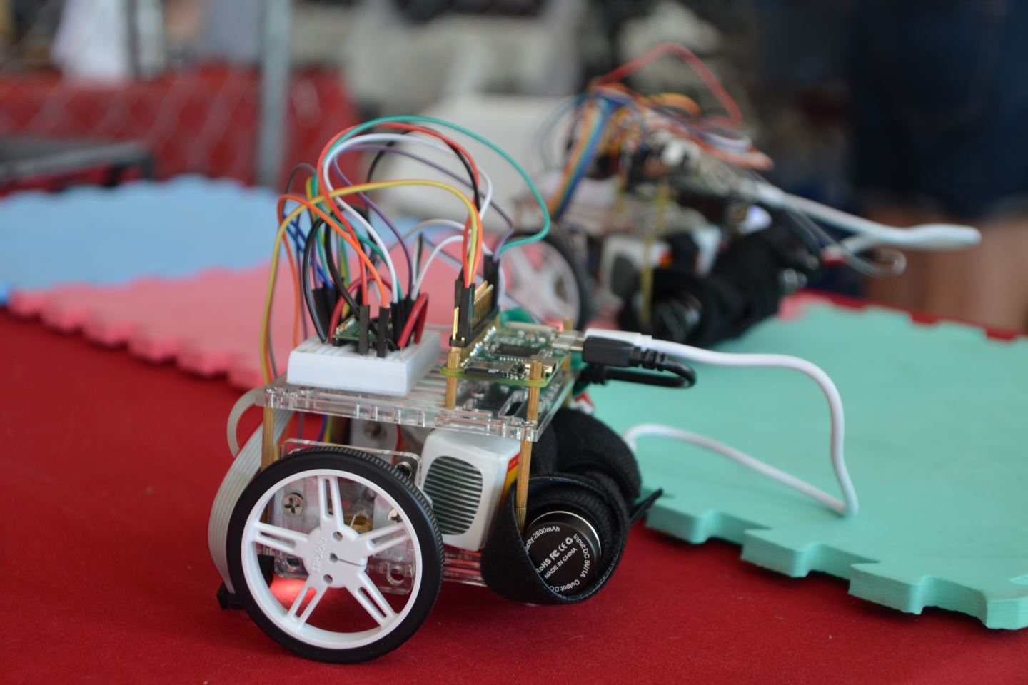

Q1- What is embedded system?

An embedded system is one kind of a computer system mainly designed to perform several tasks like to access, process, store and also control the data in various electronics-based systems. [Embedded systems](https://www.elprocus.com/mini-embedded-systems-projects-ideas/) are a combination of hardware and software where software is usually known as firmware that is embedded into the hardware. One of its most important characteristics of these systems is, it gives the o/p within the time limits. Embedded systems support to make the work more perfect and convenient. So, we frequently use embedded systems in simple and complex devices too. The applications of embedded systems mainly involve in our real life for several devices like microwave, calculators, TV remote control, home security and traffic control systems, etc.

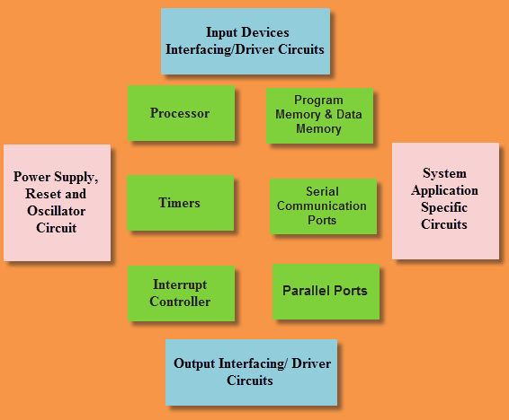

(Basics of embedded systems)

#### **Types of embedded system**

**Real-time embedded system:**

Real-time systems are those which give a quick response to critical situations. They are used in military, medical and industrial applications. Engineers working in these systems have high demand is current days. To develop the real-time embedded system we require timing analysis, multitasking design, debugging, cross-platform testing and architecture design. In these systems, quick response is very important. Better hardware is also used in these systems to avoid failure in performance. Real-time systems control the external environment by input & output interfaces and sensors. The external environment includes human and other animals. Some **examples of real-time embedded systems** include:-

* Controlling heat, elevators, lights, and doors in buildings
* Robots
* Traffic control system including railway tracks, airspace, shipping lines, highways
* Radio, satellite and telephone communication
* Patient monitoring system
* Radiation therapy system in the hospital
* Computer games
* Multimedia systems which consist of video, audio, text and graphics interfaces
* Military usage that includes tracking, weapons, and command & control

**Standalone embedded system:**

This type of embedded system works for itself as a device without needing any interconnected computer. It can take data in the form of analog or digital signals. This system first process data and then outputs data by displaying on the screen. It can also output data to any attached device. Examples of standalone embedded systems include:-

* Microwave ovens
* Digital cameras
* Mp3 players
* Video game consoles
* Temperature measurement systems

**Networked embedded system:**

Networked embedded systems are those systems which are connected to the network to give output to the attached resources. The devices in the networked embedded system are connected to the network with network interfaces. The network can be either a local area network (LAN) or a wide area network (WAN). The connection in networked embedded systems can be wireless or wired. This embedded system is fast and emerging its popularity over days. The embedded web server is that which is connected to network devices and is controlled by the web browser also. Example of this is the office security system. In office security system, different sensors (light sensors, smoke sensors or motion detectors) are networked together through LAN and controlled over the WAN (internet).

**Mobile embedded system:**

Mobile embedded systems are limited in resources including memory. Examples of mobile embedded systems include:-

* Personal digital assistants (PDA)
* Cellular phones
* Mp3 players
* Digital cameras

**Small-scale embedded system:**

Small-scale embedded systems consist of **8-16 bit** microcontroller. This system can perform tasks at a small level. They have on-chip ROM and RAM. Small-scale systems can be even activated by the battery. The tools used to develop small-scale embedded systems are an editor, cross assembler, assembler and integrated development environment (IDE). The purpose of this system is not computation but to control as a computer embedded inside it. It behaves as a component of a computer and its function is not to compute. The small-scale system is dedicated to some specific task. To apply for the job as a small-scale embedded designer you need **skills** including data communication, digital electronic design, control engineering, software engineering, computer architecture, motors & actuators, analog electronic design, sensors & measurement and IC design & measurement.

**Medium scale embedded system:**

This embedded system has **16-32 bit** microprocessor or microcontroller with external RAM and ROM They can perform medium to complex level works. The integration between hardware and software is complex in these embedded systems. Programming languages used to develop medium scale embedded systems include Java, C, Visual C++, debugger, C++, RTOS, simulator, source code engineering tool and IDE. The designer of the medium scale embedded system should also know how to use semaphores, queues, mailboxes, pipes, and sockets. Knowing the application programming interface (API) in the RTOS tool for controlling microcontroller is also necessary.

**Sophisticated embedded system:**

The embedded system which can do large-scale works with multiple **32-64 bit** chips is known as sophisticated embedded systems. They can perform distributed work on a large scale. The complexity of hardware and software is very high in these systems. In sophisticated embedded systems, hardware and software are assembled together on large scale and designing of hardware products is also included in these systems.

#### **Examples of embedded system**

Some examples of embedded systems are below:-

* ATM
* Digital Cameras
* Microwave ovens
* Factory controllers
* Washing machine
* Calculator

### Q-2 What is a Microcontroller?

A microcontroller is a small, low-cost and self-contained computer-on-a-chip that can be used as an embedded system. A few microcontrollers may utilize four-bit expressions and work at clock rate frequencies, which usually include:

* An 8 or 16 bit microprocessor.
* A little measure of RAM.
* Programmable ROM and flash memory.
* Parallel and serial I/O.
* Timers and signal generators.
* Analog to Digital and Digital to Analog conversion

Microcontrollers usually must have low-power requirements since many devices they control are battery-operated. Microcontrollers are used in many consumer electronics, car engines, computer peripherals and test or measurement equipment. And these are well suited for long lasting battery applications. The dominant part of microcontrollers being used now a days are implanted in other apparatus.

ARDUINO-UNO

(For Beginners)

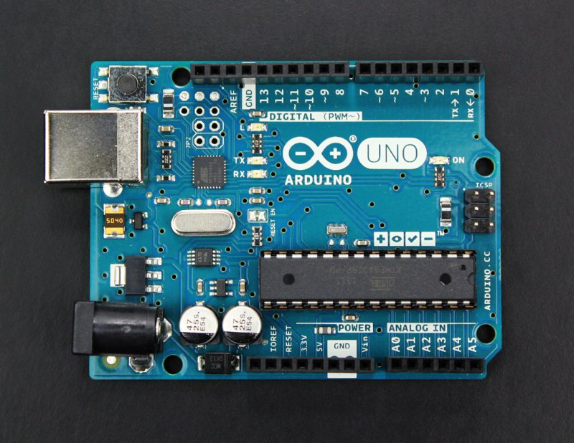

* **Arduino Uno** is a microcontroller board developed by Arduino.cc which is an open-source electronics platform mainly based on AVR microcontroller Atmega328.
* The current version of Arduino Uno comes with USB interface, 6 analog input pins, 14 I/O digital ports that are used to connect with external electronic circuits. Out of 14 I/O ports, 6 pins can be used for PWM output.
* It allows the designers to control and sense the external electronic devices in the real world.
* This board comes with all the features required to run the controller and can be directly connected to the computer through USB cable that is used to transfer the code to the controller using IDE (Integrated Development Environment) software, mainly developed to program Arduino. IDE is equally compatible with Windows, MAC or Linux Systems, however, Windows is preferable to use. Programming languages like C and C++ are used in IDE.
* Apart from USB, battery or AC to DC adopter can also be used to power the board.
* Arduino Uno boards are quite similar to other boards in Arduino family in terms of use and functionality, however, Uno boards don’t come with FTDI USB to Serial driver chip.
* There are many versions of Uno boards available, however, Arduino Nano V3 and Arduino Uno are the most official versions that come with Atmega328 8-bit AVR Atmel microcontroller where RAM memory is 32KB.
* When nature and functionality of the task go complex, Mirco SD card can be added in the boards to make them store more information.

**FEATURES OF ARDUINO BOARD**

* Arduino Uno comes with USB interface i.e. USB port is added on the board to develop serial communication with the computer.
* [Atmega328](https://www.theengineeringprojects.com/2017/08/introduction-to-atmega328.html) microcontroller is placed on the board that comes with a number of features like timers, counters, interrupts, PWM, CPU, I/O pins and based on a 16MHz clock that helps in producing more frequency and number of instructions per cycle.
* It is an open source platform where anyone can modify and optimize the board based on the number of instructions and task they want to achieve.
* This board comes with a built-in regulation feature which keeps the voltage under control when the device is connected to the external device.
* Reset pin is added in the board that reset the whole board and takes the running program in the initial stage. This pin is useful when board hangs up in the middle of the running program; pushing this pin will clear everything up in the program and starts the program right from the beginning.
* There are 14 I/O digital and 6 analog pins incorporated in the board that allows the external connection with any circuit with the board. These pins provide the flexibility and ease of use to the external devices that can be connected through these pins. There is no hard and fast interface required to connect the devices to the board. Simply plug the external device into the pins of the board that are laid out on the board in the form of the header.
* The 6 analog pins are marked as A0 to A5 and come with a resolution of 10bits. These pins measure from 0 to 5V, however, they can be configured to the high range using analogReference() function and AREF pin.
* 13KB of flash memory is used to store the number of instructions in the form of code.
* Only 5 V is required to turn the board on, which can be achieved directly using USB port or external adopter, however, it can support external power source up to 12 V which can be regulated and limit to 5 V or 3.3 V based on the requirement of the project.

FOR A MORE DETAILED VERSION

**REGISTER** YOURSELF FOR OUR UPCOMING WORKSHOPS ON EMBEDDED SYSTEMS.