SIM808 NOTIFICATION SYSTEM

# Description

This device is programmed to monitor a specific table in Biostar Database. For every new record it detects, it will send an SMS to the contact number registered in the Biostar Database.

## Materials

* [Raspberry Pi 3 Model B+](https://www.raspberrypi.com/products/raspberry-pi-3-model-b-plus/)
* [Sim 808 Module with GPS Antenna](https://www.makerlab-electronics.com/product/sim808-module-with-gps-antenna/)
* [Female-to-Female Connecting wires](https://www.makerlab-electronics.com/product/40-pin-10cm-jumper-wires/)
* LED indicatior (red and green)
* Optional (3D Printer / filament), plastic stand-offs screws.

## How it works

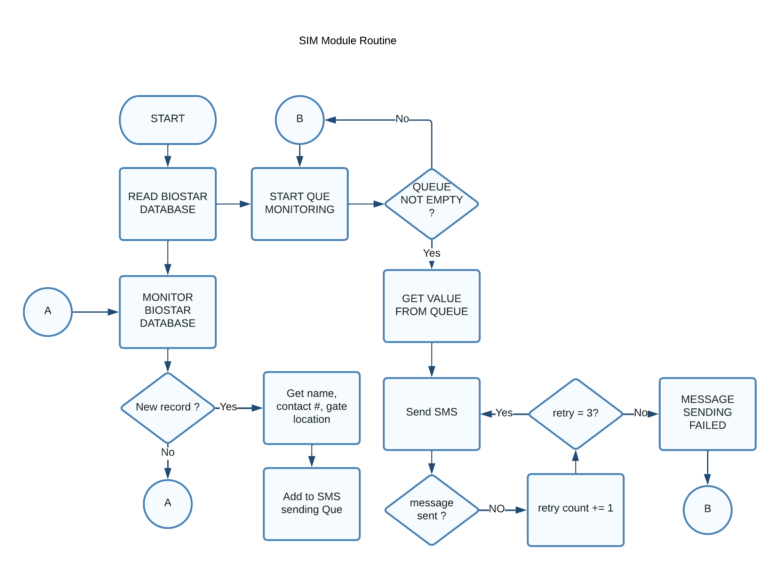Figure 1: SIM808 Program flow

Program written in python and running as a service. The program follows this event upon boot to make sure all of the communication is working as expected before going to actual Database monitoring.

1. SIM808 Test communication.
   * The program will try over and over again until the SIM808 responds and is ready to take any commands.
2. Database Test communication.
   * The program will try to do a basic query of reading existing records (master table) of the target table. If the query succeeded, it will proceed to the next process.
   * If query failed, it will wait 10 seconds and try over and over again
3. Program enters a loop process where it monitors the database contents by querying record count. If the record count is not the same as the master table, it will retrieve the new record and other information associated with it then update the master table.
4. Sends an SMS to target contact number and log the status. The program will retry sending message for at least 3 times before going back to the loop.
5. The loop process starts again

## Troubleshooting

The device is working as headless *(without attached display)* and has an LED (*red and green)* attached to it. Red LED indicates that something was wrong and that the process fails.

To monitor the process, the device has a detailed logging system that logs each events happening within the routine. The logs renew every day and the old logs can be retained up to 7 days. Logs that is older than 7days will be deleted automatically.

Filepath of the source code:

*/home*/elid/sim/sim808_integration/app/main.py

Filepath of the logs:

*/home/elid/sim/sim8080_integration/logs/*

to monitor the logs in realtime, SSH to the device with credentials:  
user : elid  
pass: ELID-SIM  
  
Enter the command  
  
*tail -f ./sim/sim_integration/app/logs/sim.log*

## Hardware connection

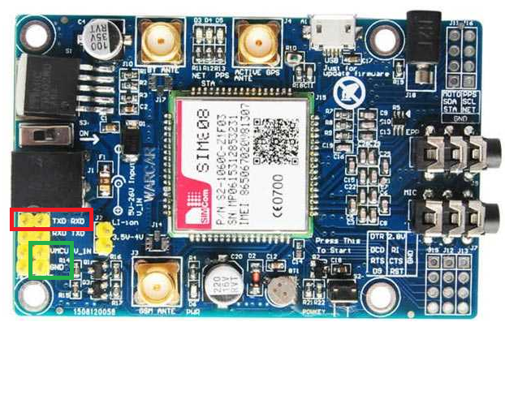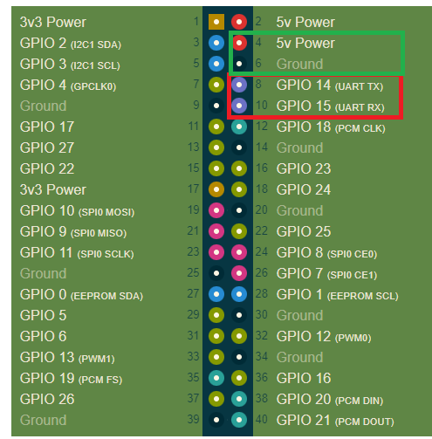

*RPI RX to SIM808 TX  
RPI TX to SIM808 RX  
RPI GND to SIM808 GND*

*RPI 5v to SIM808 VMCV*

Use 12v to 24v DC power supply directly to SIM808. Rasberry Pi will get its power through the SIM808 regulator.