**CogView: Mastering Text-to-Image Generation via Transformers**

**Project Team:**

Leela Prasanna

Mahitha

Lija George

George Emmanuel

Prathyush Turaga

**Implementation Process**

1. As part of this process, we will be implementing CogView project on a simulation system.
2. For this purpose, we will take a virtualization software like VMWare or Virtual Box.
3. Upon the virtualization software, we will mount a server-based operating system like any available Linux distribution.
4. We have taken Kali Linux here as the virtual environment.

1. Inside latest image of Kali Linux, we will check if Python is installed and available. Also, we will need pip as python package manager for installing required libraries.
2. Upon checking the Virtual Machine (VM), we observed that latest Python 3.10 is pre-installed along with pip with version 20+.
3. Now, we will down the CogView github repository and extract it in a folder on Kali Linux.

<https://github.com/THUDM/CogView>

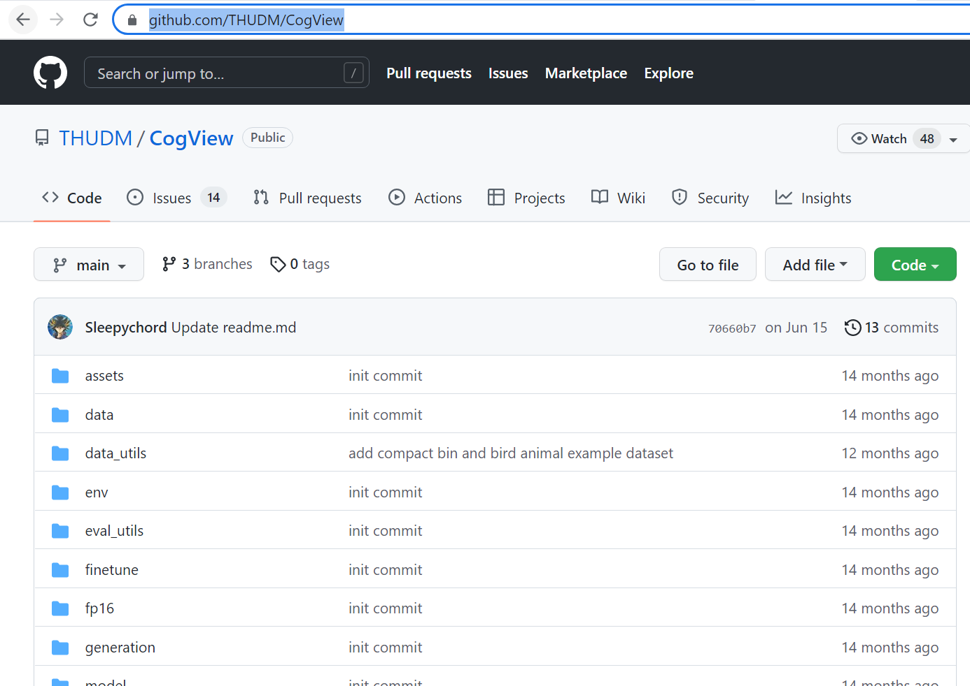

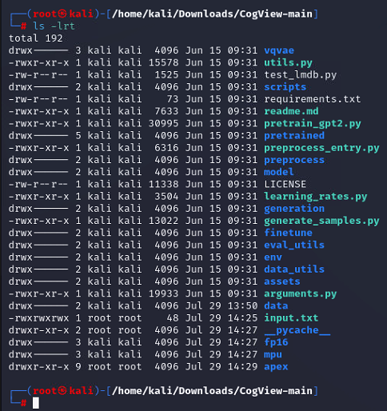

1. After extracting, we will install required python libraries with below command.

#pip install -r requirements.txt

1. Subsequently we will run commands as advised in github repository read.me section of existing research work.

1. Here we will execute sequence of python and shell scripts to setup the environment and creating the neural network model.
2. Finally when we execute the model it will find the right image for given text.