ZJU_IBM Joint Project Proposal
(# , input by UR team)
Basic Information
Project Title: Social Enabled Semantic Data Mashup
2008 UR Theme: WATP
CRL Contact/Reporting manager: Gou Tong Xie
Contact phone: 010-58748425
Email: xieguot@cn.ibm.com

Department/ University: College of Computer Science, Zhejiang University
Professor: Huajun Chen
Contact Person: Huajun Chen
Contact Phone: 13958093536
E-mail: huajunsir@gmail.com
Project Start Date: 07/01/2008

Project End Date: 06/31/2009
Project Description
- Focus Areas: Semantic Web, Data Mashup, Collective Intelligence, Social Software, Schema/Semantic Mapping, Information Integration.
- Description:
  - Research Background
There is an essential transformation taking place on the web around data composition through so-called mashups [1,2]. Their popularity stems from the emphasis on building situational applications which are typically drawn upon content retrieved from external data sources and constructed on the fly for a transit period. A typical example is chicagocrime.org which mashes crime data from Chicago Police Department’s online database with cartography from Google maps.
Another prominent trend is the structurization and semantization of web content. For instance, as a type of structured format embedded in HTML, microformat prevails in many Web 2.0 applications such as LinkedIn, Twitter, Yahoo Local, Google Base, etc. More significantly, as semantic web technologies receive wider and wider industrial acceptance, more and more open linked data is becoming available on the Web. A typical example is DBPedia. In the current, the DBpedia dataset provides RDF descriptions about more than 2.18 million “things”, including at least 80,000 persons, 293,000 places, 62,000 music albums, 36,000 films. Many other new startups are opening their data and provide structured data API such as Freebase.com, twin.com ect..
However, the current mashup technology such as Yahoo Pipe and Microsoft Popfly mainly deals with news feeds, with rare consideration of more structured information such as Microformat and open linked data. In other words, one of the typical limitations of current mashup applications is the lack of logical foundation for data description, semantic mapping, and annotation, particularly for rich structured information.
This project aims at providing a novel data mashup framework based upon semantic web technologies. Specifically, we emphasize on resolving two principal problems:
- How does collective intelligence help resolve the notorious issue of semantic heterogeneity for mashing up more structured web content such as microformat and open linked data. For this problem, we propose the idea of “Social Semantic Mapping” that intend to take advantage of social aspect of web community to incrementally establish semantic mapping among large amount of data items.
- How does semantics enable more intelligent and automatic mashup composition and discovery. For the problem, we are going to develop key technology and prototype system for end user to annotate, publish, sharing, composite mashup blocks with semantics.
The project will leverage the experiences learned from previous semantic web data integration projects such as DartGrid [5,6] from Zhejiang University , and IBM Metadata Web project. The major deliverables will be a prototype system, several key technologies and high-quality conference publications.

- Project Definition/Description
Distinguished from those prevalent mashup approaches, the framework features in utilizing semantic web technologies and collective intelligence to tackle the data diversity and model heterogeneity issues for mashing up more structured web content such as Microformat, open linked data, SPARQL endpoint etc.. Specifically, the project consists of the following parts of research:
    - Social Semantic Mapping.
In addition to managing social networking, the social component will also serve a particular purpose terms as “social mapping” in the proposed framework. By social mapping, we mean the semantic mapping will be built up incrementally by a community, among which users can share their mappings and form a large mapping network collaboratively. The key research issues includes mapping sharing, mapping composition, mapping inconsistence, etc..
    - Semantic-based Automatic Mashup Composition.
One big challenge for current mashup applications is how to make mashup manipulation automatic and intelligent as far as possible. We are going to study in depth on how semantic technology can facilitate in automatic mashup annotation, discovery, recommendation, and composition.
    - Visualization and Interaction Component
The major objective of this component is to facilitate the interaction and manipulation of both semantics and mashups. Figure 1 illustrated an envisioned feature of the mashup visualization, in which data item is modeled as pieces of JIGSAW. The mapping is modeled as matching between interfaces of different pieces.
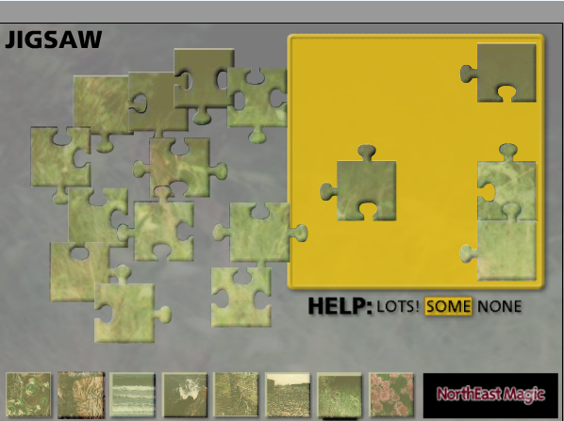
Figure 1. Envisioned mashup manipulation user interface.
- Potential Business Value
Web Information Integration is a big business for IBM, and information server contains a set of design time (Data Studio, Rational Data Architect, WebSphere Business Glossary etc.) and runtime tools (WebSphere Federation Server, WebSphere DataStage etc.) to integrate enterprise data sources. Also, other data management offerings like business intelligence or master data management require the integrated data. This project will greatly simplify information integration tasks in the above products.
Social software and semantic technology is gaining wider and wider attention in many modern Web applications. The project tries to advance the social technology in terms of a combination of data mashup and semantic web applications . It has the potential of inspiring and driving new types of mashup and semantic web applications.
- Innovation/Technical Value
The key innovation and technical value underlying this project are the social enabled semantic mapping and semantic-based mashup composition and discovery for more mashing up more structured web content such as microformat, open linked data and SPARQL endpoint.
3) Project Milestone/Checkpoint/Key Results
09/2008, develop semantic annotation tool for mashup blocks.
12/2008, develop social semantic mapping components and submit 1 paper to PIC top quality conference (e.g. WWW). (mid-year review)
3/2009, develop mashup algorithm and components for mashup discovery and composition.
5/2009, submit 1 paper to PIC top quality conference (e.g. ISWC).

A Workshop will be hold in 12/2008 and 3/2009.
Project Sizing & Funding Request
Research People | Average  Utilization | Period  (Month) | Total No. of Person Month | Funding  Request  (RMB)
Huajun Chen | 30% | 12 |  | 100K
Chunyin Zhou | 100% | 12 |  | 100K
Junjian Wang | 100% | 12 |  | 100K
Chao Wang | 100% | 12 |  | 100K
University Investment:
- People
No. of professor: 1 No. of PhD: 1
No. of Master: 1 No. of Bachelor: 3 Others:
2) Others
Brief bio of lead professor from university
Huajun Chen received a bachelor degree in Biochemical engineering in 2000, and PhD degree in computer science in 2004 respectively, both from Zhejiang University. He was a visiting assistant professor in Yale Center for Medical Informatics of Yale University from June, 2006 to June, 2007. He also did a visiting researcher position in School of Computer Science, Carnegie Mellon University from June, 2007 to April, 2008. His major research interest is the Semantic Web, Data Integration and their applications in life science and heath-care. He won the best paper award in the in-use track of 2006’s international semantic web conference. He chaired or co-chaired several events relevant to semantic web such as AAAI2007’s workshop on Semantic e-Science, WWW2007/2008’s serial workshops on Semantic Web for Life Science and Healthcare. He has ever served as guest editor for BMC Bioinformatics (SCI Impact 3.6), Journal of Biomedical Informatics (SCI Impact 2.34), and Journal of Computing and Informatics.
Reference
- D. Butler. Mashups mix data into global service. Nature., 439(5):6–7, 2006.
- A. Jhingran. Enterprise information mashups: Integrating information, simply. In VLDB, pages 3–4, 2006.
- Anupriya Ankolekar, Markus Krötzsch, Thanh Tran, Denny Vrandecic. The Two Cultures：Mashing up Web 2.0 and the Semantic Web. WWW2007.
- Giovanni Tummarello, Axel Polleres, Christian Morbidoni and Danh Le Phuoc. Data Level Mashups with Semantic Web Pipes. WWW2008.
- H. Chen, Z. Wu, H. Wang, and Y. Mao. Rdf/rdfs-based relational database integration. In ICDE, page 94, 2006.
- H. Chen, Z Wu, etal. Towards a Semantic Web of Relational Databases: a Practical Semantic Toolkit and an In-Use Case from Traditional Chinese Medicine. ISWC2006.

