**Lab 7: Scale and Load Balance your Architecture**

**Figure 1**

*A screenshot of the auto scaling group page.*

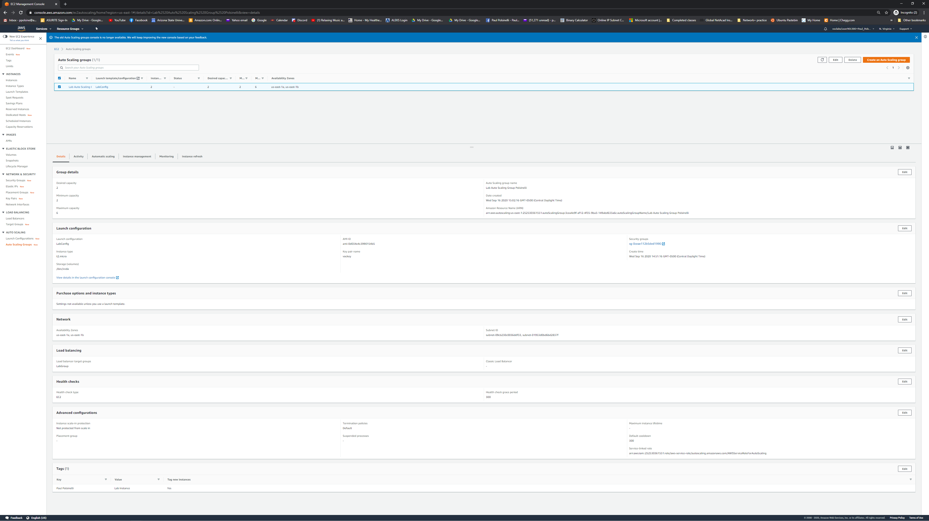

**Figure 2**

*A screenshot of the Load Balancers page.*

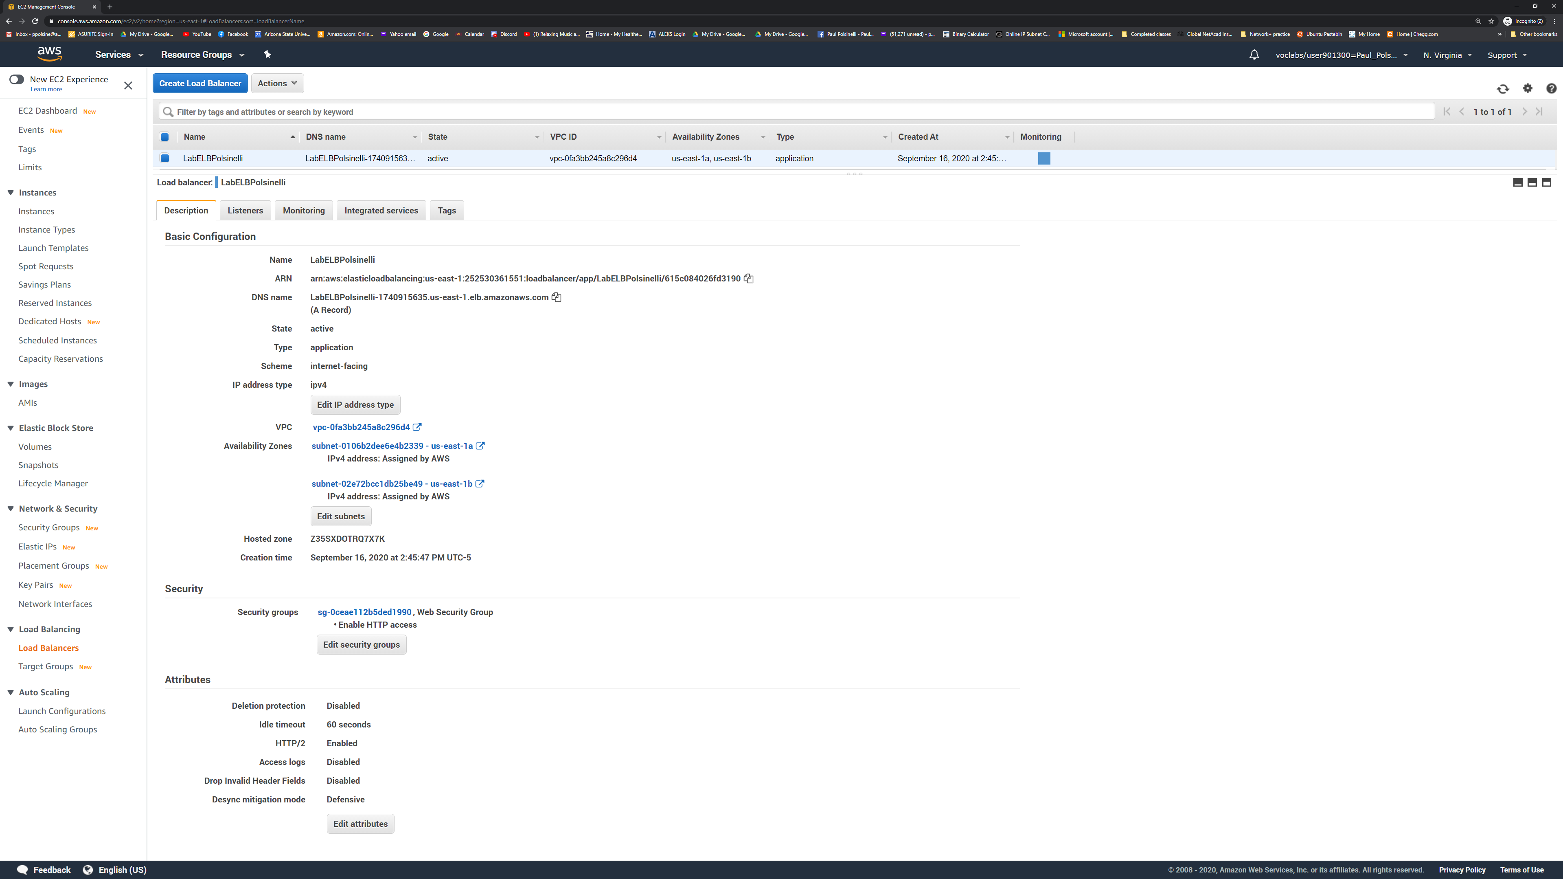

**Figure 3**

*A screenshot of browser hitting website.*

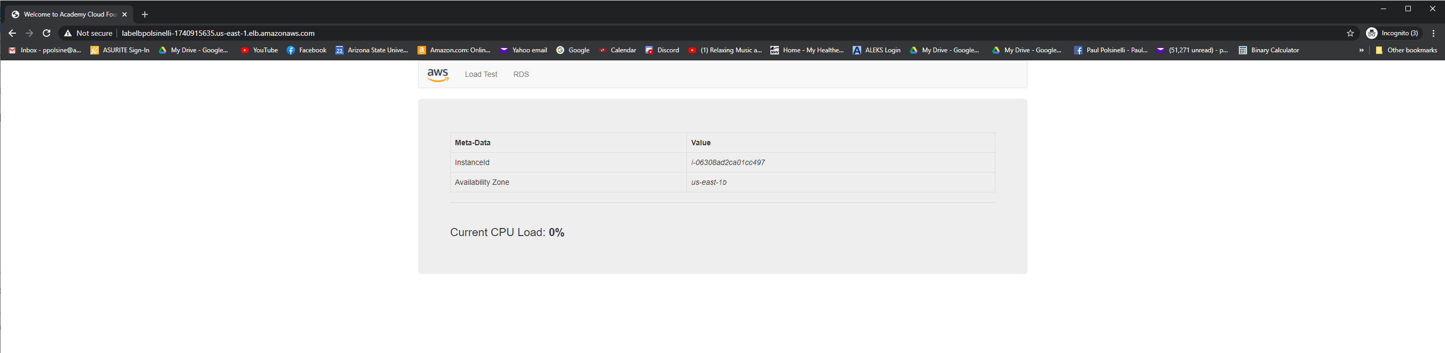

**Figure 4**

*A screenshot of instances page.*

