**Lab 2: Create Your VPC**

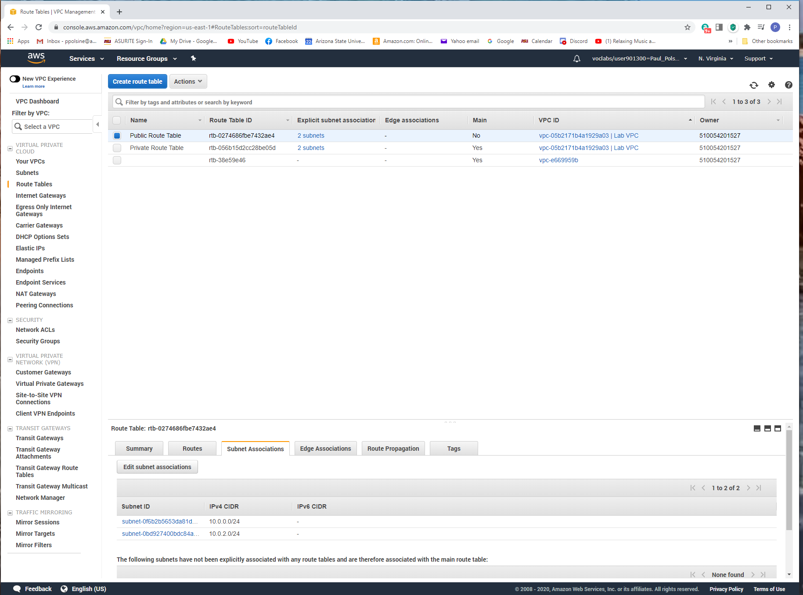

*Figure 1*. Screenshot of both subnets associated with your VPC.

**Lab 2: Create Your VPC**

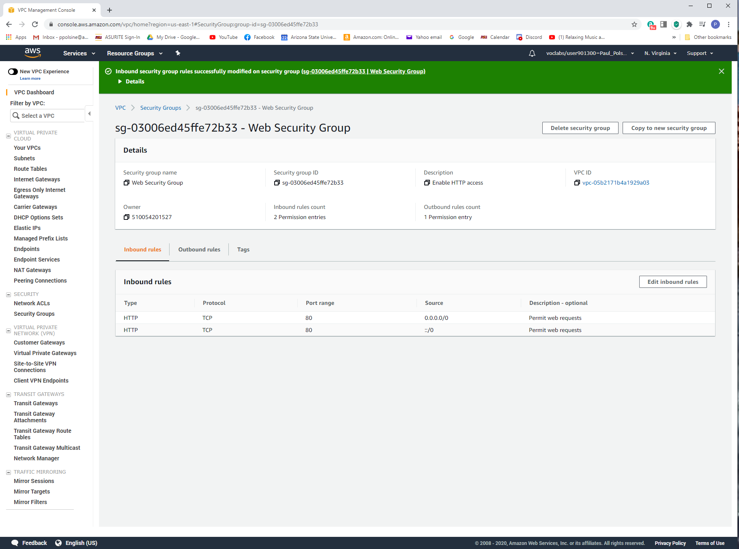

*Figure 2.* Screenshot of the security group rules.

**Lab 2: Create Your VPC**

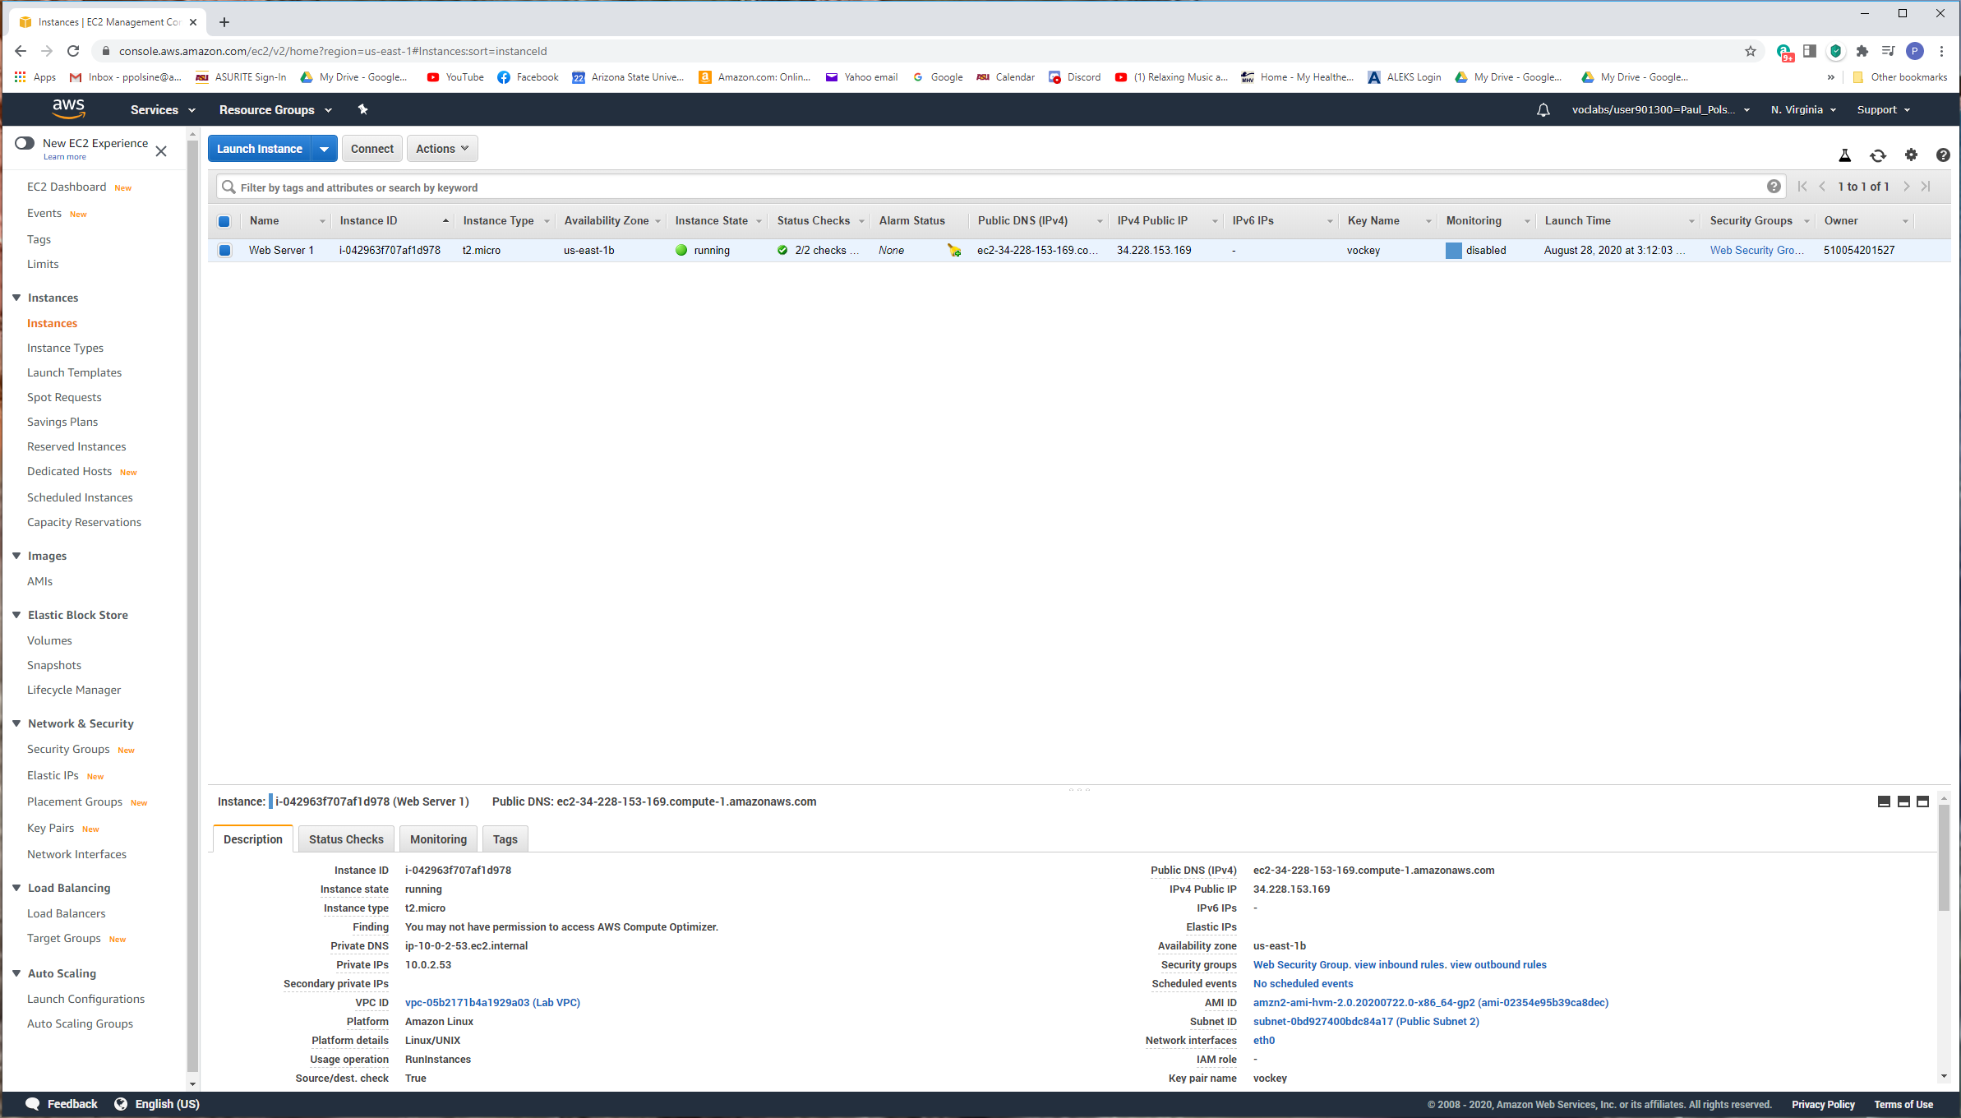

*Figure 3.* Screenshot including the details of the webserver.

**Lab 2: Create Your VPC**

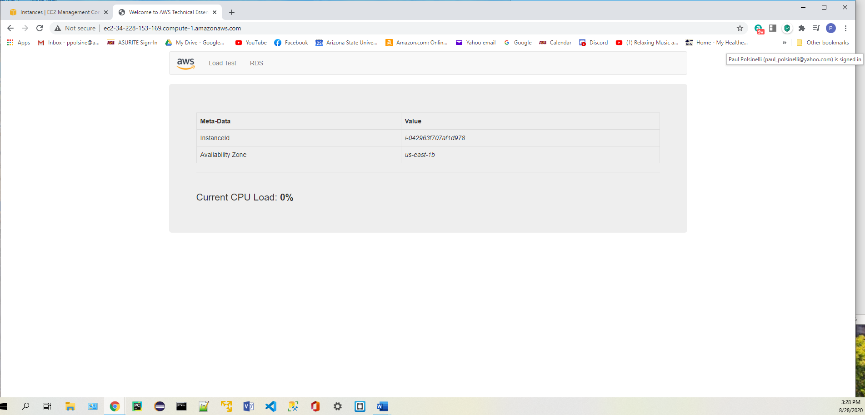

*Figure 4.* Screenshot of accessing the webserver through a web browser.