Paul Polsinelli

5/28/2020

Lab 2: Computer Information System Protections

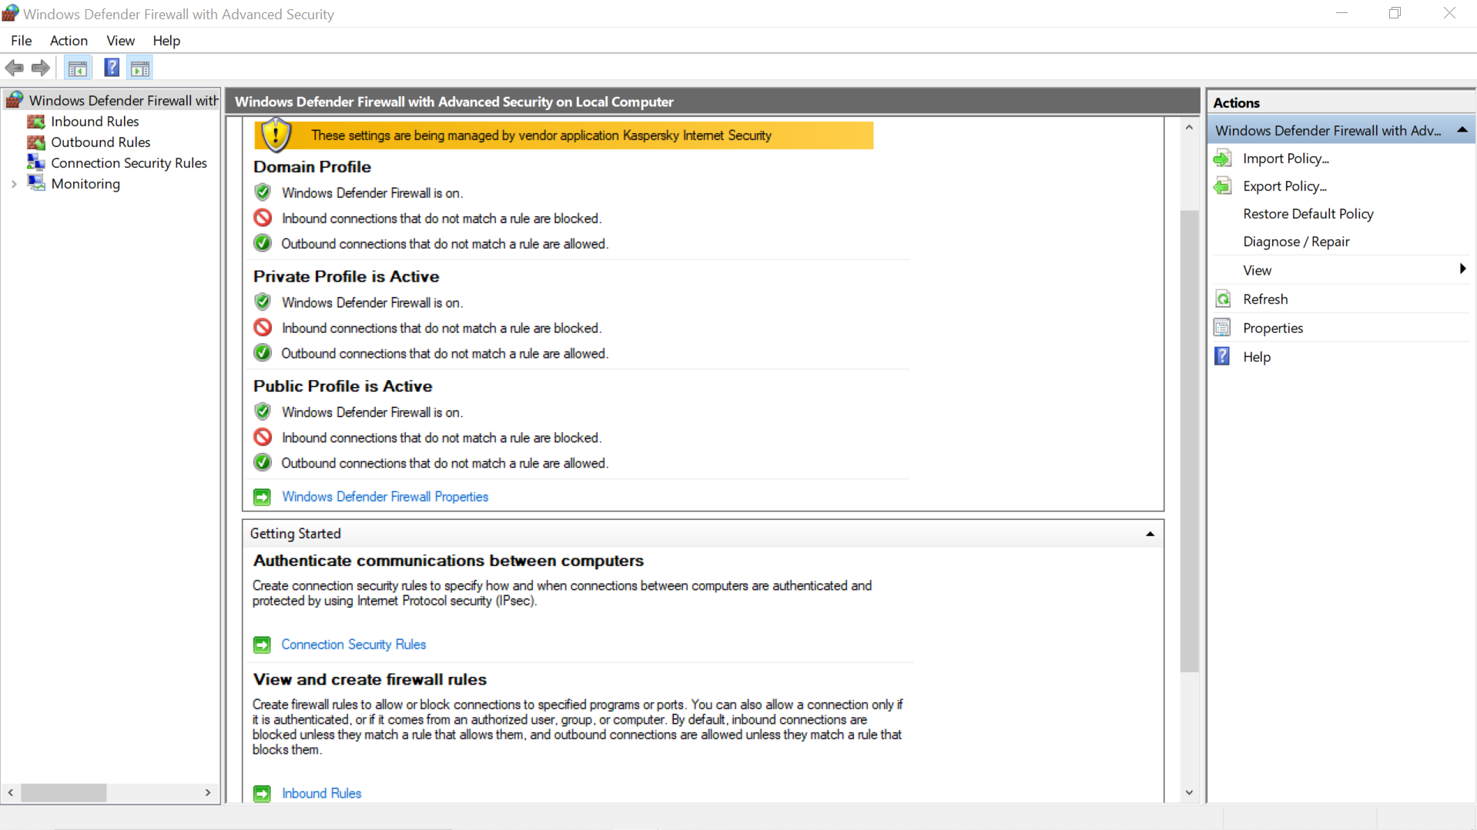

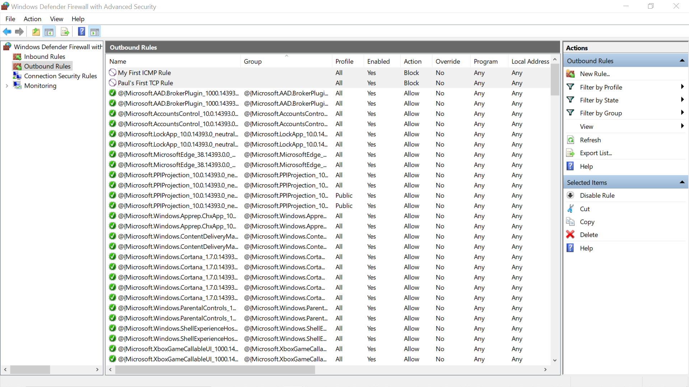

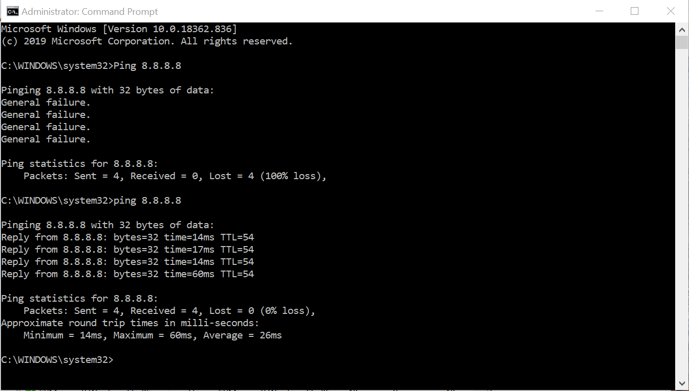

Respond to the following questions. Provide APA formatted citations and references to your resources.

1. What are the three main types of networks that Windows Firewall handles?

Domain, Private, and Public. (Brooks et al., 2008, pg 226)

1. When might you disable Windows Firewall?

If your network administrator is running a physical firewall appliance and it is simpler for them to manage network-wide permissions for security. (2)

1. What are the four Rule types that you can create with the New Rule Outbound Wizard?

Program, Port, Predefined, and Custom. (Brooks et al., 2008, pg 231)

1. What is an easy way to test ICMP echo requests? What responses are possible?

Enable and disable ICMPv4 through Windows Firewall Advanced Security ICMP Outbound Rule Wizard then ping a known working address. You’ll either get General Failure or a Reply. (Brooks et al., 2008, pgs 234 - 240)

1. Do you have the option to block all incoming traffic? Why would you want to do this?

Yes. If you want to see if and when a program is blocked. (Brooks et al., 2008, pg 227)

References

1. Brooks, Grow, Craig, & Short, 2018, *Cybersecurity Essentials*, John Wiley and Sons Inc.
2. Shawn Jordan, What is the advantage of disabling the Window’s Firewall?, <https://www.quora.com/What-is-the-advantage-of-disabling-the-Windows-Firewall>, Jan 5, 2017