核心思路重新梳理
要解决的不只是single-shot evaluation的问题，而是要建立一个comprehensive benchmark that addresses two critical dimensions:
- Realistic Data Composition: 通过调整spam ratio来模拟real-world scenarios
- Synthetic Data Integration: 通过调整synthetic ratio来找到optimal mixing strategies

实验设计的两个关键维度
基于我的理解，实验设计应该包含：
Dimension 1: Spam Ratio Control
- 5% spam: 50 malicious + 950 benign = 1000 total
- 10% spam: 100 malicious + 900 benign = 1000 total
- 15% spam: 150 malicious + 850 benign = 1000 total
- 20% spam: 200 malicious + 800 benign = 1000 total
Dimension 2: Synthetic Mixing Ratio (within malicious samples)
- 0% synthetic: 100% real malicious
- 25% synthetic: 25 synthetic + 75 real malicious
- 50% synthetic: 50 synthetic + 50 real malicious
- 75% synthetic: 75 synthetic + 25 real malicious
- 100% synthetic: 100% synthetic malicious
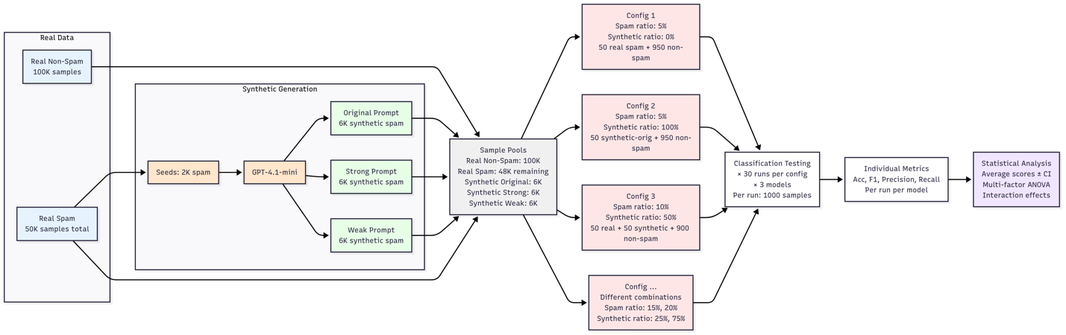

实验规模估算
基于这种设计，总实验规模为：
- 4 spam ratios × 5 synthetic ratios × 3 prompt strategies × 3 models × 30 runs
- 总计: 5,400 individual experiments

典型Configuration示例
- Pure Real Baseline: 10% spam (100 real malicious + 900 real benign)
- Pure Synthetic: 10% spam (100 synthetic-original + 900 real benign)
- Balanced Mix: 10% spam (50 real + 50 synthetic-original + 900 real benign)
- Multi-Strategy: 10% spam (33 original + 33 strong + 34 weak + 900 real benign)

🔧 我建议的具体实施设计

Data Pipeline Architecture
基于现有的batch6架构，我建议以下实施方案：
数据准备:
- 利用现有的2K seeds和已生成的18K synthetic samples
- 从CEAS-08剩余的48K real spam和100K benign构建sampling pools
- 为multi-sample evaluation设计stratified sampling protocol
实验配置管理:
Configuration Matrix:
- 每个config由(spam_ratio, synthetic_ratio, strategy, model)唯一标识
- 每个config重复30次runs
- 每次run生成1000个test samples
- 使用pre-trained models避免重复训练成本
统计分析框架:
- 每个configuration: 30个F1 scores → mean ± CI
- Cross-configuration comparisons: paired t-tests
- Multi-factor ANOVA for interaction effects
- Effect size analysis for practical significance

分阶段实施策略
Phase 1: Pilot Study
- 限制scope: 2 spam ratios × 3 synthetic ratios × 2 strategies × 1 model × 5 runs
- 总计: 60 experiments
- 目的: validate methodology和identify key factors
Phase 2: Selective Expansion
- 基于pilot results，expand到most promising combinations
- 目的: focus on configurations with largest effect sizes
Phase 3: Full Deployment
- 仅在proven value后进行complete experimental matrix

❓ 我的关键疑问和担心

疑问1: 实验规模的可行性
5,400个experiments的规模让我担心：
- 计算时间和成本是否现实？
- 数据管理和结果tracking的复杂度？
- 是否需要cloud computing infrastructure？

疑问2: Statistical Design的优化
- 是否可以用fractional factorial design减少experiments？
- 如何处理multiple comparisons问题？
- Response surface methodology是否更适合这种multi-dimensional optimization？

疑问3: 实际价值的评估
- 在CEAS-08上找到的optimal ratios能否推广到其他cybersecurity datasets？
- 这种highly specific的tuning是否有practical deployment value？
- 投入这么大规模的实验，expected insights的价值如何量化？

疑问4: 技术实施细节
- Multi-run的sampling strategy: 是否需要ensure no overlap between runs？
- Different configurations在同一run中是否应该使用same benign samples？
- Pre-trained models的consistency across different data compositions？

疑问5: 结果解释的复杂性
- Multi-way ANOVA results如何interpret for practical guidance？
- 如何处理potential interaction effects between factors？
- 最终如何提供actionable recommendations for practitioners？

