NICO - Joint Convention - Last updated: 17.Feb 2016

- “Intrinsic” - Positive orientation: the resulting position of a link is closer to NICO's front torso (as in zero position and orientation)

- “Right hand rule” - Example of a robot (see [here]): “(..) all joint displacements are given as relative motions and the right hand rule convention determines the direction of positive rotations.” – Also: Right hand rule is for example used in the popular Denavit Hartenberg Convention
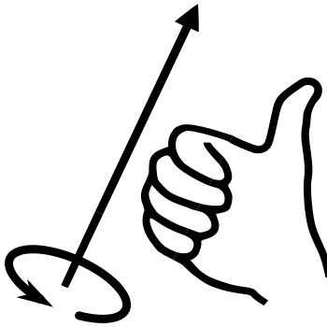
Definition “Right hand rule”: Wikipedia
Used when vector must be defined to represent the rotation of a body. “When gripping the imaginary axis of rotation of the rotational force so that your fingers point in the direction of the force, the extended thumb points in the direction of the torque vector.”
Difference between left-hand-rule and right-hand-rule :
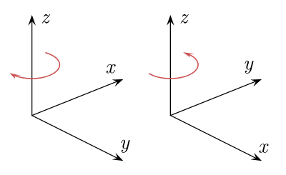
→ Convention used : “intrinsic” (if not clear as for “head_z”: right hand rule)

Upper_part:

Joint name | Simulation | URDF | Real | JSON | Should be
head_z | Right-handed |  | Right-handed | direct | Right-handed
head_y | Right-handed |  | Right-handed | indirect | Right-handed
r_shoulder_z | Right-handed |  | Right-handed | direct | Right-handed
r_shoulder_y | Left-handed | -1 | Left-handed | direct | Left-handed
r_arm_x | Right-handed |  | Right-handed | indirect | Right-handed
r_elbow_y | Left-handed | -1 | Left-handed | indirect | Left-handed
r_wrist_z | Right-handed |  | Right-handed | indirect | Right-handed
r_gripper_x | Right-handed |  | Right-handed | indirect | Right-handed
l_shoulder_z | Left-handed | -1 | Left-handed | indirect | Left-handed
l_shoulder_y | Left-handed | -1 | Left-handed | indirect | Left-handed
l_arm_x | Left-handed | -1 | Left-handed | direct | Left-handed
l_elbow_y | Left-handed | -1 | Left-handed | direct | Left-handed
l_wrist_z | Left-handed | -1 | Left-handed | direct | Left-handed
l_gripper_x | Left-handed | -1 | Left-handed | direct | Left-handed

Lower_part:

Joint name | Simulation | URDF | Real | JSON | Should be
r_hip_z | Right-handed |  | Right-handed | indirect | Right-handed
r_hip_y | Left-handed | -1 | Left-handed | direct | Left-handed
r_hip_x | Right-handed |  | Right-handed | direct | Right-handed
r_knee_y | Left-handed | -1 | Left-handed | direct | Left-handed
r_ankle_y | Left-handed | -1 | Left-handed | indirect | Left-handed
r_ankle_x | Right-handed |  | Right-handed | indirect | Right-handed
l_hip_z | Left-handed | -1 | Left-handed | direct | Left-handed
l_hip_y | Left-handed | -1 | Not checked | direct | Left-handed
l_hip_x | Left-handed | -1 | Not checked | direct | Left-handed
l_knee_y | Left-handed | -1 | Not checked | indirect | Left-handed
l_ankle_y | Left-handed | -1 | Not checked | direct | Left-handed
l_ankle_x | Left-handed | -1 | Not checked | direct | Left-handed

Notes:

- To enable “symmetric” orientation convention:
  - rotation around y: both same handed
  - rotation around x or z: one left- the other one right handed

- VREP TROUBLES:
  - Importing correct joint orientation via the URDF
  - See also here: http://www.forum.coppeliarobotics.com/viewtopic.php?f=5&t=1969

  - Problem:
When importing the URDF all joints, that rotate around the z axis are all RIGHT-Handed, this means following joints are different: l_shoulder_z , l_wrist_z , l_hip_z

