Had Lab Flutter Basics

Sohan M
1NT19IS155

Main.dart

import 'package:flutter/material.dart';
void main() {
runApp(MaterialApp(
home:Scaffold(
appBar : AppBar (
title : Text (" First Flutter App ") ,
), body : Center (
child : Text ('Abd is the G.O.A.T' ,
style : TextStyle (
fontSize : 40.0 ,
fontStyle : FontStyle . italic ,
fontWeight : FontWeight . bold ,
),
),
) ,
) ,
) );
}
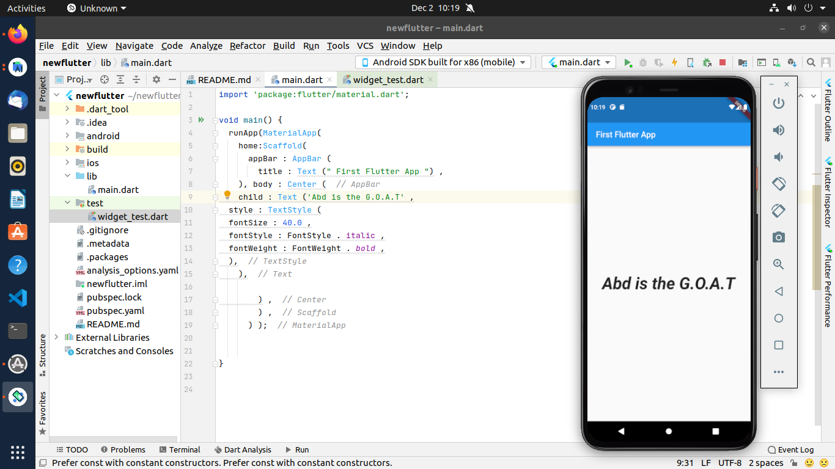
// This is a basic Flutter widget test.
//
// To perform an interaction with a widget in your test, use the WidgetTester
// utility that Flutter provides. For example, you can send tap and scroll
// gestures. You can also use WidgetTester to find child widgets in the widget
// tree, read text, and verify that the values of widget properties are correct.
import 'package:flutter/material.dart';
import 'package:flutter_test/flutter_test.dart';
import 'package:newflutter/main.dart';
void main() {
testWidgets('Counter increments smoke test', (WidgetTester tester) async {
// Build our app and trigger a frame.
await tester.pumpWidget(MaterialApp());
// Verify that our counter starts at 0.
expect(find.text('0'), findsOneWidget);
expect(find.text('1'), findsNothing);
// Tap the '+' icon and trigger a frame.
await tester.tap(find.byIcon(Icons.add));
await tester.pump();
// Verify that our counter has incremented.
expect(find.text('0'), findsNothing);
expect(find.text('1'), findsOneWidget);
});
}

