HAD SAFE AREA

SOHAN M
1NT19IS155

// This is a basic Flutter widget test.
//
// To perform an interaction with a widget in your test, use the WidgetTester
// utility that Flutter provides. For example, you can send tap and scroll
// gestures. You can also use WidgetTester to find child widgets in the widget
// tree, read text, and verify that the values of widget properties are correct.
import 'package:flutter/material.dart';
import 'package:flutter_test/flutter_test.dart';
import 'package:safearea/main.dart';
void main() {
testWidgets('Counter increments smoke test', (WidgetTester tester) async {
// Build our app and trigger a frame.
await tester.pumpWidget(MaterialApp());
// Verify that our counter starts at 0.
expect(find.text('0'), findsOneWidget);
expect(find.text('1'), findsNothing);
// Tap the '+' icon and trigger a frame.
await tester.tap(find.byIcon(Icons.add));
await tester.pump();
// Verify that our counter has incremented.
expect(find.text('0'), findsNothing);
expect(find.text('1'), findsOneWidget);
});
}

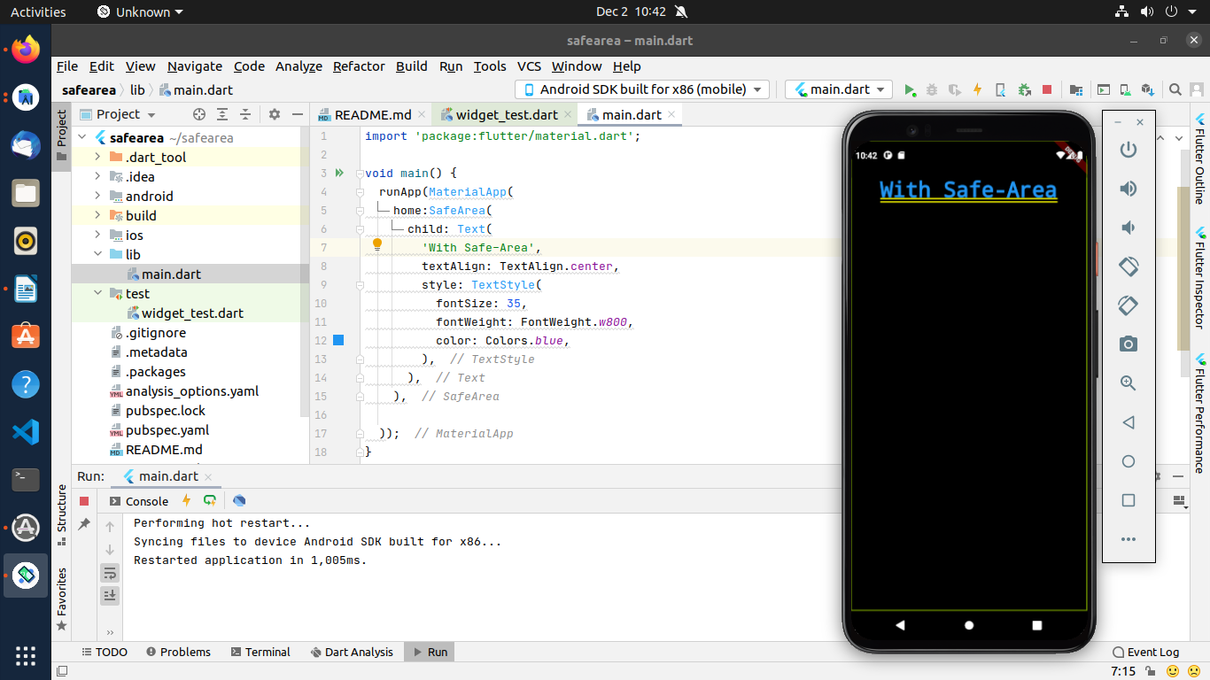
import 'package:flutter/material.dart';
void main() {
runApp(MaterialApp(
home:SafeArea(
child: Text(
'With-Out Safe-Area',
textAlign: TextAlign.center,
style: TextStyle(
fontSize: 35,
fontWeight: FontWeight.w800,
color: Colors.blue,
),
),
),
));
}

WITHOUT SAFE AREA

// This is a basic Flutter widget test.
//
// To perform an interaction with a widget in your test, use the WidgetTester
// utility that Flutter provides. For example, you can send tap and scroll
// gestures. You can also use WidgetTester to find child widgets in the widget
// tree, read text, and verify that the values of widget properties are correct.
import 'package:flutter/material.dart';
import 'package:flutter_test/flutter_test.dart';
import 'package:safearea/main.dart';
void main() {
testWidgets('Counter increments smoke test', (WidgetTester tester) async {
// Build our app and trigger a frame.
await tester.pumpWidget(MaterialApp());
// Verify that our counter starts at 0.
expect(find.text('0'), findsOneWidget);
expect(find.text('1'), findsNothing);
// Tap the '+' icon and trigger a frame.
await tester.tap(find.byIcon(Icons.add));
await tester.pump();
// Verify that our counter has incremented.
expect(find.text('0'), findsNothing);
expect(find.text('1'), findsOneWidget);
});
}

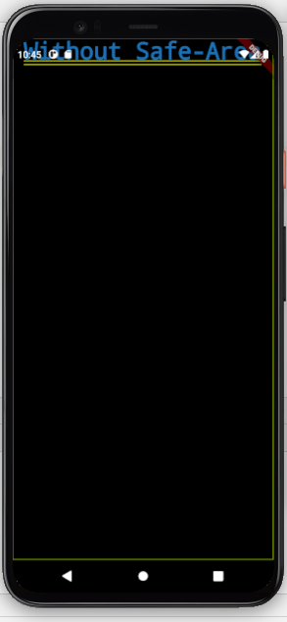
import 'package:flutter/material.dart';
void main() {
runApp(MaterialApp(
home:
Text(
'Without Safe-Area',
textAlign: TextAlign.center,
style: TextStyle(
fontSize: 35,
fontWeight: FontWeight.w800,
color: Colors.blue,
),
),
));
}

