

**A**

**Mini Project Report On**

**“Blood Search”**

**Submitted By**

**Roll No Name of Student**

**40 SalilKumar Natoo**

**22 Jivan Ghadage**

**24 Akshay Gonjari**

**29 Vikas Khade**

**Under The Guidance Of**

**Mr. N. S. Mahajan**

**Department Of Computer Science & Engineering**

Kolhapur Institute of Technology’s

**College of Engineering, Kolhapur.**

**Academic Year 2013-14**

**CERTIFICATE**



This is to Certify that the project entitled

“Blood Search”

has been satisfactorily completed by:

1.Salilkumar Natoo

2.Jivan Ghadage

3.Akshay Gonjari

4.Vikas Khade

The students of T.E. Computer Science & Engineering department, in partial fulfilment of the “Mini Project II” laid down by Shivaji University, Kolhapur for the academic year 2010-11.

This project report is a record of student’s own work carried by them under my supervision and guidance in a satisfactory manner.

***Prof. N. S. Mahajan Prof. P. S. Patil***

*(Guide) (HOD)*

*Principal*

Kolhapur Institute of Technology’s

**College of Engineering, Kolhapur.**

**Academic Year 2013-14**

**ACKNOWLEDGEMENT**

We would like to express our deepest gratitude to Prof. N.S. Mahajan and H.O.D Prof. P. S. Patil for their constant encouragement and belief in us. Their guidance and attention throughout the project work has been of immense help to us.

We express our sincere thanks to all the teaching and non teaching staff and all those who have directly or indirectly helped in making project a success.

Sincerely by

Roll No Name

40 Salilkumar Natoo

22 Jivan Ghadage

24 Akshay Gonjari

29 Vikas Khade

**Index**

|  |  |  |
| --- | --- | --- |
| **Sr. No.** | **Contents** | **Page No.** |
| 1 | Abstract | 5 |
| 2 | Introduction | 7 |
| 3 | Feasibility Study | 9 |
| 4 | Sitemap | 12 |
| 5 | ER-Diagrams | 14 |
| 6 | Data Tables |  |
| 7 | Screen Shots |  |
| 8 | Hardware and Software | 16 |
| 9 | Conclusion | 18 |
| 10 | References | 20 |
| 11 |  | 26 |
| 12 |  | 29 |
| 13 |  | 30 |

**ABSTRACT**

It is hard to find donors in Maharashtra. Maximum casualties can be saved if necessary amount of blood could be made available. Thus to help people find the donors, Blood Search website will be useful. By entering the blood group and the city location of the recipient, list of blood donors can be shown at once. Their contact numbers and secret id is shown. As to hide the real identity and protect the donors a code name is used.

Blood Search website also describes about the facts about blood donation. Various Information regarding donation of blood is stated in the website. Blood Donors have numerous queries regarding health and proper donation of blood. Answer to the frequently asked questions is stated in right manner.

One can register himself/herself on the site and can contribute to the donation. Your identity will be kept hidden as only code name of the person is generated while finding the donor.

**INTRODUCTION**

Human blood groups were discovered in 1900 and since then a variety of different styles of terminology has been used to denote them. In 1980 the International Society of Blood Transfusion (ISBT) established a Working Party (later to become a Committee) to devise a genetically based numerical terminology for red cell surface antigens. The mandate of the Committee is to maintain the numerical terminology for red cell surface antigens. By definition, these antigens must be defined serologically by the use of a specific antibody. All antigens receiving ISBT numbers must have been shown to be inherited characters. The information presented on this website is an update of the latest publication of the Committee.

All authenticated antigens fall into one of four classifications: systems, collections (200 series), low incidence antigens (700 series), and high incidence antigens (901 series).

A blood group system consists of one or more antigens controlled at a single gene locus, or by two or more very closely linked homologous genes with little or no observable recombination between them. Currently recognized antigens within blood group systems are shown in the table.

Collections consist of serologically, biochemically, or genetically related antigens, which do not fit the criteria required for system status.

The 700 Series contains antigens with an incidence of less than 1% and which cannot be included in a system or collection.

The 901 Series contains antigens with an incidence of greater than 90% and which cannot be included in a system or collection.



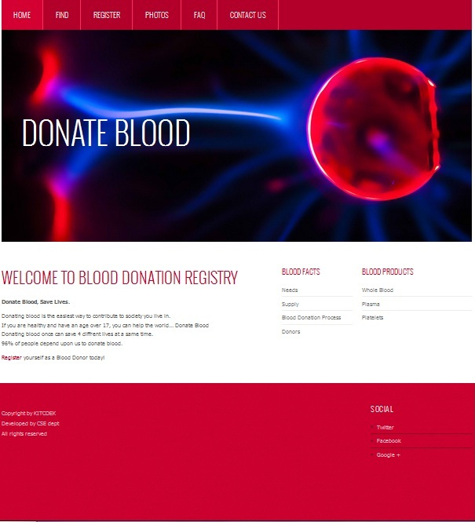

DONATE BLOOD

CONTACT US

FAQ

PHOTOS

REGISTER

FIND

HOME

**ER-DIAGRAM**

1. List of Figures
2. Introduction
3. Software Model
4. Design
   1. System Design
   2. Detailed Design
   3. Data flow Diagram
5. Technology Used
   1. Sample Code
   2. Text files created for project
6. Snapshots
7. Testing
8. Deployment
9. Hardware and Software Requiremnts
10. Future Work
11. Conclusion
12. Bibliography and References

Mini Project II report format

Font – Times New Roman

Chapter heading size 16 Bold

Section Heading size 14 Bold

Subsection size 12 Bold

Text size 12

Figure labels at bottom of figure size 10

Table labels at top of table size 10

Give Section numbers, subsection numbers and figure number, table number according to chapter viz. 2.1, Figure 4.2, Table 5.2 etc.

Sample 2

------------

Certificates (2)

Acknowledgment

Abstract

Table of Contents

Introduction

Business Requirement

UML Design

Use case diagram

UML Classes

Framework of the development

Logical architectural diagram

IDE and tools

Prototype of the System

Reference and Bibliography

Appendix A (Project Plan)

--------------------------------

Sample 3

------------

Certificates (2)

Acknowledgment

Abstract

Table of Contents

Introduction

System Analysis

Introduction

Existing System

Proposed System

Features of Software

HTML

DREAMWEAVER

PHP

MYSQL

JAVA SCRIPT

The Architectural Model

Software Requirments

Hardware Requirements

System Design

Web Form Design

Home Page

Database / Table Design

Link and Web Pages

Coding

Features of Language

Testing

System Testing

Unit Testing

Integration Testing

Validation Testing

Output Testing

Conclusion

References and Bibliography

Appendix / Appendices