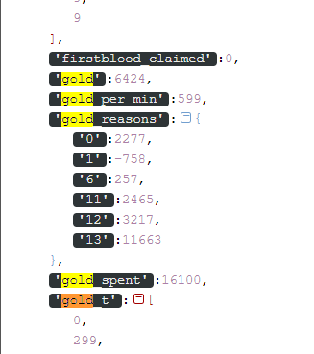

'xp_reasons':{

* '0':13,
* '1':10419,
* '2':17702

'total_gold':22412,

'total_xp':28474,

'win':1,

* 'total_xp':28474,
* 'kills_per_min':0.267260579064588,
* 'kda':6,
* 'abandons':0,
* 'neutral_kills':76,
* 'tower_kills':2,
* 'courier_kills':0,
* 'lane_kills':195,
* 'hero_kills':10,
* 'observer_kills':1,
* 'sentry_kills':0,
* 'roshan_kills':0,
* 'necronomicon_kills':0,
* 'ancient_kills':6,
* 'buyback_count':0,
* 'observer_uses':2,
* 'sentry_uses':0,
* 'lane_efficiency':0.746229640056304,
* 'lane_efficiency_pct':74,
* 'lane':2,
* 'lane_role':2,
* 'is_roaming':False,

'benchmarks':{

* 'gold_per_min':{
  + 'raw':599,
  + 'pct':0.8935400516795866

},

* 'xp_per_min':{
  + 'raw':761,
  + 'pct':0.9167958656330749

},

* 'kills_per_min':{
  + 'raw':0.26726057906458794,
  + 'pct':0.7126614987080103

},

* 'last_hits_per_min':{
  + 'raw':7.269487750556793,
  + 'pct':0.903359173126615

},

* 'hero_damage_per_min':{
  + 'raw':717.2472160356348,
  + 'pct':0.7700258397932817

},

* 'hero_healing_per_min':{
  + 'raw':0,
  + 'pct':0.7824289405684755

},

* 'tower_damage':{
  + 'raw':9657,
  + 'pct':0.958139534883721

},

* 'stuns_per_min':{
  + 'raw':2.27823714922049,
  + 'pct':0.8397932816537468

},

* 'lhten':{
  + 'raw':60,
  + 'pct':0.9491437467566165

}

}

|  |  |  |
| --- | --- | --- |
| **Name** | **Value** | **Description** |
| DOTA_ModifyGold_Unspecified | 0 |  |
| DOTA_ModifyGold_Death | 1 |  |
| DOTA_ModifyGold_Buyback | 2 |  |
| DOTA_ModifyGold_PurchaseConsumable | 3 |  |
| DOTA_ModifyGold_PurchaseItem | 4 |  |
| DOTA_ModifyGold_AbandonedRedistribute | 5 |  |
| DOTA_ModifyGold_SellItem | 6 |  |
| DOTA_ModifyGold_AbilityCost | 7 |  |
| DOTA_ModifyGold_CheatCommand | 8 |  |
| DOTA_ModifyGold_SelectionPenalty | 9 |  |
| DOTA_ModifyGold_GameTick | 10 |  |
| DOTA_ModifyGold_Building | 11 |  |
| DOTA_ModifyGold_HeroKill | 12 |  |
| DOTA_ModifyGold_CreepKill | 13 |  |
| DOTA_ModifyGold_RoshanKill | 14 |  |
| DOTA_ModifyGold_CourierKill | 15 |  |
| DOTA_ModifyGold_SharedGold | 16 |  |

**EDOTA_ModifyXP_Reason**

|  |  |  |
| --- | --- | --- |
| **Name** | **Value** | **Description** |
| DOTA_ModifyXP_Unspecified | 0 |  |
| DOTA_ModifyXP_HeroKill | 1 |  |
| DOTA_ModifyXP_CreepKill | 2 |  |
| DOTA_ModifyXP_RoshanKill | 3 |  |