**Topics: Normal distribution, Functions of Random Variables**

1. The time required for servicing transmissions is normally distributed with *μ* = 45 minutes and *σ* = 8 minutes. The service manager plans to have work begin on the transmission of a customer’s car 10 minutes after the car is dropped off and the customer is told that the car will be ready within 1 hour from drop-off. What is the probability that the service manager cannot meet his commitment?
2. 0.3875
3. 0.2676
4. 0.5
5. 0.6987

ANS: B

*μ* = 45 min, SD = 8 min

time to fix the car = 50 min

: probability that service manager cannot meet his commitment = p(>50min)

Z=x-*μ*/SD

50-45/0.8 = 0.625

P (>50) = 1-0.7324 = 0.267

1. The current age (in years) of 400 clerical employees at an insurance claims processing center is normally distributed with mean *μ* = 38 and Standard deviation *σ* =6. For each statement below, please specify True/False. If false, briefly explain why.
2. More employees at the processing center are older than 44 than between 38 and 44.
3. A training program for employees under the age of 30 at the center would be expected to attract about 36 employees.

ANS:

1. false

Approximately 68% of the data falls within one standard deviation of the mean

Mean =38

Standard deviation = 6

38+6 = 44

Therefore 68% employees lie between 38&44

1. true

z= x-*μ*/*σ*

= 30 -38/6 = -1.33

P (<= -1.33) = 0.0918

Number of employees = 0.0918*400 =36

1. If *X1* ~ *N* (μ, σ2) and *X*2 ~ *N* (μ, σ2) are *iid* normal random variables, then what is the difference between 2 *X*1 and *X*1 + *X*2? Discuss both their distributions and parameters.

ANS:

2X1 = N (2μ, (2σ)2))

= N (2 μ, 4 σ2)

= 2N (μ, 2 σ2)

X1 + x2 = *N* (μ, σ2) + *N* (μ, σ2)

= 2N (μ, σ2)

1. Let X ~ N (100, 202). Find two values, *a* and *b*, symmetric about the mean, such that the probability of the random variable taking a value between them is 0.99.
2. 90.5, 105.9
3. 80.2, 119.8
4. 22, 78
5. 48.5, 151.5
6. 90.1, 109.9

ANS:

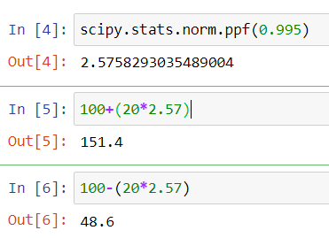

1. Consider a company that has two different divisions. The annual profits from the two divisions are independent and have distributions Profit1 ~ N (5, 32) and Profit2 ~ N(7, 42) respectively. Both the profits are in $ Million. Answer the following questions about the total profit of the company in Rupees. Assume that $1 = Rs. 45
2. Specify a Rupee range (centered on the mean) such that it contains 95% probability for the annual profit of the company.
3. Specify the 5th percentile of profit (in Rupees) for the company
4. Which of the two divisions has a larger probability of making a loss each year?

ANS:

A.

mean profits from two different divisions of a company = (Mean1 + Mean2) *45

= (5+7) *45 = 12*45

= 540 million

Variance of profits from two different divisions of a company =sqrt (SD1^2 + SD2^2) *45

=sqrt (16+9) *45

= 5*45

= 225 million. 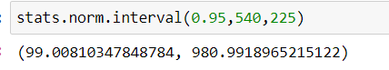

B.

The formula below is used to compute percentiles of a normal distribution.

https://sphweb.bumc.bu.edu/otlt/mph-modules/bs/bs704_probability/ada-reference.gifhttps://sphweb.bumc.bu.edu/otlt/mph-modules/bs/bs704_probability/lessonimages/equation_image113.gif

where μ is the mean and σ is the standard deviation of the variable X, and Z is the value from the standard normal distribution for the desired percentile.

from z table value for, 5 percentiles = -1.645

X= 540+(-1.645) *(225)

= 170

C.

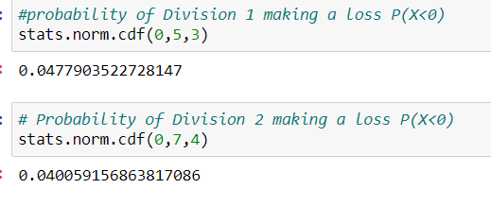

Therefore, Probability of Division 1 making a loss each year is more than Division 2.