Computer Systems Engineering 2008
Keywords: optimization, flow allocation,
dimensioning problem, multilayer network
Michał KUCHARZAK
Leszek KOSZAŁKA
Andrzej KASPRZAK

OPTIMIZATION ALGORITHMS FOR TWO LAYER NETWORK DIMENSIONING
Modern computer networks utilise integration of different technologies. This led to a multilayered model of network, raised new questions and challenged most of the existing optimization algorithms developed for a single layer. This paper considers flow allocation in multilayered networks and investigates dimensioning of networks involving two layers of resources. Two different strategies for dimensioning network links capacities based on the Dijkstra’s shortest path algorithm are compared. The first strategy concerns the dimensioning directly from the mean traffic load in the individual layers from the top layer to the bottom layer in a multilayered network. The second approach considers actual flow and multilayered path regarding the coordination of the individual network layers. Experimentation results and comparison strategy are illustrated and discussed.
- INTRODUCTION
Modern communication networks can be composed of more than one layer of resources. Multi-layer technology has evolved with many different multi-layering possibilities, e.g., IP networks can be provided over ATM, MPLS, SONET or WDM. In fact, it is possible to have more than two layers, e.g. IP over ATM over SONET network [8]. Unlike regular networks, these multilayer networks allow users and other networks to interface on different technology layers.
Introduction of multilayered models of networks resulted in most of the network optimization problems becoming more computationally demanding. Furthermore, many of existing well-understood optimisation problems on single layer networks changed to be far-from-trivial on multilayered networks [3]. Problems defined on multilayered networks are more difficult to solve than these stated for flat networks [4]. The integration of different technologies such as ATM, SDH, and WDM in multilayer transport networks raises many questions regarding the coordination of the individual network layers [1]. In this work authors compare two deterministic methodologies for off-line solving of dimensioning problems for multilayered networks involving two layers of resources. The first approach concerns flow allocation directly from the mean traffic load in the individual layers from the top layer to the bottom in the multilayered network respectively, the second approach considers actual flow and multilayered path regarding the coordination of the individual network layers.
This paper is divided into six main sections. The main idea and a model of multilayered networks is discussed in Section 2, supported by examples and related illustrations. In the same section a logical model of multilayer networks involving two layers of resources is introduced. Section 3 presents a dimensioning optimization problem statement with particular assumptions and constraints. Section 4 describes two deterministic approaches for solving dimensioning problems. Investigations are described in Section 5. This section illustrates basic principles and algorithms comparison with evaluation results. Final remarks appear in Section 6.
2. MULTILAYER NETWORK
2.1 CONCEPT OF MULTILAYER NETWORKS
Multilayer networks are networks composed of more than one layer of resources [5, 8]. In Fig. 1 an idea of two-layer network is illustrated as an example. The example shows network which consists of two layers: traffic network and transport network.
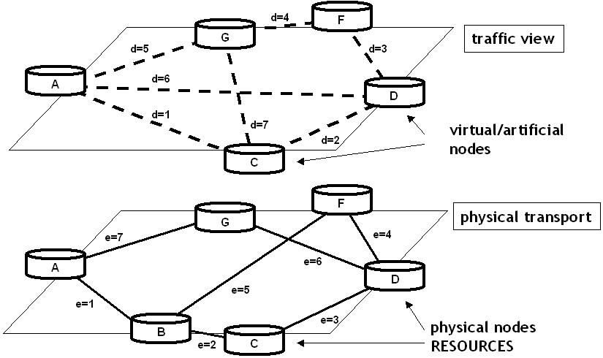

Fig. 1. Two-layer network example
Traffic network represents a logical capacity to carry the traffic (tagged links d are logical). To route these logical links and the associated capacity it is necessary to introduce and set a transport network. For example, the logical link d=1, between nodes A and C, in the traffic network illustrated in Fig. 1 can be connected with the transport network route A-B-C (or e=1, e=2). Similarly, data unit for the logical link d=6, between nodes A and D, can be connected via the transport route A-B-F-D (or by links e=1, e=5, e=4). The logical capacities in traffic layer are realized by means of flows in physical transport layer.
2.2 MULTILAYER NETWORKS MODELLING
Consider the network example illustrated in Fig. 2 and the model presented in [8]. The network consists of two layers of resources (layer 1: equipment, transport layer; layer 2: Virtual Capacity layer) and an additional auxiliary layer (demand layer) used merely to specify the demands (logical capacity to carry the traffic).

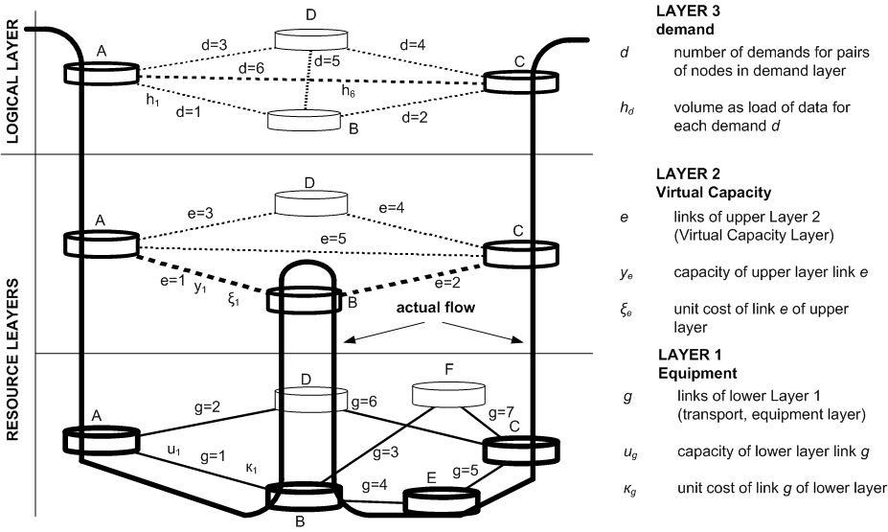
Fig. 2. Three-layer network model
For each demand d its demand volume h_{d} is realized by means of flows x_{dp} assigned to paths P_{d} of Layer 2 (Fig. 3). In accordance to [8], P_{d} = (P_{d1}, P_{d2}, …, P_{dPd}) is used for denoting Layer 2 candidate link-path list for demand d while Q_{e} = (Q_{e1}, Q_{e2}, …, Q_{eQe}) is used for denoting Layer 1 candidate link-path list for link e. Examples of candidate paths P_{d} and Q_{e} for network presented in Fig. 2 are shown in Table 11.
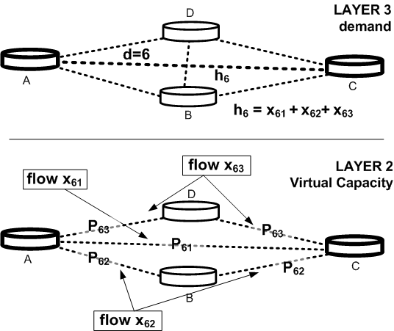
Table 1. Candidate Path Lists

Link | Path List
d =1 | P₁₁={1} P₁₂={3, 4, 2} P₁₃={5, 2}
d =2 | P₂₁={1} P₂₂={1, 3, 4} P₂₃={1, 5}
d =3 | P₃₁={3} P₃₂={5, 4}
d =4 | P₄₁={3} P₄₂={3, 5} P₄₃={3, 1, 2}
d =5 | P₅₁={3, 1} P₅₂={4, 2} P₅₃={3, 5, 2}
d =6 | P₆₁={5} P₆₂={3, 4} P₆₃={1, 2}
Link | Path List
e =1 | Q₁₁={1} Q₁₂={2, 6, 5, 4} Q₁₃={2, 6, 7, 3}
e =2 | Q₂₁={4, 5} Q₂₂={3, 7} Q₂₃={1, 2, 6}
e =3 | Q₃₁={2} Q₃₂={1, 3, 7, 6} Q₃₃={1, 4, 5, 6}
e =4 | Q₄₁={6} Q₄₂={2, 1, 3, 7}
e =5 | Q₅₁={2, 6} Q₅₂={1, 4, 5}

Fig. 3. Demand d=6 of volume h₆ realization by means of bifurcated flow x₆ on three paths from path list P₆ in VC layer
The resulting loads of flows x_{dp} on each link e of Layer 2 determine link capacity vector, denoted y, of the layer (as in the example in Fig. 3). The next step is analogous. The capacity of each link e in Layer 2 is realized by means of flow in Layer 1, and the resulting Layer 1 flows z_{eq} determine the load of each link g of Layer 1, and hence its capacity u_{g}. Unit costs (ξ_{e}, κ_{g}) define the cost of transporting data on each link in each layer. Considered multilayer network model is based on the following assumption: if a node appears in an upper layer, then it automatically appears downwards.
In a nutshell, the resources (links and nodes) of communication and computer networks are configured in a multi-layered fashion, forming a hierarchical structure with each layer being a proper network on its own. The links of an upper layer are formed using paths of the lower layer, and this pattern repeats as one goes down the resources hierarchy [8].
Actual flow in a multilayer network is assigned to a multilayered path that describes a path throughout the entire network.
3. NETWORK DIMENSIONING PROBLEM
The network dimensioning problem concerns finding flow allocations in the upper layer (VC layer) and in the lower layer (equipment), as well as the capacity of links in both layers, given the cost of modules capacity unit of link for data transferring in both layers. According to the multilayer network model described in Section 2 and considerations in [8] the dimensioning problem formulation for a network containing two layers of resources can be stated as follows:

A two layer network dimensioning problem

indices
d = 1, 2, . . . , D demands
p = 1, 2, . . . , P_{d} candidate paths in upper layer for flows realizing demand d
e = 1, 2, . . . , E links of upper layer
q = 1, 2, . . . , Q_{e} candidate paths in lower layer for flows realizing link e
g = 1, 2, . . . , G links of lower layer

constants
h_{d} volume of demand d
δ_{edp} = 1 if link e belongs to path p realizing demand d, 0 otherwise
ξ_{e} cost of one capacity unit of link e
γ_{geq} = 1 if link g belongs to path q realizing capacity of link e, 0 otherwise
κ_{g} cost of one capacity unit of link g

variables
x_{dp} flow allocated to path p of demand d
y_{e} capacity of link e in the VC layer
z_{eq} flow allocated to path q realizing capacity of link e
u_{g} capacity of (physical, transport) link g in the lower layer

objective
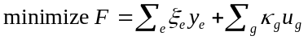 (1)

constraints
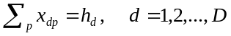 (2)

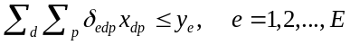 (3)

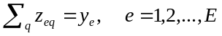 (4)

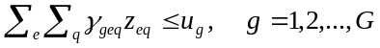 (5)

Constraint (2) describes that flows in the VC layer realize the assumed demand volumes and (3) defines required capacity of each link e. By analogy, y_{e} determines demand for the lower layer that must be realized by means of flows z_{eq} (4), and formula (5) specifies the lower layer capacity constraint.
4. ALGORITHMS
Both presented approaches, Top-to-Bottom and Flat Cost Strategies, are based on the well-understood Dijkstra’s shortest path finding algorithm [2].
4.1 TOP-TO-BOTTOM OPTIMIZATION
Top-to-Bottom (TtB) optimization approach is a simple algorithm based on an assumption that all of resource layers (VC and lower) are networks on their own sense with their own individual demands. Flow allocation is performed separately for each layer, from the uppermost layer to the bottom one.
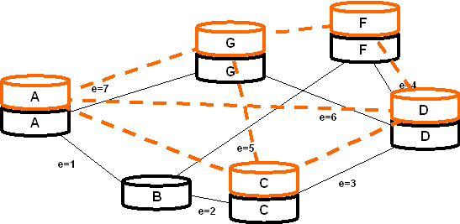
Fig. 4a. Defined volume of demand h_{d} is demand to be routed directly in VC layer.
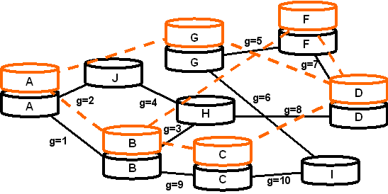
Fig. 4b. Capacity y_{e} of all links e determines demand to be routed in transport layer
This approach can be considered as different flow problems for each layer which are combined together in such a way, that the upper layer imposes demand on the neighbouring lower layer (Fig. 4a and Fig. 4b). An exact formulation of the TtB algorithm can be stated as follows:
TtB pseudo-code:

1: FOR EACH d
2: P_{d} := {P_{d1}}, where P_{d1} is derived from Dijksta's shortest path
3: x_{d1} := h_{d} (demand realization in the way of non-bifurcated flow)
4: FOR EACH e,
5: IF δ_{ed1} = 1
6: y_{e} := y_{e} + x_{d1}
7: END IF
8: END FOR
9: END FOR
10: FOR EACH e
11: Q_{e} := {Q_{e1}}, where Q_{e1} is derived from Dijksta's shortest path
12: z_{e1} := y_{e}
13: FOR EACH g,
14: IF γ_{ge1} = 1
15: u_{g} := u_{g} + z_{e1}
16: END IF
17: END FOR
18: END FOR
19: RETURN F

4.2 FLAT COST OPTIMIZATION
Flat Cost (FC) optimization approach considers all layers (VC and lower) as one integrated network. Flow allocation is performed not on the cheapest path in each layer separately but on the cheapest multilayered path throughout the entire multilayered network.
Dijkstra’s algorithm is well defined for network composed of single layer of resources. FC strategy treats a two-layer network as a flat (single layer) artificial network composed of nodes of VC layer and links e represented as lower layer topology (Fig. 5) with new cost of links assigned to each e.

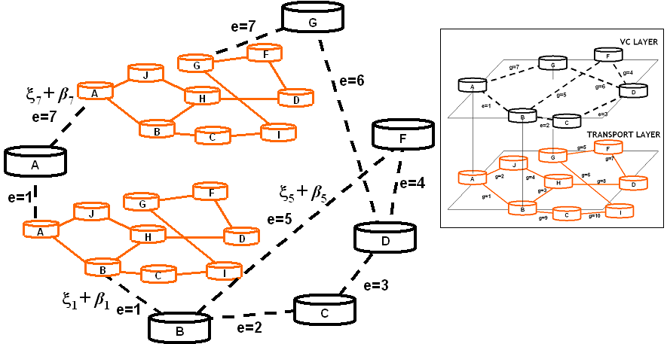
Fig. 5. Each link e is represented as network topology of lower layer (new artificial network is flat with new costs of links ξe + βe, and Dijkstra’s algorithm can be performed easily). In the example links e=1 and e=7 are depicted. Other links are prepared in the same way.
Flat Cost methodology introduces a Flat Cost Coefficient (FCC) – ξ_{e} + β_{e}. FCC describes a total cost of realization a data unit on the shortest path in lower layer and in VC layer.
Let q=1,path list equals Q_{e}={Q_{e1}}, where Q_{e1} is the Dijkstra’s shortest path. FCC is stated as ξ_{e} + β_{e}, where ξ_{e} cost of one capacity unit of link e and:
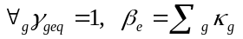 (6)

FC pseudo-code:

1: FOR EACH e
2: Q_{e} := {Q_{e1}}, where Q_{e1} is derived from Dijksta's shortest path
3: FOR EACH g,
4: IF γ_{ge1} = 1
5: δ_{e} := β_{e} + κ_{g} (realization cost of load ye on the path Q_{e1})
6: END IF
7: END FOR
8: FOR EACH d
9: P_{d} := {P_{d1}}, where P_{d1} is derived from Dijksta's shortest path regarding cost of one capacity unit of link ξ_{e} + β_{e}
10: x_{d1} := h_{d}
11: FOR EACH e,
12: IF δ_{ed1} = 1
13: y_{e} := y_{e} + x_{d1}
14: END IF
15: END FOR
16: END FOR
17: FOR EACH e
18: z_{e1} := y_{e}
19: FOR EACH g,
20: IF γ_{ge1} = 1
21: u_{g} := u_{g} + z_{e1}
22: END IF
23: END FOR
24: END FOR
25: RETURN F
5. INVESTIGATIONS
5.1 PROBLEM INSTANCES
Examination of the algorithms is performed for three hypothetic multilayered networks. Each of them consists of demand layer with the same topology (Fig. 6).
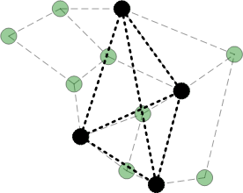  Fig. 6. Layer 3: Demand, layer, in the background transport layer is shown | 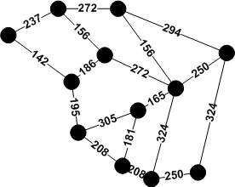  Fig. 7. Layer 1: Transport layer scenario
Transport layer 1 with costs of links g (Fig. 7.) is adapted from the core telecommunication network in Poland originated by Polish Telecom [7]. Fig. 7. illustrates three different topologies of Virtual Capacity layers with unit costs of links e.

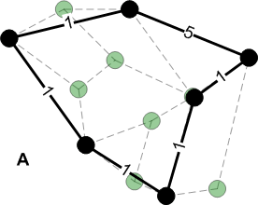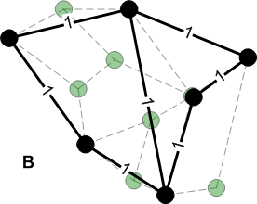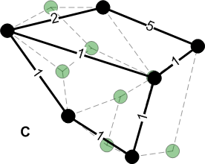

Fig. 7. Layer 2: Different Virtual Capacity layer scenarios, in the background transport layer is shown
In the problem defined in Section 3 the modularization of links’ capacities y_{e} and u_{g} is not taken into consideration, thus flow allocation assigned to the shortest Dijkstra’s path (in a non-bifurcated way) ensures that the obtained transportation cost is minimized [6].
Volume of demand h_{d} for each d equals to 1 for all instances. In fact for non-bifurcated flow and a case without modularization of links’ capacities it is sufficient to determine the shortest paths for single unit of data.
5.2 OPTIMIZATION RESULTS
The objective function F according to formula (1) for mixed integral case of dimensioning problem is compound by two sub-functions: summation of all flow costs in VC layer ∑_{e}ξ_{e}y_{e} and summation of all flow costs in lower layer ∑_{g}κ_{g}u_{g}. The objective of optimization is to find flow allocations x_{dp} in the VC layer and flow z_{eq} in the transport layer that the total cost F is minimized.
Optimised values of the cost function F are shown in Fig. 8a. The best optimization results were obtained using Flat Cost algorithm for all defined instances. However, TtB approach achieves lower values of cost in its first step, the volume of demand h_{d} realization directly in VC layer is locally allocated more effectively than in FC strategy (Fig. 8b). FC which uses FCC resulted in finding the globally cheapest route throughout all layers in because of high level of minimization of costs in transport layer (Fig. 8c).
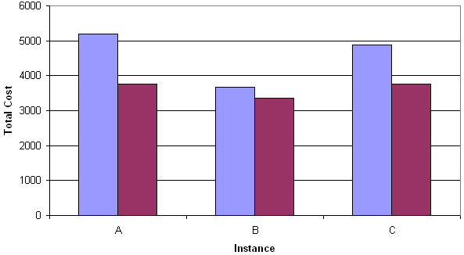
TtB
FC
Fig. 8a. Dimensioning problem optimization results for three multilayer networks A, B and C

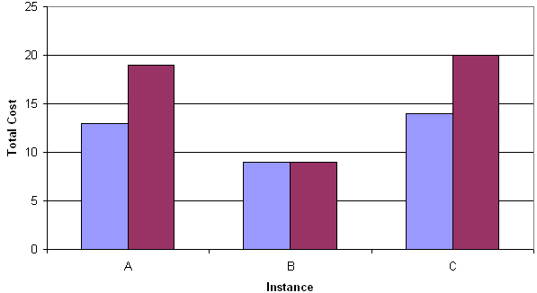  FC  TtB  Fig. 8b. Costs in VC layers | 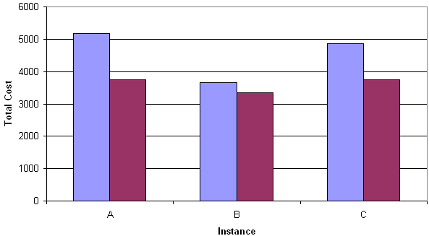  FC  TtB  Fig. 8c. Costs in transport layers
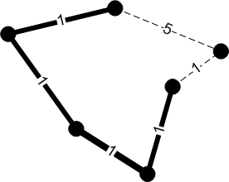TtB | 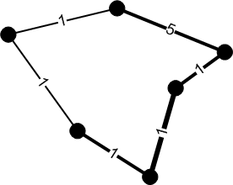FC
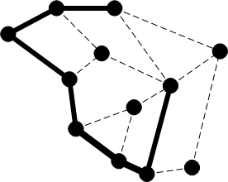 | 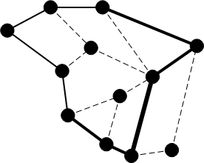
Fig. 9a. Traffic load visualization in VC and transport layers for instance A

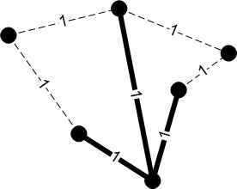TtB | 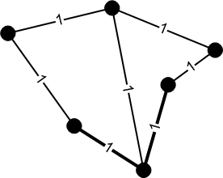FC
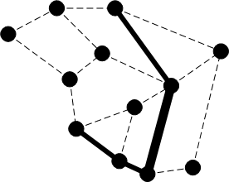 | 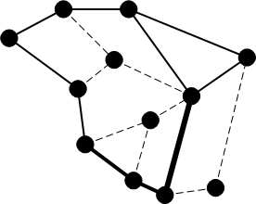
Fig. 9b. Traffic load visualization in VC and transport layers for instance B

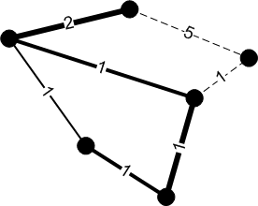TtB | 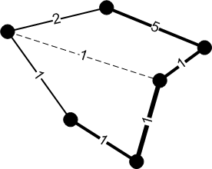FC
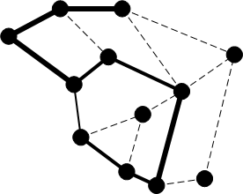
Fig. 9c. Traffic load visualization in VC and transport layers for instance C
Dimensioning optimization causes the flow to be allocated in each of two layers VC and transport layer. In Fig. 9a – 9c traffic load on each link for these layers is visualized. Non-zero capacity links are marked proportionally to the volume of load and dashed lines indicate unused links in each layer of resources.
6. FINAL REMARKS
This paper compared two deterministic approaches for multilayered networking dimensioning problem. The main statements can be formulated as follows:
- Flat Cost strategy is better approach than Top-to-Bottom optimization for dimensioning problem for the considered networks;
- Multilayer Network should not be considered as a set of separate layers but rather as an integrated model;
- Sometimes it is worth to allocate flow in a more expensive way locally in the VC layer, to obtain better results globally;
The main goals of computer networks optimization are: to ensure networks reliability, efficiency, security, to reduce utilization of devices, to minimize the use of resources etc. In general, all of these goals lead to improved financial benefits and reduced expenses, hence, it is possible to state the following general statement: dimensioning optimization result depends on topology in each layer of resources and the multilayer network should not be considered as a set of separate layers but as an integrated model. Sometimes it may be worth to install more links, prepare more interfaces and adapt more nodes to minimize the total cost of dimensioning problem in multilayered networks.

REFERENCES

[1] DEMESTER P., GRYSSELS M., et al. Resilience in Multilayer Networks. IEEE Communications Magazine 37/8, 1999, pp. 70–76.
[2] DIJKSTRA E. W., A note on two problems in connexion with graphs, Numerische Mathematik, No. 1, 1959, pp. 269–271.
[3] DIJKSTRA F., ANDREE B., KOYMANS K., HAM J. and LAAT C., A Multi-Layer Network Model Based on ITU-T G.805, In Press, May 2007.
[4] KOHN M., Improving Fairness in Multi Service Multi Layer Networks, Transparent Optical Networks, No.1), 2005, pp. 53–56.
[5] KUBILINSKAS E. and PIÓRO M., An IP/MPLS over WDM network design problem, International Network Optimization Conference (INOC), 2005, pp. 20–23.
[6] KUCHARZAK M., Bifurcated and non-bifurcated flows in multilayered networks dimensioning issues, 6th Student Scientific Conference (KNS), Wroclaw, Poland, 2008 (in Polish)
[7] ONLINE, The library of test instances for survivable fixed telecommunication network design, http://sndlib.zib.de, (accessed 2006).
[8] PIÓRO M. and MEDHI D., Routing, Flow, and Capacity Design in Communication and Computer Networks, Morgan Kaufmann Publishers, 2004.

Chair of Systems and Computer Networks, Wroclaw University of Technology, Poland, e-mail: leszek.koszalka@pwr.wroc.pl
 The routing lists do not necessarily contain all possible paths.

