MACHINE LEARNING PROJECT
Review 1 Project Report
Exploratory Data Analysis and Preprocessing of Women's Clothing E-Commerce Reviews
Submitted by
Yash Kumar
University Roll No: 22515000163 | Section: NB
B.Tech Computer Science & Engineering
GLA University
GitHub: github.com/knslyash
October 2026

Contents
1. Introduction
2. Dataset Description
3. Data Quality Checks and Cleaning
4. Exploratory Data Analysis
5. Data Preprocessing
6. Key Findings
7. Conclusion and Next Steps
8. Repository Structure and How to Run

1. Introduction
Online fashion stores collect thousands of customer reviews. Each review contains a star rating, some text and a simple answer to the question "Would you recommend this product?". Studying this data helps a business understand what customers like, which product groups cause disappointment, and how satisfied different customer groups are.
Objective. This report covers the first review of the project. It explains the Exploratory Data Analysis (EDA) and the data preprocessing carried out on the Women's Clothing E-Commerce Reviews dataset. The work prepares the data for the machine learning models of the next stage, where the planned task is to predict Recommended IND (whether a customer recommends the product).
The report follows the two marking areas of Review 1:
- EDA: clear exploratory analysis with proper graphs (Section 4).
- Preprocessing: data cleaning, outlier detection and removal, encoding, scaling and standardization (Sections 3 and 5).
All code is available in the same GitHub repository as this report (see Section 8). Every number and figure in this report is produced by that code.

2. Dataset Description
The dataset contains 23,486 customer reviews of women's clothing from an e-commerce website, with 11 columns. The customers' personal details were anonymised and the store name was replaced in the original data. The file used is Womens_Clothing_E-Commerce_Reviews.csv.
Column | Type | Meaning
Unnamed: 0 | Integer | Old row index (not useful, dropped)
Clothing ID | Integer | Identifier of the product (1,199 unique products)
Age | Integer | Age of the reviewer
Title | Text | Title of the review
Review Text | Text | Body of the review
Rating | Ordinal (1-5) | Star rating given by the customer
Recommended IND | Binary | 1 = recommends the product, 0 = does not (target for later work)
Positive Feedback Count | Integer | Number of other customers who found the review helpful
Division Name | Categorical | High-level division (General, General Petite, Intimates)
Department Name | Categorical | Department (Tops, Dresses, Bottoms, Intimate, Jackets, Trend)
Class Name | Categorical | Product class (20 classes such as Dresses, Knits, Jeans)

3. Data Quality Checks and Cleaning

3.1 Missing values
Five columns contain missing values (Figure 1). The Title column has the most missing values (16.22%), followed by Review Text (3.60%). Division Name, Department Name and Class Name each miss the same 14 rows (0.06%).
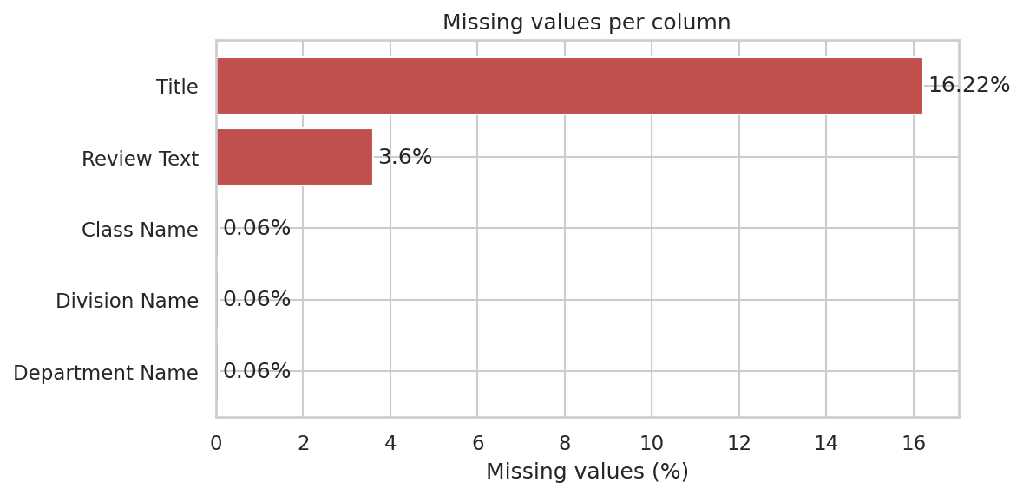
Figure 1: Percentage of missing values per column

3.2 Cleaning steps
Issue | Action taken | Reason
Index column Unnamed: 0 | Dropped | Only an old row number, no information
Missing Title (3,810) and Review Text (845) | Filled with an empty string; flags has_title and has_review_text added | A customer can give a rating without writing text. The flag keeps that information
14 rows with missing Division/Department/Class | Rows dropped | Only 0.06% of data; these rows cannot be encoded
21 exact duplicate reviews | Removed | Duplicates would be counted twice and could leak into the test set
Spelling mistake "Initmates" in Division Name | Corrected to "Intimates" | Data entry error in the source file

After cleaning, the dataset has 23,451 rows (a loss of only 35 rows).

3.3 Feature engineering from text
Three numeric features were created so that the text columns can also be analysed and scaled: review_char_len (characters in the review), review_word_count (words in the review) and title_word_count (words in the title). A cleaned lowercase version of the review (only letters) was also saved for the NLP stage.

4. Exploratory Data Analysis

4.1 Target variable and rating
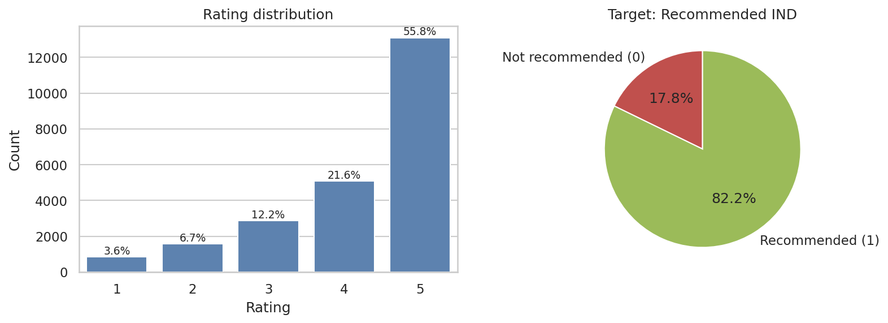
Figure 2: Distribution of ratings (left) and of the target Recommended IND (right)
Customers are mostly happy. 5-star reviews make up 55.8% of all reviews and 4-star reviews another 21.6%, while 1-star reviews are only 3.6%. In line with this, 82.2% of reviews recommend the product (19,279 recommended against 4,172 not recommended). The target is therefore imbalanced at roughly 82:18. This matters for modelling: accuracy alone would be misleading (a model that always predicts "recommended" is already 82% accurate), so F1-score, precision/recall and stratified splitting should be used later.

4.2 Age of customers
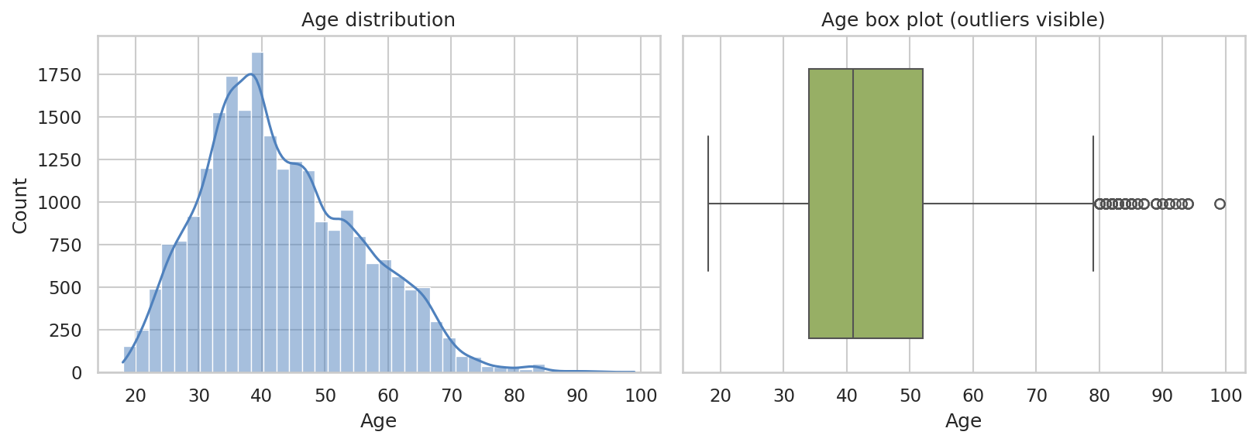
Figure 3: Age distribution (left) and box plot (right)
Ages range from 18 to 99, with a mean of 43.2 and a median of 41. The distribution is slightly right-skewed (skewness 0.52). Most reviewers are between 34 and 52 years old. The box plot shows a tail of very high ages (above 79), which are examined as outliers in Section 5.1.

4.3 Positive Feedback Count
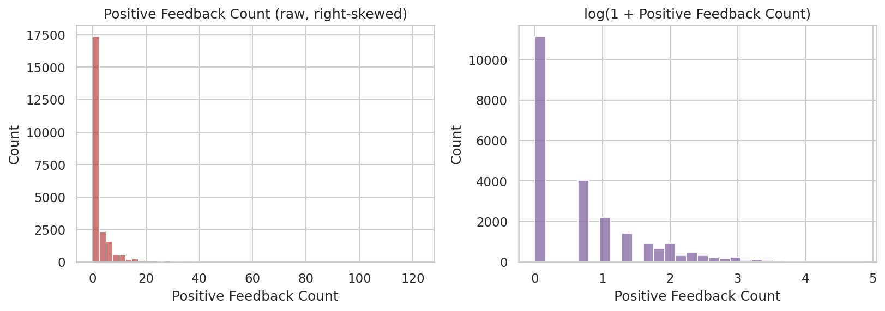
Figure 4: Positive Feedback Count: raw (left) and after log(1+x) transformation (right)
This feature is extremely right-skewed (skewness 6.47). 47.5% of reviews received no helpful votes at all, the median is 1, but the maximum is 122. A log(1+x) transformation makes the distribution far more balanced and is used in preprocessing.

4.4 Product categories
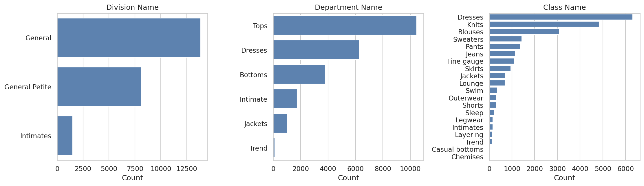
Figure 5: Number of reviews per Division, Department and Class
Most reviews are for General (13,839) and General Petite (8,110) products; Intimates are only 1,502. By department, Tops lead with 10,455 reviews, followed by Dresses (6,312) and Bottoms (3,798). The Trend department is very small (119 reviews). Within the 20 classes, Dresses and Knits are the biggest, while a few classes such as Chemises and Casual bottoms have only 1 to 2 reviews after cleaning, so conclusions about them are unreliable.

4.5 Recommendation rate by department and class
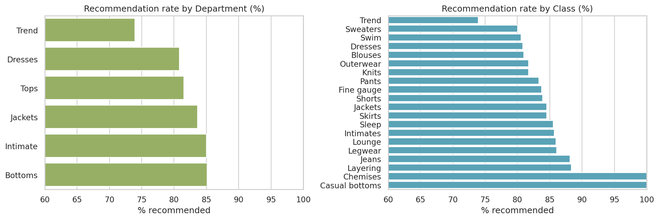
Figure 6: Share of customers recommending the product, by department (left) and class (right)
The recommendation rate is fairly similar across departments, between 80.8% (Dresses) and 85.1% (Bottoms). The Trend department is the lowest at 73.9%, which suggests that trendy items disappoint more often. Among classes, Jeans (88.1%) and Layering (88.4%) do best, while Sweaters (80.0%) and Swim (80.6%) are at the bottom. Chemises and Casual bottoms show 100% only because they have one or two reviews.

4.6 Rating versus recommendation
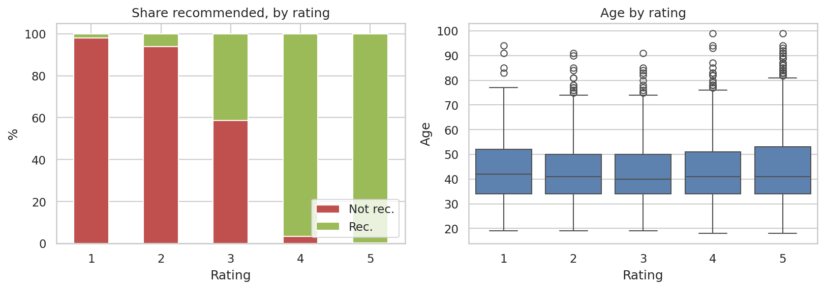
Figure 7: Share recommended for each rating (left) and age by rating (right)
Rating and recommendation are closely linked (correlation 0.79). 99.8% of 5-star reviewers and 96.7% of 4-star reviewers recommend the product, against only 1.9% of 1-star and 6.0% of 2-star reviewers. The 3-star group is the uncertain one: 41.4% of them still recommend. Age is practically unrelated to the rating (correlation 0.03); the median age is about 41 for every rating.
Important observation: because Rating almost decides Recommended IND, using Rating as an input feature to predict the target would give a model that looks very accurate but learns little. In the modelling stage the plan is to build models both with and without Rating (using the review text instead), and to compare them.

4.7 Age groups
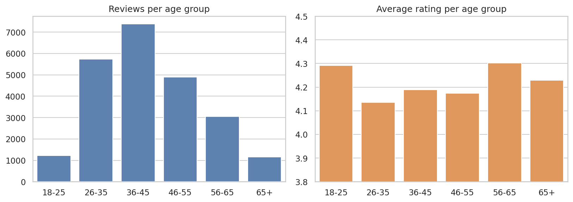
Figure 8: Number of reviews (left) and average rating (right) per age group
The 36-45 group writes the most reviews (7,377), followed by 26-35 (5,744) and 46-55 (4,902). Average ratings are close in all groups, between 4.14 (26-35, the lowest) and 4.30 (56-65, the highest), so age has only a small effect on satisfaction.

4.8 Review length
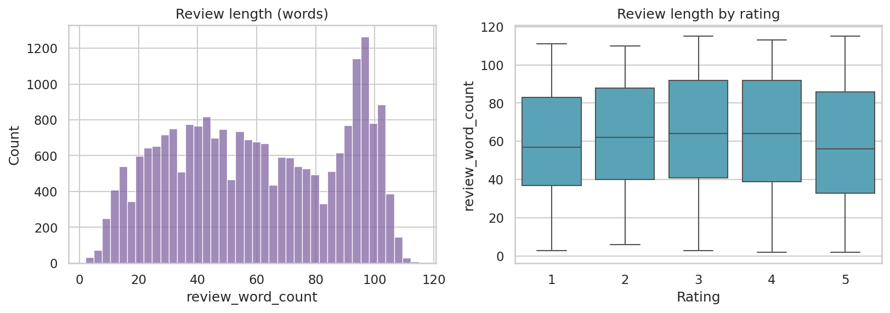
Figure 9: Distribution of review length in words (left) and length by rating (right)
Reviews contain 58 words on average (maximum 115), because the source limits review size. Review length is only weakly related to the rating (correlation -0.07); lower-rated reviews tend to be slightly longer, as unhappy customers explain their problem.

4.9 Most frequent words
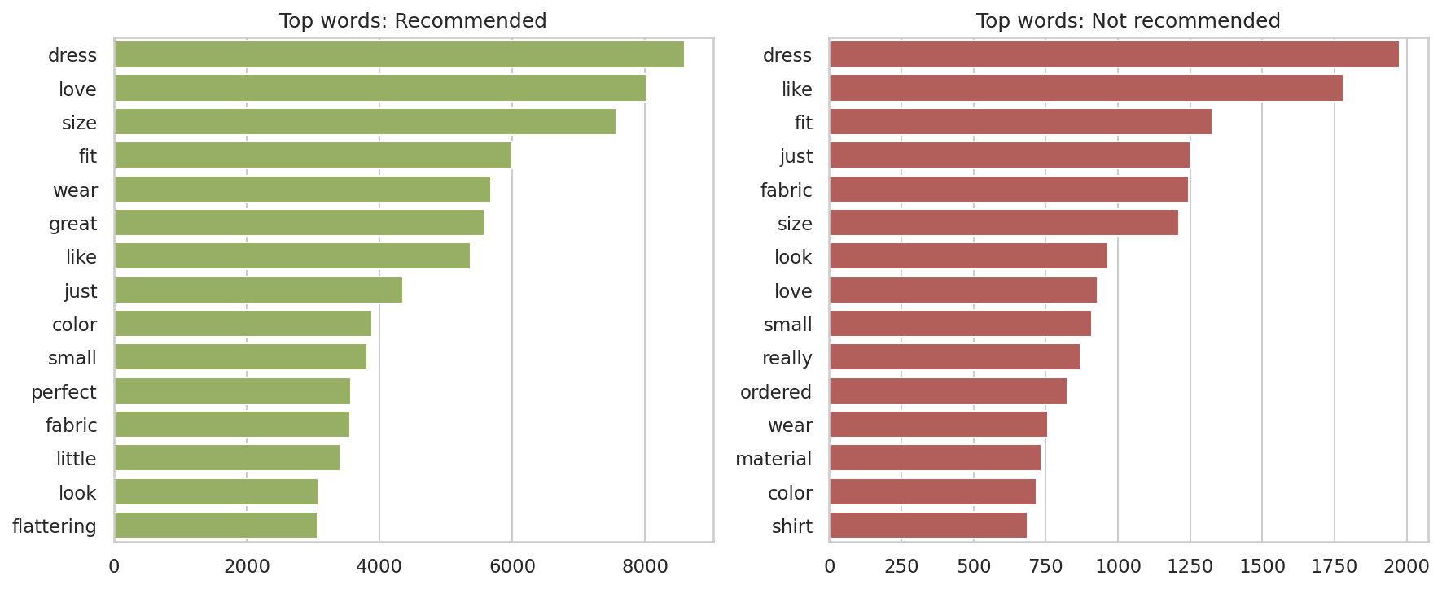
Figure 10: Most frequent words (after stop-word removal) in recommended and not recommended reviews
Recommended reviews are full of positive words such as love (8,014 mentions) and great (5,584), together with fit and size. In not-recommended reviews, "love" is far less common relative to the number of reviews, and words about fabric, size and look appear more often. Fit/size is the central topic in both groups, which shows that sizing is the main theme of the reviews. This supports using text features in the next stage.

4.10 Correlation analysis
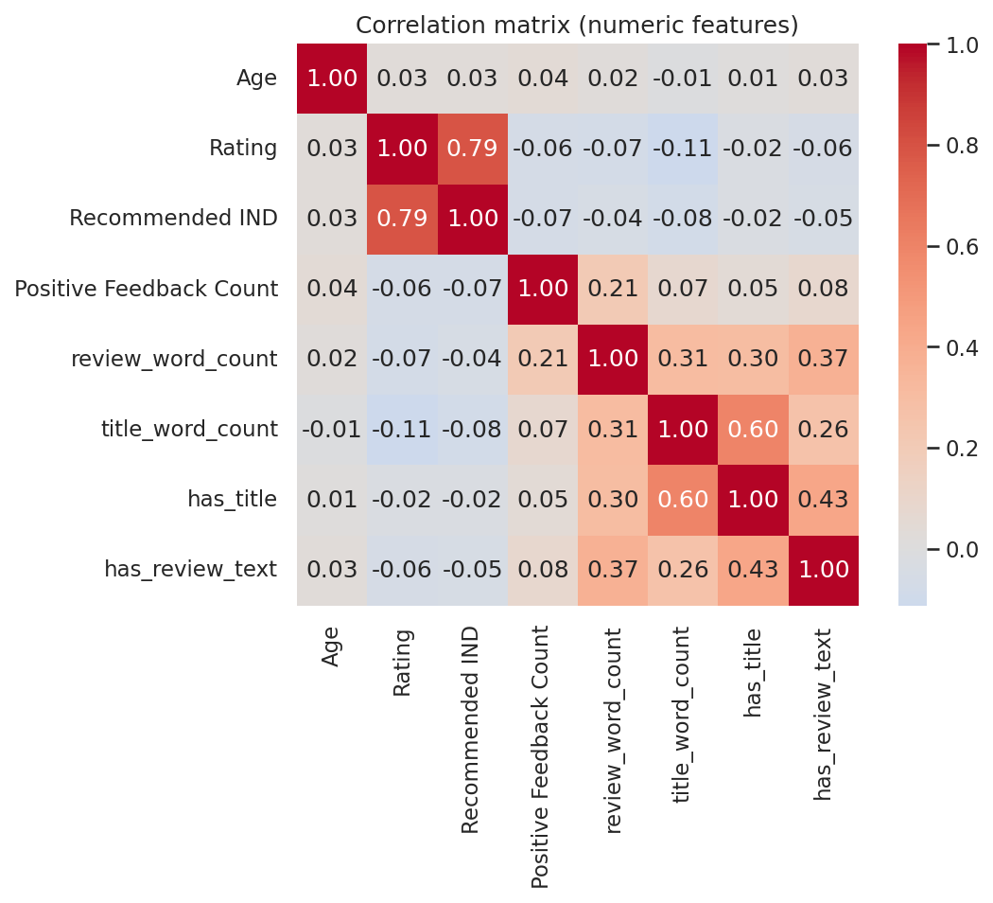
Figure 11: Correlation matrix of the numeric features
Apart from the strong Rating-Recommended IND link (0.79), correlations are small. Positive Feedback Count, review length and age have almost no linear relationship with the target. This means the structured columns alone carry limited predictive power, and the review text will be an important source of information later.

5. Data Preprocessing

5.1 Outlier detection
Two standard methods were compared. The IQR rule marks a value as an outlier if it lies below Q1 - 1.5 x IQR or above Q3 + 1.5 x IQR. The Z-score rule marks a value if its absolute z-score is greater than 3.
Feature | IQR lower | IQR upper | IQR outliers | Z-score outliers
Age | 7.0 | 79.0 | 109 | 99
Positive Feedback Count (raw) | -4.5 | 7.5 | 2,147 | 430
log(1 + Positive Feedback Count) | -2.08 | 3.47 | 154 | 172
review_word_count | -45.5 | 166.5 | 0 | 0
review_char_len | -241.5 | 866.5 | 0 | 0

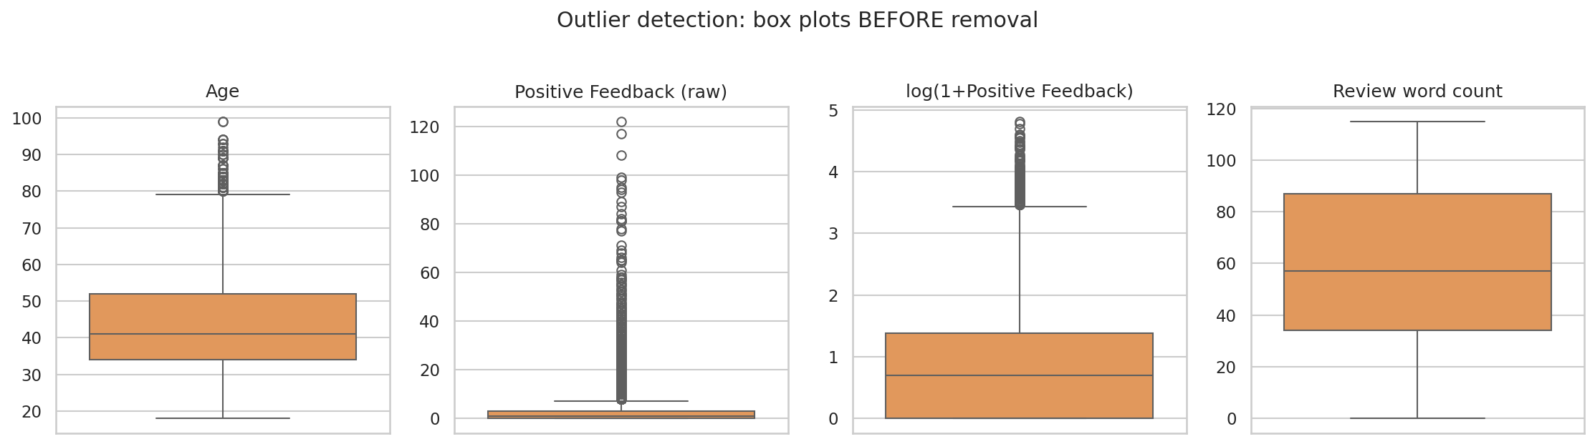
Figure 12: Box plots used for outlier detection (before removal)
Decisions. Age is roughly bell shaped, so the IQR rule is applied directly: ages above 79 are treated as outliers (109 rows). For Positive Feedback Count, the raw IQR rule would flag 2,147 rows (about 9% of the data), but these are genuine popular reviews and not errors. Because the feature is very skewed, the IQR rule is applied after the log(1+x) transformation, which flags 154 rows with more than 31 helpful votes. Review length has no outliers.

5.2 Outlier removal
Rows flagged by the IQR rule on Age (109 rows) and on log(1 + Positive Feedback Count) (154 rows) were removed. In total 263 rows were removed (1.1% of the cleaned data), leaving 23,188 reviews. The share of recommended reviews stayed almost unchanged (0.822 before, 0.823 after), so the removal did not distort the target.
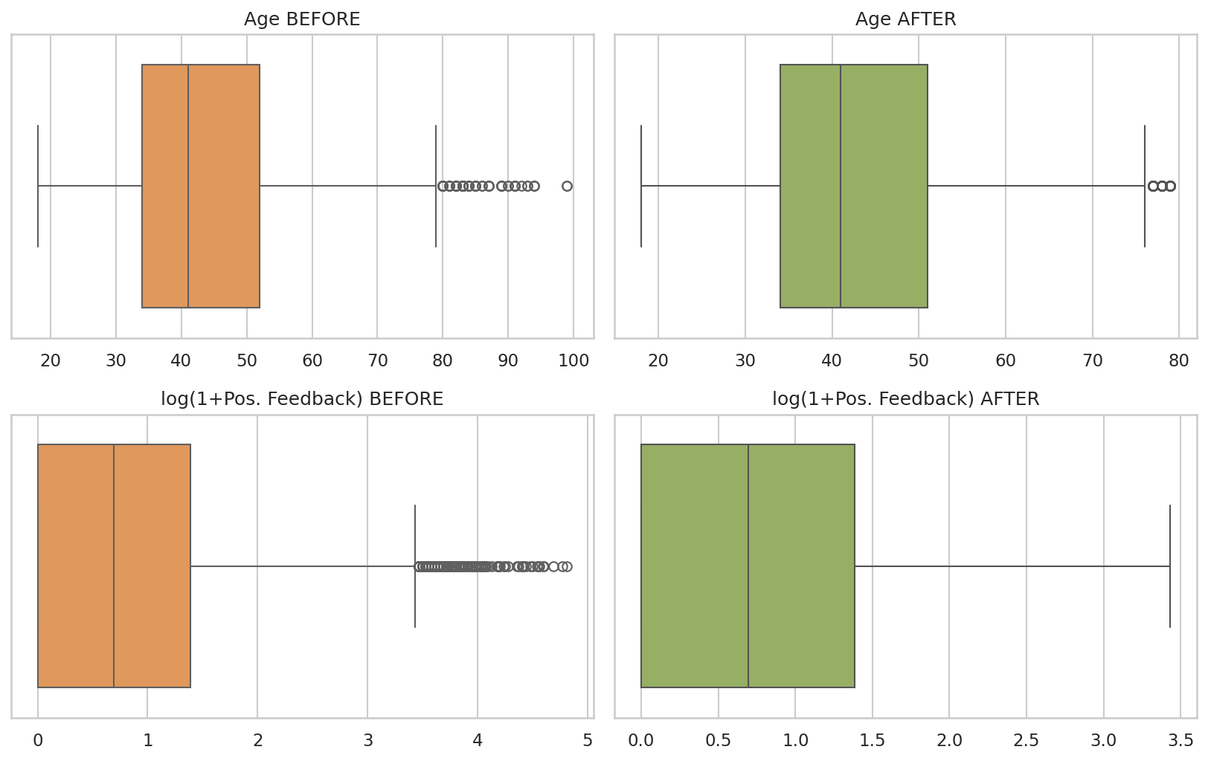
Figure 13: Box plots before (orange) and after (green) outlier removal

5.3 Encoding categorical variables
Column | Encoding | Reason
Division Name (3), Department Name (6), Class Name (20) | One-hot encoding with drop_first=True (26 dummy columns) | Nominal categories with no natural order. Dropping the first level avoids the dummy-variable trap
Rating | Kept as numeric 1-5 | Already ordinal and numeric
Clothing ID | Dropped; product_review_count (how many reviews the product has) created instead | About 1,200 unique IDs would create too many columns if one-hot encoded
Has title / has review text | Binary flags (0/1) | Keep information about missing text
Title, Review Text | Saved separately as text files | Will be vectorised (TF-IDF / embeddings) in the NLP stage

5.4 Train-test split
The data was split 80% / 20% into 18,550 training rows and 4,638 test rows, stratified on Recommended IND so both parts keep the same 82.3% share of recommended reviews. The split is done before scaling on purpose, so that the scalers learn only from the training data and no information from the test set leaks into training.

5.5 Scaling and standardization
Six continuous features were scaled: Age, log_pos_feedback (log of Positive Feedback Count), review_word_count, review_char_len, title_word_count and log_product_review_count. The binary and one-hot columns are left unchanged because they are already 0/1.
- Standardization (StandardScaler): subtracts the mean and divides by the standard deviation, giving mean 0 and standard deviation 1. This is the main version, suited to Logistic Regression, SVM, KNN and neural networks.
- Min-Max scaling (MinMaxScaler): rescales values to the range 0 to 1. A second version is saved for comparison and for algorithms that need bounded inputs.
- Log transformation: applied to Positive Feedback Count and the product review count before scaling to reduce skewness.
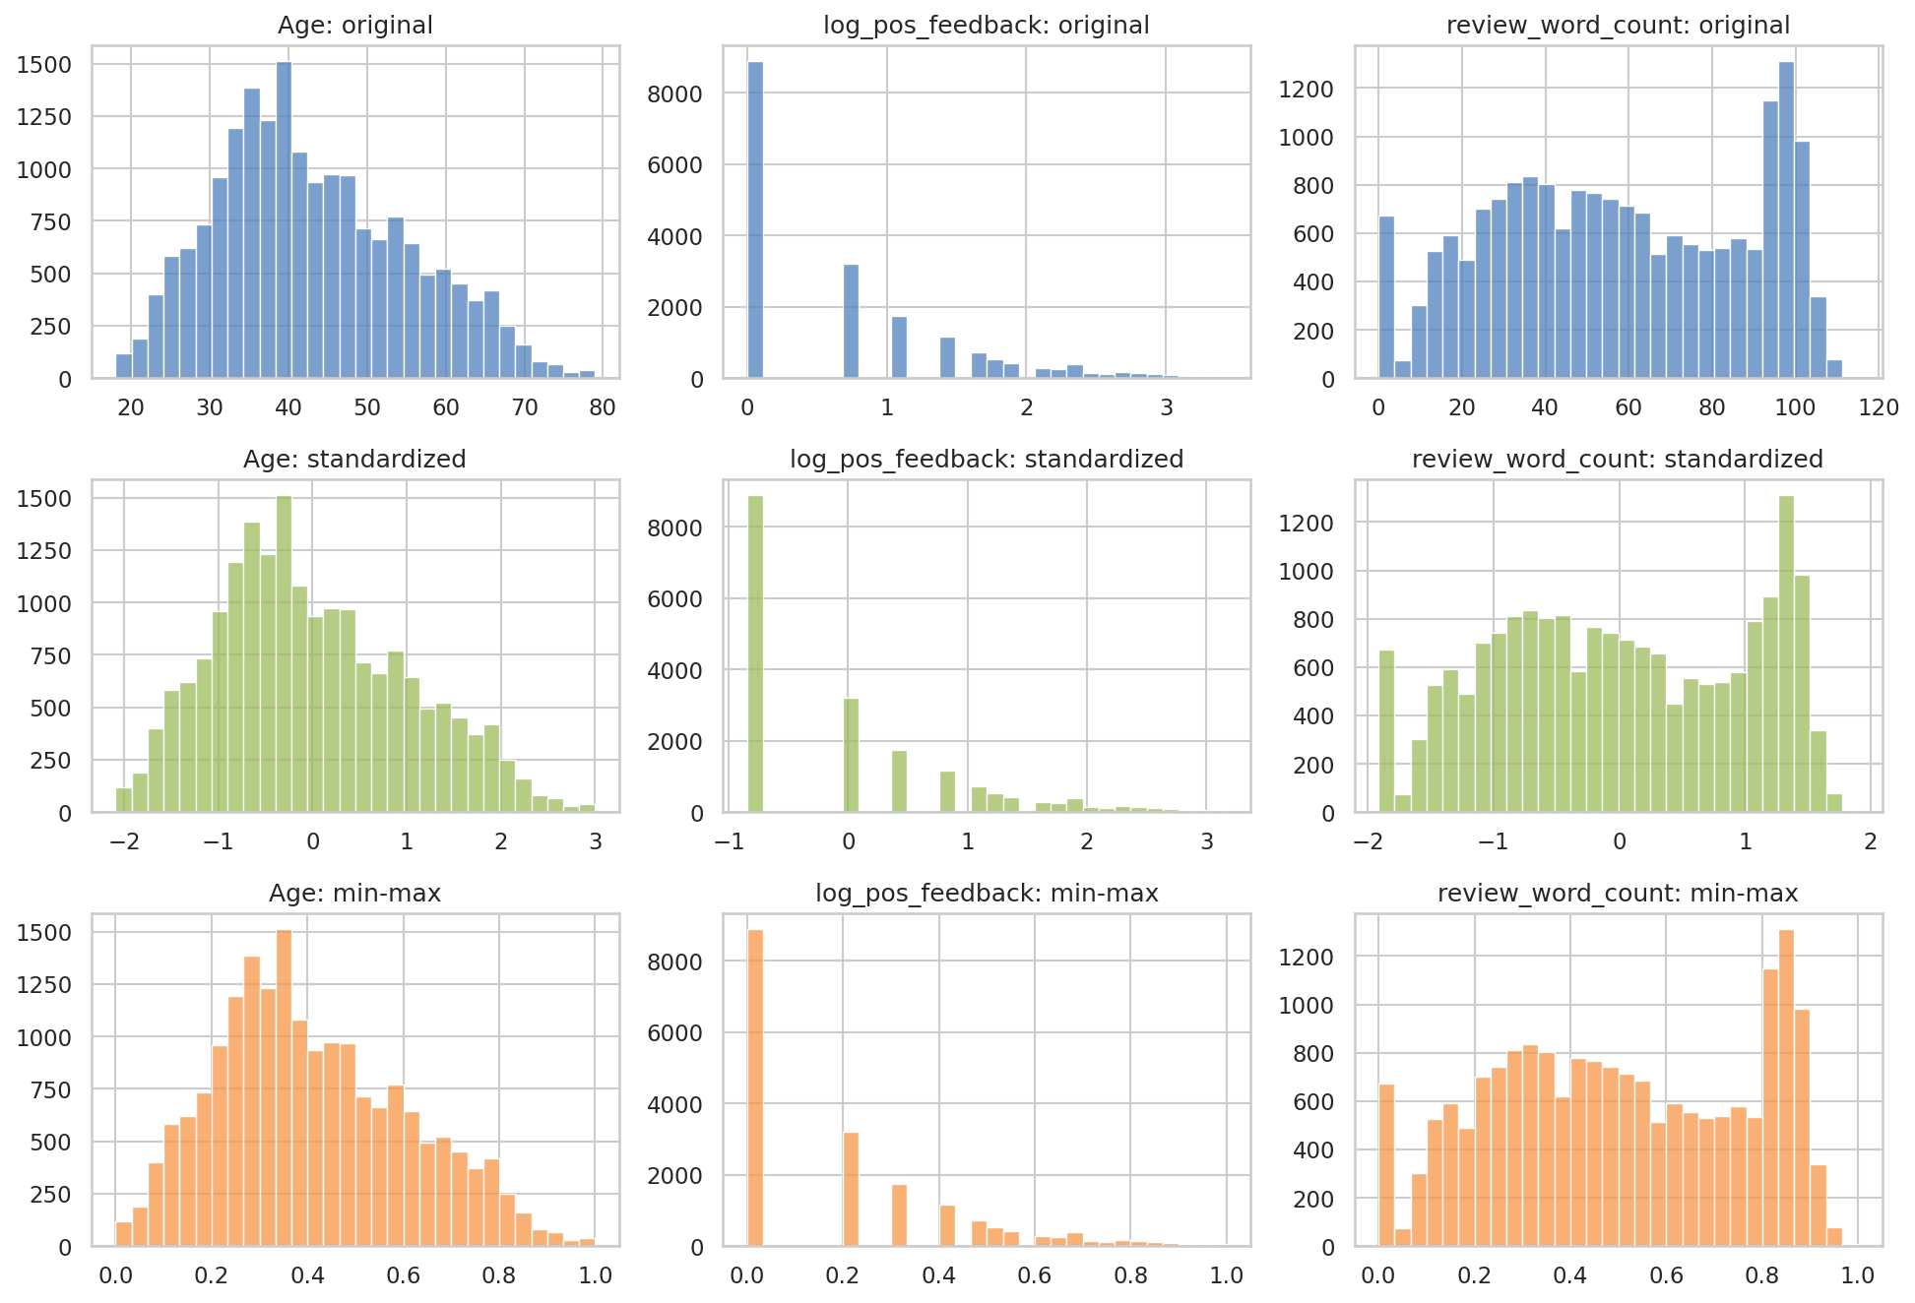
Figure 14: Three features before scaling, after standardization and after min-max scaling
The shapes of the distributions stay the same, only the scale changes. A check on the training data confirmed that all standardized features have mean 0.0 and standard deviation 1.0, and that all min-max features lie between 0 and 1.

5.6 Final processed dataset
Stage | Rows | Columns
Raw dataset | 23,486 | 11
After cleaning (missing values, duplicates) | 23,451 | 12 (with engineered flags)
After outlier removal | 23,188 | 18 (with engineered features)
Final model-ready features (train / test) | 18,550 / 4,638 | 35 features + target

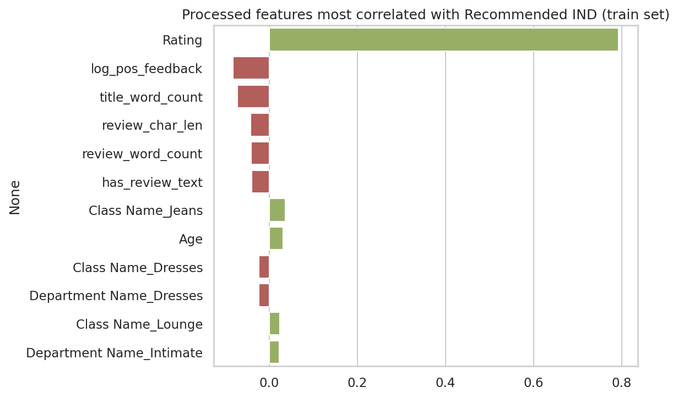
Figure 15: Processed features most correlated with Recommended IND (training set)
After preprocessing, Rating is by far the feature most correlated with the target (0.79). All other features are weak (absolute correlation below 0.1), which confirms the observation from the EDA.

6. Key Findings
- The data is clean and reliable: only 0.15% of rows were lost to missing values and duplicates, and 1.1% to outliers.
- Customers are generally satisfied: 82.2% recommend the product and the average rating is 4.19.
- The target is imbalanced (about 82:18), so evaluation should use F1-score, precision, recall and stratified splits.
- Rating almost determines Recommended IND (correlation 0.79). Models should be compared with and without Rating to avoid an over-optimistic result.
- Age, review length and helpful votes have very little linear relationship with the target, so review text is likely to be the most valuable extra source of information.
- Sizing and fit dominate the review vocabulary, and the Trend department has the lowest recommendation rate (73.9%).
- Positive Feedback Count needed a log transformation because of its extreme skew (6.47).

7. Conclusion and Next Steps
In this review, the dataset was explored in depth with fifteen graphs and prepared for machine learning. Missing values and duplicates were handled, outliers were detected with two methods and removed with the IQR rule, categorical variables were one-hot encoded, and the numeric features were standardized and min-max scaled using a leakage-free train-test split. The final standardized and min-max datasets, together with the text columns, are saved and ready to use.
Planned work for the next review:
- Convert review text into features using TF-IDF and compare with word embeddings.
- Train baseline models (Logistic Regression, Naive Bayes, Random Forest, SVM) to predict Recommended IND, with and without the Rating feature.
- Handle the class imbalance (class weights or SMOTE) and evaluate using F1-score, precision, recall and ROC-AUC.
- Tune hyperparameters with cross-validation and compare the models.

8. Repository Structure and How to Run
The project is stored in a public GitHub repository with the following structure:
File / Folder | Description
EDA_and_Preprocessing.ipynb | Main notebook with code, outputs and explanations (already executed)
eda_preprocessing.py | The same code as a runnable Python script
data/ | Original dataset (Womens_Clothing_E-Commerce_Reviews.csv)
figures/ | All 15 graphs used in this report
outputs/ | Processed datasets (standardized, min-max, text) and results_summary.json
report/ | This project report
requirements.txt | Python libraries needed
README.md | Project overview and instructions

To reproduce the results: install the libraries with "pip install -r requirements.txt" and run "python eda_preprocessing.py" from the project folder (or open the notebook and choose Run All). Python 3.10 or newer is recommended. A fixed random seed (42) is used, so the results are the same on every run.

