Thompson Rivers University
Special Topics: Machine Learning
COMP 4980
Multi-Model Stock Forecasting with Monte Carlo Risk Analysis
Karen Nurlybekov
T00696311
Dec 12, 2025

- Data Description
I selected a time-series dataset containing daily financial features for the S&P 500, NASDAQ Composite, Dow Jones Industrial Average, Russell 2000, and NYSE Composite from 2010 to 2017 [1]. Each row represents one trading day, and the dataset includes 84 feature columns covering price data, momentum indicators, rate-of-change metrics, volume changes, and a wide range of macro-financial variables such as currency movements, commodity futures, and equity index futures. The dataset has already been preprocessed and was previously used in a CNN-based market prediction model.
a. The data contains stock market and macro-financial metrics that could be useful for predicting stock prices. In essence, it is a multi-asset, macro-financial panel centered on the S&P 500.
b. The dataset consists mostly of numerical variables.
c. It has 84 columns and 1,985 rows, where each row corresponds to a trading day.
d. The key components are:
- A time variable representing the trading day
- Core S&P 500 variables such as close price and volume
- Technical indicators including momentum, rate of change, and exponential moving averages
- Additional macro-financial variables: interest rates and bond yields; commodities and metals; currency pairs and the dollar index; equity indicators and futures; and selected large-cap stocks.
Most variables are expressed as numeric values or positive/negative percentage changes.
e. The data is stored as a CSV (plain text) file, and I am using Processed_S&P.csv.
f. The dataset is easy to load and requires minimal preprocessing on my side.
g. The data appears reliable: there are few missing values and many features, which makes it a good setting for practicing feature selection.
h. The frequency is one observation per trading day (business day), covering the period from 2009-12-31 to 2017-11-15.

- Data Analysis
As mentioned above, I work with financial time-series data from the 2009–2017 period. My main goal is to build a model that could be useful for day-traders or possibly be automated to trade equity index futures. For this reason, I did not simply use all raw columns from the original dataset. Instead, I engineered a smaller set of features that are more directly related to short-horizon trading decisions and easier to interpret. These include return_1 (one-day simple return from yesterday to today), return_5 (five-day simple return to capture short-term momentum), and return_10 (ten-day return to capture slightly longer trends). I also added Exponential Moving Average (EMA) gap features, which measure how far the current price is from its 10-, 20-, 50- and 200-day EMAs. EMAs help filter out short-term noise and are widely used to capture momentum and trend-following behaviour in practice. From the Heatmat (Fig 2.1) we see that some variables are correlated with each other. The 1-day return (return_1) is almost perfectly correlated with log_return, which indicates that this feature is essentially a duplicate of the target (simple vs log return). The 5-day and 10-day returns (return_5, return_10) show moderate positive correlations with log_return (around 0.3–0.4), and the lagged log-returns (log_return_lag1, log_return_lag2, etc.) also have small but non-zero correlations. This reflects short-term momentum or autocorrelation in the series. The EMA gap features (ema_gap_10, ema_gap_20, ema_gap_50, ema_gap_200) are strongly correlated with each other (correlations often above 0.7–0.9) and moderately correlated with current returns. This indicates that they capture very similar information about the relative position of price vs its moving averages. From a modelling perspective, this strong multicollinearity means that regularization or feature selection may be necessary to avoid redundancy. The volatility windows (volatility_10, volatility_20) are, as expected, strongly positively correlated with each other and negatively correlated with several EMA gaps. Periods when price is far above/below its moving average tend to coincide with lower short-term realized volatility, and vice versa. Among macro variables, Oil shows a small positive correlation with S&P returns, while the Dollar index is moderately negatively correlated with log_return. This is consistent with the intuition that a stronger dollar is often associated with weaker US equity performance. Gold has almost zero correlation with log_return in this sample, suggesting it does not move systematically with daily S&P returns. Moreover, Bell Curve (Fig 2.2) Shows that distribution is around the center, showing around the normal distribution, which is expectable from an index fund as S&P500.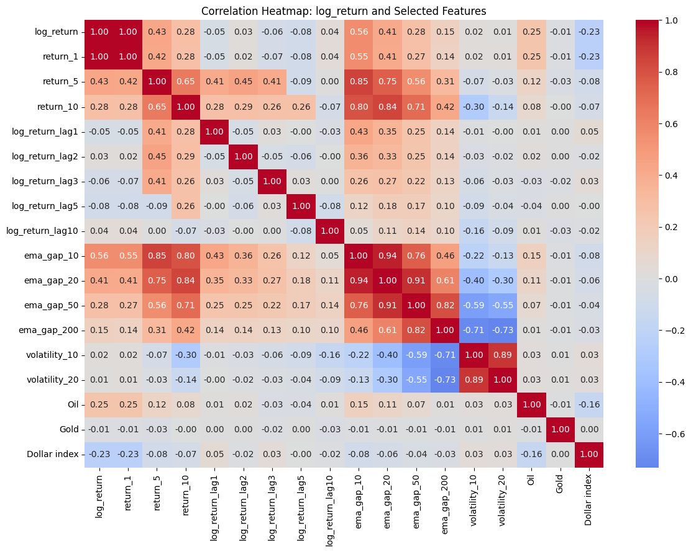
Fig 2.1- Correlation Heatmap

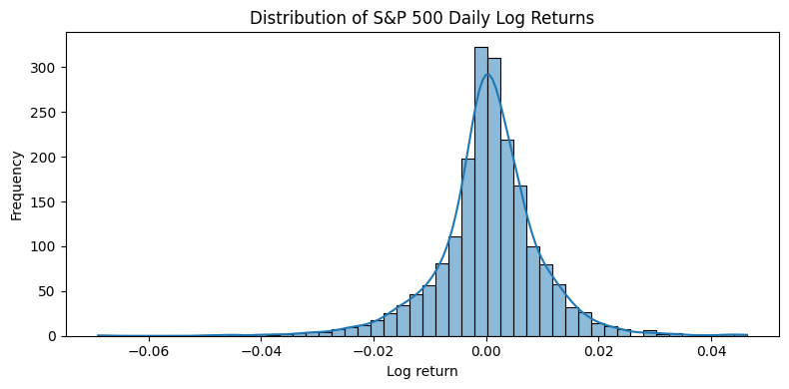
Fig 2.2 – Bell curve of Log Returns

- Data Exploration
As of PCA, I decided to not use all 84 features, as they may add more noise to already noisy financial data. So, in this section I will add a bit more ground why I chose those specific features. To handle the time-varying behaviour of financial series, I include several exponential moving average (EMA) gap features, which give more weight to recent prices and are standard in technical analysis. This is conceptually similar to the exponential weighting of historical observations used by Ghorbani and Chong [2] to model time-varying covariance in stock prices. They show that exponentially weighted averages provide a better way to handle non-stationary volatility in financial data than treating all past observations equally. I also construct rolling volatility features (10-day and 20-day realized volatility), defined as the standard deviation of recent returns. Volatility is widely used as a measure of risk; for example, Ghorbani and Chong [3] explicitly evaluate the volatility of their prediction. In my opinion, by engineering those features models will be able to distinguish between trending versus mean-reverting periods and calm versus turbulent markets, which improves the ability of both tree-based methods and neural networks to learn meaningful patterns rather than overfitting to random day-to-day fluctuations. However, applying PCA to the 17 standardized features shows that the first principal component alone explains about 31% of the total variance, and the first 11 components together explain roughly 96%. Regardless of those numbers, I will keep 14-17 features depending on a task, regression or classification. Because, 14-17 variables is already a strong reduction from the initial 84, so the potential efficiency gain from shrinking further is small, in my opinion. Secondly, each of the engineered features (returns, EMA gaps, volatilities, and macro variables) has a clear financial meaning, which would be lost if I replaced them with abstract principal components; keeping the original features makes it easier to interpret model behavior. For these reasons, PCA is used here mainly as a diagnostic tool to understand redundancy in the feature set, rather than as a strict dimensionality-reduction step
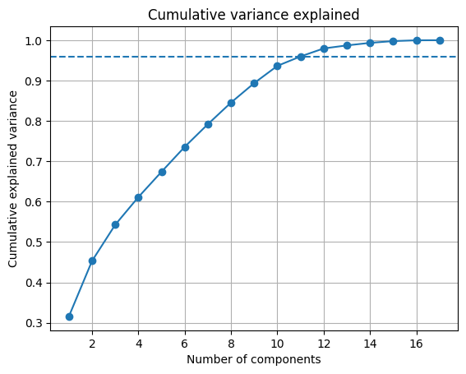


return_1 return_5 return_10 log_return_lag1 log_return_lag2
PC1 0.154286 0.338705 0.355854 0.130264 0.148250
PC2 0.233611 0.288298 0.140074 0.120923 0.145176
PC3 0.512857 -0.059844 -0.123834 -0.363059 0.070173
PC4 0.068118 -0.139020 0.110500 0.133261 -0.462791
PC5 -0.106650 -0.037342 0.121153 -0.416293 0.600768

log_return_lag3 log_return_lag5 log_return_lag10 ema_gap_10
PC1 0.159430 0.065548 0.023651 0.393167
PC2 0.060316 -0.013879 -0.090345 0.235373
PC3 -0.336630 -0.236214 0.143694 0.004346
PC4 0.026520 0.517307 -0.469806 -0.003817
PC5 -0.191126 0.353613 -0.146137 -0.015959

ema_gap_20 ema_gap_50 ema_gap_200 volatility_10 volatility_20
PC1 0.415845 0.395731 0.309902 -0.213778 -0.176595
PC2 0.085755 -0.134029 -0.353257 0.514909 0.545900
PC3 -0.032801 -0.006079 0.054577 -0.067711 -0.093480
PC4 -0.009333 -0.015700 -0.004529 -0.003710 -0.027807
PC5 0.018876 0.004702 -0.024690 0.023145 0.042203

Oil Gold Dollar index
PC1 0.065597 -0.011694 -0.064393
PC2 0.153161 -0.024689 -0.047778
PC3 0.439990 0.099635 -0.413048
PC4 0.210317 0.333882 -0.293249
PC5 -0.324065 0.377606 -0.065115

- Experimental Method
- Regression
Firstly, my main assumption was that I must predict the price, which was a mistake as it is impossible to do accurately. So, I decided to move to predict next day return. Even though it sounds similar to my first assumption; next day return are a bit easier to predict as well as they can be negative, which is also useful for predicting a direction of a graph. As I gave a time series data, I think that the best way to split train and test is to assign all years except 2017 to training, and 2017 for testing; and if needed I scaled only trained data and used Time Series Aware Cross Validation when applicable. Interesting fact – Oil, Gold and Dollar Index values are negatively affecting the performance of regression models. For all models I used RandomizedSearchCV to find best parameters.
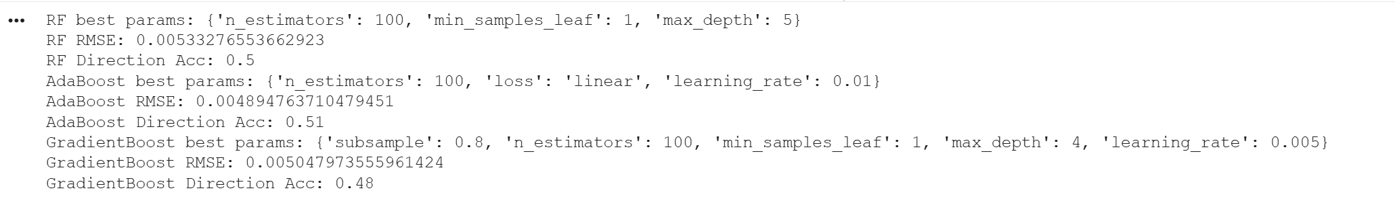
Image 4.1 – Performance of regressor models
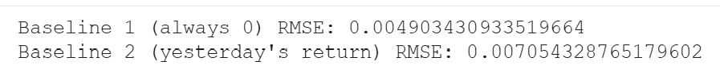
Image 4.2 – Performance of baseline models
From Image 4.1 and Image 4.2 we can see that the only acceptable candidate from those models is AdaBoost.
1. MLP
It did not perform well; I decided to abandon this way as soon as possible. Computational power consumption to performance is not optimal.
- Classification
For a classification problem I choose to predict the direction of a graph.
- RandomForestClassifiert, AdaBoost, Gradient Boost
None of them stood out, coin-flip performance.
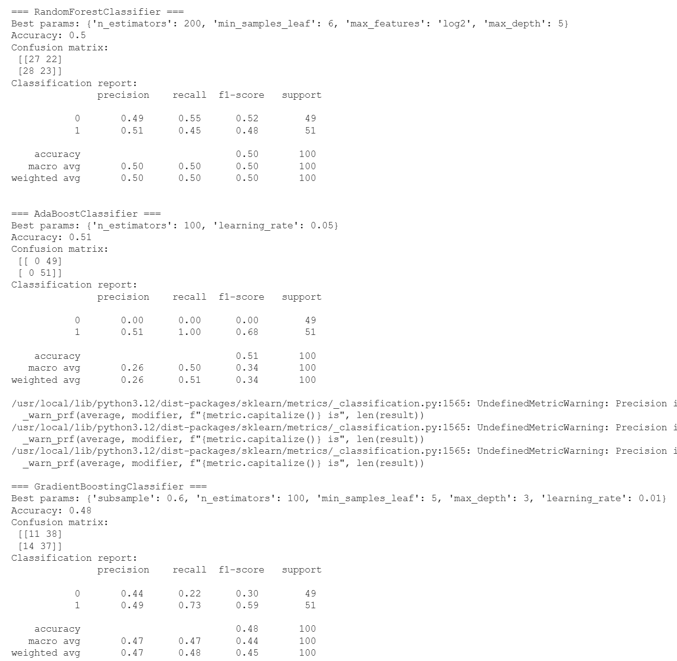
Image 4.3 – Tree based classifiers performance
- MLP Classification
The network has two hidden layers with 128 and 64 neurons respectively, each followed by a LeakyReLU activation function to introduce non-linearity while avoiding dead neurons. The output layer consists of a single neuron producing a logit, which is transformed into a probability of an upward move using the sigmoid function and trained with a binary cross-entropy loss (BCEWithLogitsLoss) and the Adam optimizer. And it worked out, see Image 4.4.
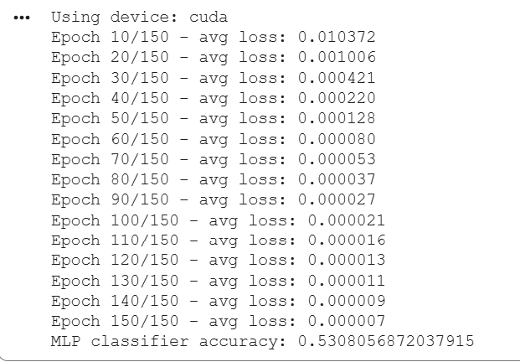
Image 4.4 – MLP Classifier Performance

- LSTM
Long Short Term Memory is widely know as to-go tool when you are working with time-series data, so I was interested in trying it out, basing my trial on Media post of M. Rowe [4]. My take on LSTM with early stopping achieved a final test MSE of 0.27 (RMSE ≈ 0.52) and a direction accuracy of 50.2%, unable to extract a strong, exploitable signal from daily S&P 500 returns. My assumption – ether its not good for short-term data or it needs more data.
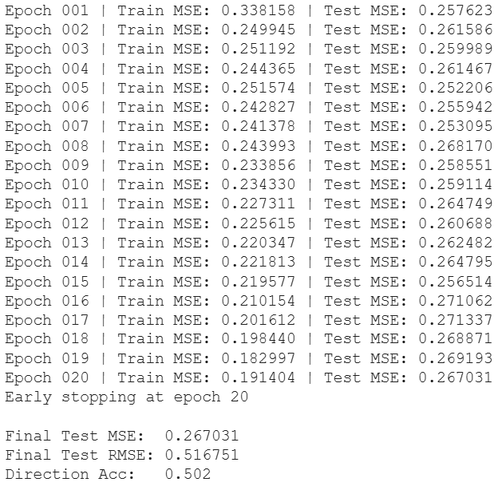
Image 4.5 – LSTM Performance
- Ensabling
By enabling my models I wanted to see if they are going to improve the performance of each other, or just be as their originals.
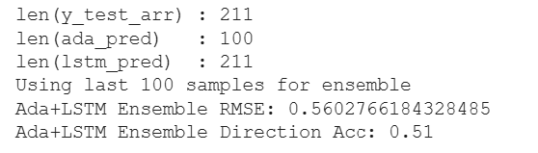
Image 4.6 – Ada+LSTM Perfomance
In this case (Image 4.6), I am putting 2 models – AdaBoost and LSTM together, hoping that they will complement each other. However, results are not the best ones, compared to MLP classifier. My assumption why it might underperform is that its tested on limited amount of records, as I couldn’t increase this number.

- Results and analysis
Name | RMSE | Direction Accuracy
Random Forest | 0.005399078524744366 | 0.53
AdaBoost | 0.004901083844217549 | 0.54
Gradient Boost | 0.005079857201359945 | 0.5
MLP | 0.01637618835218314 | -
LSTM | 0.525369 | 0.507
Table 5.1 – Regression models result

Name | Direct Accuracy
Random Forest | 0.50
AdaBoost | 0.51
Gradient Boost | 0.48
MLP | 0.5355450236966824
Table 5.2 – Classification models result

Regarding results, we noticed that each model does not exceed 60% in accuracy, some of them are not even better than a coin flip, RMSE is not the greatest; but it’s just one metrics. Main point of the model is to be profitable, or at least don’t loose money. For this task, Monte Carlo simulation is a suitable tool, and it is widely used in finance as described by Will Kenton [5]. For each strategy (Buy & Hold, AdaBoost, LSTM, Ada+LSTM ensemble, and MLP), I first computed the series of daily simple returns over the 2017 test period and clipped extreme values to the range −20% to +20%. I then converted these returns to log-returns and estimated their mean (μ) and standard deviation (σ). Using the standard GBM formula $S_{t+1}=S_{t}exp⁡(\text{drift}+σZ_{t})$with $\text{drift}=μ-0.5σ^{2}$and $Z_{t}∼N(0,1)$, I simulated 500 random equity paths starting from 1.
Buy and Hold strategy serves as a baseline with mu=8.354322e-04, sigma=5.523145e-03, drift=8.201796e-04, which can be translated to ~23% annual return. Apparently, for my simulation, AdaBoost decided that the best strategy is to buy all the time, which is basically as same as Buy and Hold Strategy. LSTM surprisingly shown a 7% annual return and ensemble LSTM + AdaBoost managed to score 15% annual return, but to be fair, ensemble also been entering long most of the time. At the end, even though MLP was one of the most accurate classifier, it managed to loose money having -12% annual return.

Index returns stats (full): 0.0008508772279172632 0.005491624818258014 -0.0181782145892192 0.013910120286568572
BH stats: mean=8.508772e-04 std=5.491625e-03
Ada stats: mean=8.508772e-04 std=5.491625e-03
LSTM stats:mean=2.833725e-04 std=5.549922e-03
ENS stats: mean=5.671249e-04 std=4.164602e-03
MLP stats: mean=-4.947372e-04 std=5.535085e-03
Buy & Hold (index): mu=8.354322e-04, sigma=5.523145e-03, drift=8.201796e-04
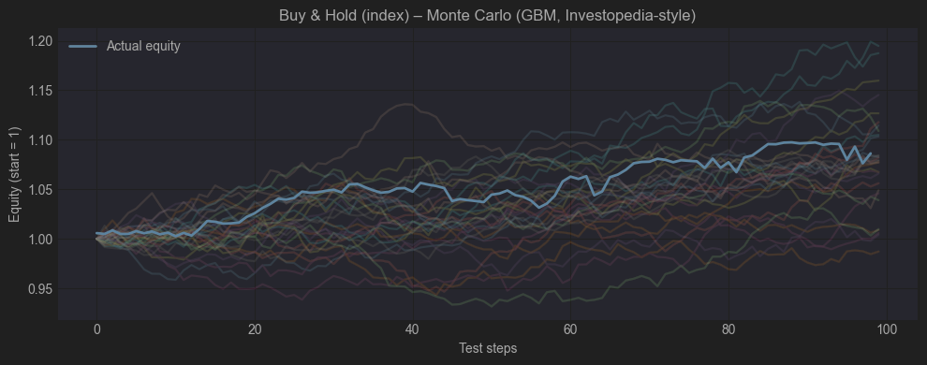
Image 5.1 – Buy and Hold

AdaBoost: mu=8.354322e-04, sigma=5.523145e-03, drift=8.201796e-04
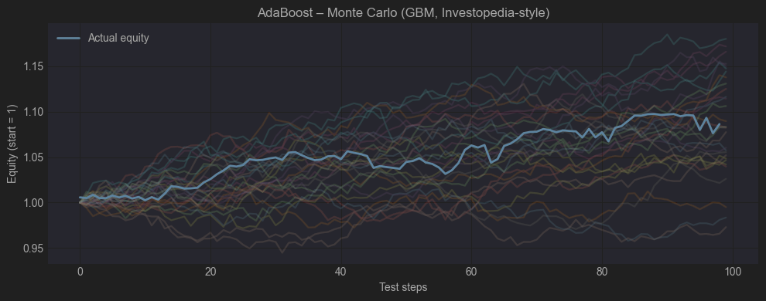
Image 5.2 – AdaBoost
LSTM: mu=2.679312e-04, sigma=5.579103e-03, drift=2.523680e-04
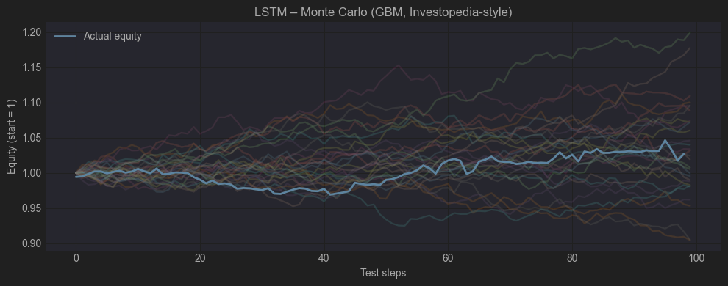
Image 5.3 – LSTM

Ada + LSTM ensemble: mu=5.582902e-04, sigma=4.187758e-03, drift=5.495215e-04
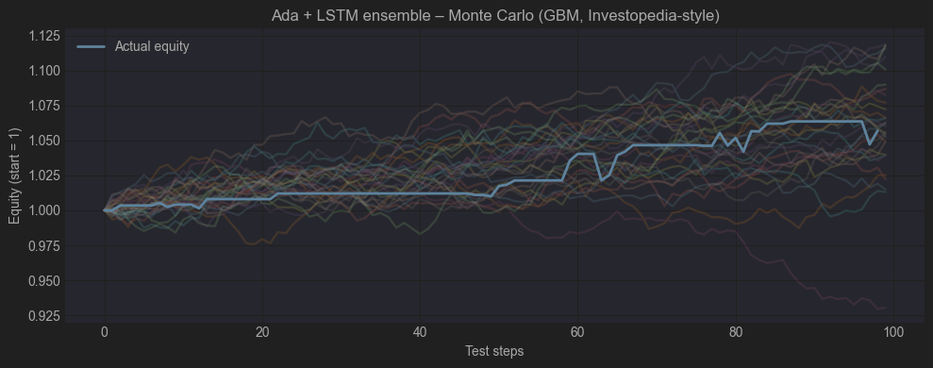
Image 5.4 – LSTM+AdaBoost ensemble

MLP classifier (dir): mu=-5.102316e-04, sigma=5.576459e-03, drift=-5.257801e-04
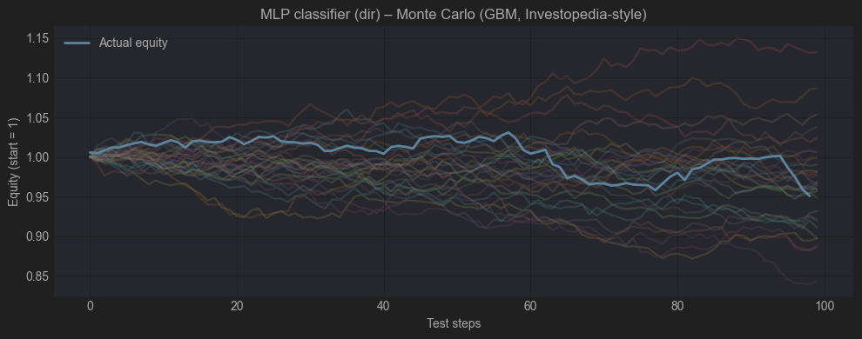
Image 5.5 – MLP Classifier

- References
- CNNpred: CNN-based stock market prediction using a diverse set of variables [Dataset]. (2019). UCI Machine Learning Repository. https://doi.org/10.24432/C55P70
- Ghorbani M, Chong EKP. Stock price prediction using principal components. Gherghina SC, editor. PLOS ONE. 2020 Mar 20;15(3):e0230124
https://journals.plos.org/plosone/article?id=10.1371/journal.pone.0230124#:~:text=The%20literature%20provides%20strong%20evidence,and%20analysis%20of%20the%20data
- Ghorbani M, Chong EKP. Stock price prediction using principal components. Gherghina SC, editor. PLOS ONE. 2020 Mar 20;15(3):e0230124
https://journals.plos.org/plosone/article?id=10.1371/journal.pone.0230124#:~:text=The%20literature%20provides%20strong%20evidence,and%20analysis%20of%20the%20data.
- Rowe M. Using PyTorch to Train an LSTM Forecasting Model [Internet]. Medium. 2023. Available from: https://medium.com/@mike.roweprediger/using-pytorch-to-train-an-lstm-forecasting-model-e5a04b6e0e67
- Kenton W. Monte Carlo Simulation: What It Is, How It Works, History, 4 Key Steps [Internet]. Investopedia. 2024. Available from: https://www.investopedia.com/terms/m/montecarlosimulation.asp
- Project link - https://colab.research.google.com/drive/1d05mTy_xGOCNq5zYt5ltzSG49FusgkAt?usp=sharing

