We chose a network to use in our experiment by reviewing 17 real-world datasets. Names, sources, and details of these networks are listed below. The network we chose, recipe ingredients, is larger than networks previously evaluated but small enough to be visualized smoothly in a browser, has a ratio of edges-to-nodes close to the median, and has a node-degree distribution similar to most networks.

|  |  |  |  |  |  |
| --- | --- | --- | --- | --- | --- |
| Dataset name and source | *N* | *E* | *E/N* | *√(E/N2)* | Description |
| Les Miserables  <http://networkdata.ics.uci.edu/data/lesmis/lesmis.gml> | 77 | 254 | 3.2 | 0.04 | Co-appearances of characters in Victor Hugo's novel "Les Miserables". |
| Universities  <http://gmap.cs.arizona.edu/static/media/univ.gv> | 161 | 745 | 4.6 | 0.02 | US universities and their average SAT scores. Edges are constructed based on their similarities of admission data. |
| World-trade  <http://gmap.cs.arizona.edu/static/media/trade.gv> | 211 | 1671 | 7.9 | 0.03 | Trade relationships between countries. Links are imports /exports between countries. |
| **Recipe-ingredients**  [**http://gmap.cs.arizona.edu/static/media/recipes.gv**](http://gmap.cs.arizona.edu/static/media/recipes.gv) | **258** | **1090** | **4.2** | **0.016** | **Unique cooking ingredients extracted from 56498 cooking recipes. Links are co-occurrence in recipes.** |
| Colors  <http://gmap.cs.arizona.edu/static/media/colors.gv> | 949 | 3378 | 3.5 | 0.003 | 949 uniquely named colors with links defined by the distance in RGB space between corresponding pairs. |
| GD collaboration  <http://gmap.cs.arizona.edu/static/media/gd.gv> | 1001 | 2627 | 2.6 | 0.002 | Co-authorship for the international symposiums on Graph Drawing, 1994 - 2015. |
| Music-Land (last.fm)  <http://gmap.cs.arizona.edu/static/media/lastfm.gv> | 2588 | 28221 | 10.9 | 0.004 | Data crawled from the last.fm website. A graph containing 2588 musicians, edge weight corresponds to the similarity of musicians. |
| Book-Land (Amazon book titles)  <http://gmap.cs.arizona.edu/static/media/books.gv> | 3204 | 9639 | 3.0 | 0.9m | 3204 books and 9639 edges based on Amazon’s “Customers Who Bought This Item Also Bought” links. |
| Facebook | 4039 | 88234 | 21.8 | 0.005 | Facebook friendship data. |
| TVCG colloaboration  <http://gmap.cs.arizona.edu/static/media/tvcg.gv> | 4345 | 11732 | 2.7 | 0.6m | Co-authorship network from the IEEE TVCG 1995-2015. |
| Protein_Graph_Sparser  <http://vizlab.cs.fiu.edu/graphtasks/protein_graph_sparser.gv> | 6313 | 17865 | 2.8 | 0.4m | Proteins and interactions between them (from hprd.org) |
| Knowledge Repo  <https://github.com/graphbig/graphBIG/wiki/GraphBIG-Dataset> | 154K | 1.72M | 11.1 | 0.07m |  |
| CA RoadNet  <https://github.com/graphbig/graphBIG/wiki/GraphBIG-Dataset> | 1.9M | 2.8M | 1.4 | 0.7μ |  |
| Watson Gene graph  <https://github.com/graphbig/graphBIG/wiki/GraphBIG-Dataset> | 2M | 12.2M | 6.1 | 0.003m |  |
| Web crawling pay-level-domain  <http://webdatacommons.org/hyperlinkgraph/> | 43M | 623M | 14.4 | 0.3μ |  |
| Web crawling Host  <http://webdatacommons.org/hyperlinkgraph/> | 101M | 2043M | 20.2 | 0.02μ | Web pages and hyperlinks |
| Web crawling Page  <http://webdatacommons.org/hyperlinkgraph/> | 3563M | 128T | 36.1 | 0.01μ | Web pages and hyperlinks |

X: log(#nodes)

Y: #edges/#nodes Y: sqrt(#edges/#nodes2)

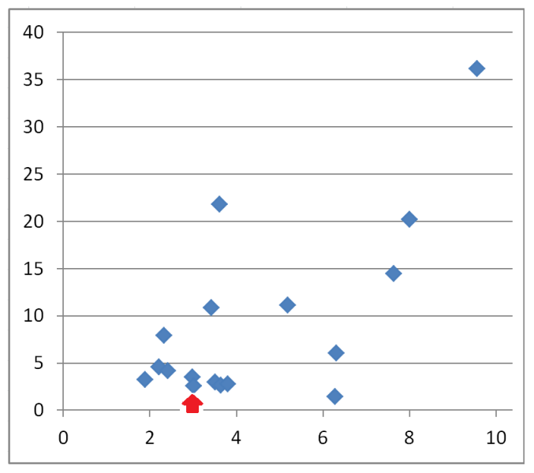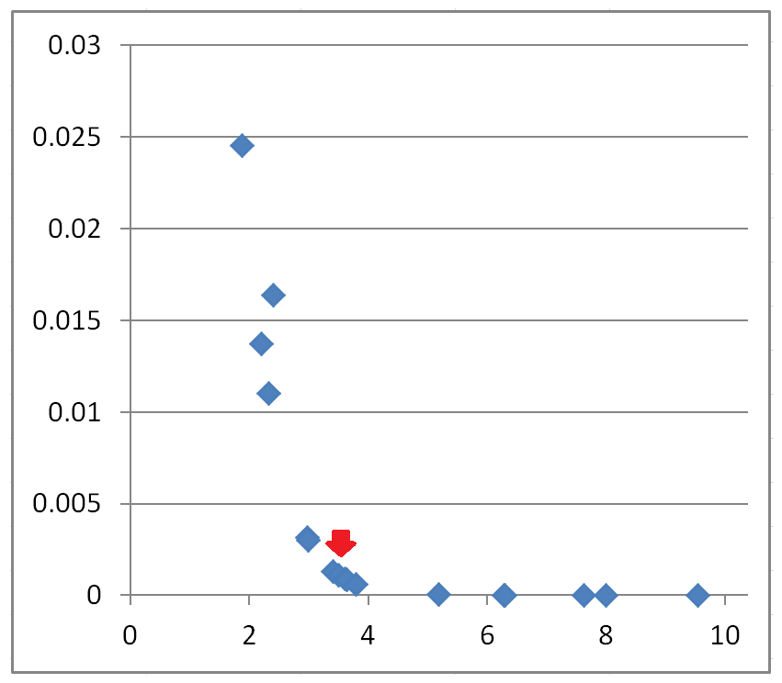

Red arrows points to the evaluated network. The chart on the right shows that large networks rarely come with large densities.

Node degree distributions for a subset of the networks. Red marks the evaluated network.

