**TM Forum Specification**

${ApiName}

**${DocumentNumber}**

**${Release}**

**${Date}**

|  |  |
| --- | --- |
| **Latest Update: TM Forum Release ${Release}** | **Member Evaluation** |
| **Version ${version}** | **IPR Mode: RAND** |

# NOTICE

Copyright © TM Forum ${Year}. All Rights Reserved.

This document and translations of it may be copied and furnished to others, and derivative works that comment on or otherwise explain it or assist in its implementation may be prepared, copied, published, and distributed, in whole or in part, without restriction of any kind, provided that the above copyright notice and this section are included on all such copies and derivative works. However, this document itself may not be modified in any way, including by removing the copyright notice or references to TM FORUM, except as needed for the purpose of developing any document or deliverable produced by a TM FORUM Collaboration Project Team (in which case the rules applicable to copyrights, as set forth in the [TM FORUM IPR Policy](http://www.tmforum.org/IPRPolicy/11525/home.html), must be followed) or as required to translate it into languages other than English.

The limited permissions granted above are perpetual and will not be revoked by TM FORUM or its successors or assigns.

This document and the information contained herein is provided on an "AS IS" basis and TM FORUM DISCLAIMS ALL WARRANTIES, EXPRESS OR IMPLIED, INCLUDING BUT NOT LIMITED TO ANY WARRANTY THAT THE USE OF THE INFORMATION HEREIN WILL NOT INFRINGE ANY OWNERSHIP RIGHTS OR ANY IMPLIED WARRANTIES OF MERCHANTABILITY OR FITNESS FOR A PARTICULAR PURPOSE.

Direct inquiries to the TM Forum office:

4 Century Drive, Suite 100

Parsippany, NJ 07054, USA

Tel No. +1 973 944 5100

Fax No. +1 973 998 7916

TM Forum Web Page: [www.tmforum.org](http://www.tmforum.org/)

# Table of Contents

**INSERT-TOC**

# Introduction

${userguide.variables.intro}

# SAMPLE USE CASES

## Service inventory query for a customer

The Service Inventory API can be used to query the service instances for a customer via Self Service Portal or the Call Centre operator can query the service instances on behalf of the customer while a customer may have a complaint or a query.

Note: Only the CustomerFacingServices instances will be presented to the customer.

## Service inventory update as part of service provisioning

The Service Inventory API can be called by the Service Order Management to create a new service instance/ update an existing service instance in the Service Inventory.

# Support of polymorphism and extension patterns

Support of polymorphic collections and types and schema based extension is provided by means of a list of generic meta-attributes that we describe below. Polymorphism in collections occurs when entities inherit from base entities, for instance a TypeAService or TypeBService inheriting properties from the base Service entity.

Generic support of polymorphism and pattern extensions is described in the TMF API Guidelines v3.0 Part 2 document.

The @type attribute provides a way to represent the actual class type of an entity. For example, within a list of Service instances some may be instances of TypeAService where other could be instances of TypeBService. The @type gives this information. All resources and sub-resources of this API have a @type attributes that can be provided when this is useful.

The @referredType can be used within reference entities (like for instance an RelatedParty object) to explicitly denote the actual entity type of the referred class. Notice that in reference entities the @type, when used, denotes the class type of the reference itself, such as RelatedParty, and not the class type of the referred object. However since reference classes are rarely sub-classed, @type is generally not useful in reference objects.

The @schemaLocation property can be used in resources to allow specifying user-defined properties of an Entity or to specify the expected characteristics of an entity.

The @baseType attribute gives a way to provide explicitly the base of class of a given resource that has been extended.

# RESOURCE MODEL

## Managed Entity and Task Resource Models

### FIRST resource

## Lifecycle of Service

Here is the state machine diagram for a Service:

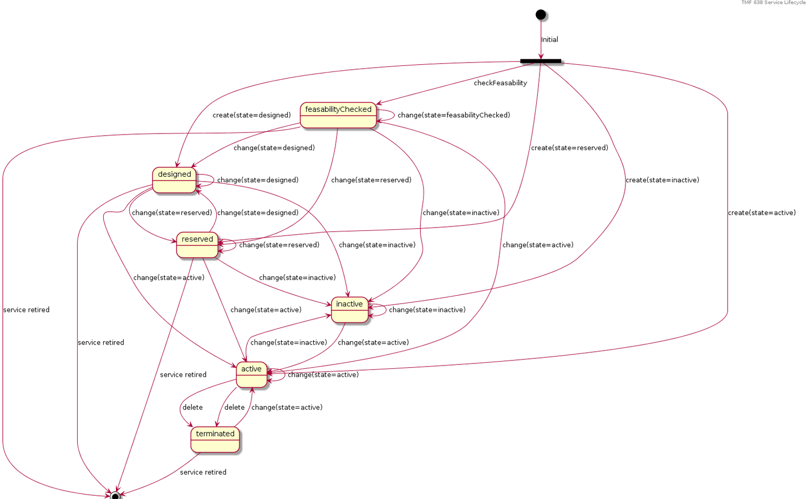

The following table provided service state explanation:

|  |  |
| --- | --- |
| A service is in state… | when the Service Component Activation Interface shall support the following operations |
| feasabilityChecked | The service component OS is requested to determine whether the necessary resources are available and sufficient for the installation of a given service.  It should be noted that this is just an initial feasibility check and no RFS is created. |
| designed | The Service Component OS is requested to design the service. This could be use to allocate resource but nothing is supposed to be reserved. |
| reserved | The Service Component OS is requested to reserve a resource, or a set of resources, required for a service. This situation allows for the requesting OS to determine whether the underlying resources are available and reserve them in order to support a service (a RFS).  As a result of the reservation request, a servce is instantiated & reserved. |
| inactive | The service is deactivated - The Resource Facing service is deactivated and thus is no longer available for service. It remains allocated to the CFS that is managed by the high level service activation OS |
| active | The service component OS is requested to activate a given resource facing service such that the component is fully available and active as part of the CFS.  When this request is complete, all RFS component shall be in active state |
| terminated | The service is ‘logically deleted’. The resource facing service is deleted and thus allocated from the CFS. All associated resources are freed and made available for service to other users. |

## Notification Resource Models

### First Notification

# API OPERATIONS

Remember the following Uniform Contract:

|  |  |  |
| --- | --- | --- |
| Operation on Entities | Uniform API Operation | Description |
| Query Entities | GET Resource | GET must be used to retrieve a representation of a resource. |
| Create Entity | POST Resource | POST must be used to create a new resource |
| Partial Update of an Entity | PATCH Resource | PATCH must be used to partially update a resource |
| Remove an Entity | DELETE Resource | DELETE must be used to remove a resource |

Filtering and attribute selection rules are described in the TMF REST Design Guidelines Part 1 document.

Notifications are also described in a subsequent section.

## VERB url

# API NOTIFICATIONS

For every single of operation on the entities use the following templates and provide sample REST notification POST calls.

It is assumed that the Pub/Sub uses the Register and UnRegister mechanisms described in the REST Guidelines part 1. Refer to the guidelines for more details.

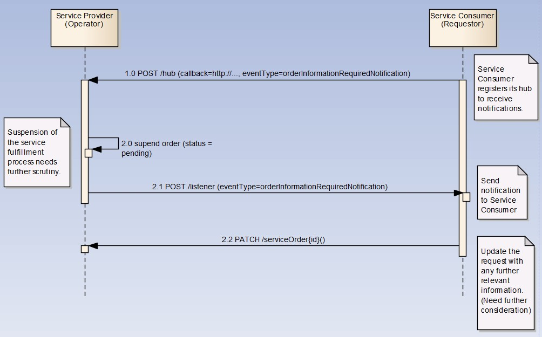

## Register listener

**POST /hub**

**Description**

Sets the communication endpoint address the service instance must use to deliver information about its health state, execution state, failures and metrics. Subsequent POST calls will be rejected by the service if it does not support multiple listeners. In this case DELETE /api/hub/{id} must be called before an endpoint can be created again.

**Behavior**

Returns HTTP/1.1 status code 204 if the request was successful.

Returns HTTP/1.1 status code 409 if request is not successful.

**Usage Samples**

Here's an example of a request for registering a listener.

|  |
| --- |
| **Request** |
| POST /api/hub  Accept: application/json  {"callback": "http://in.listener.com"} |
| **Response** |
| 201  Content-Type: application/json  Location: /api/hub/42  {"id":"42","callback":"http://in.listener.com","query":null} |

## Unregister listener

**DELETE /hub/{id}**

**Description**

Clears the communication endpoint address that was set by creating the Hub.

**Behavior**

Returns HTTP/1.1 status code 204 if the request was successful.

Returns HTTP/1.1 status code 404 if the resource is not found.

**Usage Samples**

Here's an example of a request for un-registering a listener.

|  |
| --- |
| **Request** |
| DELETE /api/hub/42  Accept: application/json |
| **Response** |
| 204 |

## Publish Event to listener

**POST /client/listener**

**Description**

Clears the communication endpoint address that was set by creating the Hub.

Provides to a registered listener the description of the event that was raised. The /client/listener url is the callback url passed when registering the listener.

**Behavior**

Returns HTTP/1.1 status code 201 if the service is able to set the configuration.

**Usage Samples**

Here's an example of a notification received by the listener. In this example “EVENT TYPE” should be replaced by one of the notification types supported by this API (see Notification resources Models section) and EVENT BODY refers to the data structure of the given notification type.

|  |
| --- |
| **Request** |
| POST /client/listener  Accept: application/json  {  "event": {  EVENT BODY  },  "eventType": "EVENT_TYPE"  } |
| **Response** |
| 201 |

For detailed examples on the general TM Forum notification mechanism, see the TMF REST Design Guidelines Part 1 document.

# Acknowledgements

## Release History

|  |  |  |  |
| --- | --- | --- | --- |
| **Release Number** | **Date** | **Release led by:** | **Description** |
|  |  |  |  |

## Contributors to Document

|  |  |
| --- | --- |
| **Name** | **Organization** |
|  |  |
|  |  |
|  |  |
|  |  |