TLC Sprint 2 Meeting |MINUTES

*03/01/2019 9:00 AM*

Cegep Heritage College RoomB219

# Attendees

|  |  |  |
| --- | --- | --- |
| Guy Beaulieu | Product Owner |  |
| Richard Chan | Project Coordinator |  |
| Cody Douris | Developer |  |
| Slava Knyazev | Developer |  |
| Patrick Mirowski | Developer |  |
| Thomas Palaisy | Developer & Scribe |  |

# Invited but Did Not Attend

# Subject

Display of Teams progress on committed work items during sprint 2b. Discussion of completeness of work items, review of work items left to complete, and review of work item priorities. Discussion fuzzy or unsure topics of the project with product owner.

# Discussion Topics

Work items committed on:

Complete

Student sees topic

Student sees schedule by department

Not Complete

Student views queues

Student adds themselves

User stories for the next sprint will be prioritized in such a way as the photo below.

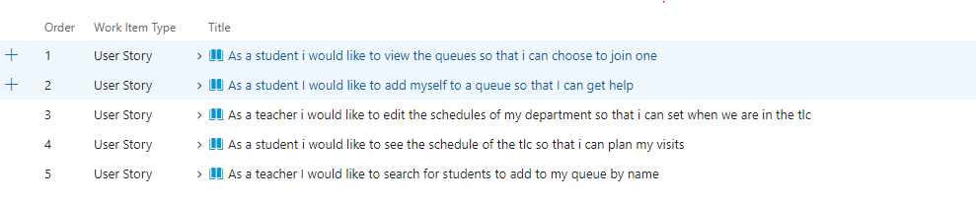

# Decisions

|  |  |
| --- | --- |
| D1 | Topics will include their respective 3 letter code preface |
| D2 | An extra “Other” topic will be added to the list of possible topics |
| D3 | Showing summery of queue to student is the best option. Teacher name, hours, today’s date |
| D4 | Students should only be able to see where they are in the queue |
| D5 | Schedule should have a department |
| D6 | Student must login on tablet in TLC with their student id and are confirmed with their initials |
| D7 | Data given to teacher should be given report first but both would be preferred |
| D8 | Schedule timeslots are split by hour and not by half hour |
| D10 | Sandbox will contain full teacher functionality and select student functionality with updated GUI |

# Actions

|  |  |  |  |  |
| --- | --- | --- | --- | --- |
| A1 | Cody | Email meeting minutes to attendees | Open | 03/02/2020 |
| A2 | Cody | Email sprint commit email to attendees | Open | 03/02/2020 |
| A3 | Thomas | Remove redundant or refactored user stories such as time estimates, group functionality, and student viewing topic | Open | 03/02/2020 |
| A4 | Thomas | Create specific GUI user story in TFS | Open | 03/02/2020 |

# Follow up and next steps

* The development team will send out the Meeting Minutes.
* Complete actions mentioned in above.
* A commit email will be sent out to the client outlining the next sprint.
* Next meeting will be scheduled on February 14th, 2020.