Supplementary Figures

Supplementary Figure 1: PlasmoFAST’s k-mer approach differentiates between lab strains when applied to samples used to curate variable positions. This figure shows, for each of the 7 samples used to determine variable positions between strains, a breakdown of positions found by PlasmoFAST for the two strains with the greatest proportion of “Specific” covered positions [Supplementary Data 1].
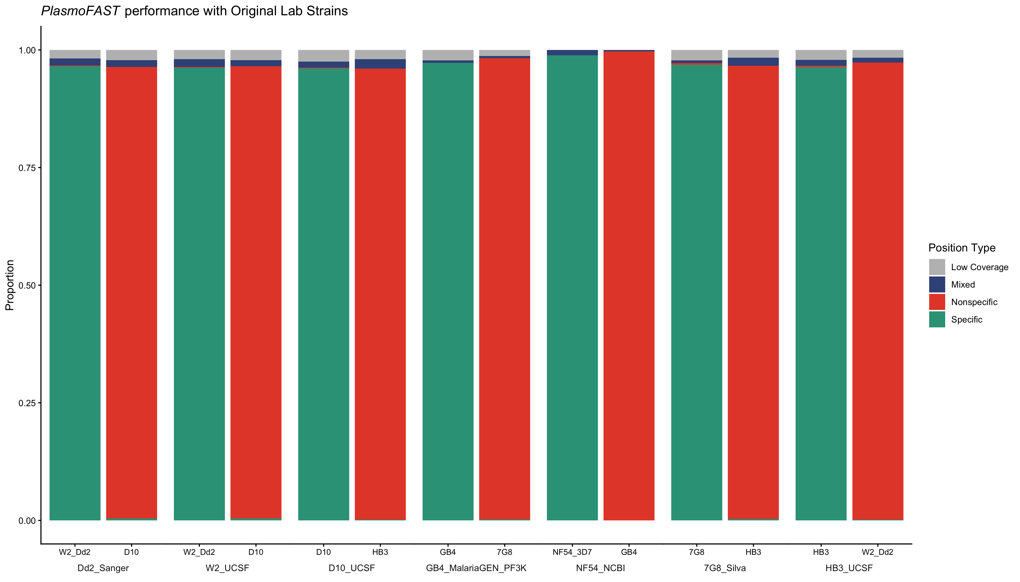
Supplementary Figure 2: PlasmoFAST is effective at identifying lab strains from Illumina WGS data. This figure shows, for each Illumina WGS sample of P. falciparum lab strains, the breakdown of positions found by PlasmoFAST for the two strains with the greatest proportion of “Specific” covered positions [Supplementary Data 2].
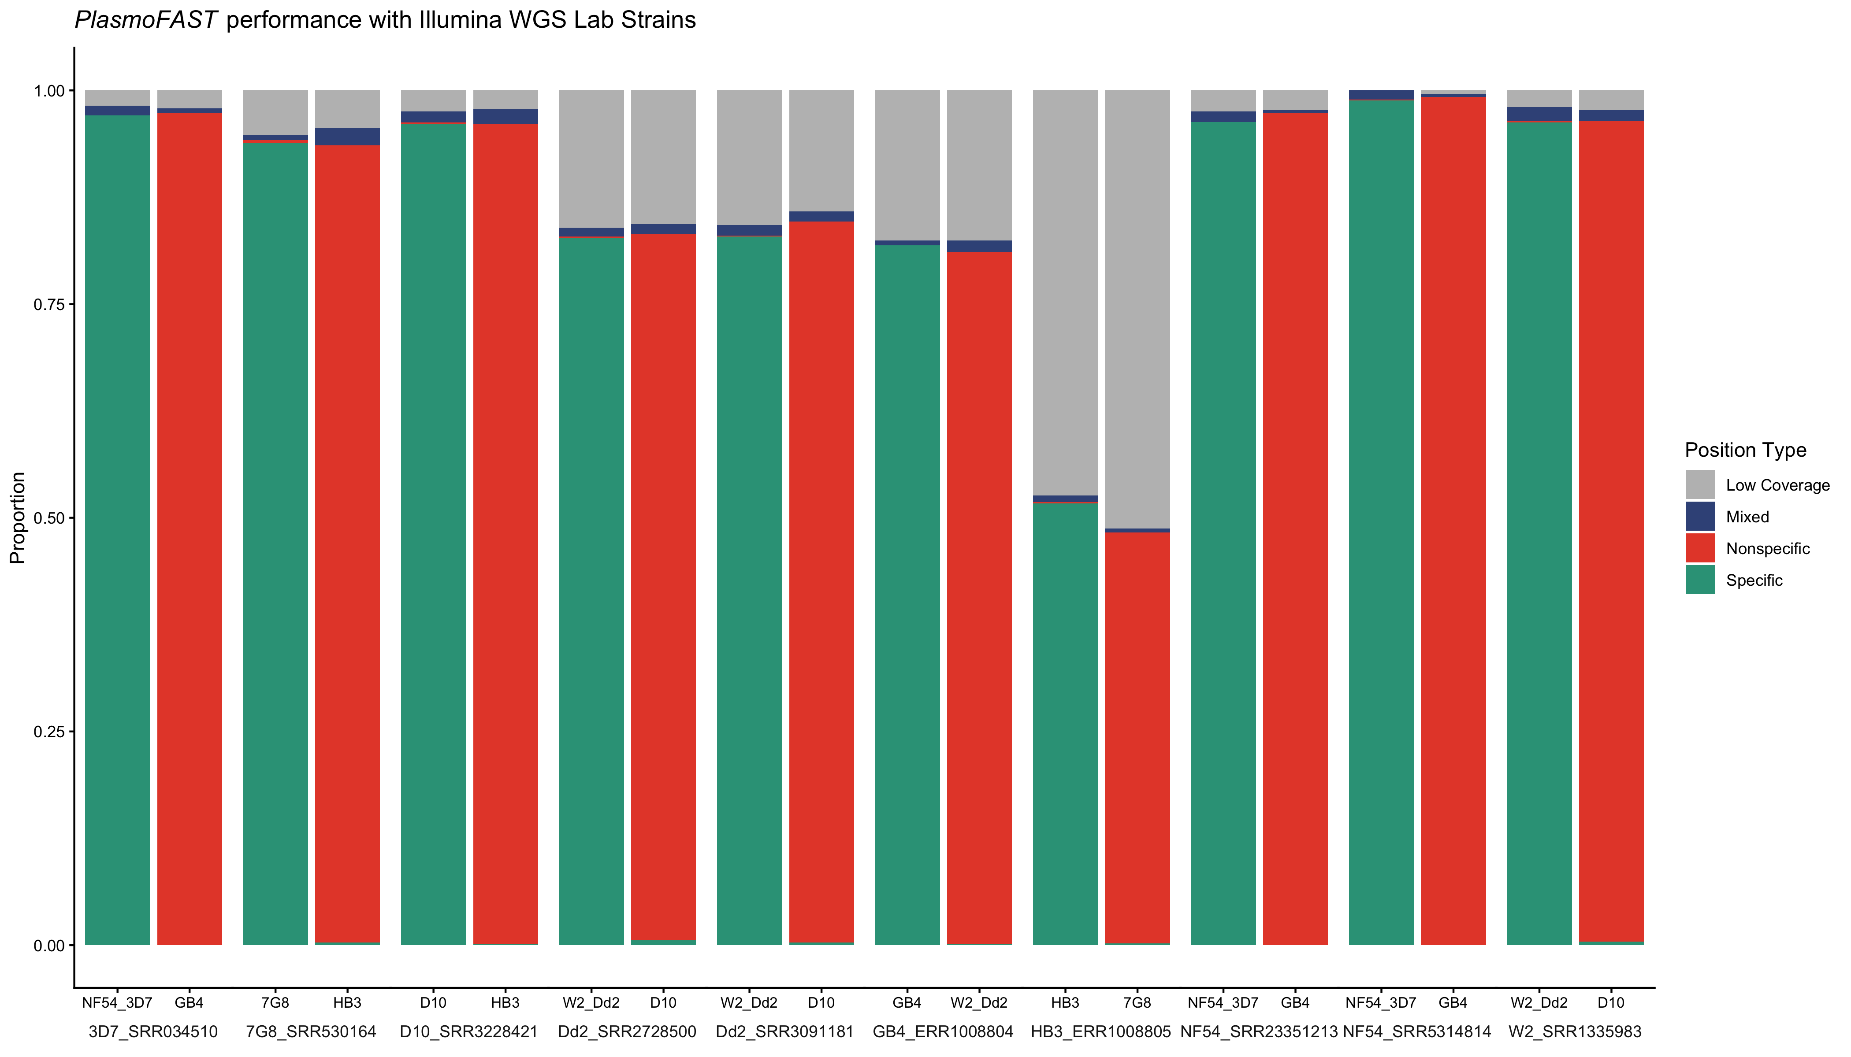

Supplementary Figure 3: Field isolates of P. falciparum are not identified as lab strains by PlasmoFAST. For each field isolate sequenced with Illumina WGS, this figure shows the breakdown of positions found by PlasmoFAST for the two strains with the greatest proportion of “Specific” covered positions [Supplementary Data 4].
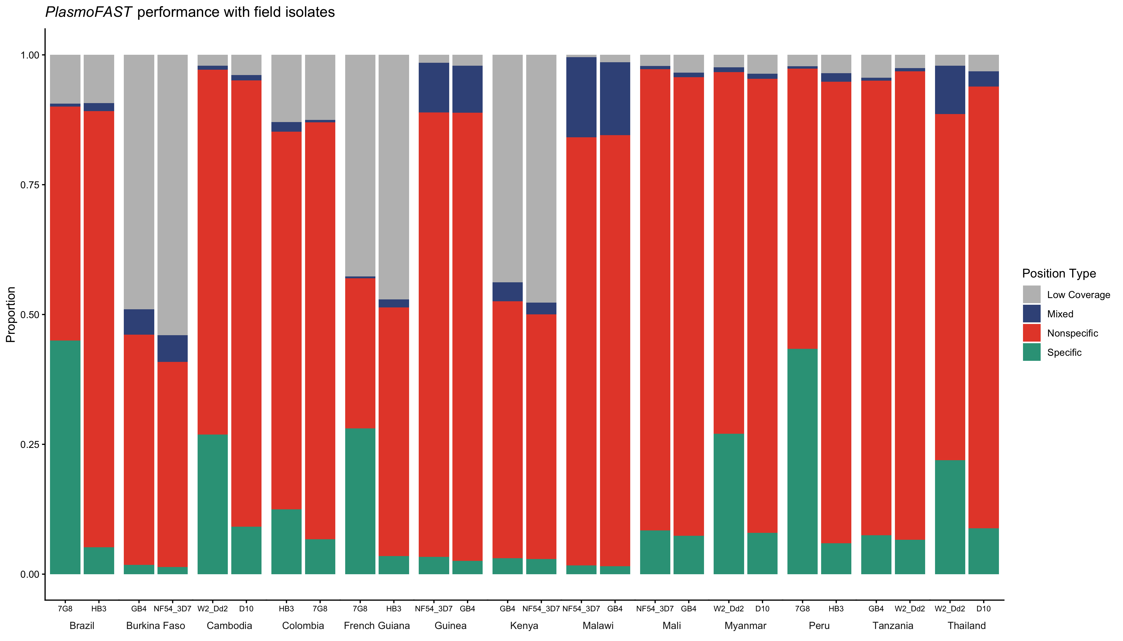

Supplementary Figure 4. PlasmoFAST is sensitive to mixtures of laboratory strains present in sequencing data. This figure shows the results of running PlasmoFAST on a mock dataset created by subsampling and combining RNA-seq reads from Dd2 (SRR3107187) and 3D7 (SRR3107189) [Supplementary Data 5].
Supplementary Figure 5. The k-mers used by PlasmoFAST are specific to P. falciparum. This figure shows the results of running PlasmoFAST on WGS from common laboratory strains of P. knowlesi and P. vivax. For each sample tested, the figure displays the breakdown of positions found by PlasmoFAST for the two strains with the greatest proportion of “Specific” covered positions [Supplementary Data 6].
