Supplementary Figures
Supplementary Figure 1. 25bp k-mers allow the majority of k-mers expected in 3D7 to be present only once and minimizes detection of k-mers not expected in 3D7. This figure shows, for k-mers of length 5-30, the number of k-mers specific to 3D7 that appear only once in the 3D7 genome and the number of k-mers not expected in 3D7 found at least once in the 3D7 genome, in blue and red, respectively (see also Supplementary Data 2). The vertical dotted line indicates that k-mers of length 25bp.

Supplementary Figure 2: PlasmoFAST is effective at identifying lab strains from Illumina WGS data. This figure shows, for each Illumina WGS sample of P. falciparum lab strains, the breakdown of positions found by PlasmoFAST for the two strains with the greatest proportion of “Specific” covered positions (see also Supplementary Data 3).

Supplementary Figure 3. PlasmoFAST is sensitive to mixtures of laboratory strains present in sequencing data. This figure shows the results of running PlasmoFAST on a mock dataset created by subsampling and combining RNA-seq reads from Dd2 (SRR3107187) and 3D7 (SRR3107189) (see also Supplementary Data 5)

Supplementary Figure 4: Field isolates of P. falciparum are not identified as lab strains by PlasmoFAST. For each field isolate sequenced with Illumina WGS, this figure shows the breakdown of positions found by PlasmoFAST for the two strains with the greatest proportion of “Specific” covered positions (see also Supplementary Data 6).
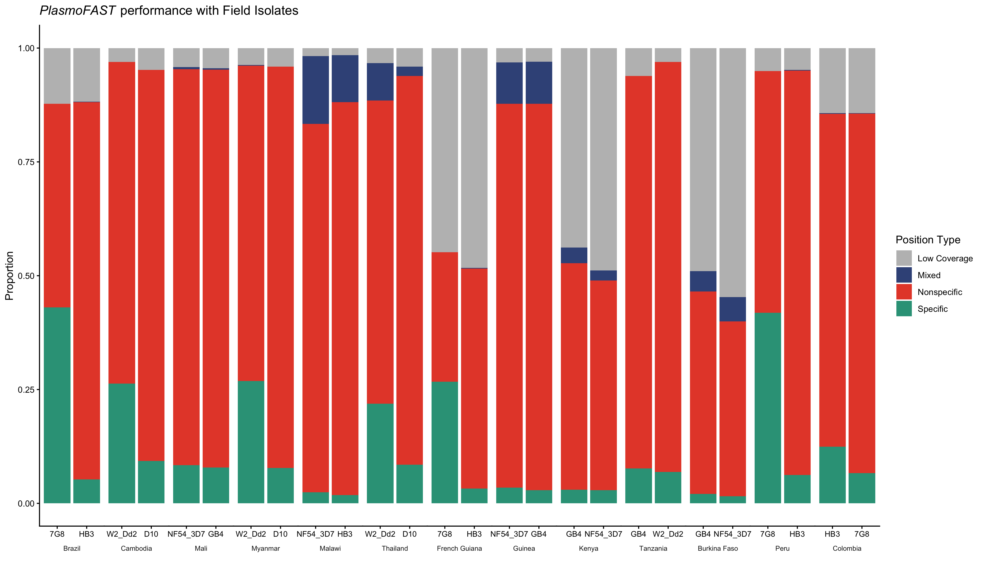

Supplementary Figure 5. The k-mers used by PlasmoFAST are specific to P. falciparum. This figure shows the results of running PlasmoFAST on WGS from common laboratory strains of P. knowlesi and P. vivax. For each sample tested, the figure displays the breakdown of positions found by PlasmoFAST for the two strains with the greatest proportion of “Specific” covered positions (see also Supplementary Data 7).

